A learning from home pack
for learners in years 1–3
We shape an education system that delivers equitable and excellent outcomes
He mea tārai e mātou te mātauranga kia rangatira ai, kia mana taurite ai ōna huanga
4 Feb 2022 | Trial version published
28 Feb 2022 | Version 2 – includes extension to 10 days of activities, improvements from trial feedback

Creativity – How do we express ourselves?
“Creativity is intelligence having fun.”  ~Albert Einstein | I orea te tuatara ka patu ki waho
 | A problem is solved by continuing to find solutions

Notes for teachers

Purpose
We know there will be additional challenges for our schools, our learners, and their whānau in 2022. The purpose of these learning from home packs is to support you as you prepare to provide continuous learning for all learners through the next period of the Covid pandemic.

Flexibility
The packs are designed to be used flexibly for the types of interruptions learners may face.
- They may need to isolate at home.
- Due to health and safety requirements, such as social distancing, your school might not be able to have all students on site. Hybrid learning may start.
- Your school might close, and learners would need to learn from home. (Note: the intention under the Covid Protection Framework is to keep schools open.)

Hybrid learning
Hybrid learning describes when schools and kura are simultaneously teaching some learners face-to-face on site and supporting others to through distance-learning options. You may also be teaching learners who are not normally in your class. For most of us, hybrid learning is a new experience.

Realities
You know your learners and have a good understanding of their learning situations.
Many learners will have siblings at home, as well as whānau who share the same space and devices. Some may have access to the internet and devices, and others may not. Learners will also have varying levels of adult support.
There are a mix of activities in this pack that use materials commonly found in most homes. Some activities will require adult support while others can be managed independently. This resource is provided as a Word document so that you can adapt it for your learners.
We suggest starting each day with a karakia (see p. 9), check in with the teacher, followed by setting up the learning environment. The pack contains suggestions, but you can replace these with however you want your learner to start their day.

Resources
The resource uses a range of books from the Ready to Read and School Journal series. You might want to send these home with the learner, along with a “my home learning” exercise book, pencils, crayons, or felts, and some craft materials (glue, scissors, construction paper). Learners can bring their home learning book back to class to share.
If your learners do not have reliable access to the internet, here are the resources to print and send home with this to create a paper-based pack.

Pages to print for this pack:
- Face cards https://pb4l.tki.org.nz/content/download/576/2328/file/PB4LIYTEmotionalFaces.pdf
- 2 copies BLANK map of New Zealand: https://blankworldmap.net/wordpress/wp-content/uploads/2021/02/Blank-Map-of-New-Zealand-Outline.jpg
- Number Cards for taniwha activity: https://hereoora.tki.org.nz/content/download/748/11765/version/4/file/Nga+Tau+Worksheet+6.1.pdf
- Volcano colour by numbers: http://www.homemade-preschool.com/support-files/mw-color-by-numbers-volcano-1-5.pdf
- Identity card (first page only): https://www.pottonandburton.co.nz/wp-content/uploads/2019/11/At-the-Beach-identity-card.pdf

School journals / Ready to Reads used in this pack:
- Two Homes https://instructionalseries.tki.org.nz/Instructional-Series/Ready-to-Read-Colour-Wheel/Two-Homes
- Whai (String Games) https://instructionalseries.tki.org.nz/Instructional-Series/Ready-to-Read-Colour-Wheel/Whai-String-Games
- Hannah’s Game https://instructionalseries.tki.org.nz/Instructional-Series/Ready-to-Read-Colour-Wheel/Hannah-s-Game
- The Gardener’s Maze https://instructionalseries.tki.org.nz/Instructional-Series/Ready-to-Read-Colour-Wheel/The-Gardener-s-Maze
- Maui and the Sun (audio clip) https://instructionalseries.tki.org.nz/Media/Instructional-Series/Ready-to-Read/LIVE-Ready-to-Read-audio-versions/Maui-and-the-Sun-audio)
- Maui and the Sun (PDF text) https://esolonline.tki.org.nz/Media/Instructional-Series/Ready-to-Read/Ready-to-Read-Online-2020/RTR-Maui-and-the-Sun-PDF
- The Gardener and the Scarecrow https://instructionalseries.tki.org.nz/Instructional-Series/Ready-to-Read-Colour-Wheel/The-Gardener-and-the-Scarecrow
- Scarecrows from Space https://instructionalseries.tki.org.nz/Instructional-Series/Ready-to-Read-Colour-Wheel/Scarecrows-from-Space
- Pepeha https://instructionalseries.tki.org.nz/Instructional-Series/Junior-Journal/Junior-Journal-53-Level-2-2016/Pepeha
- Toku Pepeha https://instructionalseries.tki.org.nz/Instructional-Series/Junior-Journal/Junior-Journal-53-Level-2-2016/Toku-Pepeha
- Kākahu Pekepeke https://instructionalseries.tki.org.nz/Instructional-Series/Junior-Journal/Junior-Journal-61-Level-2-2020/Kakahu-Pekepeke
- Awarua the Taniwha of Porirua https://instructionalseries.tki.org.nz/Instructional-Series/School-Journal/School-Journal-Level-2-May-2016/Awarua-The-Taniwha-of-Porirua
- Baskets of Fire https://instructionalseries.tki.org.nz/Instructional-Series/School-Journal/School-Journal-Level-2-November-2018/Baskets-of-Fire
- Ask Eddie https://instructionalseries.tki.org.nz/Instructional-Series/School-Journal/School-Journal-Level-2-April-2013/Ask-Eddie
- Super Shells from: https://instructionalseries.tki.org.nz/Instructional-Series/Junior-Journal/Junior-Journal-60-Level-2-2020/Super-Shells

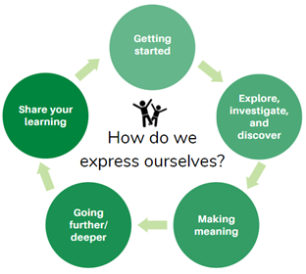
Layout of this resource
This pack is filled with learning activities for your learners that can be used at school or at home. All activities are framed around the big idea of Creativity – how do we express ourselves?
This pack contains suggestions for starting the day with a karakia (See p. 9), check in with the teacher, and setting up the learning environment. You can replace these with how you want your learner to start their day
The activities follow an inquiry learning model (figure 1) exploring one big idea through two contexts. Each day the learner will work through one part of the model culminating with sharing their learning on days five and ten.
Figure 1 Inquiry learning model

Setting up the learning environment
Encourage whānau to support learners to set up a space for learning at home. Learners might like to design their own space as a separate learning activity. Some materials they may need could include pen, pencils, paper, a notebook, colouring pencils, glue, scissors, and a device to access the internet.

Many of the suggested activities and experiences include the use of online resources which can be accessed and viewed using a Smartphone.

Overview of the learning in this pack
In week 1 we will be looking at how we can express ourselves creatively through exploration in and around our home looking at our place, games, superheroes, and birds. This context should appeal to younger learners.
In week 2 we will be looking at how we express ourselves creatively through our language and culture in our pepeha, mihi, maps, and art. Each of the learning tasks in days 6—10 will explore different forms of expressing ourselves. This week’s tasks will also focus on using critical thinking to make links between the content and their own personal experiences.
Learners will explore, investigate, discover, and make meaning as they go through each task. There are times where they look a little deeper into the topic. Some of the tasks may be independent hands-on tasks while some may involve connecting and sharing with others.
Day 1 | Day 2 | Day 3 | Day 4 | Day 5
Observing and noticing inside and outside our homes | Creativity through games. | Creating, inventing, and designing our own superhero. | Being creative through art and nature. | Sharing our creations in different ways.

Day 6 | Day 7 | Day 8 | Day 9 | Day 10
Communicating what is special to us | Using stories to describe special places. | Making connections to natural wonders through stories, poems, and art. | Creating and writing to express ourselves. | Sharing our learning, our pepeha and visual mihi.

Daily timetable
Spend the first hour setting up for the day’s learning. This could include checking in with the teacher and classmates, singing waiata, and exploring the inquiry topic. As part of the start of the day and setting up the learning environment, help your learner look through the activities for that day and let them choose the order they would like to do them in. You could turn this into a visual timetable by cutting out images (like the ones below) and putting them in order.
Below is a possible daily timetable. We have allocated 30 minutes for most activities. Your learner may take more or less time than this for an activity.
We suggest your learner takes the time they need to complete an activity. This may mean they choose which activities they will complete for the day, rather than having to complete them all.

Time | Activity
9:00 am | Starting the day
9:30 am | Activity 1
10:00 am | Break
10:30 am | Activity 2
11:00 am | Fitness break
11:30 am | Activity 3
12:00 pm | Lunch time
1:00 pm | Activity 4
1:30 pm | Reflection time
2:00 pm | End of the school day

Daily fitness – Choose something each day
It is important to include a fitness activity every day. Please ensure that your learner includes this in their daily timetable. If possible, it would be great to do the fitness activity with your learner or have them complete it with their siblings where appropriate. Below are a range of activities to choose from – or you can make up your own ideas! Please choose activities that are appropriate to your learner’s abilities and talents.
Exploring our section
Run around the inside of your section two times (just like how you walked around the inside of your bedroom). Check where you are allowed to go (don’t leave your section).
Plan a course and touch any of these in your section – fence, letterbox, gate, door, tree.
Go around your section two more times using different movements. You can jump, hop, skip, sidestep, gallop (or if you are inside you can crawl, slide, walk backwards, tiptoe).
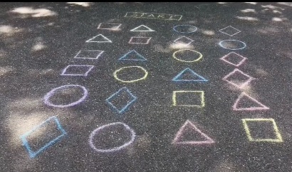
Shape hopscotch
Choose 4 shapes and draw them in a row (using chalk or draw them on paper and tape them to the ground).
Draw 3 more rows with the shapes in a different order.
Write start at one end and finish at the other.
If you have different coloured chalk, you could make each shape a different colour.
- Call out a shape – can you make it to the finish line by only jumping on that shape?
- Call out a colour – can you make it to the finish line by only jumping on that colour?
Superhero Obstacle Course
Create an obstacle course using household objects (ask first!). Some ideas:
- Running through hula hoops (or draw circles on a path).
- Jumping on a pile of cushions.
- Doing the limbo under a stick or tape.
- Karate chop a villain (you could use a cushion or pillow for the villain).
- Climb through a tunnel.
- Weave in and out of cones (cones can be anything).
- Bust through a wall. Stack up cardboard boxes to make a wall.
After you make your obstacle course and try it - think about what would make it better?
Weekly fitness tracker
Keep daily track of your fitness. Can you improve your own record over time?
Do as many repetitions of each exercise as you can. Count them and record below
 | # push ups | # burpees | # star jumps | # sit ups | # squats
Monday
Tuesday
Wednesday
Thursday
Friday

Spelling fitness
Can you do the exercises to spell out your name? What about another word?
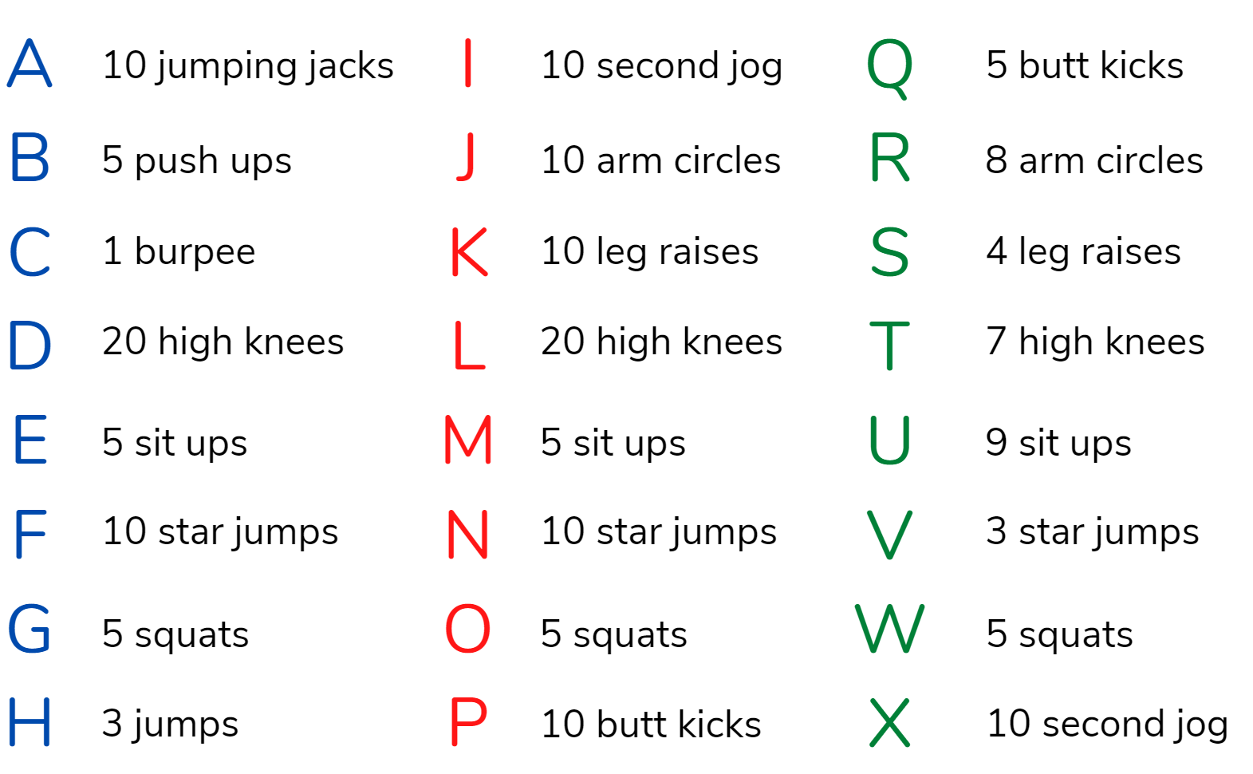

Fitness online activities
If you have access to the internet, you could try out this fitness activities:
Born to Move: Baila with me video on the Home Learning TV channel: https://www.tvnz.co.nz/shows/les-mills-born-to-move/episodes/s2-e20
Born to Move: Heroes video on the Home Learning TV channel: https://www.tvnz.co.nz/shows/les-mills-born-to-move/episodes/s2-e13
Born to Move: Reflection video on the Home Learning TV channel: https://www.tvnz.co.nz/shows/les-mills-born-to-move/episodes/s2-e11
Dance along with Gonoodle – Trolls can’t stop feeling https://www.youtube.com/watch?v=0OldvpJTktw
Superhero yoga for kids
https://www.youtube.com/watch?v=7i0tUVNHfLA&t=54s
Join Maximo in the chicken dance
https://www.youtube.com/watch?v=kiK0QvDtoWU
Sesame Street: Common and Colbie Caillat Sing "Belly Breathe" with Elmo on https://www.youtube.com/watch?v=_mZbzDOpylA

Mindfulness activities
These activities are good to do at the beginning and the end of the day. They can help you get ready for learning, and help you to reflect on your learning:

Belly breathing
Belly breathing is easy to do and very relaxing. ... Put one hand on your belly just below your ribs and the other hand on your chest. Take a deep breath in through your nose, and let your belly push your hand out. Your chest should not move. Breathe out through pursed lips as if you were whistling. Repeat this ten times.
Balloon breathing
Draw a picture to show how you are feeling today.
Sometimes when we are feeling excited, upset, or scared we forget how to breathe and that can make it feel even worse.
Try this breathing exercise.
- Put your hands on your belly.
- Breathe in through your nose and feel your belly get bigger like a balloon.
- Breathe out through your nose and feel your belly get smaller and smaller.
- Do this five times.
How do you feel now? Draw another picture if you are feeling different to before.
Square breathing
- Imagine you are drawing a large square in front of you while you are sitting down.
- Start at the bottom right of the square.
- Breathe in for 4 counts as you trace the first side of the square in the air with your finger.
- Hold your breath for 4 counts as you trace the second side of the square in the air.
- Breathe out for 4 counts as you trace the third side of the square in the air.
- Hold your breath for 4 counts as you trace the final side of the square in the air.
You just completed one deep breath! Repeat.

Starting the day – Each and every day
Notes for teachers and whānau
You can use this suggestion to start the beginning of each day.
Starting the same way each day helps create a structure for your learner. Your school might have your own way to do this, for example starting the day together as a class on Zoom. In this pack we provide a karakia to settle into the day. Saying the karakia with your learner a few times will help them be able to do this more independently tomorrow and beyond. As part of the start of the day and setting up the learning environment, help your learner look through the activities suggested for that day and choose a fitness activity. They could fill out their daily timetable and think of other activities they might like to do, like reading.
Note that our Inquiry focus for today is – “getting started” which includes generating questions, activating prior knowledge, and introducing the big idea.
In this activity I am learning to:  - Practise your karakia  - Do a mindfulness activity (See p. 8)  - Plan out my day and where I will learn  - Choose a fitness activity (See p. 6-7)  - Check in with your teacher. | What do I need?
- 30 minutes
- Check with your teacher to see if there is a special way they would like you to start your day
- My home learning book, pencil/pen
- Optional: Karakia video at: https://www.youtube.com/watch?v=3em_pulEjT0

Karakia
Do you have a karakia that you say in your house or at school? If not here is a karakia to welcome in the day. You can listen to it here if you have a device: Kia Hora te Marino
Kia hora te marino May peace be widespread
Kia whakapapa pounamu te moana May the sea be like greenstone
Hei huarahi mā tātou i te rangi nei A pathway for us all this day
Aroha atu, aroha mai Give love, receive love
Tātou i a tātou katoa Let us show respect for each other
Have you chosen a mindfulness activity (See p. 8)?
Planning my day
Set up your space for learning. Grab the things you need. These are the activities for today.
My home  Observing and noticing things inside my house. | My room  Observing my room and drawing a map. | My section  Using my body to explore outside my house. | My treasures  Observe our special things and create a picture in a frame.
Remember to choose a fitness activity (See p. 6-7).

Day 1 activity 1: My home – reading
The activities for today will be located around the home/whare. It is intended that your learner will explore how people create their personal spaces to reflect what is important to them through their language and culture. It will also explore what your learner likes to do that makes them feel confident, proud, and happy. We will also look at how people use art, dance, music, writing and sport to express themselves creatively. The learning will build up to a presentation.
Note that our Inquiry focus for today is – “getting started” which includes generating questions, activating prior knowledge, and introducing the big idea.
What do I need?
- 30 minutes
- My home learning book, pen/pencil
- Look for a copy of Two homes in your pack or online at https://instructionalseries.tki.org.nz/Instructional-Series/Ready-to-Read-Colour-Wheel/Two-Homes
- You will need a device (a smartphone would work perfectly)
- Your house

In this activity I am learning to: Make observations, make a list, compare and contrast.
Follow the instructions.
- Walk around inside your house from room to room. In each room:
- Look up – what do you notice?
- Look down – what do you notice?
- Look all around – what do you notice?

Write or draw some things that you have noticed on your walk in your home learning book.
Listen to or read Two Homes / Ready to Read (tki.org.nz).

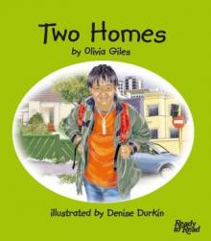
Talk about what you see in the two homes in the story.
Write or draw some things that are the same about the two homes and what is different on the first table on the next page.

Is there anything the same about your house? Is there anything different?
Write or draw some things that are the same about your home and what is different on the second table on the next page.

Write a list or draw things that are the same or different about the two homes in the book
Write a list or draw things that are the same or different about my home
.

Day 1 activity 2 & 3: My room – mapping
Your learner is going to draw a floor plan of their room. This is a challenging maths activity. They will be walking around the room to look at the shape. They will be looking at the big pieces of furniture and thinking about position. Reassure them that their map doesn’t have to be perfect. Mapping is the language of geographers!
What do I need?
- 60 minutes
- My home learning book, pencils/crayons/felts, and a room in my house

In this activity I am learning to: Draw a map of a room, make observations.
Go into your bedroom. You are going to draw a map of this room.
Walk around the edges of the room. What shape is it? Draw this shape on a page in your home learning book.
Look at one of the walls. Does it have a door or a window? Draw this on your map. Do this with the other three walls.
Now have a look at the furniture. Draw shapes to show where the furniture is.
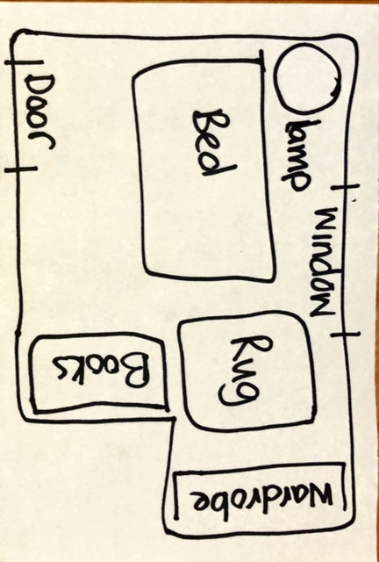
Now that you have looked at the things in your room, find something in your room that is special for you.

Write or draw about this item in your home learning book.

Get creative and think about what your imaginary perfect room would look like. What would you add? A swimming pool? A slide? A zoo? More windows?

Get creative and draw a map of your super cool imaginary bedroom.

Day 1 activity 4: Our treasures (taonga)Note
This activity requires adult support.
We are looking at the things in our homes that show what is important to us. We begin with a video in te reo Māori that introduces us to Te Awarangi’s whānau and shows us pictures of his family members on the wall. Talk to your learner about why these photos are on the wall and what they might mean. Walk around your house and talk about the special things in your house that are important to you. Our taonga often reflect our culture creatively.
Note that our Inquiry focus for today is – “getting started” which includes generating questions, activating prior knowledge, and introducing the big idea.
What do I need?
- 30 minutes
- My home learning book, pencils/crayons/felts, and construction materials
- Optional: Video of Taku whānau (My family) at: https://vimeo.com/226228367

In this activity I am learning to: Notice what is important to me and my whānau.
Watch the video Taku whānau (My family) on Vimeo (Transcript below)
Taku whānau means my family in te reo Māori. In this video Te Awarangi is telling us about the people in his whānau.
Talk with someone in your whānau about this video.
- What does he show us on the wall of his home?
- What do you have on the walls in your home?
- Why do you think they have these photographs on their wall?
- Are there other taonga (treasures) on display in your home?
- What are they?
- Do they tell you anything about the culture of your family?

Draw a picture or create something that you would like to see on your wall or on display in your home using the next page. This will be a taonga.

This picture or creation will show something that is special to you. It could be a place, a person, a pet, or an activity you like doing

Transcript and Translation

Speaker | Māori | English
Rōpū tamariki (off-screen) | Taku whānau | My family
Te Awarangi | Kia ora. Ko Te Awarangi au. | Hello. I’m Te Awarangi.
Te Awarangi | Ko Peter taku koro. Ko Mere taku kuia. Ko Andrew taku koro. Ko Peti taku kuia. Ko Mike taku pāpā. Ko Ani taku māmā. Ko Ropata taku tuakana. Ko Marama taku tuahine. Ko au tana tungāne. Ko Paora taku teina. | Peter is my grandfather. Mere is my grandmother. Andrew is my grandfather. Peti is my grandmother. Mike is my dad. Ani is my mum. Ropata is my older brother. Marama is my sister. I am her brother. Paora is my younger brother.
Rōpū tamariki (off-screen) | Ko wai mā rātou? | Who are they?
Te Awarangi | Ko tēnei taku whānau. Ko ia taku pāpā. Ko ia taku māmā. Ko ia taku tuahine. | This is my family. He’s my dad. She’s my mum. She’s my sister.
Rōpū tamariki (off-screen) | Ko wai ia? | Who’s she?
Te Awarangi | Ko ia taku whaea kēkē. Ko ia te tuahine o taku pāpā. | She’s my auntie. She’s the sister of my dad.
Rōpū tamariki (off-screen) | Ko wai rāua? | Who are they?
Te Awarangi | Ko ia taku whaea kēkē. Ko ia taku matua kēkē. Ko ia te tungāne o taku māmā. Tokomaha aku kaihana. | She’s my auntie. He’s my uncle. He’s the brother of my mum. I have lots of cousins.
Rōpū tamariki (off-screen) | Ae. Tokomaha ō kaihana. | Yes. You have lots of cousins.
Te Awarangi | Ko tēnei taku whānau. | This is my family.

Day 1: Reflection

This activity requires adult support.
Today has been a special day. We have looked around our own whare (home) and noticed all the things that make it special. Take some time to talk about the things you have done together. What has surprised you? What did you notice that you hadn’t noticed before?
Note: Reflection can be challenging for all learners, but it can also provide them with rich opportunities to think about how their learning is progressing. Use the questions below as prompts to encourage your learner to think about what they have learned so far and help them to plan out their next steps. If you have concerns with their learning or find that your learner is needing more help, contact their teacher for more support.
Talk with someone in your whānau.
Tell them all the things you have done today.
Explain all the things you have noticed around your whare (home).
How did those things make you feel?

Wellbeing check
How are you feeling now?
Write or draw something in your home learning book to show how you are feeling.
Look back at the very first thing you did in your home learning book today – how did you feel then?
Do you feel the same or different now?

Planning for tomorrow
Thinking about your learning today, what is something that you want to do tomorrow to make your learning day even better?
Write or draw this in your home learning book.
Close your book – School is finished for today. 😊

Day 2: Getting started
Take the first 30 minutes of the day getting ready for learning:
- Practise your karakia (See p. 9)
- Do a mindfulness activity (See p. 8)
- Plan out my day and where I will learn
- Choose a fitness activity (See p. 6-7)
- Check in with your teacher.
Set up your space for learning. Grab the things you are going to need. These are the activities for today. We are exploring creativity through games. Our Inquiry focus for today is “explore, investigate, and discover”.
My favourite games  Reading, thinking, and drawing about my favourite games | My favourite games  Writing about my favourite games | Making a game  Using what I know about games to create my own game

Day 2 activity 1: Reading, my favourite games
Your learner is thinking about all the things they can do that make them happy. They will think, make a list, listen, or read, and then draw and write about their favourite games.
What do I need?
- 30 minutes
- My home learning book and Pencils/crayons/felts
- Look for a copy of Whai (String Games) in your pack or online at: https://instructionalseries.tki.org.nz/Instructional-Series/Ready-to-Read-Colour-Wheel/Whai-String-Games
- Look for a copy of Hannah’s Game in your pack or online at: https://instructionalseries.tki.org.nz/Instructional-Series/Ready-to-Read-Colour-Wheel/Hannah-s-Game

In this activity I am learning to: Read a story and identify the things I love to do
Let’s do some thinking
What do you love to do at home? Where do you go to do things that you love doing? (Inside or outside)
Write or draw these in your home learning book or you could tell someone in your whānau.
Read or listen to Whai (String Games)
- Mahi and Hani in our story learn to play sting games.
- What do you know about string games? Have you ever played them?
Read or listen to Hannah's Game
- Hannah shows Sam how to play a card game.
- Do you know any card games? What other kind of games do you like?

Day 2 activity 2: Writing, my favourite games
In this activity your learner is using what they have read, told, and drawn to help them with their writing task about their favourite games. If applicable and if there is time, allow your learner to play their favourite game and/or look at it. This will help them think about how it is played and why they like it so much.
What do I need?
- 30 minutes
- My home learning book and pencils/crayons/felts

In this activity I am learning to: Write a list and write about my favourite game.

Write a list of all the games you like to play.
Pick one of the games and draw yourself playing it.
You could write a story to go with your picture in your home learning book

Write a list of all the games you like to play

Draw yourself playing your favourite game

Day 2 activity 3 and 4: Making a game
In this activity your learner is going to create and make a game using simple materials and their creativity.
It might be good to get the learner to brainstorm what they have learned from thinking about their favourite games, reading the books, setting up and playing hopscotch and use this to create their own simple game – what are the rules, how do you take turns, other). They can also use any materials around the house to create their own games after this activity.
Note that our Inquiry focus for today is – “explore, investigate, and discover” which includes choosing and evaluating information, and thinking critically.
What do I need?
- 60 minutes
- Piece of paper (graph paper if available), a pencil, rubber, black felt tip pen, and coloured pencils/crayons
- Look for a copy of the Gardener’s Maze in your pack or online at: https://instructionalseries.tki.org.nz/Instructional-Series/Ready-to-Read-Colour-Wheel/The-Gardener-s-Maze

In this activity I am learning to: Think about what I have learned about games today and make a game for someone to play
Let’s do some thinking.
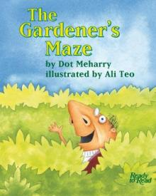
Today we have already learned about card games, string games and hopscotch. Think about all the other games you know such as board games, video games, tag games. There are also fun paper games like tic tac toe, hangman, and drawing a picture with your eyes closed!
Today we will make a maze game. Use the instructions on the next page to help you. Challenge yourself and make two or three more using different shapes.

Read this before you get started to get inspired:
The Gardener’s Maze (https://instructionalseries.tki.org.nz/Instructional-Series/Ready-to-Read-Colour-Wheel/The-Gardener-s-Maze)
There is a video and audio clip at this link, which can be played from a smartphone.

Instructions | Picture
How do you start? A maze is a network of complex passages with only one single escape route. The object is to find this route. Draw a big circle or square or any shape you like to start – but be sure to leave two gaps for your start and finish. | 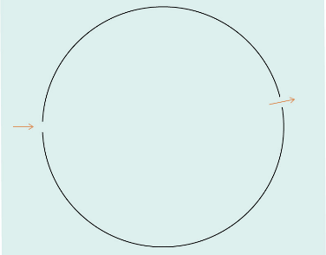
Draw a second shape inside the first shape and leave at least two openings | 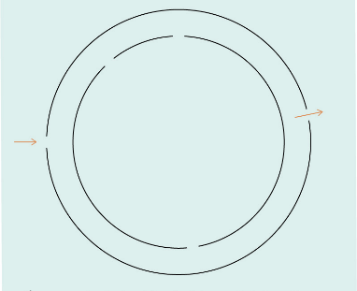
Keep drawing shapes inside making sure each has at least two openings. | 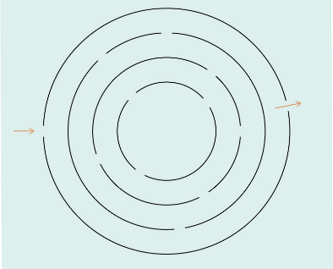
Right, the fun part: draw the solution. Use a pencil and press as lightly as you can, to make a thin visible line that you can erase later. | 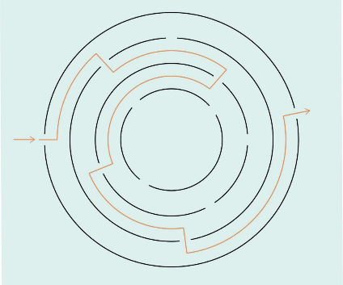
Make sure your maze has only one solution. Use straight lines to close all the other pathways on your maze.  Have fun and get someone at home to try your maze game. | 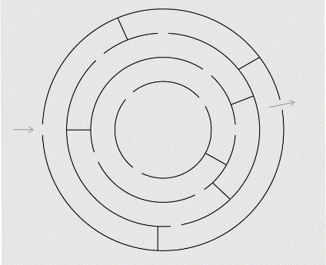
Source: https://studio-stilla.com/how-to-make-a-maze-with-your-kids-quick-tutorial-learn-how/

Day 2: Reflection
Today we have looked at the places and games that make us happy. This is a time to reflect on the day and look forward to tomorrow.
Talk with someone in your whānau. Tell them all the things you have done today. Talk about all the things you have created this week.
- How did today make you feel?
- Which activity did you enjoy the most today?
- What did you learn today?
Wellbeing check
Put the Face cards on the table or floor in front of you.
This morning you chose a card for how you wanted to feel at the end of the day. Find this card. Is that how you feel?
Write or draw about this in your home learning book.
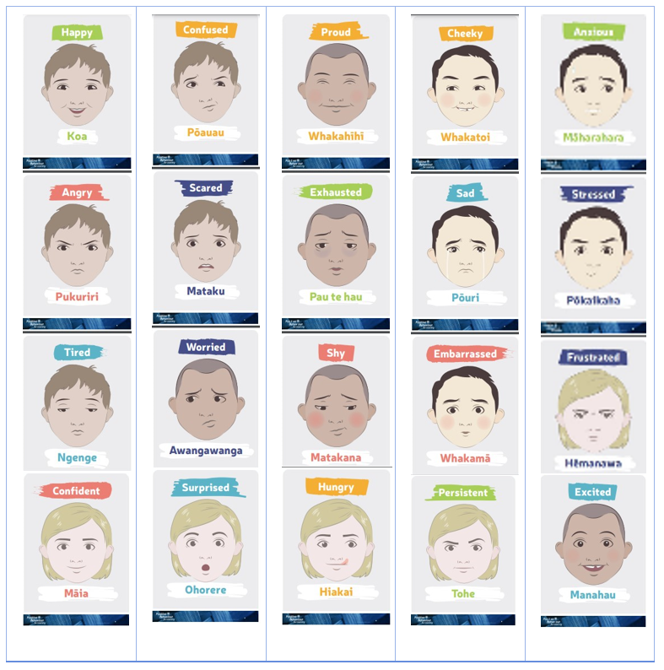

Day 3: Getting started
Take the first 30 minutes of the day getting ready for learning:
- Practise your karakia (See p. 9)
- Do a mindfulness activity (See p. 8)
- Plan out my day and where I will learn
- Choose a fitness activity (See p. 6-7)
- Check in with your teacher.
Wellbeing check
- Put the Face cards on the table or floor in front of you. Pick out a card that shows how you are feeling now. Talk about why you chose this card.
- Now pick out a card that shows how you want to feel at the end of the day. Talk about what you might need to do so that you can feel like that?
Planning my day
Being creative is about being inventive. Inventors and creators think up things that haven’t been thought of before. You can be a creator or inventor of stories, art, music, science and more. Today we are going to invent a new superhero. Our inquiry focus is ‘making meaning’.
Set up your space. Grab the things you need. These are the activities for today:
My favourite superhero  Thinking, drawing, and writing about my favourite superhero. | Creating a physical activity  Setting up an activity to get someone active and moving. | Writing poetry  Using what I know about superhero to create a poem for someone to read.

Day 1 activity 1: Literacy, reading, listening, and writing
In this activity your learner is exploring Maui as a superhero in Māori legends. Then they will then be imagining and creating their own superhero.
What do I need?
- 30 minutes
- My home learning book and pencils/crayons/felts
- Look for a copy of Maui and the Sun in your pack or online as a PDF text here https://esolonline.tki.org.nz/Media/Instructional-Series/Ready-to-Read/Ready-to-Read-Online-2020/RTR-Maui-and-the-Sun-PDF
- Online audio clip of Maui and the Sun https://instructionalseries.tki.org.nz/Media/Instructional-Series/Ready-to-Read/LIVE-Ready-to-Read-audio-versions/Maui-and-the-Sun-audio

In this activity I am learning to: Describe a superhero using words and pictures.
What superheroes do you know?
- Tell someone as many as you can and write a list in your home learning book.
- Read or listen to the story of Maui and the Sun
Maui is a kind of superhero.
- Talk about what makes Maui a superhero and write a list in your home learning book.

Day 3 activity 2: My Superhero
In this activity your learner is exploring Maui as a superhero in Māori legends. Then they will then be imagining and creating their own superhero.
Note that our Inquiry focus for today is – “making meaning” which includes making connections, organising information, and thinking critically.
What do I need?
- 30 minutes
- My home learning book and pencils/crayons/felts

In this activity I am learning to: Invent and describe a new superhero using words and pictures.
Think about ‘What if you were a Superhero?”
- What would you look like?
- What powers would you have?
- How could you use your superhero powers to be creative and solve problems?
- What would you wear?
- How would you travel around?
- What would your superhero name be?

You can:

Draw your Superhero and add some words around it to tell us about their powers and what they do.

And/or:

Make one of your toys or dolls into your Superhero. Then: make a small poster describing their powers and what they do.

And/or:

Dress up as your hero and act out using your powers.

Day 3 activity 4: Literacy, superhero poetry
Your learner is exploring words that describe a superhero. Language is one way we can express ourselves creatively. Talk about what different superheroes might look like, actions they might do, characteristics they might have. Write these down for your learner.
What do I need?
- 30 minutes
- Your home learning book and a pen or pencil

In this activity I am learning to: Write an acrostic poem and identify the qualities and behaviours of your superhero.
Your superhero is amazing. Your superhero can create poetry.
Talk about different words that could describe your superhero. You can think about what they look like, what they do, and how they act.
Write your Superhero’s name down the side of your paper with a letter at the beginning of each line.
Write a word or phrase for each letter of their name that describes something about them. (A phrase is an idea that might not be a whole sentence).
Draw a picture to go with your poem.
Here is one someone else has made up about Batman.
Brave and strong
Always there to help
Towering over buildings and trees
Making people safe again
Against the might of the villains
Never giving up on what is right

Day 3: Reflection
Today we have looked at the places and games that make us happy.
Talk with someone in your whānau. Tell them all the things you have done today. Talk about all the things you have created this week.
- How did today make you feel?
- Which activity did you enjoy the most today?
- What did you learn today?
Wellbeing check
Put the Face cards on the table or floor in front of you.
This morning you chose a card for how you wanted to feel at the end of the day. Find this card. Is that how you feel?
Write or draw about this in your home learning book.
Close your book – School is finished for today. 😊

Day 4: Getting started
Take the first 30 minutes of the day getting ready for learning:
- Practise your karakia (See p. 9)
- Do a mindfulness activity (See p. 8)
- Plan out my day and where I will learn
- Choose a fitness activity (See p. 6-7)
- Check in with your teacher.
Yesterday we looked at how inventors and creators design or make new things. We were inventors because we created a new superhero. Today we are going to think about how we can create some art using materials around our home.
Set up your space. Grab the things you need. These are the activities for today:
Making a collage  Using materials found around the garden make a collage of a bird | Movement and maths  Doing some creative bird exercises by moving your body and counting birds | Reading about scarecrows  Reading and exploring compound words.

Day 4 activity 1 and 2: Making a collage
This week your learner has been looking at how we can be creative. Today we are going to create some art using some materials we might find around our place. It’s all about getting creative and expressing ourselves. Our inquiry focus is "making meaning".
What do I need?
- 60 minutes
- Natural materials you can find outside, glue
- Optional:
- Home-made glue https://www.thoughtco.com/homemade-glue-recipes-607826
- Natural owl collage: https://iheartcraftythings.com/stick-owl-craft-for-kids.html

In this activity I am learning to: Make a collage using natural materials.
Walk around outside – look, listen, smell, touch what you can see. Can you see or hear any birds?
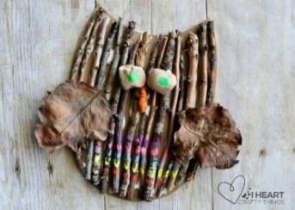
Find things that you might be able to use to create some art. Can you sort your materials into different categories?
You might look for sticks and bark, leaves, berries, small stones, grass, flowers seeds.
Look at this picture of an Owl Collage that someone has made.
Create your own imaginary bird (or another animal you like) from the bits and pieces you found outside. You will need a large piece of paper or cardboard for the background and some glue to stick your things down.
You can use a phone or iPad to take a picture when you are done. Then you can use the same materials to make another creation! Maybe you could even design your superhero out of natural materials? What else could you design?

Day 4 activity 3: Bird maths
In this activity your learner will do some creative bird maths. They are encouraged to extend their thinking and creativity by creating some activities that their classmates could use.
What do I need?
- 30 minutes
- Your home learning book, pen or pencil, and colouring pencils/crayons/felt pens

In this activity I am learning to: Add sets, compare sizes, and create picture problems
How many?
Add together the birds in each row and write down how many there are in the box.
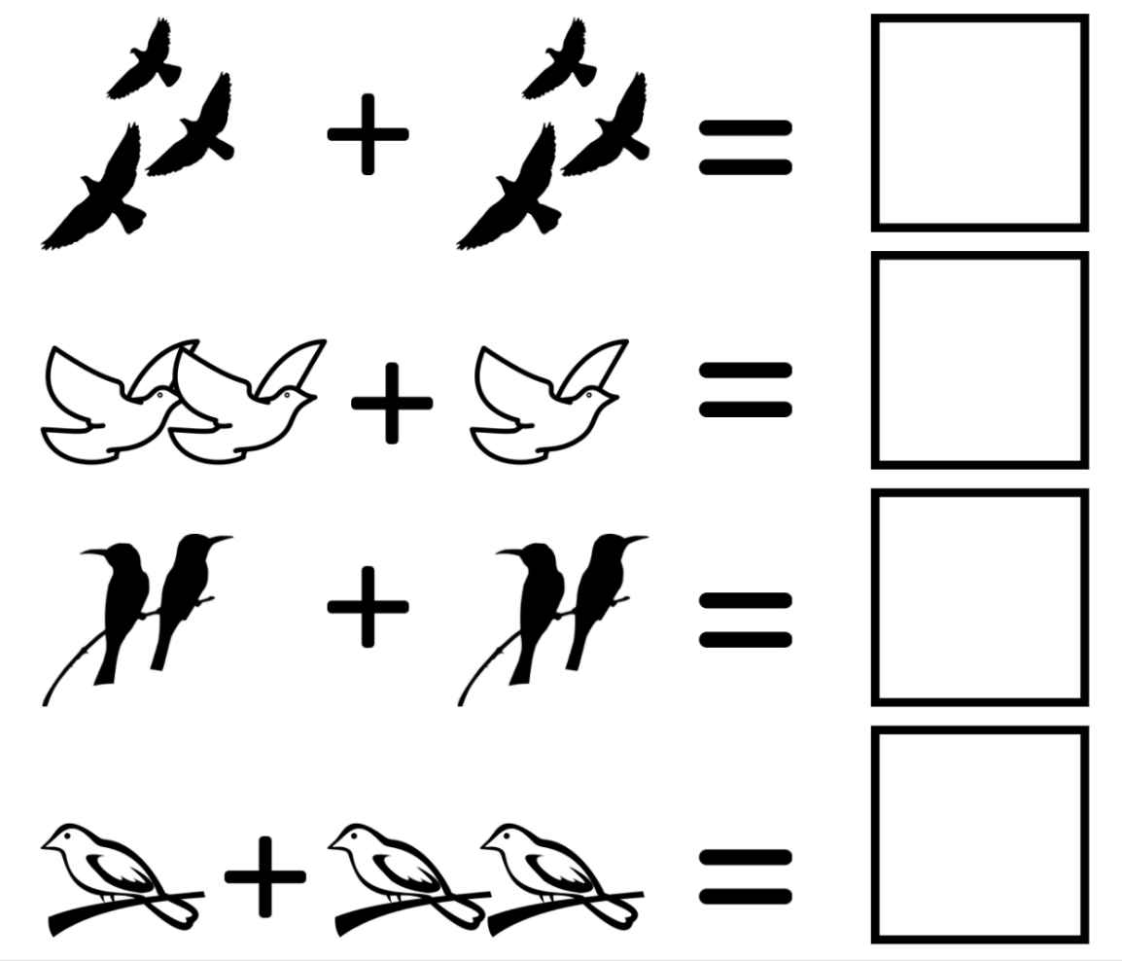
Challenge: can you create a bird maths problem worksheet for a classmate?
- Write 1 to 3 on a blank piece of paper (leave a big space for each problem).
- Start with 1
- draw 3 of something then add the ‘+’ sign
- then draw four of something and then write the ‘=’ sign
- Then draw a box for their answer
- Repeat 2 more times with new picture problems

Bigger or smaller
Look at the birds in each box and put a circle around the one that is smaller.

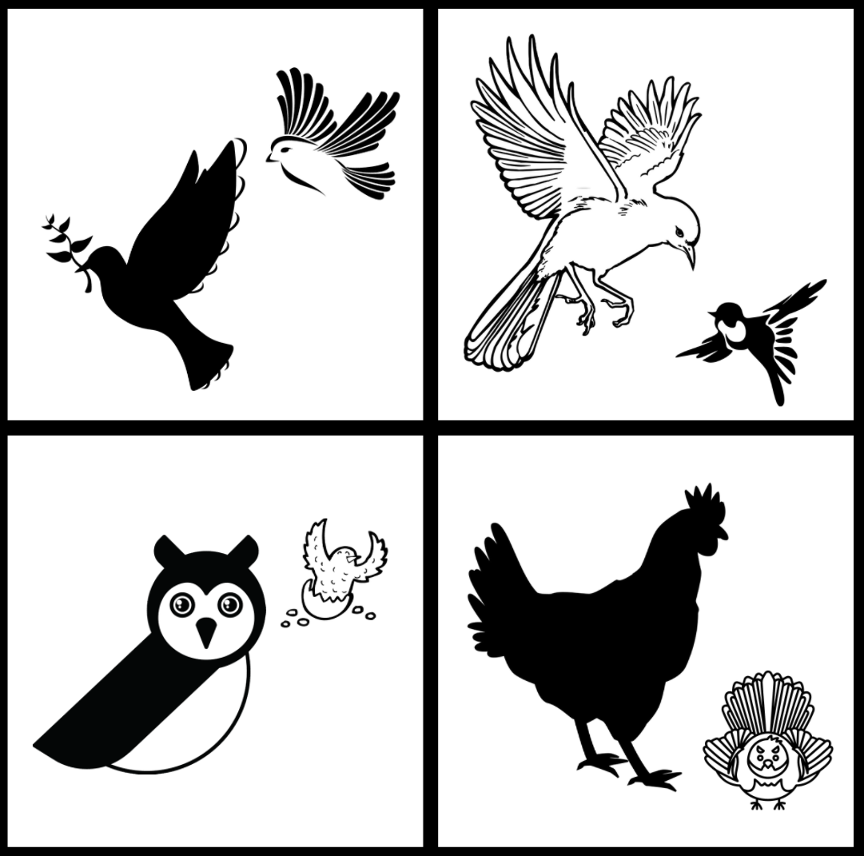

Challenge: can you create a bigger smaller worksheet for a classmate?
Draw a grid with four squares
Draw 2 animals in each box, make sure one is bigger than the other
Give it a title: ‘Bigger or Smaller’
Now go and get five different toys or things in your house and see if you can put them in a line from biggest to smallest.

Day 4 activity 4: Literacy, scarecrow: a compound word
In this activity your learner will be exploring compound words and try to think of as many as they can. We will focus on scarecrow. Scarecrows are a creative solution to a problem that many farmers face. Your learner will be encouraged to consider other creative ways to keep birds away from our growing vegetables.
What do I need?
- 30 minutes
- Your home book and pen/coloured pencils/crayons/felt pens
- Look for your copies or these texts in your pack or online The Gardener and the Scarecrow at: https://instructionalseries.tki.org.nz/Instructional-Series/Ready-to-Read-Colour-Wheel/The-Gardener-and-the-Scarecrow
- Scarecrows from Space at: https://instructionalseries.tki.org.nz/Instructional-Series/Ready-to-Read-Colour-Wheel/Scarecrows-from-Space

In this activity I am learning about: Compound words and to think creatively about keeping the birds from my vegetables.
Listen to The Gardener and the Scarecrow (3-minute clip; perfect to play on your phone).

What is a scarecrow?
Scarecrow is a compound word. A compound work is one word made up of two separate words joined together – scare and crow. It is a word that describes and means a human-like, human-sized doll that farmers make and put in their fields to scare birds away from their crops.
In your home learning book:
Write some other compound words you have heard e.g., bellbird, sunflower, moonlight.
Write or draw some other ways to keep the birds away from the vegetables?

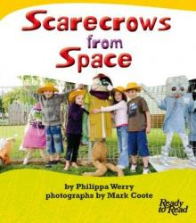
Here is another story about birds and scarecrows.
Listen or read to Scarecrows from Space
Design your own scarecrow. Think about:
- what do you want it to look like?
- what could you use to make your scarecrow?

Draw a plan of what your scarecrow could look like.

Day 4: Reflection
Today we have looked at creativity through the context of birds. Your learner has had the opportunity to be creative multiple times: making a collage with natural materials, creating new maths problems for their classmates, and creating an original scarecrow all of which can help them make connections with the learning from Day 1-3.
In literacy, they also learned about compound words – prompt your learner to reflect on the word ‘superhero’ to help them make another connection.
Talk with someone in your whānau.
- Tell them all the things you have done today.
- Talk about all the things you have created this week Can you think of something you have created with your family?
- How did today make you feel?
Wellbeing check
Put the Face cards on the table or floor in front of you.
- This morning you chose a face card for how you wanted to feel at the end of the day. Find this card. Is that how you feel?
- Which activity did you enjoy the most today?
- What did you learn today?
Write or draw about this in your home learning book.
Close your book – School is finished for today. 😊

Day 5: Getting started
Take the first 30 minutes of the day getting ready for learning:
- Practise your karakia (See p. 9)
- Do a mindfulness activity (See p. 8)
- Plan out my day and where I will learn
- Choose a fitness activity (See p. 6-7)
- Check in with your teacher.
Today we will reflect on all the creative things we have done this week. Your learner has had lots of different learning experiences to draw from. Consider spending some time re-reading all the stories from the week. Our inquiry focus today is ‘sharing our learning’.
Set up your space for learning. Grab the things you need. These are today’s activities.
My favourite creation  Pick your favourite creation from this week. Write about it in your home learning book. | Sharing my creations  Take your story about your creation outside and practice reading out loud. | Choosing time  Spend more time on any of your creations. Or you could create something brand new.

Activity 1: My favourite creation
Today is spent reflecting on the last four days learning. Your learner will take a deeper look at one of the activities they have enjoyed and identify why they liked that activity the most. They will write with the purpose of telling others about their learning.
What do I need?
- 30 – 60 minutes
- My home learning book, pen/pencil, and someone to teach

In this activity I am learning to: Reflect on my creations. Write about it and draw it.
Circle or highlight the things you have created this week in this list below.

Picture or treasure for your whare
Colour Hopscotch
Maze Game
Superhero
Obstacle Course
Superhero poem
Imaginary bird collage
Scarecrow design
Choose the very favourite thing that you created this week.
Write in your home learning book and tell us:
- what thing you liked creating the most and why you liked creating it
- how making your creation made you feel.
Draw the creation you have written about.
Optional – Pretend you are going to teach someone else to create the same thing – how would you do that? See if there is someone in your whānau who you can teach.

Day 5 activity 2: Sharing my creations
In this activity your learner is learning to read aloud to present their ideas. They are being asked to seek feedback on their writing and think about ways they might be able to improve their writing.
What do I need?
- 30 minutes
- Your story from the last activity and someone to share your story with

In this activity I am learning to: Present my ideas clearly, share my writing, and seek feedback to improve my writing.
Go outside with your story from the last activity.
Find a place you like and practise reading your story out loud.
Read it to the grass.
Read it to the trees.
Read it to the birds.
Read it to the sky.

Now go inside.
Read your story to your toys or pets.
Find someone who is at home and ask them to sit down and read your story to them.

If you can
Ask someone at home to record you reading your story and send it to your teacher or another family member or friend who might not be at home.

Show the creation you wrote about to the person who listened to your story.

Ask them for some feedback.
- What do you like about my story?
- How do you think I could make my story even better?

Make one change to your story.

Day 5 activity 3 and 4: Take 2!
This time is to go back and continue or re-work one of the creations from the week. This is an opportunity to focus on the Going further, deeper aspect of the inquiry process. It is also a chance for your learner to "Present- share learning about the big idea"
What do I need?
- 60 minutes
- My home learning book, my creations, and my imagination

In this activity I am learning to: Improve on a piece of work or creation and share my learning with others
Going deeper to end the week:
Go back and work on any of your creations from this week that you might not have finished or want to add to or want to do all over again. When you are finished, share your creation with someone. You also might like to compare your new creation with your first one. Which one is better? Why do you think so?
Or you could do some more creating:
- Create a bird or superhero dance.
- Design and/or build a home for your superhero or scarecrow.
- Make up a new game to play with someone at home.
Share your new creation with someone else.

Day 5: Reflection
Today we have looked back through our home learning books and looked at all the creative things we have done. Take the time to reflect about you have enjoyed and learnt. You could also talk about what could make the learning day even better.
Talk with someone in your whānau.
- Tell them all the things you have done today.
- Talk about all the things you have created this week Can you think of something you have created with your family?
- How did today make you feel?
Wellbeing check
Put the Face cards on the table or floor in front of you.
- This morning you chose a face card for how you wanted to feel at the end of the day. Find this card. Is that how you feel?
- Which activity did you enjoy the most today?
- What did you learn today?
Write or draw about this in your home learning book.
Close your book – School is finished for today. 😊

Day 6: Getting started
Take the first 30 minutes of the day getting ready for learning:
- Practise your karakia (See p. 9)
- Do a mindfulness activity (See p. 8)
- Plan out my day and where I will learn
- Choose a fitness activity (See p. 6-7)
- Check in with your teacher.
This week’s activities will explore how we tell people about ourselves, where we come from and what is important to us through mihi and pepeha. We will also look at how the places we come from may have changed over time by building knowledge of stories, people, events and changes that have been important in our local area and New Zealand.
Set up your space. Grab the things you need. These are the activities for today:
Pepeha  Create and practice your pepeha to share information about yourself | NZ connections  Brainstorming ideas about New Zealand and learning some te reo Māori | Map locations  Use a map to locate some places in New Zealand | Getting creative  Make a collage to creatively share and show what makes where you are from special

Activity 1: Literacy & inquiry
Today we are learing about ‘mihi’ or ‘pepeha’, two ways that many New Zealanders share information about who they are. A mihi is a greeting while a pepeha is an introduction that tells more about your background.
Note that our Inquiry focus for today is – “getting started” which includes generating questions, activating prior knowledge, and introducing the big idea.
What do I need?
- 30 minutes
- Look for a copy of Pepeha in your pack or online at: https://instructionalseries.tki.org.nz/Instructional-Series/Junior-Journal/Junior-Journal-53-Level-2-2016/Pepeha
- A pen/pencil

In this activity I am learning to: Explain what a ‘pepeha’ or ‘mihi’ is and that it can be used to express and share information about myself
Think
- When have you heard someone do a ‘mihi’ or ‘pepeha?’
- You might even be able to share your own mihi.
By the end of the week you will be able to tell us more about the people and places that are important to you and you may be able to put that together into a mihi or pepeha.
We will look closely at different parts of the mihi like the mountains, lakes, rivers and special places in our country and do some creative activities around these.
When we share our pepeha we are telling others a lot about ourselves. It is an important aspect of Māori culture.
We are telling them:
- where we come from
- how we came there
- places that are important to us – like mountains, rivers, lakes or seas
- our family
- our special places like towns, cities, marae
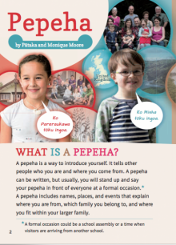
Listen to or read this story Pepeha.
Then you might light to read it out loud.
There are lots of new kupu (words) in this story.
- Maunga – mountain
- Awa, roto, moana – river, lake, sea
- Marae – gathering place
- Iwi – large family grouping
- Hapū -smaller family grouping
- Kaumatua- important elder
- Matua – parents
- Koroua – grandparents
- Tīpuna - ancestors
- Ingoa – name

Write: Can you write the Māori kupu under each picture?
 | 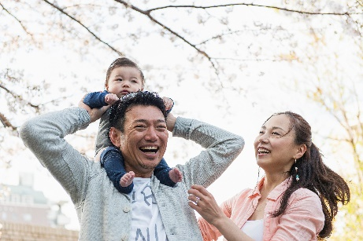 | 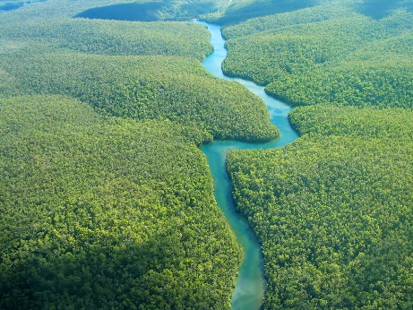

Draw: Can you draw a picture of the Māori kupu in the boxes below?
marae | koroua | Lake

Day 6 activity 2: Listening, speaking, and writing
In this activity your learner is using what they have learned about Pepeha and mihi to understand why it is important to ask where someone is from and how to respond in te reo Māori. Once they have an understanding that they are from New Zealand, they will look at New Zealand on a map of the world and then write words that they know about Aotearoa on a blank map of New Zealand. If you have a globe or world map at home, use this to show them as well.
What do I need?
- 45 minutes
- Optional video: https://hereoora.tki.org.nz/Unit-plans/Unit-1-Ko-au/Reomations/No-hea-ia-Where-is-he-she-from
- Look for your copies of the Map of New Zealand in your pack or online at: https://blankworldmap.net/wordpress/wp-content/uploads/2021/02/Printable-Map-of-New-Zealand.gif
- https://blankworldmap.net/wordpress/wp-content/uploads/2021/02/Blank-Map-of-New-Zealand-Outline.jpg

In this activity I am learning to: Say where I am from and ask where someone else is from in te reo Māori, and write words to express simple ideas about New Zealand
Watch this little video: No hea ia - where is he/she from?
Transcript and translation
Māori | English
Nō hea ia? | Where’s s/he from?
Nō Ahitereiria ia. | S/he’s from Australia.
Nō hea ia? | Where’s s/he from?
Nō Āwherika ia. | S/he’s from Africa.
Nō hea ia? | Where’s s/he from?
Nō Haina ia. | S/he’s from China.
Nō hea ia? | Where’s s/he from?
Nō Kaikōura ia. | S/he’s from Kaikōura.
Nō hea ia? | Where’s s/he from?
Nō Kānata ia. | S/he’s from Canada.
Nō hea ia? | Where’s s/he from?
Nō Hāmoa ia. | S/he’s from Samoa.
Nō hea ia? | Where’s s/he from?
Nō Aotearoa ia. | S/he’s from New Zealand.
Nō hea ia? | Where’s s/he from?
Nō tuarangi ia. | S/he’s from outer space.

Practise:
- Nō hea –ia? Where is he/she from?
- Nō ____ ia. He/she is from ____.

Practise:
- Nō hea koe? Where are you from?
- Nō Aotearoa ahua. I am from New Zealand.

We live in Aotearoa/New Zealand.
- Look at the MAP of New Zealand here: https://blankworldmap.net/wordpress/wp-content/uploads/2021/02/Printable-Map-of-New-Zealand.gif

- Can you find your city/region on the map?

- Here is a BLANK map of New Zealand: https://blankworldmap.net/wordpress/wp-content/uploads/2021/02/Blank-Map-of-New-Zealand-Outline.jpg

- Use your copy of the blank map to:
  - Write all the special things you know about New Zealand on the outside of the map.
  - Ask your whānau what special things they know about New Zealand to add to your map.
  - Keep your map safe for later.

Day 6 activity 3: Literacy and maths
Today your learner is going to find out more about someone from their mihi/pepeha. We have already found that a mihi can tell you where someone is from; now we are going to see what else we can find out about what is special to the person. As we do this we will also be finding out a bit more about where these special places are in our country – New Zealand. We will also be telling someone about the places that are special to us.
What do I need?
- 30-45 minutes
- Look for a copy of Toku Pepeha in your pack or online: https://instructionalseries.tki.org.nz/Instructional-Series/Junior-Journal/Junior-Journal-53-Level-2-2016/Toku-Pepeha
- Look for a blank copy of the New Zealand Map in your pack https://blankworldmap.net/wordpress/wp-content/uploads/2021/02/Blank-Map-of-New-Zealand-Outline.jpg
- Or this one: https://datastore.landcareresearch.co.nz/dataset/4dae6113-a078-4c00-ac1d-b062058e3dfb/resource/cc777171-18b0-4f48-bc88-999d182b6c57/download/gbs-mapsnz2_bw_h.jpg

In this activity I am learning to: Listen to select and use information and locate places on a map
We are going to listen to a girl called Pareraukawa tell us about her mihi. Let’s see what we can find out about Pareraukawa as she tells us about the things, places and people that are special to her.

Listen to or read Tokū Pepeha
Answer these questions:
- What is Pareraukawa’s special river?/awa
- What are Pareraukawa’s special mountains/maunga?

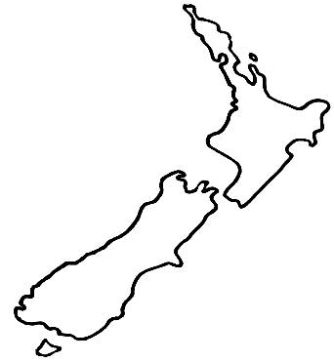
Now, we are going to see if we can find places on a map of our country – New Zealand. Use your new, blank copy of the map of New Zealand (keep this as you will add to it each day). NZ map.

Can you:
- Show on the map where you live?
- Write the name of that place?
- Can you show on the map where Pareraukawa is from?

(She doesn’t tell us the place but she tells us about her river and mountains – see if you can work it out from that).

- Add the Tararua mountains to your map if you can.

Are there special places you like to go with your whānau?

- Show those places on the map too.

Can you write the names of the places on your map?

Write down the place where you live.

I live in __________________________________________________________________

Write down your special river/lake or sea if you have any.

________________________________________________________________________

________________________________________________________________________

Write down your special mountain/s if you have any.

________________________________________________________________________

You might not have always lived where you live now. Can you find out any other places you have lived on a map? Write them here and show them on your map.

________________________________________________________________________

________________________________________________________________________

Day 6 activity 4: Creative expression
Making a collage will require some materials and if the scissors, glue, and magazine option is possible will give your learner practice with cutting – motor skills practice. This is all about being creative and giving your learner the opportunity to express themselves artistically while they make connections to their learning from the day.
What do I need?
- 45 minutes
- Paper, scissors, glue, newspapers/magazines,
- or coloured pencils/felts for a drawing

In this activity I am learning to: Create a visual to show ‘Nō hea koe?’ Where are you from.
Today we found out a little bit about mihi/pepeha and how we use it to tell others about ourselves. Mihi and pepeha are important aspects of Māori culture and how Māori express themselves through language.
Like Pareraukawa, today you have told us about where you live and other places that are special to you.
Draw or make a collage of the place you live – can you include the water – (river, lake or sea), and the mountains? What else can you include?
You can use a piece of paper or page in your notebook. When you are finished share and explain your creation to someone in your whānau, your class or your teacher the next time you meet online.

Reflection
30 minutes
Today we have learned about where we are from, how to ask and answer this in te reo Māori and to locate places on a map.
Talk with someone in your whānau.
Tell them all the things you have done today.
- How did today make you feel?
- Which activity did you enjoy the most today?
- What did you learn today?
Wellbeing check
Put the Face cards you used last week on the table or floor in front of you.
- Which card shows how you felt this morning? Which card shows how you feel now?
Write or draw this in your home learning book.
Close your book – School is finished for today. 😊

Day 7: Getting started
Take the first 30 minutes of the day getting ready for learning:
- Practise your karakia (See p. 9)
- Do a mindfulness activity (See p. 8)
- Plan out my day and where I will learn
- Choose a fitness activity (See p. 6-7)
- Check in with your teacher.
The main focus of the day’s learning is about how people can use things and stories to explain, describe and name their special places. This is how people can express themselves.
Inquiry focus – “explore, investigate, and discover”
Set up your space. Grab the things you need. These are the activities for today:
Express myself:  Share where I am from using objects | Make connections:  between a story and the map of New Zealand | Creative maths:  Draw a taniwha and show I can make a set of a number | More mapping:  Explore stories to help identify volcanoes on a map of New Zealand.

Activity 1: Literacy, writing
Let’s explore today how people tell stories about their place. Objects that are special to a school help to form the cultural narrative and local history of that school. This helps all the learners in that school feel a sense of belonging and connectedness to their school. This is especially important in this time of disrupted at school learning. Your learner could look at your school website to help them remember more about what makes their school special. They are also going to practice writing verbs today; this will help them communicate more clearly when describing an action and expressing themselves.
What do I need?
- 45 minutes
- My home learning book and pen/pencil
- Your copy of the blank New Zealand map
- Look for a copy of Kākahu Pekepeke in your pack or online at: https://instructionalseries.tki.org.nz/Instructional-Series/Junior-Journal/Junior-Journal-61-Level-2-2020/Kakahu-Pekepeke

In this activity I am learning to: Use objects to share about where I am from, write verbs with the ending -ing
Let’s explore today how others use things to tell stories about their place.
Yesterday we started exploring how the mihi/pepeha helps us tell others about ourselves.
One school in New Zealand, near Tauranga, has some special things (taonga) in their school that tell a story about their place from long ago.
Listen to or read Kākahu Pekepeke
Can you show Tauranga on your New Zealand map, can you write ‘Tauranga’ on your map?
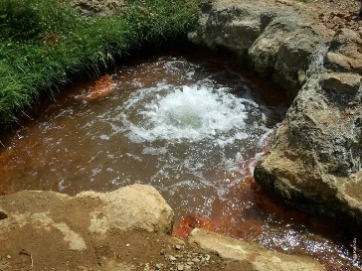
In the story, the carving at the school shows three springs (water flowing up from under the ground). A spring might look something like this.
In the story it says:
“The carving tells the story of three local springs that were very important to the iwi living around them. Long ago, the people of Ngāi Tamarāwaho drank from the first spring, bathed in the second spring, and washed their clothes in the third spring.”
2 Source: https://imaggeo.egu.eu/view/1533/
Draw the three springs below (or in your book) and what was happening in each spring.
You would have drawn:
- Drinking
- Bathing
- Washing clothes
We have added the –ing ending to some words that tell what we are doing. These kinds of words are called verbs.
Can you change these verbs by adding the –ing ending?
drink | drinking
bath | bathing
wash | washing
sing
play
eat
jump
see
hear
look
The springs in the story we just listened to flow into a creek that goes past the schools. When the learnerren get older the creek will remind them of the story of the springs.
Write down (or draw) some things that are in or near to your school that you think you will always remember? What makes your school special? What do you know about the history of your school and the area it is built on? What do you love about your school? What might be different about your school compared to any other school in Aotearoa, New Zealand?

Day 7 activity 2: Literacy and visual art
In this learning activity we will dig a little deeper into stories and read another awesome story from a different part of New Zealand. Your learner will learn about how a natural disaster impacted the land through a creative story about a taniwha. Your learner has some questions to answer and may need some help with this as well as finding Porirua on their map. Consider using google maps to find it.
Inquiry focus – “explore, investigate, and discover”
What do I need?
- 30 minutes
- My home learning book and pen/pencil
- Your copy of the New Zealand map
- Look for a copy of Awarua the Taniwha of Porirua in your pack or online at: https://instructionalseries.tki.org.nz/Instructional-Series/School-Journal/School-Journal-Level-2-May-2016/Awarua-The-Taniwha-of-Porirua

In this activity I am learning to: Identify places on the map of New Zealand and predict what a volcanic island looked like before it erupted

Listen to or read Awarua The Taniwha (or ask someone to read it to you).
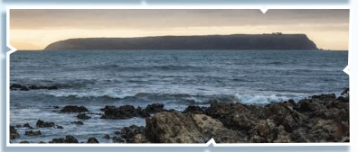
Can you show Porirua on your map? Can you write Porirua on your copy of the New Zealand map? The story talks about Mana Island. This is what Mana Island looks today.

Answer these questions in your Home Learning book:
- How did Mana Island get its flat top?
- What happened when Awarua crashed into Whitireia?
Awarua is a taniwha.
Rereroa is the albatross who taught Awarua to fly.
The harbour was deep and the hills were covered in trees.
Let’s get creative and draw how you think Mana Island might have looked before Awarua flew into it. Do this on a big piece of paper or in your Home Learning book. You might include Awarua and Rereora in your picture.

Day 7 activity 3: Maths, number recognition
Taniwha can take all kinds of shapes and forms. In this activity learners use some maths (number recognition and making a set of the number) and their imagination to create a taniwha. They may draw on the images from the story of Awarua for some ideas. Your learner will need a copy of the number cards for this activity. They will have to pick a number card to decide how many different body parts their taniwha has. This will make for some very creative Taniwha drawings!
What do I need?
- 45 minutes
- Large blank piece of paper and Coloured pens/pencils/felts
- Look in your pack for a set of number cards 1-9 in English or access online at: https://hereoora.tki.org.nz/content/download/748/11765/version/4/file/Nga+Tau+Worksheet+6.1.pdf
- Optional: A device or smartphone to listen to and sing along to ‘One Day a Taniwha’ https://www.youtube.com/watch?v=zsYlZkevrKA
*Source: https://hereoora.tki.org.nz/Unit-plans/Unit-6-Nga-tau/Tasks-and-activities/Describing-a-taniwha

In this activity I am learning to: Make a set of a number (drawing)
Awarua was a taniwha.
Let’s try some Taniwha Maths!
- You are going to create your very own taniwha.
- Start by drawing a body shape in the middle of your paper, then:
- Ask each of the following questions:
  - How many wings? Pick a number card and draw that many wings.
  - How many eyes? Pick a number card and draw that many eyes.
  - How many legs? Pick a number card and draw that many legs.
  - How many claws on each foot? Pick a number card and draw that many claws.
You might like to sing along to One day a taniwha. This song is song to the tune of ‘You are my sunshine’. Sing along in English or te reo Māori. Here are the lyrics:
English | Te reo Māori
One day a taniwha  Went swimming in the moana  He whispered in my taringa  "Won't you come along with me  There’s such a lot to see  Underneath the deep blue sea.”  I said "Oh, no, no, no!  You'd better go, go, go,  Although I know we could be friends.  My Mama's waiting for me  Underneath the kowhai tree  Taniwha, haere rā!" | Tetahi taniwha  Kauhoe i te moana  Kohimu i taku taringa  "Kia haere taua  Tipi haere tirotiro  I raro i te moana.”  Ka mea au "Kao, kao, kao!  Me haere, haere koe  Ahakoa he hoa taua.  Tatari ana taku Mama  Kei raro i te rakau kowhai  Taniwha, haere rā."
Don’t forget Awarua and Rereora!

Day 7 activity 4: Exploring maps
Your learner will be thinking about how stories are used to explain landforms and events. They will locate places on a map and see where some landmarks are in relation to their home. You could use an online map to find the volcanoes mentioned below.
Note that our Inquiry focus for today is – “explore, investigate, and discover”..
What do I need?
- 30 minutes
- My copy of the blank map of New Zealand
- Look in your pack for a copy of Baskets of Fire or access online at: https://instructionalseries.tki.org.nz/Instructional-Series/School-Journal/School-Journal-Level-2-November-2018/Baskets-of-Fire

In this activity I am learning to: Identify places on a map
Look at your New Zealand map. You might have been to a place called Lake Taupō.
- Can you show Lake Taupō on your map – it is near the middle of the North Island.
If you have been there, you might have noticed there are a lot of mountains surrounding it, and some of these are volcanoes. Baskets of Fire tells the story of Ngātoro-i-rangi, the tohunga or expert and how he brought volcanic fire to New Zealand.
Listen to Baskets of Fire (or have a caregiver read it to you).
See if you can add these places to your NZ map:
- Tongariro
- Ngauruhoe
- Ruapehu

Day 7: Reflection
30 minutes
Today we have learned more about places in New Zealand by reading stories and used what we learned to help be able to identify them on a map. We have made creative taniwha and even learned a little about volcanoes. Your will now be able to make the connection between a mountain (maunga) and a volcano.
Talk with someone in your whānau. Tell them all the things you have done today.
- How did today make you feel?
- Which activity did you enjoy the most today?
- What did you learn today?
Wellbeing check
Put the Face cards you used last week on the table or floor in front of you.
- Which card shows how you felt this morning? Which card shows how you feel now?
- Write or draw this in your home learning book.
Close your book – School is finished for today. 😊

Day 8: Getting started
Take the first 30 minutes of the day getting ready for learning:
- Practise your karakia (See p. 9)
- Do a mindfulness activity (See p. 8)
- Plan out my day and where I will learn
- Choose a fitness activity (See p. 6-7)
- Check in with your teacher.
The focus of today’s learning is to explore and make meaning about how the people in the stories use things in nature to help them? And then to think about how do we use things in nature to help us now? Help your learner consider how things have changed over time.
Note that our Inquiry focus for today is – “making meaning” which includes making connections, organising information, and thinking critically.
Set up your space for learning. Grab the things you need. These are the activities for today.
Make connections:  Identify and describe landforms like the Pink and White terraces | Write poetry:  Make a volcano shape poem | Colour by Number:  Complete a colourful picture using my number recognition. | Going deeper:  Write a story to explore a natural feature or phenomenon.

Activity 1: Literacy and landforms
Our focus for today is – “making meaning”. Your learner will begin to make connections about how landforms are represented in stories and how people make predictions based on these stories and scientific evidence. They can practice locating places on their map.
What do I need?
- 45 minutes
- Watch the 8th Wonder of the World https://www.youtube.com/watch?v=e44iyz0T8Ts or read the transcript below to your learner

In this activity I am learning to: Identify and describe landforms
The natural environment is an important part of a mihi/pepeha. When we talk about the natural environment we mean:
Land Water Air Plants Animals Events
Earlier this week when we learned about the mihi/pepeha, we heard from Pareraukawa that the water and the mountains are included. Māori people often use stories to explain how they think different landforms have come to be the way they are such as in the story of Awarua and Rereroa. Today we are going to think creatively about some of the landforms we have and have had in the past in New Zealand.
- Watch The Eighth Wonder of the World
8th wonder of the world rediscovered in New Zealand (transcript of video)
The 8th wonder of the world, known as the pink and white terraces of Lake Rotomahana, was a popular attraction in the 19th century. Tourists from around the world travelled to see these terraces and bathe in their springs. Sadly, after the 1886 volcanic eruption of Mount Tarawera, the terraces were never to be found again. Many believed that the terraces were buried underneath the eruption and eventually destroyed. And, just like that the 8th wonder of the world supposedly vanished forever.
A recent discovery proves that the beautiful white and pink terraces still exist but are hidden under 50 feet of ash and mud. Thanks to an old field book from a geologist named Ferdinand von Hochstetter, scientists were able to locate the approximate location of the 8th wonder in New Zealand. This discovery was published in the Journal of the Royal Society of New Zealand with information on how the location of the terraces was found.
The 8th wonder of the world is the pink and white silica terraces located near Lake Rotomahana in the North Island. They are a combination of rice field terraces and thermal pools. These terraces were formed when hot spring water cooled, and the minerals were deposited at the edges of the pool. These minerals eventually created a barrier-like structure around the pool, which in turn created a terrace. More and more terraces were made every time hot spring water spilled out of the terraces and flowed to different locations, forming new banks of water that became their own little terraces.
The white and pink colour of the terraces are caused by the minerals and bacteria thriving within the springs. Another example of bacteria affecting the colour of springs is Yellowstone’s Grand Prismatic Spring. Where you see rings of colour there are actually different bacteria, each group adapted to the conditions of their environments.
After the discovery of the approximate location for the 8th wonder, scientists are now waiting for the government’s approval to excavate the site and possible revive one to the most amazing places on the planet.
Find and label Lake Rotomahana where the Pink and White Terraces were, on your map
Here are two pictures of the Pink and White Terraces.
What people think the pink and white Terraces looked like long ago. | How the pink and white terraces look now
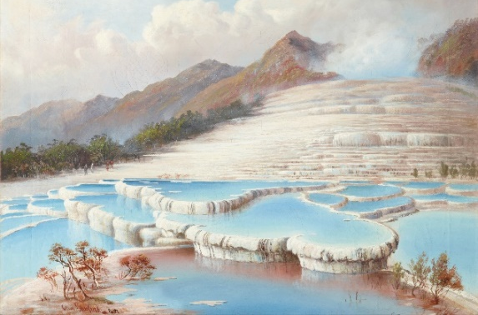 | 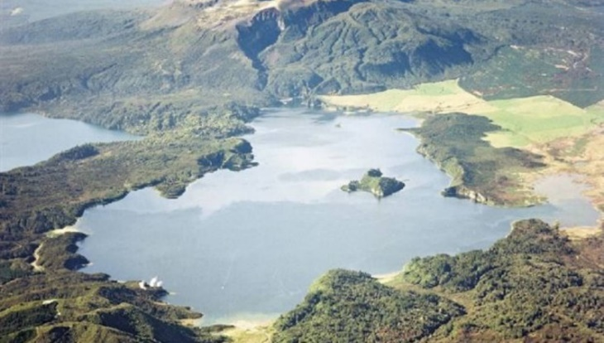
Source: Wikimedia commons | Source: Stuff.co.nz
Answer these questions:
- What can you see in the first picture?
- What can you see in the second picture?
- What do you think might have happened that changed the way this place looked.

Day 8 activity 2: Literacy, shape poems
Your learner will use their prior knowledge from this week to brainstorm words about volcanoes and then then will get creative to write a Volcano word poem.
The Inquiry focus for today is – “making meaning” which includes making connections, organising information, and thinking critically. In this activity, your learner will be making connections with their other learning experiences and what they already know.
What do I need?
- 45 minutes
- My Home Learning book and pen/pencil

In this activity I am learning to: Write a shape poem
A volcano erupting could be one of the reasons you came up with to explain what happened to the Pink and White Terraces.
What do you already know about volcanoes?
Brainstorm all the things you can think of about volcanoes.
Here are some words you might have come up with:
- Erupt, Explode, Dangerous
- Lava, Rock
- Molten, Hot
- Sparks, Ash
- Red, Orange
- Noisy, Embers, Glow
- Boiling, Mud, Rocks

Use all the words you have brainstormed to make a shape poem about volcanoes.
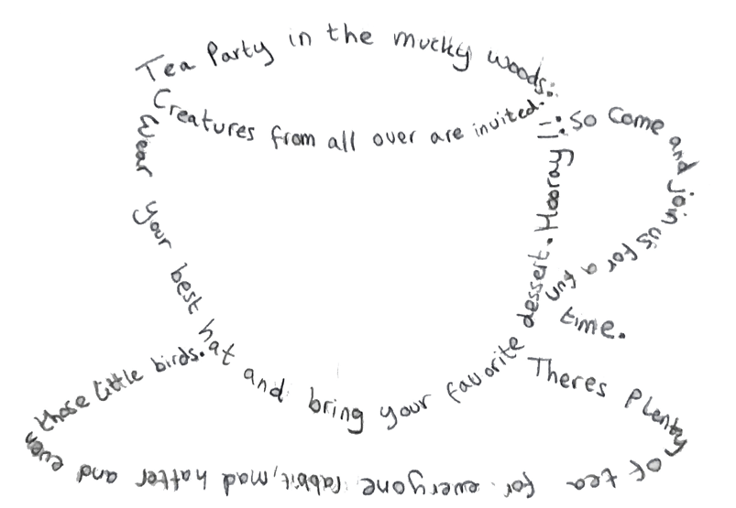
A shape poem is a poem that takes on the shape of the thing you're writing about. So, if you wanted to write a poem about a volcano, you could write it inside of the outline of a volcano or you could write a short poem and make the words the outline of the volcano ... Then, take those words and form them into your shape.

Take a photo of your poem to share with your teacher.
There are many volcanoes in New Zealand. I wonder why that is?
What do you think?

Source: https://www.imagineforest.com/blog/alice-in-the-wonderland-shape-poetry/

Day 8 activity 3: Maths, colour by number
A fun, light and soothing activity to practice our number recognition and see how patience and focus can yield beautiful results. Let’s get creative – can your learner create their own paint by number picture?
What do I need?
- 30 minutes
- Look in your pack for a copy of the Volcano colour by numbers page or access online at: http://www.homemade-preschool.com/support-files/mw-color-by-numbers-volcano-1-5.pdf
- Coloured pencils or felts

In this activity I am learning to: Practice my number recognition to create a colourful picture
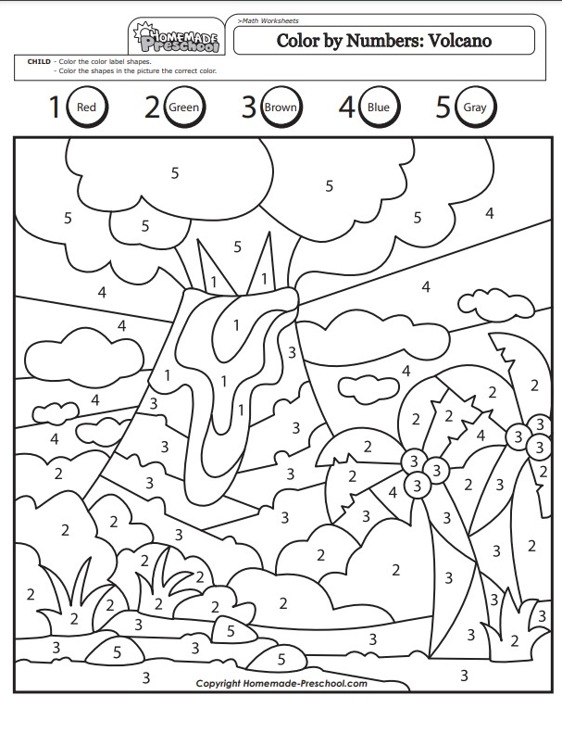
Volcano Colour by number
Print out the volcano picture using the link in the table.

Colour the volcano using the colours on the sheet or you might like to make up your own colour combination. You will need five colours of your choice.

Then: Let’s get creative – can you create your own paint by number picture?

Day 8 activity 4: Inquiry writing
Inquiry focus for today is – “making meaning” which includes making connections, organising information, and thinking critically. In this activity your learner will delve deeper into an investigation of their choice before writing about their learning.
What do I need?
- 45 minutes
- My Home Learning book and pen/pencil

In this activity I am learning to: Build a deeper understanding and write creatively
Stories have been used to make meaning about landforms in New Zealand.
Pick one of these ideas and write your own story to explain why it is the way it is in your Home Learning book. Try to use some ‘ing’ words in your writing too!
Ask someone at home to help you have a closer look at these things online. Here are some ideas to choose from:
- Why beaches on the west coast of Auckland have black sand?
- Why Franz Josef Glacier is blue.
- How the Moeraki Boulders were formed.
- How the Huka Falls were made.
- Why Rotorua smells funny.
- How the tree came to be in Lake Wanaka.
- What made the tunnels at Cathedral Cove.

Day 8: Reflection
Today we learnt about some different natural features in New Zealand and delved deeper into one area of interest to write a story about. Take time to discuss what you enjoyed today and what you might like to learn more about.
Talk with someone in your whānau.
Tell them all the things you have done today.
- How did today make you feel?
- Which activity did you enjoy the most today?
- What did you learn today?
Wellbeing check
Put the Face cards you used last week on the table or floor in front of you.
- Which card shows how you felt this morning? Which card shows how you feel now?
Write or draw this in your home learning book.
Close your book – School is finished for today. 😊

Day 9: Getting started
Take the first 30 minutes of the day getting ready for learning:
- Practise your karakia (See p. 9)
- Do a mindfulness activity (See p. 8)
- Plan out my day and where I will learn
- Choose a fitness activity (See p. 6-7)
- Check in with your teacher.
Our Inquiry focus for today is – “making meaning”. Today also provides an opportunity to engage further and dive deeper through discussions.
Set up your space for learning. Grab the things you need. These are the activities for today.
Express myself:  Create something that will express information about where I live | Be a scientist:  Classify and graph information that I collect about shells / marine life | Descriptive writing:  Write a description about my favourite shell or marine creature and twist my tongue!

Activity 1-2: Getting creative
Today is another opportunity to find a place on the map. Hopefully that map is still in one piece! Your learner will create something to share information about where they are from.
What do I need?
- 60 minutes
- Look in your pack for a copy of Eddie or access online https://instructionalseries.tki.org.nz/Instructional-Series/School-Journal/School-Journal-Level-2-April-2013/Ask-Eddie
- Your copy of the New Zealand map

In this activity I am learning to: Make a creation that reflects where I live
Listen to or read Ask Eddie
Eddie has a problem at school.
- How did Eddie share something that was special to him?
- How could you share special things about the place you come from without using words?
Think about where you live. Can you mark and label it on your New Zealand map?
Create something that will tell others things about the place where you live.

It could be a:
- painting
- a model
- a play
- a dance
You might include:
- Scenery
- Important buildings like school, church
- Things people do

Share your creation with people at home.
Explain the things you have shown in your creation and tell how they are special.
Take a photo of your creation and send it to your teacher.

Day 9: Activity 3 – Science & maths
A fantastic activity to get everyone wanting a trip to the beach! In this activity your learner will classify different New Zealand shells / marine creatures and measure them. Lots of people collect seashells, talk to your learner about why this isn’t a good idea.
What do I need?
- 45 minutes
- Look in your pack for a copy of this identity card or access online at: https://www.pottonandburton.co.nz/wp-content/uploads/2019/11/At-the-Beach-identity-card.pdf (only the first page).
- Scissors
- Optional: Glue

In this activity I am learning to: Classify and measure
There are many things around us that become special to us for some reason.
It might be that we use them to help us in our daily lives; it might be that we like to look at them; it might be because they remind us of something or a place; it might be that we can make other things from them. Many of us in New Zealand do not live far from a beach, sea, ocean. We do live on an island after all! We often find shells when we are there.

Your task
- Print (or have your school print out and provide you with) the identity card - https://www.pottonandburton.co.nz/wp-content/uploads/2019/11/At-the-Beach-identity-card.pdf
- Look at the identity card and write the names of shells you have seen at the beach in your home learning book.
- Cut off the right-hand side of the Identity Card Chart where the measuring stick is.
- Cut out each shell on the shell resource sheet.
- Sort the shells into groups of the same kind. What categories are you using?
- Using the measuring stick – choose 5 shells to measure the width of each shell/ creature in centimetres (cm) and record in your home learning book.

Answer these questions in your Home Learning book:
- How many paua shells did we have?
- Which column had the most shells?
- Which column had the least number of shells?
- How many shells on our graph altogether?
- Which of your chosen shells was the biggest?
- Which of your chosen shells was the smallest?
Now you might like to use your cut out shells to make a collage. Be creative!

Day 9: Activity 4 - Literacy
In this activity your learner will explore a text and practice some writing. If they want an extra challenge at the end, ask them to write their own tongue twister. Consider sharing your favourite tongue twister with them.
What do I need?
- 30 minutes
- My Home Learning book and pen/pencil
- Look in your pack for a copy of Super Shells or access online at: https://instructionalseries.tki.org.nz/Instructional-Series/Junior-Journal/Junior-Journal-60-Level-2-2020/Super-Shells
- Optional: A device or smartphone to watch the ‘She sells seashells tongue twister on Youtube: https://www.youtube.com/watch?v=ZNhmcVgjZ08

In this activity I am learning to: Write a description
Shells can be used for many things. They are also a big part of what makes sand on many beaches.
Listen to or read Super Shells
List all the things shells have been used for in your Home Learning book
Write and draw: Describe your favourite shell (or marine creature)– think about its size, shape, colour, how it feels, how it lives, etc.
Describe your shell here: | Draw your shell here:
To finish off our shell study, try saying this tongue-twister.
Watch and listen to She sells seashells or read below. Ask your caregiver for help if needed.
“She Sells Seashells”
She sells seashells by the seashore,
The shells she sells are seashells, I’m sure.
So if she sells seashells on the seashore,
Then I’m sure she sells seashore shells.

Write a list of all the ‘s’ and ‘sh’ words your know below. How many can you write?
“s” words | “sh” words
sells | shells

Could you write your own tongue twister? Give it a try here:

Day 9: Reflection
So today we made more meaning and delved deeper into things that reflect us when we express to others more about where we live. Your learner also acted like a Scientist when they classified and measured shell specimens (even though they were only paper!). Finally, your learner was challenged to write a description. Hopefully, it was a good day.
Talk with someone in your whānau. Tell them all the things you have done today. Talk about all the things you have created this week.
- How did today make you feel?
- Which activity did you enjoy the most today?
- What did you learn today?
Write or draw this in your home learning book.
Wellbeing check
- Put the Face cards you used last week on the table or floor in front of you.
- Which card shows how you felt this morning? Which card shows how you feel now?
Close your book – School is finished for today. 😊

Day 10: Getting started
Take the first 30 minutes of the day getting ready for learning:
- Practise your karakia (See p. 9)
- Do a mindfulness activity (See p. 8)
- Plan out my day and where I will learn
- Choose a fitness activity (See p. 6-7)
- Check in with your teacher.
Today is the last day of this learning pack – how exciting! You did it! Today your learner will have opportunities to share their learning – usually the final part of an inquiry. Be sure to celebrate and acknowledge them. Consider contacting your learner’s teacher to share that they are finished.
Set up your space for learning. Grab the things you need. These are the activities for today.
Express myself  Write my own pepeha | Share my learning  Share my pepeha by presenting it to others | Share my learning  Create and share a visual mihi that reflects me, what is important to me and what I wrote in my pepeha

Activity 1: Getting ready to share our learning
This activity is about putting it all together. Writing your pepeha is needed before you can share your learning with others.
What do I need?
- 60 minutes
- Pen/pencil

In this activity I am learning to: Write my pepeha
Preparing to present
This week we have learnt about:
- How people tell others about themselves through mihi/pepeha
- Other ways we can show or tell people about ourselves
- How groups of people use stories to explain things
- our natural environment – volcanoes, shells.
- How we use things in nature to help us now.
In this session, let’s try and write our own mihi/pepeha.
Pareraukawa shared a model for us to use to make up our own mihi/pepeha
Fill in as many of these things that are special to you as possible using the template on the next page.
You might need to ask your whānau for some help with this.

My pepeha

Ko _____________________________ te waka.

Ko _____________________________ te maunga.

Ko _____________________________ te awa (or roto or moana).

Ko _____________________________ te iwi.

Ko _____________________________ te hapū.

Ko _____________________________ te marae.

Ko _____________ raua ko _________ tōku mātua.

Ko ______________________________ tōku kāinga.

Ko _____________________________ tōku ingoa.

Nō reira, tēnā koutou, tēnā koutou, tēnā tātou katoa.

Ka pai! Now you have your pepeha ready.

Day 10 activity 2 - Sharing our learning
This activity is your learner’s chance to shine! They will have time to practice reciting their pepeha and then they will present it to someone, maybe you?!
Today our Inquiry focus is – "Present- share learning about the big idea" which includes thinking about who the audience is and considering different ways of communicating learning e.g., presentation, video, poster, etc.
What do I need?
- 30 minutes
- Look in your pack for a copy Tōku Pepeha or access online at: https://instructionalseries.tki.org.nz/Instructional-Series/Junior-Journal/Junior-Journal-53-Level-2-2016/Toku-Pepeha
- Optional: online ‘pepeha’ makers: https://www.nzherald.co.nz/kahu/maori-language-week-2021-create-your-own-pepeha/PJPFQLE6WAGNSNGUFMBIMS764Y/
- And https://pepeha.nz/

In this activity I am learning to: Share my learning by sharing my pepeha
Listen again to Pareraukawa saying her pepeha here: Tōku Pepeha
Say your pepeha out loud, the one you just wrote.
Take it outside and read it to the trees, grass, fence, pets.

When you are finished practicing it out loud and you are feeling confident, share it with a family member, classmate or your teacher. You may even want to record yourself saying it and sending it to your teacher.

For fun, you and your family might also like to try one of the online ‘pepeha’ makers as well:
https://www.nzherald.co.nz/kahu/maori-language-week-2021-create-your-own-pepeha/PJPFQLE6WAGNSNGUFMBIMS764Y/
https://pepeha.nz/

Day 10 activity 3 & 4: Create a visual mihi
Your learner will combine their learning about their pepeha and special places in a ‘visual mihi’. When they are finished they will present it to someone, maybe you?!
What do I need?
- 60 minutes
- Paper and colouring in pencils, felts, crayons etc

In this activity I am learning to: Create a visual mihi
Create a visual mihi – one that is made up of pictures rather than words.
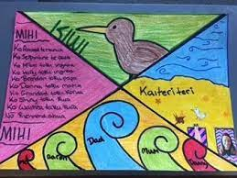
- Divide your page into four spaces by folding on the diagonal or using a straight edge to draw lines from top corner to bottom corners
- In the top space – draw your mountain/s.
- In the bottom space, draw your special water: lake, sea, river
- In one side box, draw your whānau
- In the other side, draw your special places or you could write out your pepeha again.
- Use lots of colour, creativity and express yourself.
Share with your whānau when you are finished. Take a photo and send it to your teacher.

Day 10: Reflection
Congratulations, that is our last learning activity for this pack. Help your learner reflect on all the amazing learning they have done across ten days.
Talk with someone in your whānau.
Tell them all the things you have done today.
- How did today make you feel?
- Which activity did you enjoy the most today?
- What did you learn today?
Wellbeing check
Put the Face cards you used last week on the table or floor in front of you.
- Which card shows how you felt this morning? Which card shows how you feel now?
Write or draw this in your home learning book.
Close your book – School is finished for today. 😊

