A learning from home pack
for learners in years 4 to 6

We shape an education system that delivers equitable and excellent outcomes
He mea tārai e mātou te mātauranga kia rangatira ai, kia mana taurite ai ōna huanga

7 Feb 2022 | Trial version published
28 Feb 2022 | Version 2 – includes extension to 10 days of activities, improvements from trial feedback

Creativity – How do we express ourselves?
“Creativity is intelligence having fun.”  ~Albert Einstein | I orea te tuatara ka patu ki waho
 | A problem is solved by continuing to find solutions

Notes for teachers

Purpose
We know there will be additional challenges for our schools, our learners, and their whānau in 2022. The purpose of these learning from home packs is to support you as you prepare to provide continuous learning for all learners through the next period of the Covid pandemic.

Flexibility
The packs are designed to be used flexibly for the types of interruptions learners may face.
- They may need to isolate at home.
- Due to health and safety requirements, such as social distancing, your school might not be able to have all students on site. Hybrid learning may start.
- Your school might close, and learners would need to learn from home. (Note: the intention under the Covid Protection Framework is to keep schools open.)

Hybrid learning
Hybrid learning describes when schools and kura are simultaneously teaching some learners face-to-face on site and supporting others to through distance-learning options. You may also be teaching learners who are not normally in your class. For most of us, hybrid learning is a new experience.

Realities
You know your learners and have a good understanding of their learning situations.
Many learners will have siblings at home, as well as whānau who share the same space and devices. Some may have access to the internet and devices, and others may not. Learners will also have varying levels of adult support.
There are a mix of activities in this pack that use materials commonly found in most homes. Some activities will require adult support while others can be managed independently. This resource is provided as a Word document so that you can adapt it for your learners.
We suggest starting each day with a karakia (See p. 9), check in with the teacher, followed by setting up the learning environment. The pack contains suggestions, but you can replace these with however you want your learner to start their day.

Resources
The resource uses a range of books from the School Journal series. You might want to send these home, along with a “my home learning” exercise book, pencils, crayons, or felts, and some craft materials (glue, scissors, construction paper). Learners can bring their home learning book back to class to share.
If your learners do not have reliable access to the internet, here are the resources to send home with this to create a paper-based pack.

School Journals used in this pack:
- https://instructionalseries.tki.org.nz/Instructional-Series/Junior-Journal/Junior-Journal-49-Level-2-2014/Tu-i
- https://instructionalseries.tki.org.nz/Instructional-Series/School-Journal/School-Journal-Level-2-November-2018/Tafoe-O
- https://instructionalseries.tki.org.nz/Instructional-Series/School-Journal/School-Journal-Level-2-November-2016/Close-up
- https://instructionalseries.tki.org.nz/Instructional-Series/Junior-Journal/Junior-Journal-59-Level-2-2019/Bird-of-the-Year
Other resources to print:
Face cards https://pb4l.tki.org.nz/content/download/576/2328/file/PB4LIYTEmotionalFaces.pdf
Garden bird survey document: https://gardenbirdsurvey.landcareresearch.co.nz/uploads/1/1/5/9/115962649/what_is_nzgbs_teacher_resource.pdf
Bird identification card - Māori: https://gardenbirdsurvey.landcareresearch.co.nz/uploads/1/1/5/9/115962649/a3_bird_id_poster_portrait_maori_1.pdf
Bird identification card - English: https://gardenbirdsurvey.landcareresearch.co.nz/uploads/1/1/5/9/115962649/a3_nzgbs_bird_id_poster.pdf

Layout of this resource
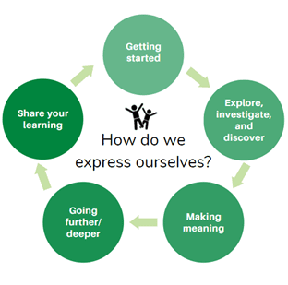
This pack is filled with learning activities for your learner that can be used at school or at home. All activities are framed around the big idea of Creativity – how do we express ourselves?
This pack contains suggestions for starting the day with a karakia (See p. 9), check in with the teacher, and setting up the learning environment. You can replace these with how you want your learner to start their day
The activities in this pack follow an inquiry learning model (figure 1) exploring one big idea through two contexts. Each day the learner will work through one part of the model culminating with sharing their learning on day five.
Figure 1 Inquiry learning model
The learner is provided with four activities and a fitness break for each day

Setting up the learning environment
Encourage whānau to support learners to set up a space for learning at home. Learners might like to design their own space as a separate learning activity. Some materials they may need could include pen, pencils, paper, a notebook, colouring pencils, glue, scissors, and a device to access the internet. You can borrow some of these items from your school.

Many of the suggested activities and experiences can be extended with the use of online resources which can be accessed and viewed using a Smartphone.

Overview of the learning in this pack
Week 1 will focus on our own, and other people’s experiences as birdwatchers.
Week 2 will focus on people’s relationships with birds in the past and our role as a guardian. Birds are taonga. We will be learning how positive action leads to positive change.
Learners will explore, investigate, discover, and make meaning as they go through each task. There are times where they look a little deeper into the topic. Some of the tasks may be independent hands-on tasks while some may involve connecting and sharing with others.
Day 1 | Day 2 | Day 3 | Day 4 | Day 5
Activate our prior knowledge and create our bird watching experience | Explore how people are inspired by birdwatching. | Observe bird movements and watch dancers making bird movements. | Create a poster. Look at how dance is used to share culture. | Reflect on our week of creativity and bird watching.
Day 6 | Day 7 | Day 8 | Day 9 | Day 10
Discover what it takes to look after rescue birds. | Use infographics to process information | Explore what it takes to be a volunteer. | Learn about bird sanctuaries. | Celebrate our learning journey.

Daily timetable
Spend the first hour setting up for the day’s learning. This could include checking in with the teacher and classmates, singing waiata, and exploring the inquiry topic. Help your learner look through the activities for that day and choose the order to do them in. You could turn this into a visual timetable by cutting out images (like the ones below) and putting them in order.
Below is a possible daily timetable. We have allocated 30 minutes for most activities. Your learner may take more or less time than this. We suggest they take the time they need to complete an activity. This may mean they choose which activities they will complete for the day, rather than having to complete them all.
Time | Activity
9:00 am | Starting the day
9:30 am | Activity 1
10:00 am | Break
10:30 am | Activity 2
11:00 am | Fitness break
11:30 am | Activity 3
12:00 pm | Lunch time
1:00 pm | Activity 4
1:30 pm | Reflection time
2:00 pm | End of the school day

Daily fitness – Choose something each day
It is important to include a fitness activity every day. Please ensure that your learner includes this in their daily timetable. If possible, it would be great to do the fitness activity with your learner or have them complete it with their siblings where appropriate. Below are a range of activities to choose from – or you can make up your own ideas! Please choose activities that are appropriate to your learner’s abilities and talents.
Exploring our section
Run around the inside of your section two times (just like how you walked around the inside of your bedroom). Check where you are allowed to go (don’t leave your section).
Plan a course and touch any of these in your section – fence, letterbox, gate, door, tree
Go around your section two more times using different movements. You can jump, hop, skip, sidestep, gallop (or if you are inside you can crawl, slide, walk backwards, tiptoe).
Weekly fitness tracker
Keep daily track of your fitness. Can you improve your own record over time?
Do as many repetitions of each exercise as you can. Count them and record below
 | # push ups | # burpees | # star jumps | # sit ups | # squats
Monday
Tuesday
Wednesday
Thursday
Friday

Spelling fitness
Can you do the exercises to spell out your name? What about another word?
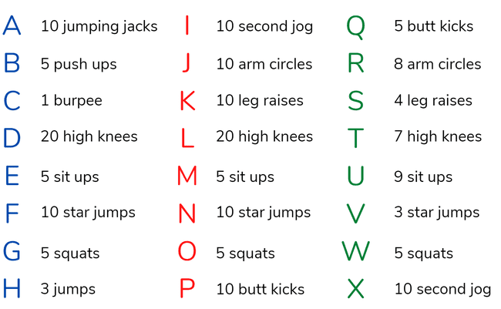
Les Mills Born to Move videos
https://www.tvnz.co.nz/shows/les-mills-born-to-move

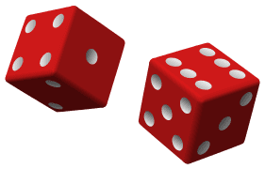
Dice Fitness
On six small pieces of paper/card write the numbers 1-6. Then on each of the numbered pieces of paper write or draw an action or move (see example below).
Place the cards in a container in the middle of the space you are going to exercise in.
Turn on some music (radio, TV music) and move around however you like – skipping, hopping, walking, jogging.
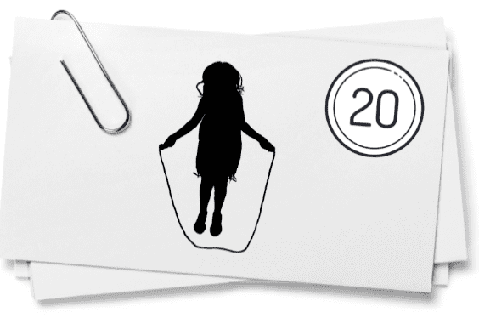
When the music pauses (helper presses pause or a natural pause in the music if working independently) roll the dice, find the card with the dice number on it and do the fitness move on the card.
You may like to ask people in your home to join in, it is lots of fun when there are others giving it a go too!

Playing Card Fitness
How to play:
- Each card number represents an exercise.
- Each suit represents the number of repetitions.
Pull a card from the deck of cards and do the exercise. Repeat until your time is up.
Or follow along with this video – you will still need your pack of cards! https://www.youtube.com/watch?v=_zaJa_U3ZJQ

Mindfulness activities
These activities are good to do at the beginning and the end of the day. They can help you get ready for learning, and help you to reflect on your learning:
Belly breathing
Belly breathing is easy to do and very relaxing. ... Put one hand on your belly just below your ribs and the other hand on your chest. Take a deep breath in through your nose, and let your belly push your hand out. Your chest should not move. Breathe out through pursed lips as if you were whistling. Repeat this ten times.
Balloon breathing
Sometimes when we are feeling excited, upset, or scared we forget how to breathe and that can make it feel even worse.
- Put your hands on your belly.
- Breathe in through your nose and feel your belly get bigger like a balloon.
- Breathe out through your nose and feel your belly get smaller and smaller.
- Do this five times.
Square breathing
- Imagine you are drawing a large square in front of you while you are sitting down.
- Start at the bottom right of the square.
- Breathe in for 4 counts as you trace the first side of the square in the air with your finger.
- Hold your breath for 4 counts as you trace the second side of the square in the air.
- Breathe out for 4 counts as you trace the third side of the square in the air.
- Hold your breath for 4 counts as you trace the final side of the square in the air.
You just completed one deep breath! Repeat.
Birdsong mindfulness
Choose a birdsong recording to listen to. Sit or lie still and listen to the recording. If you don’t have a device you could go outside to listen for real birdsong. You might like to close your eyes and focus on deep tummy breathing as you listen. This mindfulness exercise will help you feel calm and ready to take on a new day of learning.
https://sparklers.org.nz/activities/birdsong-mindfulness/
Make a drawing that reflects the music you are hearing
Imagine colours, lines, and shapes as you listen to music, and add these to your drawing.
As you make the marks, match them to the rhythm you are hearing.
Your movement across the page will turn your hearing into movements that guide your pencil across the page. Are you noticing emotions floating out through your body?
If you fill your page, put down your drawing instrument and continue to listen mindfully to the music. Do you feel more peaceful and contented? Hope so!

Wellbeing check in
Put the Face cards on the table or floor in front of you or look at them on your device.
Pick two cards that show how you are feeling. Write these in your home learning book.
Tell someone in your whānau about why you think you feel like this?
Pick a new card that shows how you would like to feel today.
Plan to do something that will help you feel like that before the day is done.

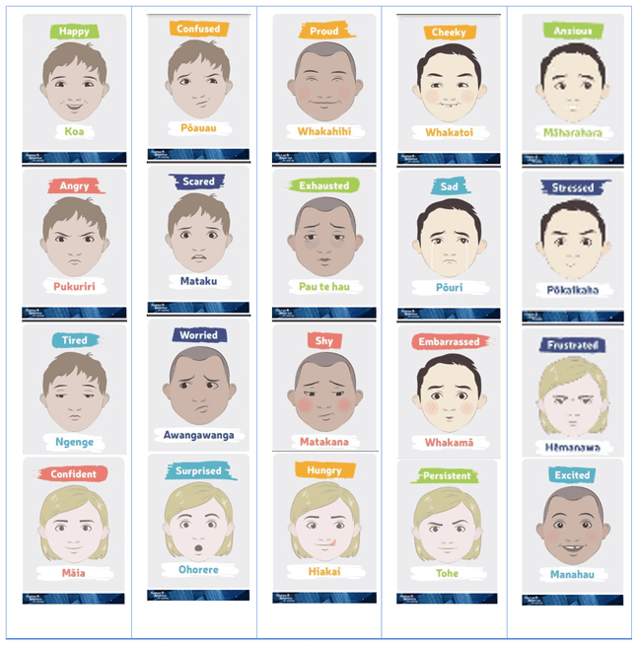

Starting the day – Each and every day
Notes for teachers and whānau
You can use this suggestion to start the beginning of each day.
Starting the same way each day helps create a structure for your learner. Your school might have your own way to do this, for example starting the day together as a class on Zoom. In this pack we provide a karakia to settle into the day. Saying the karakia with your learner a few times will help them be able to do this more independently tomorrow and beyond. As part of the start of the day and setting up the learning environment, help your learner look through the activities suggested for that day and choose a fitness activity. They could fill out their daily timetable and think of other activities they might like to do, like reading.
Note that our Inquiry focus for today is – “getting started” which includes generating questions, activating prior knowledge, and introducing the big idea.
In this activity I am learning to:  - Practise your karakia  - Do a mindfulness activity (See p. 7)  - Plan out my day and where I will learn  - Choose a fitness activity (See p. 5-6)  - Check in with your teacher. | What do I need?
- 30 minutes
- Check with your teacher to see if there is a special way they would like you to start your day
- My home learning book, pencil/pen
- Optional: Karakia video at: https://www.youtube.com/watch?v=3em_pulEjT0

Karakia
Do you have a karakia that you say in your house or at school? If not here is a karakia to welcome in the day. You can listen to it here if you have a device: Kia Hora te Marino
Kia hora te marino May peace be widespread
Kia whakapapa pounamu te moana May the sea be like greenstone
Hei huarahi mā tātou i te rangi nei A pathway for us all this day
Aroha atu, aroha mai Give love, receive love
Tātou i a tātou katoa Let us show respect for each other
Planning day 1
Set up your space for learning. Grab the things you need. These are the activities for today
Activity 1 | Activity 2 | Activity 3
Activating my prior knowledge  Reflecting on my own experiences with birds and knowledge of them. | Reflecting on a bird experience  Thinking more deeply about one bird experience. | Birdwatching  Observing birds in my garden.

Day 1 activity 1: Activating my prior knowledge
Activity 1 requires the learner to reflect on their experiences with birds and prior knowledge about them. They might like to discuss what they know about birds with whānau. You might have photographs or videos of bird experiences that can be shared.
Note that our Inquiry focus for today is – “getting started” which includes generating questions, activating prior knowledge, and introducing the big idea.
What do I need
- 30 minutes
- Home learning book

In this activity I am learning to: Activate my prior knowledge of birds.
Read this quote by Sir David Attenborough:
“Everyone likes birds. What wild creature is more accessible to our eyes and ears, and as close to us and everyone in the world, as universal as a bird?”

Close your eyes and think about all the experiences that you have had with birds.
- What birds have you seen in your neighbourhood? Can you name them?
- What birds have you seen at the beach? In the bush? At the zoo?
- Do you have birds as pets?
- Do you like birds? Why or why not?
- Do you have a favourite bird?
Think of the colours, shapes, sounds and movements of the birds that you have seen. You may even recollect touching or smelling them.
Your task
In your home learning book, write words or draw pictures to show your prior experiences. You might like to share and discuss these experiences with a family member.
Consider what facts you already know about birds and what you wonder about. The following questions might help guide your thinking:
- What do birds eat?
- Where do they live?
- How long do they live?
- How many birds can I name?
- What birds are native to Aotearoa?
- What predators do birds have?
- How have people interacted with birds in the past?
- How do people interact with birds now?
In your home learning book, write words or draw pictures in your home learning book to show your prior knowledge and wonderings.

Day 1 activity 2: Reflecting on a bird experience
Activity 2 requires the learner to reflect more deeply on one prior experience with birds. Talking about this experience with whānau will help them to deepen their ideas and clarify their memories.
What do I need?
- 30 minutes
- Home learning book

In this activity I am learning to: Reflect on one of my prior experiences with birds.
Think back to one of your experiences with a bird or group of birds and consider how it made you feel. This list of emotions might help your thinking...
excited | curious | surprised | frightened | interested
amused | calm | energised | knowledgeable

Your task
Discuss the experience with someone in your whānau if you can.
Divide a page in your home learning book into three columns (see example below) and write the following headings:
- Description of the experience (who, what, where, when)
- My emotions – how I felt
- How I shared the experience (or would like to have shared)
Fill in each column. You could draw a picture underneath to illustrate the experience.
You might like to share your virtual birdwatching experience with your teacher or a classmate.

A birdwatching experience
Description of the experience (who, what, where, when) | My emotions – how I felt | How I shared the experience (or would like to have shared)

Day 1 activity 3: Birdwatching
Activity 3 requires the learner to observe birds in their garden. To extend the activity, you might like to go for a family walk to your local beach or bush reserve to compare and contrast bird life between your garden and places in your neighbourhood.
What do I need?
- 60 minutes
- Home learning book
- A towel or blanket to lie on outside
- Department of Conservation website - https://www.doc.govt.nz/get-involved/conservation-activities/identify-common-birds-in-your-local-nature-space/
- Dawn Chorus with the Bellbird & Tūī https://www.youtube.com/watch?v=yf7Nn9CqrxI

In this activity I am learning to: Observe the birds in my garden.
Read these quotes and whakataukī, and consider why people watch and listen to birds:
“In order to see birds, it is necessary to become part of the silence” Robert Lind
“If you listen to birds, every day will have a song in it.” Kyo Mclear
“Ka korokī ngā manu ka tākiri ko te ata” – “The dawn chorus of the birds signals a new day.”
Your task
Find a place to set up a bird watching station, under a big tree if possible. Lay a towel on the ground and sit quietly, or you can sit on a chair on a deck. Let the birds get used to you.
Watch and listen for 20 to 30 minutes. You could video or photograph the birds to share with your whānau later. Even if you are near a busy place, birds will still be around.
Answer the following questions in your home learning book:
- What different kinds of birds did I see and hear? You could look at the Department of Conservation website to help identify common backyard birds.
- What sounds did they make? How would I describe the sounds?
- Was there an extended song or short bursts?
- What were the birds doing?
You might like to draw the birds that you have seen.
Extension idea:
Listen to this recording of a dawn Chorus with the Bellbird & Tūī. Consider getting up early to hear a dawn chorus in your garden. How is the bird noise and bird activity different early in the morning? Make notes in your home learning book.
If possible, go for a walk with your family to your local beach, river, or bush and compare the birds there with the birds in your garden.
- What birds are the same?
- What birds are different?
- Is the birdsong quieter or louder?
- Is the bird activity the same or different?

Day 1: Reflection
30 minutes
Note: Reflection can be challenging for all learners, but it can also provide them with rich opportunities to think about how their learning is progressing. Use the questions below as prompts to encourage your learner to think about what they have learned so far and help them to plan out their next steps. If you have concerns with their learning or find that your learner is needing more help, contact their teacher for more support.
Today we have filled our imagination with birds. Take some time to talk about the things you have done with the whānau member who helped you today. What has surprised you? What did you notice that you hadn’t noticed before?
Take some time to think about how you are feeling after today’s learning activities.

Your task
Reflect on the following prompts and write your thoughts in your home learning book:
- What did you enjoy most about today?
- What is one thing you learnt today?
- What is one strategy that helped you with your learning?
- What did you find challenging or distracting? (For example - you ran out of time for some activities, or you finished them quite quickly and felt like you needed more.)
- Is there anything you need extra help with? Who can you ask to help you with that?

Close your book – School is finished for today. 😊

Day 2: Getting started
Take the first 30 minutes of the day getting ready for learning:
- Practise your karakia (See p. 9)
- Do a mindfulness activity (See p. 7)
- Plan out my day and where I will learn
- Choose a fitness activity (See p. 5-6)
- Check in with your teacher.
Set up your space for learning. Grab the things you need. These are the activities for today. Our inquiry focus today is – “getting started” which includes generating questions, activating prior knowledge, and introducing the big idea.
Activity 1 | Activity 2 | Activity 3
How birds inspire us  View clips and read poems about birds. | How many birds?  Carry out a statistical investigation to see how many native birds people can name. | Songs about birds  Listen to songs that reference birds.

Day 2 activity 1: How birds inspire us
This activity requires the learner to investigate how birdwatching has inspired people to create film and poetry about birds. You could point out other artistic creations that have been inspired by birdwatching, for example, artwork, ornaments, books, and songs. You might have your own bird inspired artwork or artefact to share with the learner.
What do I need?
- 30 minutes
- ”Tui” by Kelly Joseph (look for a copy of this School Journal in your pack) https://instructionalseries.tki.org.nz/Instructional-Series/Junior-Journal/Junior-Journal-49-Level-2-2014/Tu-i
- Optional: Pelican waits in line to be served at fish store - https://www.youtube.com/watch?v=QqYXBX-58Z4
- A day with W the Weka - https://www.youtube.com/watch?v=EJ-MYz1_pJA
- Home learning book

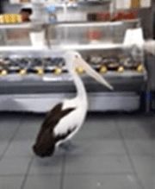
In this activity I am learning to: Explore how birds have inspired us.
Watch these two YouTube clips that feature birds:
Pelican waits in line to be served at fish store
This is a one-minute clip that shows a very large pelican in a shop. He looks like he is waiting in line to buy some yummy food!

A day with W the Weka
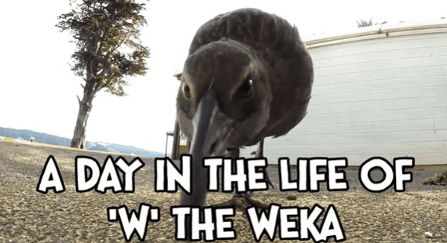
In this clip the weka is filmed singing in the morning, grabbing someone’s shoelaces, following a person running, lifting up a kitchen mat with its beak, cleaning up the beach, eating some peanut butter out of the jar, eating fruit out of a kitchen fruit basket, playing in a puddle, chasing another weka away from the house, hiding and other funny human-like activities.
Your task
As you watch the clips, and/or read the caption notes, think about why the person shared their clip. Was it to entertain? Was it to share an experience? Was it to help us to know more about the bird? Does the clip give you clues about the person who shared it?
Record your ideas about each YouTube clip in your home learning book.
You might be able to share these clips with somebody else in your home. Ask them the same questions you were asked. Were their responses the same or different to yours?
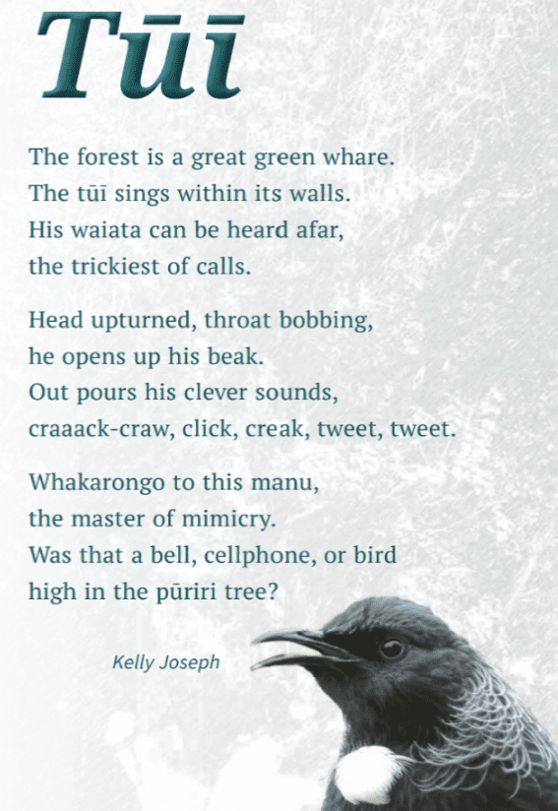
Read this poem about birds ”Tui” by Kelly Joseph
Read the poem silently and then out loud. You might like to share the poem with your whānau and/or record yourself reading it.
Your task
Work through the following questions and write your answers in your home learning book.
- How does the poet describe the bird’s appearance, movement, sounds, and habits?
- What did you learn about the bird through reading the poem?
- Why do you think the poet wrote this poem?

Extension idea
Find art, music, songs, poems, or dances that feature birds or groups of birds. What do you learn about birds through each creation? Make notes of these in your home learning book.

Day 2 activity 2: How many birds?
This activity requires your learner to ask people (those who are in the house and maybe others by telephone or other means) to name New Zealand birds. You might need to help them make a list of people to contact and how to do this.
What do I need?
- Home learning book
- Optional -Department of Conservation website - https://www.doc.govt.nz/nature/native-animals/birds/birds-a-z/

In this activity I am learning to: Investigate how many native birds people can name.
Your task
Draw a large 5x5 table on a page in your home learning book (five columns by five rows).
This page will be your data collection sheet. See the example on the next page

In each box write the name of a bird that is native to Aotearoa New Zealand.
Optional: You could use the list below to help get started and the Department of Conservation website to find more:
Kiwi  Tūī  Kākā  Kingfisher/kōtare  Bellbird/korimako | Moa  Kākāpō  Kōkako  Weka  Wax eye/tauhou | Fantail/pīwakawaka  Kea  Takahē  Morepork/ruru  Tomtit/miromiro | NZ pigeon/kererū  Pūkeko  White heron/kōtuku

Remember to label one box as “other” for birds that you have not listed.
Ask members of your family if they can name ten birds that are native to Aotearoa.
Record their answers using tally marks on your data collection sheet.
Try to interview at least five people. You could ask people outside your home through a virtual meeting or phone call.
Remember to thank each person for taking part in your investigation.

Total up your numbers. We will use the data tomorrow!

Data Collection Sheet

Moa | Tūī | Kākā | Kiwi | Kingfisher
Bellbird | White heron | Pūkeko | NZ pigeon | Tomtit
Morepork | Takahē | Kea | Fantail | Wax eye
Weka | Kōkako | Kākāpō | Other

Day 2 activity 3: Songs about birds
This activity requires a device to listen to a waiata and a poem. If you do not have access to a device this will only take a few minutes to listen to on a cell phone.
What do I need?
- Home learning book
- Optional: Hūtia – https://vimeo.com/562106367
- Yellow bird - https://www.youtube.com/watch?v=29aZiNz4ZQ4

In this activity I am learning to: Explore songs that have references to birds.
Traditional Māori waiata
Option 1: Listen to Hūtia, a waiata about nurturing (looking after) the young. The bellbird represents the young and the harakeke represents the wider community of families and social groups.
Option 2: Read the lyrics of Hūtia below and see if you can make up your own tune. You could sing it in te reo Māori and then in English to the tune of a nursery rhyme.
As you listen to the recording, read the English translation for each line.
Hūtia te rito | Pull out the shoot
Hūtia te rito o te harakeke | Pull out the shoot of the flax bush
Kei hea te kōmako e kō? | Where will the bellbird sing?
Kī mai ki ahau | Say to me
He aha te mea nui? | What is the greatest thing?
He aha te mea nui o te ao? | What is the greatest thing in this world?
Māku e kī atu | I will say
He tangata! He tangata! He tangata, hī! | The people! The people! The people, hī!

Your task
Consider the question – if you pluck the centre out of the flax, where will the bellbird sing?
- Why is the bellbird mentioned?
- Do you think the bellbird’s song is a valued taonga (treasure) to Māori?
- What messages does the waiata share?

Write your thoughts in your home learning book.
Yellow bird
Listen to Yellow Bird. This song started out as a poem entitled "Choucoune" by a Haitian poet called Roswald Durand. It was written in 1883. The poet sings to a yellow bird while praising the beauty of a young Haitian girl. The poem was transformed into music in 1893. The English version, which you are listening to, was arranged by Norman Luboff in 1957. Songs and poems, like people, have interesting histories.
If you do not have a device to listen here are the lyrics to read:
Yellow bird, up high in banana tree
Yellow bird, you sit all alone like me
Did your lady friend leave the nest again?
Oh, how very sad, make me feel so bad
You can fly away, in the sky away
You're more lucky than me
I also have a pretty girl
She's not with me today
They're all the same, this pretty gals
They leave the nest, and they fly away
Yellow bird, up high in banana tree
Yellow bird, you sit all alone like me
Black and yellow, you like banana too
You better fly away, in the sky away
The picker's coming soon
He picks from night to noon
He might pick you someday
I wish that I was a yellow bird
I could fly away with you
But I am not a yellow bird
So here I sit, nothing else to do
Yellow bird
Yellow bird
Yellow bird

Your task
Consider why the poet compares themself to the yellow bird, and why he compares his “pretty girl” to the bird’s “lady friend”?
Write (or draw) your thoughts in your home learning book.

Tomorrow you will select one of these songs to create dance moves to. Which one do you think you might choose?
Or perhaps there is another song you might like to use?

Day 2: Reflection
Today your learner has watched, read, explored, investigated, and listened across the four learning activities. Now it is a chance for them to reflect on their learning. We have included a link to some classical music that they might like to listen to as they reflect on their learning.
Take some time to think about how you are feeling after today’s learning activities.

Your task
Reflect on the following prompts and write your thoughts in your home learning book:
- What did you enjoy most about today?
- What is one thing you learnt today?
- What is one strategy that helped you with your learning?
- What did you find challenging or distracting? (For example - you ran out of time for some activities, or you finished them quite quickly and felt like you needed more.)
- Is there anything you need extra help with? Who can you ask to help you with that?

As you carry out this reflection you might like to listen to a selection of classical music that has been inspired by birdsong or other music of your choice. Or maybe you’d like to hum the tune to your favourite song.
Close your book – School is finished for today. 😊

Day 3: Getting started
Take the first 30 minutes of the day getting ready for learning:
- Practise your karakia (See p. 9)
- Do a mindfulness activity (See p. 7)
- Plan out my day and where I will learn
- Choose a fitness activity (See p. 5-6)
- Check in with your teacher.
Set up your space for learning. Grab the things you need. These are the activities for today. Our inquiry focus for today is “explore, investigate, and discover”.
Think about this whakataukī as you prepare for your learning today.
Itiiti rearea, teitei kahikatea ka taea | Although the rearea is small it can ascend the lofty heights of the Kahikatea tree

Activity 1 | Activity 2 | Activity 3
Observing how birds move  My own experience first then on the internet. | Birds and cultures  Exploring how birds have influenced cultural dances. | Dance magic  Creating your own dance inspired by birds.

Day 3 activity 1 – Today we dance
Your learner today will need courage to create and perform a dance that is inspired by observations of bird movements. They will identify bird movements: while they eat, fly, land, and react to the presence of other bird like themselves or others. To observe the bird movements, your learner can go outside and feed the birds. This won't take too much from your food supplies. Think of it as brainfood. Feeding the birds to feed your learner’s experiences. They can also watch clips of bird behaviour, however getting them outside to observe should come first. The traditional dances that they will view all started from first-hand observations of real birds.
What do I need?
- 60 minutes
- Sun hat
- Bird food (e.g., bread, rolled oats, overripe banana)
- Your garden
- Two-litre container of water
- Optional: Device (tablet/smartphone) to record individual moves.
- Slow motion - https://www.youtube.com/watch?v=VSzpM8vEAFA
- Amazing Minah - https://www.youtube.com/watch?v=5Cvve6oqgX4
- Seagulls squabbling - https://www.youtube.com/watch?v=DDpjTNc6sHE
- Fantails - https://www.youtube.com/watch?v=zeRitFb1gTQ
First-hand observational experience is the best and the most fun.
This kind of observation was used to create traditional dances around the world.
In this activity we are going to build knowledge about bird movements and behaviour by feeding some birds.

Watching birds feeding and moving in the garden

Get ready
You are going to head out into your garden or ask an adult to take you to a park. Look through this list of things you will need to do to get ready for this learning.
- Wear a sun hat.
- Take a face mask if going to a park.
- Identify a suitable space that has trees or shrubs and grass.
- Fill a large empty soft drink bottle or milk bottle with water to soak some of the grass.
- Prepare a bag/container of food: two slices of bread (torn into small pieces), half a cup of raw rolled oats, an over ripe banana, or cut up apple.

Observe
- Soak some of the grass with water. This will encourage the birds to peck/explore around that area as they are attracted to damp soil/grasses
- Feed the birds with the food that you have gathered.
- Write or draw the different movements you see the birds making. You can even try to make these movements yourself.
Watching birds feeding and moving on the Internet (optional)
Once you are back home with your notebook, you can watch some videos of birds feeding and moving. Are there any movements or behaviour that you did not see in your own observations?
- Slow motion - https://www.youtube.com/watch?v=VSzpM8vEAFA
- Amazing Minah - https://www.youtube.com/watch?v=5Cvve6oqgX4
- Seagulls squabbling - https://www.youtube.com/watch?v=DDpjTNc6sHE
- Fantails - https://www.youtube.com/watch?v=zeRitFb1gTQ
Your task
In your home learning book write a list of five different moves you observed:
1.
2.
3.
4.
5.
You could ask someone to film you making these moves using their phone. This will help you to see yourself in motion. Look at your video and see if you want to improve your moves and film them again.

Day 3 activity 2: Learning from traditional cultural dancers
The learner will watch 2 examples of cultural dances that are inspired by bird behaviour. Encourage your learner - everything they are doing in preparation for creating their own dance is the same process that went into the creation of the examples they are viewing.
What do I need?
- 30 minutes
- First Nation hoop dance (from North America) https://www.youtube.com/watch?v=GX0piwK8jRM
- Haka Manu (bird dance) Fatu iva (from Samoa) https://www.youtube.com/watch?v=8PuVPACU_bo

In this activity I am learning to: Watch cultural dances to identify how they represent bird behaviours, study the use of props that add meaning and depth to the performance, and think about what I can use in creating my dance that will add depth.
Watch the First Nation hoop dance. If you don’t have a device, examine the pictures below.
Think about the movements the dancer is making. Do they look like some of the movements you observed in birds? Look at the props he is using. How do they add to the movements?
Your task
Think of one of the bird moves that you practised yesterday. Can you add a prop to this move to make it even better? Practise your move and then show it to someone in your house.
Watch Haka Manu Fau iva If you don’t have a device, examine the pictures below.
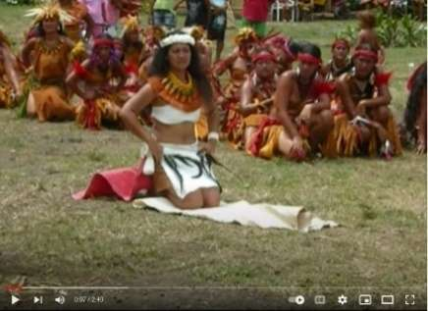 | 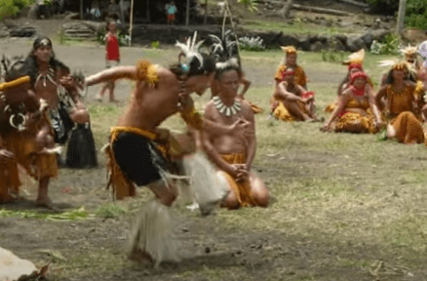 | 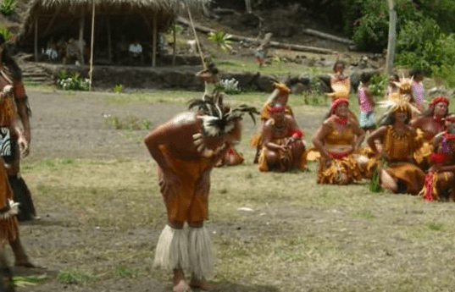
Can you see some dance moves that are the same as the hoop dance? What moves are different? How can you tell that this is a dance about a bird?
Your task
Choose another one of your bird moves and make improvements using your new ideas.

Day 3 activity 3: Dance magic
This is the mountain your learner must climb today. They may or may not need your support to create. They will need a supportive and appreciative audience. You might need to organise your household to be there. You could film their creation and share it with friends and family using messenger, zoom or another sharing platform.
What do I need?
- 60 minutes
- Video of my dance moves from activity 1
- Optional: Music to dance to (e.g., https://www.classicfm.com/discover-music/classical-music-inspired-by-birdsong/)
- Someone to film my dance

In this activity I am learning to: Use my imagination and learning to create a dance
Your task
Your task is to create your very own bird dance to music.
- Find a piece of music that you like and makes you think of your bird. You could use classical music, a waiata, or a traditional song that we have already listened to.
- Find any props that you would like to use in your dance.
- Create a dance that uses your bird movements.
- Practise until you are happy to share your dance.
- Perform your dance for someone at home OR film your dance so that you can share it with your whānau.

Day 3: Reflection
Connect with your learner and share the emotions you experienced and your response to their dance. Support them to share this with others in a real time and recorded format.
Take some time to think about how you are feeling after today’s learning activities.
Your task
Reflect on the following prompts and write your thoughts in your home learning book:
- What did you enjoy most about today?
- What is one thing you learnt today?
- What is one strategy that helped you with your learning?
- What did you find challenging or distracting? (For example - you ran out of time for some activities, or you finished them quite quickly and felt like you needed more.)
- Is there anything you need extra help with? Who can you ask to help you with that?
Close your book – School is finished for today. 😊

Day 4: Getting started
Take the first 30 minutes of the day getting ready for learning:
- Practise your karakia (See p. 9)
- Do a mindfulness activity (See p. 7)
- Plan out my day and where I will learn
- Choose a fitness activity (See p. 5-6)
- Check in with your teacher.
Set up your space for learning. Grab the things you need. These are the activities for today.
Activity 1 (60 min) | Activity 2
Audience time!  Creating a visual language poster. | Passing on information  Dance and storytelling is a way of sharing and exploring culture.

Day 4 activity 1 and 2 – Dancers love an audience
The learner is going to produce an advertising poster for the performance. They will need a photo of them in a dance pose (freeze frame) or they can draw a picture of themselves after looking in a mirror.
What do I need?
- 60 minutes
- Paper, ruler, pencils, crayons, paints
- Photo or picture of your dance move

In this activity I am learning to: Design a poster to persuade an audience and advertise my performance.
Your task
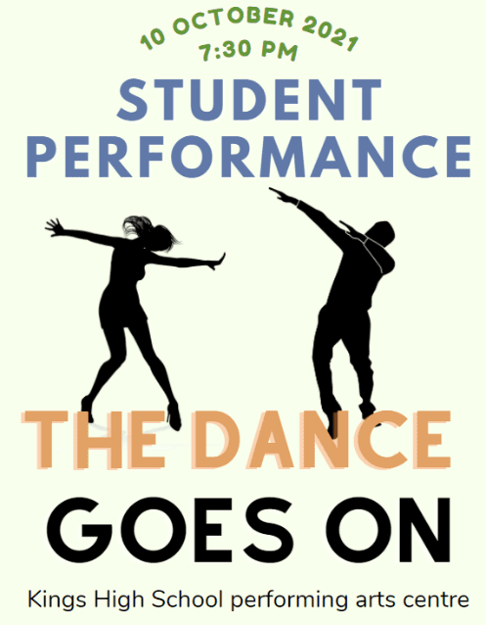
Observe this poster and then design a poster for your performance. Include a catchy phrase such as ‘Dancers love an audience!’ or ‘Why walk when you can dance?’
Look at the information that is shown in the poster. Consider:
- Who is dancing?
- What kind of dance style is it?
- What catchy phrase is used?
- What information is provided about when and where the performance is happening?
- What imagery is used?

Day 4 activity 3: Sharing language and culture
Dance, song, rhythms, and stories are treasured by the people and cultures who created them. The responsibility for preserving traditions has become a more difficult task as people have moved far away from ancestral homes. Today your learner will be able to make some connections to the mahi and determination needed to create and protect the traditional ways of being in and representing the world. There is a call to action, and it requires heroes to meet the challenge.
What do I need?
30 minutes
- Look for a copy of Tafoe-O in your pack or online at https://instructionalseries.tki.org.nz/Instructional-Series/School-Journal/School-Journal-Level-2-November-2018/Tafoe-O
Optional: A computer or phone to watch these clips:
- First Nation hoop dance (from North America) https://www.youtube.com/watch?v=GX0piwK8jRM
- Haka Manu (bird dance) Fatu iva (from Samoa) https://www.youtube.com/watch?v=8PuVPACU_bo

In this activity I am learning to: Understand that dance, songs, and stories are used to pass on the language and culture to future generations
Watch the videos of the dances one more time
The Hoop Dance and Samoan dance were inspired by the behaviour of birds. Each dance is presented using the musical sounds that are recognisable as from their culture.
Both use strong rhythms made by striking a drum. Rhythm in many cultures seems to be used more than melody. The dances tell a story. The audience can link the movements to bird behaviour because of the way the dancers use their body.
The message is reinforced using props. One uses hoops to shape the wings of the thunderbird and the Samoan woman uses feathers to signal a bird.
Your task
Read Tafoe O online or ask your teacher to send home the School Journal.
The Tokelau dance is not about a bird. When you read the article, you will find out what it is about. The prop used is a big clue.
Make a list and describe. Look around your house. What could be used as a dance prop?
Complete the table on the next page:

Prop (what is the item that you could use as a dance prop?) | Description (how could this be used in a dance?)
1.

2.

3.

Day 4 activity 4: Critical thinking
Dance, song, rhythms, and music can evoke a lot of emotion in us. For some of us it is the rhythm, the beat or the harmony of a song that elicits an emotional response. For others, it is the words and meanings of the words that impact our emotions. Today your learner will read the lyrics to a famous song. If they have access to the internet, they can listen to it as well. Then they will formulate an opinion about whether they agree with the lyrics and provide reasons why or why not.
What do I need?
- 30 minutes
- Optional: A device to access https://www.youtube.com/watch?v=A3yCcXgbKrE

In this activity I am learning to: think critically, make judgements, and justify my opinions
Listen to this song - What a Wonderful World and think about whether you agree with the reasons the world is so wonderful. If you do not have a device, read the lyrics.
Your task
Now take the time to listen and/or read again. This time you might want to highlight some words that evoke emotion in as you read the lyrics.
You may like to underline three things in the song that you agree are wonderful.
Write a paragraph in your home learning book or digital document giving at least 3 reasons why you agree or disagree with the song.

What a Wonderful World
The words and music are by Bob Thiele and George David Weiss
The most popular version is sung by Louis Armstrong
I see grass of green, red roses too
I see them bloom for me and you
And I think to myself what a wonderful world.
I see skies of blue and clouds of white
The bright blessed day, the dark sacred night
And I think to myself what a wonderful world.
The colours of the rainbow so pretty in the sky
Are also on the faces of people going by
I see friends shaking hands saying how do you do
They're really saying I love you.
I hear babies crying, I watch them grow
They'll learn much more than I'll never know
And I think to myself what a wonderful world
Yes I think to myself what a wonderful world.

Day 4: Reflection
Whakataukī
E koekoe te kōkō, e ketekete te kākā, e kūkū te kererū – The parson bird chatters, the parrot gabbles, the wood pigeon coos
We have looked at how birds move differently, this whakataukī helps us to think about how our birds all make different sounds too. It prompts us to think that we are unique like our birds – it takes all types of people to make a world, and we can celebrate our differences.
Your task
- Write or draw in your home learning book what this makes you wonder and feel.
Watch this video of a Samoan dance - https://www.youtube.com/watch?v=_cqdi74-Qn4 or if you do not have a device, examine the picture below.
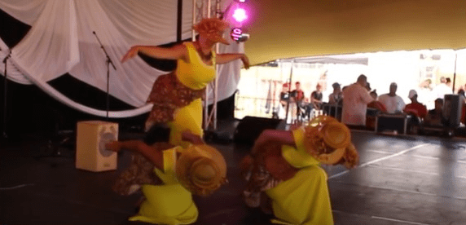
Using your learning so far this week, what do you notice in this dance?
- Why do you think the dance is called ‘Yellow Bird’?
- What bird movements does the dance make you think of?
Your task
Take some time to think about how you are feeling after today’s learning activities.
Reflect on the following prompts and write your thoughts in your home learning book:
- What did you enjoy most about today?
- What is one thing you learnt today?
- How will this help you?
- What did you find challenging or distracting? (For example - you ran out of time for some activities, or you finished them quite quickly and felt like you needed more.)
- Is there anything you need extra help with? Who can you ask to help you with that?
- You may like to record your thinking in your home learning book, or you may like to share your reflection with someone.

Close your book – School is finished for today. 😊

Day 5: Getting started
Take the first 30 minutes of the day getting ready for learning:
- Practise your karakia (See p. 9)
- Do a mindfulness activity (See p. 7)
- Plan out my day and where I will learn
- Choose a fitness activity (See p. 5-6)
- Check in with your teacher.
Set up your space for learning. Grab the things you need. These are the activities for today.
Activity 1 | Activity 2 | Activity 3 | Activity 4
Bird watching and maths  Working with data. | Bird poetry  Enjoy reading poetry about birds. | Writing  Writing our own bird poems. | Reflection  Reflecting on our week with the birds.

Day 5 activity 1: Bird watching and maths
Today we will be using the bird watching data from day 2 - activity 2 (page 17). Your learner is going to be working with the data they collected in that activity. They can also reconnect with the people they interviewed with the data. You might need to help with that.
What do I need?
- 30 minutes
- Survey results recorded in your home learning book (see day 2 activity 2.

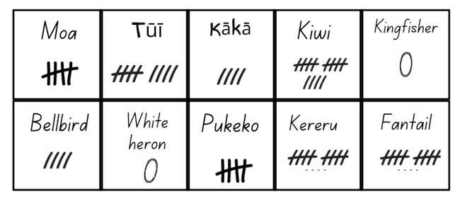
In this activity I am learning to: Sort the data I collected in my interviews, make statements about what the data shows, think about what this makes me wonder, and share the results with the people who helped me.
Interpreting your data
Your tally chart might look a bit like this:
Your task
Answer these questions in your home learning book:
- Which bird was recognised the most?
- Which bird had the second highest score?
- Which bird had the third highest score?
- How many of the birds on your list were not mentioned?
- How many birds were mentioned that you did not have on your list?
- Were you surprised about the results in this survey?

Day 5 activity 2: Reading bird poetry
In this activity your learner will be reading a poem and using their imagination build a picture in their mind. You may need to read this with them once and talk about the different describing words that are used.
What do I need?
- 30 minutes
- Home learning book
- Poem – Close up (check your pack for a copy of this School Journal) https://instructionalseries.tki.org.nz/Instructional-Series/School-Journal/School-Journal-Level-2-November-2016/Close-up

In this activity I am learning to: Identify adjectives (describing words) and use my imagination as I read a descriptive poem
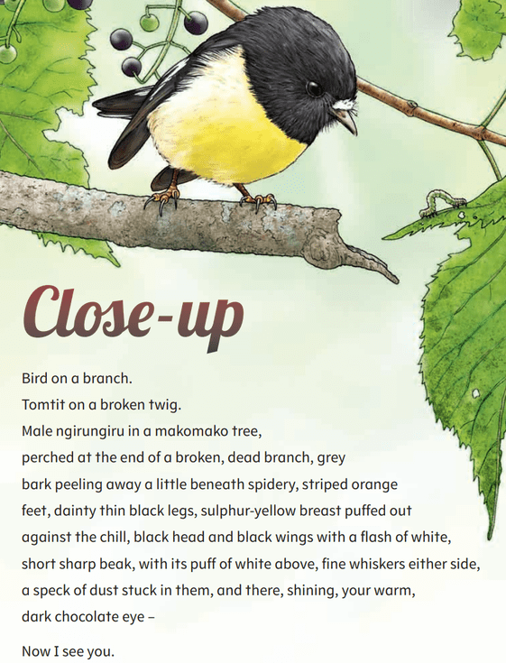
Reading and building a picture in our imaginations
This poem uses adjectives (describing words) to paint a picture in words. If you have someone at home who can help, ask them to read the poem to you while you close your eyes and use your imagination.
See if you can build the picture in your mind.

Your task
Read the poem out loud. There are some tricky words that you might need some help with.
Look through the poem and highlight the words that describe the bird.

Day 5 activity 3: Writing bird poetry
In this activity your learner will using their imagination to write a poem about the bird they have been watching using adjectives (describing words).
What do I need?
- 30 minutes
- Home learning book

In this activity I am learning to: Identify adjectives (describing words) and use my imagination to write a descriptive poem
Writing your own descriptive poem
Think back to the birds that you were observing in your garden or the park, or the ones you watched on YouTube.
Close your eyes and remember what they looked like.
- What colour was the bird?
- How big or small was it?
- Did it have a big beak or a small beak?
- Where was the bird? In the sky, on the grass, in a tree?
- What was the bird doing?
Your task
In your home learning book write three words that describe your bird for each of these characteristics:
Colours ___________ ___________ ____________
Size ___________ ___________ ____________
Beak ___________ ___________ ____________
Where it was ___________ ___________ ____________

Now use these words to write your poem. It could be something as simple as this:
I saw a bird with red, blue, and green feathers.
It was a tiny bird.
It had a large beak!
I wondered how it could fly in the deep blue sky.
Read your poem to someone in your house. Ask them to build the picture in their imaginations that you have painted with your words.

Day 5 Reflecting on bird watching
This is the final activity in this five-day period. This is an opportunity for your learner to go back through the week’s learning and think about the different things they have done. They can choose to extend any of the activities or finish off anything they haven’t quite finished.
For five days you have focused on how observing and thinking about birds has inspired people to create music, poems, dance, stories, and the wisdom contained in proverbs/ whakataukī.
Your task
Look back through the work in your home learning book.
Choose one of your learning activities, products, or accomplishments that you are most proud of from this week’s learning and present it to your whānau, family.
Think about how you could make your presentation engaging and informative for your audience.
Describe the process or learning journey you took to get to this point.
Explain why you are most proud of this piece or learning.
Invite whānau, family to ask any questions about your work or learning journey.

Finishing time
Look back through your work and see if there is anything you would like to finish off or tidy up.
Take some time to think about how you are feeling after today’s learning activities.
Your task
Reflect on the following prompts and write your thoughts in your home learning book:
- What did you enjoy most about today?
- What is one thing you learnt today?
- How will this help you?
- What did you find challenging or distracting? (For example - you ran out of time for some activities, or you finished them quite quickly and felt like you needed more.)
- Is there anything you need extra help with? Who can you ask to help you with that?
- You may like to record your thinking in your home learning book, or you may like to share your reflection with someone.

Close your book – School is finished for today. 😊

Day 6: Getting started
Take the first 30 minutes of the day getting ready for learning:
- Practise your karakia (See p. 9)
- Do a mindfulness activity (See p. 7)
- Plan out my day and where I will learn
- Choose a fitness activity (See p. 5-6)
- Check in with your teacher.
Set up your space for learning. Grab the things you need. These are the activities for today.
Activity 1 | Activity 2 | Activity 3
Bird rescue  Learning how we look after birds. | Listening time  Investigating a video transcript. | Point of view  Writing a letter.

Activity 1: Protection and guardianship
We are going to find out the ways that people have taken action to protect these animals who have given us so much and who share this earth with us.
What do I need?
- 30 minutes
- My home learning book
- Optional video: https://www.youtube.com/watch?v=ujwkIeRM3WI&t=111s

In this activity I am learning to: Understand the role we have in caring for birds, learn from someone else’s experience, and reflect on how another person’s experience made me feel
Protection and guardianship for living things always starts with our readiness to take action. Taking some one under your wing is a well-known saying. Baby birds rely on their parent birds to protect them from danger from predators, to keep them dry, and to keep them warm.
When a human looks after somebody in need of help, we say that they are taking that person under their wing. Through watching a video (or reading the transcript on the next page) we are going to learn about how Roxanne looked after two baby birds:
“Roxanne was biking through the rain when she saw a nest with two tiny baby birds inside. She brought them home with her and helped them eat and grow big. Now there was only one thing left to do... teach them to fly away!”
Watch and listen to the video wing. Turn on the closed caption function (CC) and you can read while you listen to the voice over (narration). You will see that Roxanne seems to know what she is doing as she rescues the birds.
Your task
- What would you do if you found two baby birds in a nest that has fallen from a tree?
- Write your thinking in your home learning book.

Day 6 activity 2: Video transcript
This activity encourages your learner to be an "active viewer and listener". This skill needs practise. Children need encouragement to engage more deeply with the content of visual media. Taking time to go deeper develops their ability to become critical thinkers rather than passive consumers. It is the difference between junk food and brain food!.
What do I need?
- 30 minutes
- Transcript of Roxanne’s baby bird experience
- Home learning workbook

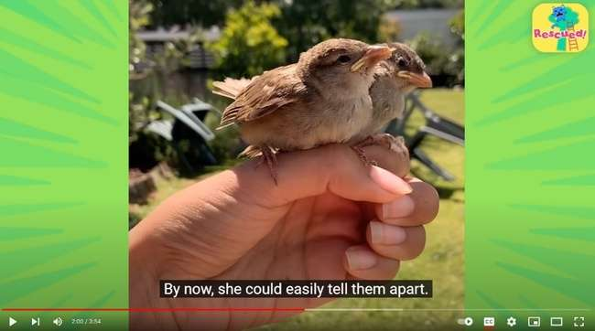
In this activity I am learning to: Read/listen to a transcript to obtain information, compare actions and emotions, and make connections between a story told digitally and written
In activity 1 we watched the video of Roxanne’s experience rescuing two baby birds.
In this activity we are going to explore the transcript (written text of the video) a little deeper. You may be able to read this yourself or you could ask someone in your whānau to help you.

Transcript:
When a rescuer found these tiny babies, she almost didn’t realise what they were! Roxanne was riding her bike when she heard something strange. A bird’s nest had fallen down in the rain with two tiny, baby chicks inside. Roxanne waited and watched to see if their mom would come back, but the chicks were on their own. So, Roxanne decided to bring them home.
These were tough little birds, but they were still babies. So, it would be a long time before they could go back to the wild where they belonged. Roxanne named them Ken and Laura. She built them a new nest with warm stuffing and put them inside. They were scared but seemed happy to finally be somewhere safe.
Next, she had to get them to eat, but they wouldn’t open their beaks. That made Roxanne nervous. If they didn’t eat, they wouldn’t grow bigger. She tried again. Maybe a good night’s sleep would make them hungry. Soon they started getting bigger and their feathers got longer. They ate and ate and ate! “You still hungry?”
But they were still too little to be left alone. So, she brought them to work with her during the day. By now she could easily tell them apart. Laura was the shy one who loved to cuddle. She liked hanging out on Roxanne’s shoulder. Ken was always hopping around and was loud!
The birds were growing fast and soon Roxanne realised she had to teach them how to fly with the birds. Sitting on her hands she would swing her arms up and down to make them use their wings.
Learning to fly wasn’t always easy. One day while Laura was flying around the room, she hit a wall! But that didn’t stop Laura from trying.
Roxanne was happy to watch them grow up. But soon they were too big for her little house... It was time for them to go back to the wild where they belonged. The first time she tried to set them free, they weren’t ready to leave. She tried again and again, but Ken and Laura just wanted to hangout! Until one day… she bounced her hand one last time, and this time they flew away. She could hear them chirping as they left. They were saying “Goodbye!”
Now whenever Roxanne hears birds, she wonders if they’re Ken and Laura. She knows they’re out there somewhere, flying high, just like she taught them.

Your task
- Underline parts that show the actions Roxanne is taking to care for the baby birds.
- Think about the emotions Roxanne might be feeling.
- Use the chart below to record 3-5 actions and emotions you think she might be having.

Note - The voice over isn’t told in a proper sequence because she is telling not writing. That’s what happens when we narrate.
Also, if you watch the clip again you might be able to “read” Roxanne’s face and “body language”.
Roxanne’s actions | Roxanne’s emotions
E.g., Found the babies

Reflection
Are you inspired by Roxanne’s actions? Why/Why not?

Day 6 activity 3: Letter writing
This activity encourages your learner to empathise with the chicks by imagining the experience from their point of view. Considering different points of view creates connections.
What do I need?
- 30 minutes
- T chart template
- Home learning book

In this activity I am learning to: Imagine how something felt from another person’s/things experience, brainstorm ideas, and plan a letter
Your task
Thinking about the video of Roxanne and the baby birds …
Imagine that you are Laura and Ken. Plan a letter to Roxanne that shows how you felt at different times as she looked after you.
Write down your thoughts in this chart or copy it into your home learning book.
Roxanne | We (Laura and Ken) felt
Picked up our nest
Made us a new nest
Fed us
Gave us flying lessons
Set us free

Day 6: Reflection
Roxanne became the protector and guardian of two little chicks. She gave them names and her affection for them made her a careful observer. She knew which was which by what they looked like and by how they behaved.
Do you think this experience helped her to understand herself too?
Reflect on the following prompts and write your thoughts in your home learning book:
- What did you enjoy most about today?
- What is one thing you learnt today?
- How will this help you?
- You may like to record your thinking in your home learning book, or you may like to share your reflection with someone.
Close your book – School is finished for today. 😊

Day 7: Getting started
Take the first 30 minutes of the day getting ready for learning:
- Practise your karakia (See p. 9)
- Do a mindfulness activity (See p. 7)
- Plan out my day and where I will learn
- Choose a fitness activity (See p. 5-6)
- Check in with your teacher.
Set up your space for learning. Grab the things you need. These are the activities for today.
Activity 1 | Activity 2 | Activity 3
Reading for meaning  Read and interpret an infographic. | Expanding our vocabulary  Use images and simple descriptions to complete a vocabulary task. | Bird maths  Explore the weights of birds and compare these to everyday objects.

Activity 1: Infographics
Using an infographic can seem straightforward to an adult. Your learner may have used them before at school. Take a few minutes to check whether they can follow the sequence in this example.
What do I need?
- 30 minutes
- Optional: https://www.birdcare.org.nz

In this activity I am learning to: Read and interpret an infographic
Roxanne responded to an immediate need. She had a successful outcome. Two beautiful birds that took to the sky. All her hard mahi worked.
Sadly, not all baby bird rescues are successful. Sometimes the babies have been too long without their parents, sometimes they are just too weak. But sometimes even though we really want the babies to survive, we don’t have the correct knowledge. So, what to do?
Luckily, there are plenty of organisations that post “on-line” help.

Experts to the rescue
The Wild Bird Charitable Trust can be found online at https://www.birdcare.org.nz.
Their motto is “Wild at Heart”. They are motivated to help others to care about our bird life. They provide people with information. They link you to other organisations. And all their work is done by volunteers. Any costs they have making the website and running courses about Bird Rescue are funded by donations.

Your task
The Wild Bird Charitable Trust provides a decision tree infographic to help people know what to do if they find a baby bird. Take a look at the infographic and answer these questions:
- What do you do if you can’t find a nest or make a nest for the bird?
- What do you do if the bird’s parents haven’t returned to feed it?
- What do you do if the bird is not fully feathered?
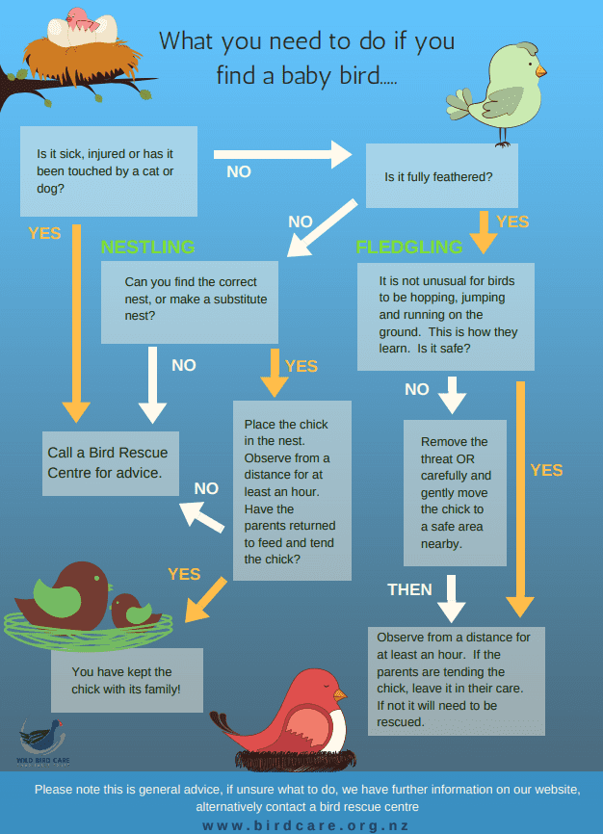
2 Source https://www.birdcare.org.nz/resources

Day 7 activity 2: Real experts at work
This activity reinforces the need for expert guidance. The clip demonstrates the level and duration of care required by both parent birds to ensure their offspring’s survival. Children have the right motivation when the see a baby bird in need. This clip will help them to be realistic about the challenge and who is best to meet it.
What do I need?
- 30 minutes
- Optional video: https://www.youtube.com/watch?v=GQbeKAtNdRQ

In this activity I am learning to: Interpret information from photos and short descriptions, and use correct topic related vocabulary
Remember we wondered whether Roxanne might be an expert?
Look at these photos from birdcare.org.nz. They model how to feed a baby bird.
Did Roxanne use any of these methods?
Feeding a bird – adapted from original https://www.birdcare.org.nz/feeding-a-bird
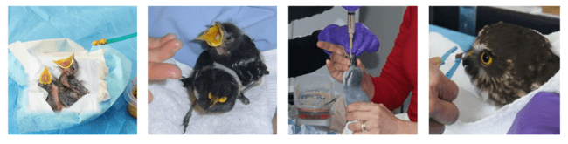

Syringe / Dropper feeding
This method can be used for very small or very weak birds

Stick or finger feeding
Make sure the stick has a blunt end, the handle end of a teaspoon works well. Place the food on the end of the stick or hold the food and place it into the bird’s mouth. Not too much at a time.
Extension
For more detailed instructions go to https://www.birdcare.org.nz/ and search for their E-book

Tweezers
Make sure you use blunt ended tweezers. These work well for birds that are alert but are not yet self-feeding.

Real experts at work
Roxanne knew what she was doing. This is why her rescue was successful. All bird rescue organisations strongly advise that you take your bird to trained helpers.
Watch the story of a little fantail https://www.youtube.com/watch?v=GQbeKAtNdRQ
Transcript:
Rufous fantails are birds of the rain forests and wet gulleys. They most commonly lay two eggs in a nest that resembles a wineglass, they prefer to make nests near streams. After the eggs have hatched around-the-clock duty for the parents begins. The demands for food never ends and it has to be ferried in continuously throughout the day. Both adults share the parenting duties. In a few days the chicks have grown and so has their appetite.
To quench the chicks’ need for more protein larger snacks will have to be on offer. A honeybee would make a good snack but what about its sting? To swallow a live bee could be fatal but the adult places it headfirst into the beak of its offspring and it immediately tries to remove the sting and perhaps instinctively the young bird cooperates. When this is deemed unsuccessful the young fantail loses its patience and drops the bee. On a hot summer's day the chicks are panting and need some extra liquid from their parents.
The plumage of the fledglings is progressing every day and soon they will be able to leave the nest. But until their big day and beyond their parents are selflessly committed to give them the best start in life.
Sadly one chick fell into a nearby creek and drowned. Both parents shower their surviving offspring with food. Fully exposed, and with no foliage cover, the young is very vulnerable on its perch. So it needs to work its way up higher while the parents keep an eye on its movements. With flying colours, the chick climbs up a little tree trunk where a snack is waiting. A cicada is brought on with great excitement, but this cicada is just too big for that little fantail. After its adventures out of the nest, the young bird begins to feel at home in its new surroundings. Overcome by tiredness, it takes a nap on its perch. But looked after by committed parents until its independence, the young fantail’s future is in good hands.
Your task
Carefully observe or read about the parenting process. Complete these sentences. Use the words in the vocabulary box.
The parent birds’ plant near a ___________
They _________lay 2 eggs.
As soon as they hatch they need _____________ feeding.
The parent birds ____________ check their chicks.
Keeping them warm is ________________
The chicks ___________ for food never stops
Parents fly out and back ______ times through the day.
As they grow their _____________increases!
Parents ___________ to feed them even when they have left the nest
constant stream essential appetite continue usually many frequently demand

Day 7 activity 3: Some more bird maths
In this task, your learner will need two of each NZ coins (10c, 20c, 50c, $1.00 and $2.00). In this clip, chocolate fish are used to represent the weight of the different birds. We could calculate an approximate weight of the bird because one chocolate fish weighs 20 gm.
What do I need?
- 30 minutes
- Optional video: https://www.youtube.com/watch?v=4I-Rw_VKDG8&t=17s
- 10c, 20c, 50c, $1, $2 coins

In this activity I am learning to: Calculate the heft of different birds (test the weight by holding) and understand how much different weights feel like to hold.
Just how much does that bird weigh?
Watch ‘How big is that bird?’ https://www.youtube.com/watch?v=4I-Rw_VKDG8&t=17s
In the video they remind us that it is easier to identify a bird when you know how big it is. We have invented ‘the chocolate fish index’ to help you - it compares the weights of 16 common garden birds with our 20g chocolate fish. You can how they do this in the screenshots below.
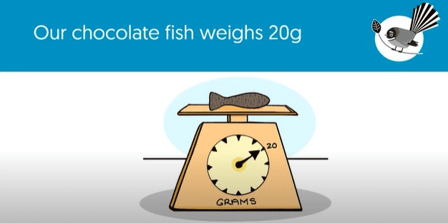 | 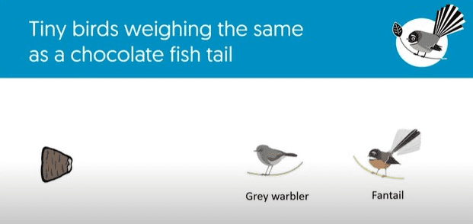
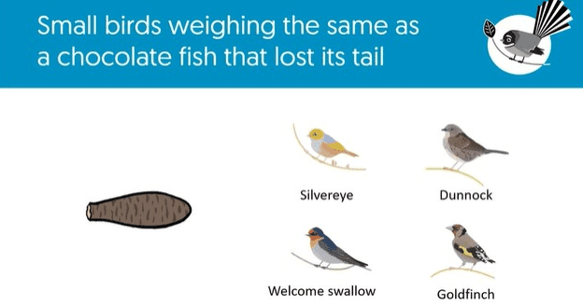 | 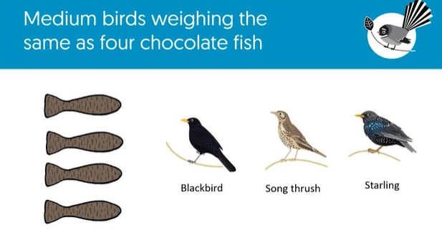
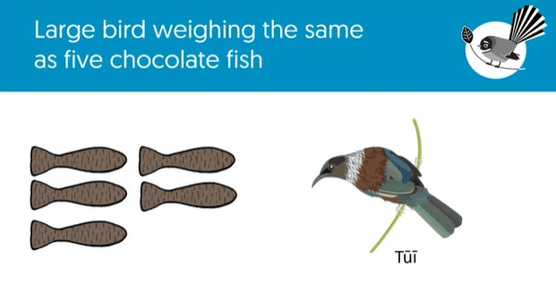 | 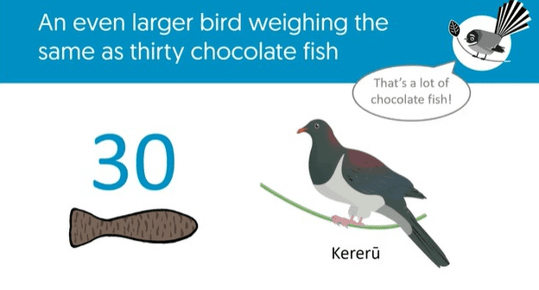
Now we know how much a bird would weigh compared to a chocolate fish, but we don’t get a sense of what it would feel like to hold the bird in our hand. We can’t feel its heft (test the weight by holding).
Your task
Using the table below calculate which coins to use to represent the weight for each bird. Then hold the coins in the palm of your hand to feel the heft of these common backyard birds.

Weight of coins
10 cent | 20 cent | 50 cent | $1.00 | $2.00
3 grams | 4 grams | 5 grams | 8 grams | 10 grams

Bird | Weight in grams | Coins
grey warbler | 6 | two 10 cent coins
fantail | 8
silver eye (wax eye) | 13
goldfinch | 15
dunnock | 21
sparrow | 28
You would need more coins to get the heft of these bigger garden visitors. And a bag full, for the kereru!
- Thrush 70 grams
- Starling 85 grams
- Blackbird 90 grams
- Kereru 630 grams

Day 7: Reflection
Your learner has been encouraged to complete a fitness activity most days. They may like to reflect on their fitness and set goals for keeping fit while learning from home. You may like to encourage them to set a mini goal (for the week) and a bigger goal (for this term).
You have made a huge effort to move and keep fit this week! Give yourself a big pat on the back. Hopefully you enjoyed the fitness tasks and even managed to get whānau to join in!
Your task
Thinking about your engagement with the fitness tasks this week, where would you place yourself on a scale of 1-5, with 5 being the highest engagement.
- Draw a scale from 1-5 in your home learning book and circle your engagement level.
- Now explain why you gave yourself this rating?
- What would it take to move you to a higher rating?
Close the book – your school day is done. 😊

Day 8: Getting started
Take the first 30 minutes of the day getting ready for learning:
- Practise your karakia (See p. 9)
- Do a mindfulness activity (See p. 7)
- Plan out my day and where I will learn
- Choose a fitness activity (See p. 5-6)
- Check in with your teacher.
Set up your space for learning. Grab the things you need. These are the activities for today.
Activity 1 | Activities 2 and 3 | Activity 4
Recalling information  Thinking about your involvement as a volunteer. | Citizen scientist  Thinking like a scientist. | Bird of the year  Nonfiction reading task.

Activity 1: Being a volunteer
At the end of this activity your learner needs to share how they feel about times they have volunteered. It is an opportunity to check their progress.
What do I need?
- 30 minutes
- Home learning book

In this activity I am learning to: Recall information and make connections to what we have been learning about.
Both Roxanne and the people at Wild Bird Charitable Trust were inspired to take action. When we are inspired we become motivated. Motivated to move mountains. Moving mountains is hard work. Big jobs need lots of workers and sometimes needs volunteers.
So, what does it mean to volunteer? This is when somebody gives their time and energy to make something happen. Volunteers are motivated by doing the right thing because it’s the right thing to do.
- Have you been a volunteer?
- Have you volunteered to do the dishes at home?
- Have you volunteered to look after your little brother or sister so the adults could cook your dinner or just have a rest from their work?
- Have you helped clean up the playground at school?
Your task
Think about three things you have volunteered to do. Write them down. That will help you to reconnect with your memory about the good you have done.
- How did you feel about yourself when the job was done?

Day 8 activity 2: Being a citizen scientist
Activity 2 and 3 are connected. Take a break between the two activities. This may be a suitable time for some fitness activities.
What do I need?
- 30 minutes
- Optional Top Citizen Science Kids video: https://www.youtube.com/watch?v=8cv30CcsFjQ
- Home learning book.

In this activity I am learning to: Think like a scientist.

What does it mean to be a citizen scientist?

Being a citizen means:
Belonging to a place, like a community, a city, a country - even the world.
Belonging means that you have rights and responsibilities.
Rights are about being looked after and valued.
Responsibilities are the kind of things you do to make sure that your place, the people, other living things that share your place, and the place itself are looked after. All are guarded, protected, and most of all loved.

Being a scientist:
Is about noticing, thinking, and wondering.
It's about collecting your noticings by being a careful observer. You think about them and that leads you to wonder or figure out what is going on.
This mahi can help us to identify and solve problems.
If you are a Citizen Scientist, you belong to a special group of people. You volunteer to help scientists do their mahi. Your efforts help to build knowledge. Wow!

Your task
Watch this clip – Top Citizen Science Kids https://www.youtube.com/watch?v=8cv30CcsFjQ. Or read the transcript on the next page. It will give you a great understanding of what you might end up volunteering to do!
Then consider:
- Do you think you might be able to be a Citizen Scientists?
Answer this question in your home learning book.
- What three actions did the Citizen Science kids take?

Transcript:
Jack: (IMITATES DAVID ATTENBOROUGH): The Anas superciliosa is the most recognisable duck in Australia. Its plumage features shades of light brown with an unmistakable glossy green near the wings.
Girl: Hey, what's an Anas super...whatever?
Jack: (SIGHS) It's the scientific name of a Pacific black duck. (CLEARS THROAT) OK.
Girl: Wait. Why are you speaking like that?
Jack: I'm rehearsing to be a citizen scientist! Rehearsing? I don't think that's how it works. The female, lighter in colour...
OK, so there might be a bit more to being a citizen scientist than a silly accent. It's when ordinary people do experiments or research to help scientists learn more about the world around us, and pretty much anyone can be one, including kids. That is Gallinula tenebrosa, a dusky moorhen.
Meet Griffin. He's only eight, but he's already one of Australia's top citizen scientists.
Griffin: See that yellow tip on the beak? That is a dead giveaway.
Jack: He spends most of his free time looking for unusual plants and animal species. And if he spots something, he snaps a pic and uploads it to a special science app. The app then classifies the find, tells him the scientific name of the species, and gives him points for each new find.
Griffin: I take pictures of an animal or plant or an organism that isn't domestic, and then you put the species' name in, and then experts sort of like identify it and you can earn gold.
Jack: Well, not real gold. The app is called QuestaGame and Griffin's not the only kid into it. I've been playing QuestaGame for about one and a half years.
Meet Austin, he's ten, and is currently the number one bird spotter in the country.
Austin: When I started playing QuestaGame I started finding new species of different animals and I wanted to make my species on the QuestaGame, being first or second in the leader board.
Jack: In fact, recently Austin beat thousands of other citizen scientists - mostly adults - to win the first-ever World BioQuest Competition. But it's not just a game, the info that these guys and the thousands of users collect is used by scientists to work out where some species can be found and can even lead to new discoveries. A young player discovered a black-faced monarch bird that was not in a region at all where it was expected to be and it's a sighting like that that gives us new knowledge about the distribution of species.
Austin: I've recently discovered a new species just by looking at the data uploaded online.
Jack: Austin and Griffin reckon the app is a great way to get outdoors and learn more about nature and they'd love to see more kids getting involved. It would be good to have more people that are very interested in animals. If you want to be a scientist, you can get a head start. So, who knows what ground-breaking discoveries young citizen scientists could make in the future?

Day 8 activity 3: A NZ wide citizen science project
Activity 3 gives your learner insight into being a citizen scientist. The Garden Survey posters signal the need to be able to identify the birds they are likely to see before they collect their data. Your learner could start their practice runs from today!
What do I need?
- 30 minutes
- Check you pack for a copy of these 3 documents:
- https://gardenbirdsurvey.landcareresearch.co.nz/uploads/1/1/5/9/115962649/a3_bird_id_poster_portrait_maori_1.pdf
- https://gardenbirdsurvey.landcareresearch.co.nz/uploads/1/1/5/9/115962649/a3_nzgbs_bird_id_poster.pdf
- https://gardenbirdsurvey.landcareresearch.co.nz/uploads/1/1/5/9/115962649/what_is_nzgbs_teacher_resource.pdf
- Optional video: https://www.youtube.com/watch?v=L1vJBv8ZBqY&t=8s

In this activity I am learning to: Gather information from a range of sources and use this information to make a plan of action.
Right now, there are many Citizen Science projects taking place in New Zealand, we are going to look at one that you can get involved in.
The New Zealand Garden Bird Survey started in 2007 and has taken place every year since. This year it takes place in the week of 25 June to 3 July. This is a few months away, but your mahi today will help you to be prepared.
You might wonder why the focus is on birds?
“Birds are indicators of the environment. If they are in trouble, we know we'll soon be in trouble.” Roger Tory Peterson
The New Zealand Garden Bird Survey is supported by Manaaki Whenua – Landcare Research. They want to find out more about all the birds around us. They also want to know more about the birds that live around, and in suburban and city gardens.
They are asking for help. Are you inspired? Are you motivated?
Of course, if you are going to count the different kinds of birds you see, you need to know what they look like first! Here are some resources to help:
Your task:
- Read the bird identification poster
- Write your plan for what you can do as a citizen scientist in your home learning book.
If you have access to a device you can watch How to take part in this year's New Zealand Garden Bird Survey - YouTube to find out how to take part in this year's New Zealand Garden Bird Survey or read this the Garden Bird Survey document.
You now have a better idea of what is involved.

Day 8 activity 4: Bird of the year – reading focus
In this activity your learner will be reading about the New Zealand bird of the year competition. You might like to read this interview once with your learner before they read it again themselves and do the activities. You can talk about what an interview is and how it is structured. You could also talk about the competition and if you have voted before.
What do I need?
- 30minutes
- https://instructionalseries.tki.org.nz/Instructional-Series/Junior-Journal/Junior-Journal-59-Level-2-2019/Bird-of-the-Year - check your pack for a copy of this School Journal

In this activity I am learning to: Read a nonfiction text to find meaning and recognise that birds have requirements so they can stay alive and healthy.

Every year, people vote for their favourite New Zealand bird in the Bird of the Year competition. This might seem like a bit of fun; however this competition does a lot to help us know about our native birds and what they need to thrive.
Your task:
Read the interview with Megan Hubscher from Forest & Bird and answer the following questions in your home learning book:
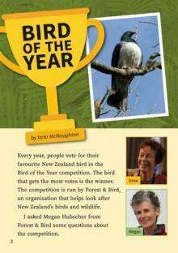
- What are the main things that Megan Hubscher wants people to know?
- What examples does she give to help the reader understand the dangers to native birds?
- Do you think the Bird of the Year competition is effective as a way of helping keep native birds safe?
- Why do you think no bird has won more than once?

Think about what bird you would vote for and why.
Find out some information or draw a picture of your bird.
Don’t forget to vote in the next competition!

Day 8: Reflection
This reflection task allows your learner to think about how their neighbour could be involved in volunteer work. They can see how the person becomes more involved. There is also a strong link re: effort and satisfaction.
What do I need?
- 30 minutes
- Optional video: https://www.youtube.com/watch?v=io1r6pa0shM

In this activity I am learning to: Reflect on the actions of myself and others.
Today you have found out about how many people are ready to contribute to making a difference. They are motivated to do the right thing because it’s the right thing to do.
Your task:
Watch this Meet the Locals episode or read the transcript on the next page.
- Identify the actions of this volunteer and the satisfaction they experienced.
- Think about some actions that you could take every day, to make something better and write these in your home learning book.

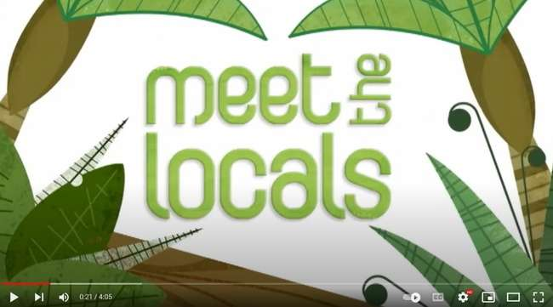

Transcript:
Life in the big smoke isn’t always easy for our native birds and in order to survive they have to run the gauntlet of introduced predators such as cats and rats and avoid hazards such as cars or flying into windows. Sometimes they get injured and come off second best but that is why the bird rescue volunteers around Auckland are so important.
Interviewer: Mandy how did you get into rescuing birds?
Mandy: Started off with my husband bringing home a little squab, a little darling duck and it was getting to the point where I didn’t know what to do with it because i couldn’t get it to eat and I took it through to one of the other rescue ladies, Hillary, and watching her work was just amazing - putting tubes down its throat and doing this and doing that and I just thought I need to know how to do this and I haven’t looked back since...We are going to hand feed this kingfisher.
Interviewer: How come he ended up in your hospital?
Mandy: He had hit a window. If that happens, rather than bring him in, they could have just kept him for a while and left him in cardboard box just to get warm just relax him a bit and he probably would have been fine.
Interviewer: But you’ve got a special permission to look after these birds?
Mandy: Yes I do. I have a permit from DOC to care for these birds. I cannot keep them. If they cannot be rehabilitated and released unless I can home them with a zoo or somewhere like Otorahanga I would probably have to have them put down.
Interviewer: There are things you can do to stop birds from flying into your windows. You can hang something in them or put stickers on them so that you can discourage them from flying away. This little kingfisher was caught in parapara which is a native tree, but it is a problem for birds because the tree has got these big, long sticky kind of bud bits on the end and insects get caught in them and the birds come down to look at the insects and also get caught, their feathers get gunged up
Mandy: (looking at a one-eyed owl) I have got his head covered because I don’t want to stress him out more than he is and transferring him to his avery is going to be a bit of a fright for him because it is very big, very different from what he has been in. So he could flip out a little bit. But like anything it is just taking time. You see he is a snapper (owl biting her under the hood).
Interviewer: How important is it for you to work with the other bird rescue volunteers throughout the Auckland area?
Mandy: Oh it is terribly important. We couldn’t cope with the numbers that we have if we didn’t help each other. There are 8 different centres, and we are located all around Auckland, and we all have a very good relationship with each other.
Interviewer: It is possible for our native wildlife to live among us in towns and cities but sometimes they need a little extra TLC. People like Mandy help ensure that our sick and injured towny birds have a chance to survive.

Day 9: Starting the day
Take the first 30 minutes of the day getting ready for learning:
- Practise your karakia (See p. 9)
- Do a mindfulness activity (See p. 7)
- Plan out my day and where I will learn
- Choose a fitness activity (See p. 5-6)
- Check in with your teacher.
Set up your space for learning. Grab the things you need. These are the activities for today.
Activity 1 | Activity 2 | Activity 3 | Activity 4
Being a scientist  Creating a logbook. | Caring for birds  Learning about how we look after birds. | Bug whare!  Planning a bug house. | Getting some physical activity.

Day 9 activity 1: Documenting our learning
In this activity the learner finds out about the importance of Tiritiri Matangi as a sanctuary – through the people, the place, and the birds. Logging their noticings provides experience in using an essential science practice.
What do I need?
- 30 minutes
- Optional video: https://www.youtube.com/watch?v=EsGEc1Mi-Sw
- Home learning book

In this activity I am learning to: Make notes in a logbook like a scientist.
Watch New Zealand Birds, Tiritiri Matangi A conservation success story in Auckland's Backyard. Or read the transcript on the next page.
In this short documentary (8 minutes) we find out about Tiritiri Matangi, the island bird sanctuary in the Hauraki Gulf. Michael Watson, a volunteer, shares his knowledge and understanding about the sanctuary on this little motu.
Your task:
It’s now your turn to “document” what you learnt about the island and the volunteers.
- Log your learnings in your home learning book.
- Don’t write sentences. Just chunks...enough words to capture your thoughts.
- Tell somebody in your whānau about what makes Tiritiri Matangi special and what you think of the workers.

Transcript:
My name is Michael Watson and I'm one of the guides on Tiritiri Matangi, a magical island off the coast of Auckland which touches the lives of visitors and saves the lives of its diverse and endangered residents.
The Department of Conservation works very closely with the supporters of Tiritiri Matangi and this partnership supports an army of volunteers who together act as kaitiaki or guardians. Much of the wildlife you find on Tiritiri Matangi are in trouble on the mainland and until recently some were even missing entirely. Their fate has been in our hands since we got here and unfortunately pests such as rodents, stouts, possums, and hedgehogs, continue to eat their way through the fractured unsuspecting and vanishing communities. Species like the bell bird the hihi, the takahē, kākāriki and the kākāpo, all find a home on the island and the populations are so successful that they are relocated to other islands, including the mainland, to start new populations there so it's a very special island.
I became a kaitiaki for Tiri around six years ago and found a real love for guiding. As a guide I take the public into the forest and share the different taonga or treasure of fauna and flora and share their history and what's so special about them but also what we can do to protect them now.
As a boy my grandparents took me to some wild places I remember when I was eight my grandpa told me about Tiritiri and showed me this brochure of all these birds that had been missing from our adventures up until that point. This was a real turning point for me as I realised that these birds were different from the magpies and the fantails seen so often. Not just in how they look though but we needed to travel to an island to see them. That's when my interest gained a purpose and conservation became the goal.
As a conservation project Tiri actually started with a bird, the bell bird, which at that time was thought to be extinct through Auckland northwards but in 1969 a count on Tiri uncovered 24 of these small birds. News spread quickly and intrigue in the small island began to snowball. This is when the intervention through planting of trees and introduction of other rare species became more justified and with these seeds a forest began to regrow. I came to Tiri for the birds, but it was the people that made me stay. So it's sort of a family we have here and the success of all those volunteers who came before us is contagious and impossible to ignore.
The special thing about Tiri is how accessible this piece of paradise is, it's like visiting a different country. When you go back you feel recharged. When people first arrived in New Zealand it was a massive island nation of forest. When we fly over New Zealand today all we're looking at is our activity, our farms and there’s no longer a forest for a community to live in. It is just concrete, grass, cows, oceans, rivers, some of the worst polluted rivers in the world. Today you can see that our priority is us, it's all about us. Tiri is a symbol of preservation. It's proof that when we work together and when we focus on the greater good we can accomplish something like this. It's a real pleasure for me to share my interest in the special place with other people. I feel extremely privileged to be able to do that.
I hope that in the future younger people will be inspired to join us and take over as the island’s new kaitiaki. Our planet is worth fighting for and Tiri is proof of what we can achieve if we really want to make a change and regenerate nature. You have a lot of power as an individual. Being a part of a community project like Tiritiri Matangi or any of the hundreds of community projects around New Zealand right now doesn't just give nature a chance it gives us all a chance. This isn't just my interest, my responsibility, or my story it's all of ours.

Day 9 activity 2: Why do we need sanctuaries?
In this activity your learner will gain a deeper understanding of the action of establishing sanctuary spaces that protect the vulnerable. It links closely with the positive work of volunteers, as much of the work carried out is performed by people doing the right thing because it’s the right thing to do. Actions taken to make change that matters.
What do I need?
- 30 minutes

In this activity I am learning to: Understand what a sanctuary provides, reflect on the changes over time that have caused harm to our birdlife, and use my knowledge to plan a safe place for birds in my garden

Read this information
A sanctuary is a safe place. A place that people have provided to keep somebody safe from harm. Somewhere where that person in great need is protected and can live their life until it is safe to go back out into the world.
- A sanctuary is also a sacred place because it is where all life is valued.
- Bird sanctuaries have been set up across Aotearoa New Zealand.
- This information will help you to understand why people have been motivated to take action:
- The world has become a dangerous place for many animals. The action of humans has caused harm to the animals that share the earth with us.
- Animals have become “threatened” and sadly, some have even become extinct.
- Long ago, New Zealand was a bird paradise. Everything was perfectly balanced.
- There was an abundance (many) of native birds.
- They lived freely in every habitat that suited their needs. The forests, the mountains, the waterways, and the seashore and beyond.
- People started to notice that the birds weren’t around us as much as they used to be.
  - The forests were becoming silent places instead of being filled with birdsong.
  - People began to identify what was harming our native birds.
The two main problems were:
- Less places for birds to live. Their habitat had disappeared.
- The arrival of predators.
It became clear that something had to be done, and before it was too late. We had to try to fix our past mistakes. We had to provide a sanctuary, a place where our birds could be safe.

Your task
Go for a walk around your garden. Do you think birds would feel safe in your garden? Is there anything you could do to make your garden more of a sanctuary? Be creative!

Day 9 activity 3: When measurement counts
In this activity the learner will explore more of what might be in their own backyard. The clip encourages children to build bug ‘hotels or whare in their own backyard. One of the important aspects of this learning is the measurements the presenter mentions in the first two minutes of the clip. Your learner may need your help to measure those millimetres on their finger or a piece of paper.
What do I need?
- 30 minutes
- Optional video: https://www.youtube.com/watch?v=oDe8_abr0bI
- Home learning book
- Your imagination

In this activity I am learning to: Make a plan and label a diagram and follow instructions.
You will notice how important measurement is in this clip. It is a matter of life and death!
You know about how bird sanctuaries are to help protect our precious manu (birds).
You may be thinking that you can only learn about what a sanctuary is. Hopefully this clip will inspire you to not just know and understand...but also to do!
Your task
Watch - Episode 4 - Building a Bug Whare or read the transcript on the next page.
- In your home learning book, plan your own bug whare.
- Draw a diagram of your whare and label all the parts.
- Think creatively about the things you have in your house or garden that you could use.

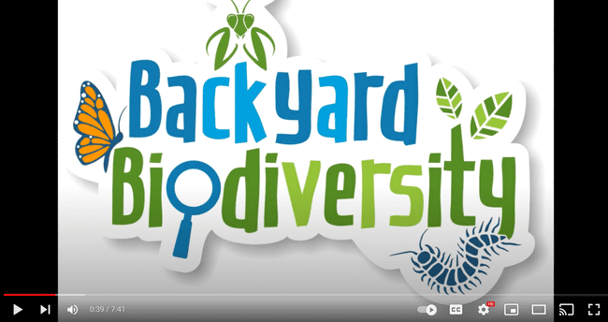
Transcript (adapted):
Let’s make your garden irresistible to native bugs by creating a good bug habitat. We'll walk you through how to create a bug hotel using materials you'll find at home or in the shed
Bugs are not too keen on gardens that look like a neatly mowed bowling green, they need somewhere to hide. One of the easiest and most natural homes that you can make is a pile of old sticks. If left undisturbed over time they'll develop a whole bug community. When building good bug habitat, it's important to keep your invertebrate friends safe from predators including mice, rats, hedgehogs, and cats. Provide them with hiding spaces that are too small for mice to crawl in. The ideal hidey hole is between 10 and 16 millimetres in diameter. This size is small enough to keep the mice out but big enough to fit a pretty large tree weta. One useful thing to make the measuring easier is to mark those measurements on your finger in advance, so I have marked 10 and 16 on my finger so I don't have to break out the ruler every time I want to measure my hidey holes. Depending on the materials you have around the house and how creative you'd like to get there's a range of hotel styles you can make for your bugs and some special motel types for your weta.
I started by building a simple frame out of untreated pine firewood blocks and nails suitable for outdoor use. You could use whatever untreated wood you have lying around. Next I collected bamboo, twigs, and sticks from the garden and cut them to size. I use natural materials that I know bugs love. Then I pack the frame leaving small gaps of no larger than 16 millimetres for the bugs to enter. I'll now go and place it in a nice sheltered, shady spot where I know lots of bugs hang out.
If you can’t build your own frame you can look around your house and find some old stuff to repurpose and make into your frame. You can use old drawers, a wooden shelf, an old toolbox, crates, or even an old empty tyre as your frame. So get creative and look around the house to use something. It's probably a good idea to check with someone first if it's okay to use.
I lined out any empty spaces with twigs and straw. You can also add a mixture of fresh and dry leaves or even strips of bags or sacks just to make it cosy. If you've got materials with holes bigger than 10 to16 millimetres, you can reduce the size by stuffing leaves and other material inside it till it's just the right size. Check your hotel occasionally to ensure everything is okay. Natural materials can degrade over time so replenish those materials if they start rotting away. You might also find some spiders trying to take over so just make sure they're not eating up all your guests.
Weta don't like to share in their spaces with all the critters. So here are some ideas just for them. You can make a motel out of bamboo. Make sure you cut the segment so that you've got a roof at the top and that you've got an entrance at the bottom and the hole that runs through the bamboo should be between ten to sixteen millimetres. Secure them to a strong tree branch or wooden post with string, cable ties, or harakeke rope. To make a three-star motel, take a piece of natural untreated wood and drill some holes in it about 10 to 16 millimetres wide and about 10 to 15 centimetres deep. Drill into the wood at an angle you can then place this wood off or on the ground on a tree or against a fence post secured with rope. You can drill different sized holes to house different kinds of weta.
Now it's your turn hunt for some resources and create your very own bug hotel or a weta motel for the backyard. This can be a fun family activity because it's always safer to have an adult helping you with the wood cutting and the drilling. Most of these bugs come out at night so the best way to find them is to go for a night-time adventure.

Day 9 activity 4: Yoga
You learner has been working incredibly hard today and now is a great time to spend some time focused on stretching and breathing techniques through yoga. A Cosmic Kids Yoga Adventure is a great YouTube channel for kids who are keen to practise yoga. Today we will try one of their introductory sessions.
What do I need?
- 20 minutes
- A device to watch Squish the Fish Yoga Video - https://www.youtube.com/watch?v=LhYtcadR9nw

In this activity I am learning to: Practise some yoga moves and engage in some breathing and relaxation techniques.
After all that hard mahi you have been doing, we thought it would be a great opportunity to engage in some yoga to help stretch and relax your body. There are so many benefits to practicing yoga. You may notice that at the end of this session your body feels more relaxed, and your mind clearer.
Follow the link above and practise some Yoga with A Cosmic Kids Yoga Adventure.

Day 9: Reflection
Reflect on the following prompts and write your thoughts in your home learning book:
- What did you enjoy most about today?
- What is one thing you learnt today?
- How will this help you?
- You may like to record your thinking in your home learning book, or you may like to share your reflection with someone.

As you carry out this reflection you might like to listen to El Condor Pasa. A favourite tune from South America about one of the world’s biggest flying birds. The people love to watch as this majestic creature soars high above them.

https://www.youtube.com/watch?v=8kQZHYbZkLs
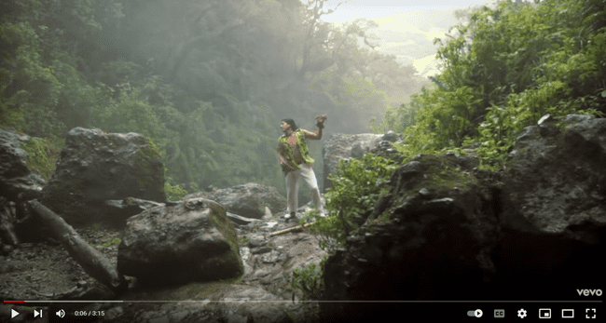

Close your book – School is finished for today. 😊

Day 10: Starting the day
Take the first 30 minutes of the day getting ready for learning:
- Practise your karakia (See p. 9)
- Do a mindfulness activity (See p. 7)
- Plan out my day and where I will learn
- Choose a fitness activity (See p. 5-6)
- Check in with your teacher.
Set up your space for learning. Grab the things you need. These are the activities for today.
Activity 1 | Activity 2 | Activity 3 | Activity 4
Change makers  Reconnecting with Roxanne’s experience | Infographics  Revision of infographics and diagrams. | Many hands make light work  Words to describe being a volunteer, expert, or citizen scientist. | Sanctuaries  Revisiting the bug sanctuary, observing, and planning.

Activity 1: Making connections
The learner will spend their activity times today reflecting on the people who have taken positive action and become change makers. They will be encouraged to re-watch/re-read things from their learning this week. They may like to discuss parts of their work that have had the most impact on them with you.
What do I need?
- 30 minutes
- Information and resources from Day 6
- Home learning workbook

In this activity I am: Connecting with prior learning, revisiting Roxanne’s rescue, and appreciating how unexpected events can motivate us to take positive action
For the past four days you have been finding out about how taking action leads to positive change. The focus has been on people who have stepped up in response to protecting the wonderful birds that have given us so much inspiration and lessons about life.
“How wonderful that no one need wait a single moment to improve the world.” Anne Frank

Your task
Today we are going to revisit Roxanne’s story (day 6). We started this week by looking at the recount of a chance encounter (meeting) with two helpless newly hatched baby birds. You could say that this was a perfect example of tuakana teina in action. Roxanne and the birds contributed to each other’s wellbeing. How great is that!
- Document any notes or thoughts you have about Roxanne’s experience in your home learning workbook. You may like to draw a picture or create a timeline of Roxanne’s experience.

Day 10 activity 2: Revision of decision tree infographic
On day 7 your learner was introduced to a decision tree infographic. Take a look back at that day and check their understanding of how to read the information. Today’s task will be to create a simple decision tree for a simple task.
What do I need?
- 30 minutes
- Information and resources from Day 7
- Home learning workbook

In this activity I am: Connecting with prior learning, and checking my understanding of how an infographic works
On day 7 we learnt about being a volunteer and about the volunteers at the Wild Bird Charitable Trust.
Think: Do you know anyone in your community or whānau who volunteers or helps out people (or animals, or our environment!)?
The Wild Bird Charitable Trust used a decision tree infographic to help people know how to look after baby birds. Decision trees are used to help you make the best decision by asking yes / no questions. Here is a simple decision tree for tying shoelaces:

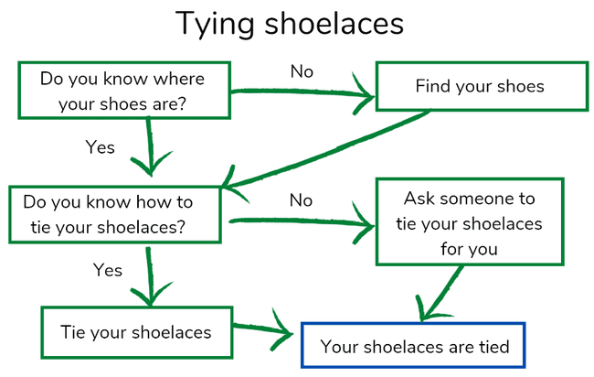
Your task
Think of a simple task that you or someone in your whānau does. It could be getting dressed for school, getting ready to play a sport, or even looking after your pet. You are going to draw a decision tree to help someone know how to do that task
- Write down 2 or more things you need to know to do the task. For example if you were helping someone to tie their shoelaces you could ask:
  - Do you know where your shoes are?
  - Do you know how to tie your shoelaces?
- Now write down what you would do if the answer to these questions were no. For example:
  - Find your shoes
  - Ask someone to tie your shoelaces for you
- Using this information see if you can draw your own decision tree in home learning book.

Day 10 activity 3: We can all make a difference
This activity encourages your learner to think about how they can be a part of the solution to big problems
What do I need?
- 30 minutes
- Information and resources from day 8
- Home learning workbook

In this activity I am: Revising the practical ways that I can make a difference.

Working together the work gets done
Throughout this week we have looked at:
- The importance of looking after our birdlife
- The work of volunteers
- The work of experts
- Being a citizen scientist.
As you can see, when people work together they can make a big difference. You might think that you can’t make much of a difference, but when you join volunteers, experts, and citizen scientists together – a lot can be achieved.

Your task
Think back about what you have learned about volunteers, experts, and citizen scientists. Reflect on how it takes different kinds of people to make a difference to both humans and animals.
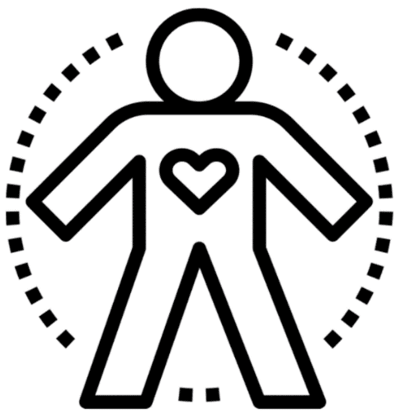
- Draw a body shape in your book. This shape represents you as someone who is helping to make a difference for others, animals, and the planet.

- Around the outside of your body shape write words that describe the following:
  - How you feel
  - What you might be doing
  - What skills you have
  - What would you like to make a difference to (birds, horses, dolphins, New Zealand’s forests, etc)?

Day 10 activity 4: Sanctuaries – a recap
In this activity, your learner will reflect on what they have learned about sanctuaries. On day 9 they were encouraged to consider a bug whare. Today they can either observe what is happening in the whare if they built one or figure out next steps if they want to build one.
What do I need?
- 30 minutes
- Information and resources from day 9
- Home learning workbook

In this activity I am: Reconnecting with prior learning and recognising what inspires and motivates people
Tiritiri Matangi is an inspirational example of how people working together can transform a small island and return it to a place where our birds (manu) can feel safe. It is known as a bird sanctuary.
Today you are encouraged to revisit the learning you completed yesterday about Tiritiri Matangi (you could rewatch Michael Watson’s story).
Look at what you noticed about this and logged on day 9

Your task
This task could almost be presented in a decision tree!
Have you decided to make a bug whare? – Yes?
Observe your bug whare and record information about what you can see happening in your home learning book – make a log.

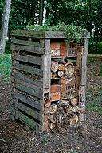
Have you decided to make a bug whare? – No?
Do you want to make a bug whare? – Yes?
Maybe you need to enlist the help of someone in your whānau might be interested.
Think about what you need to say to enlist them to help you with project.
Document your thinking in your home learning workbook.

Day 10: Reflection
Your learner has selected an accomplishment that they are most proud of from this week’s learning to share with your whānau, family. They have had 10 days working through the pack and it has been a challenge. It is always a proud moment when we can share the story of a challenge met with those who love and support us.
The inclusion of the Six60 Pepeha song is a great way to signify that connection.

Now that you have reconnected with your weeks work, get ready to celebrate the good learning times with whānau.

- Choose one of your learning activities, products, or accomplishments that you are most proud of from this week’s learning and present it to your whānau.

- Think about how you could make your presentation engaging and informative for your audience.

- Describe the process or learning journey you took to get to this point.

- Explain why you are most proud of this piece or learning.

- Invite whānau to ask any questions about your work or learning journey.

You might like to end your presentation by sharing this song.
SIX60 - Pepeha https://www.youtube.com/watch?v=y_CJFEKNvX8

