A learning from home pack
for learners in years 9-10
We shape an education system that delivers equitable and excellent outcomes
He mea tārai e mātou te mātauranga kia rangatira ai, kia mana taurite ai ōna huanga
4 Feb 2022 | Trial version published
28 Feb 2022 | Version 2 – includes extension to 10 days of activities, improvements from trial feedback

Creativity – How do we express ourselves?
“Creativity is intelligence having fun.”  ~Albert Einstein | I orea te tuatara ka patu ki waho
 | A problem is solved by continuing to find solutions

Notes for teachers

Purpose
We know there will be additional challenges for our schools, our learners, and their whānau in 2022. The purpose of these learning from home packs is to support you as you prepare to provide continuous learning for all learners through the next period of the Covid pandemic.

Flexibility
The packs are designed to be used flexibly for the types of interruptions learners may face:
- They may need to isolate at home.
- Due to health and safety requirements, such as social distancing, your school might not be able to have all students on site. Hybrid learning may start.
- Your school might close, and learners would need to learn from home. (Note: the intention under the Covid Protection Framework is to keep schools open.)

Hybrid learning
Hybrid learning describes when schools and kura are simultaneously teaching some learners face-to-face on site and supporting others through distance-learning options. You may also be teaching learners who are not normally in your class. For most of us, hybrid learning is a new experience.

Realities

You know your learners and have a good understanding of their learning situations.
Many learners will have siblings at home, as well as whānau who share the same space and devices. Some may have access to the internet and devices, and others may not. Learners will also have varying levels of adult support.
There are a mix of activities in this pack that use materials commonly found in most homes. Some activities will require adult support while others can be managed independently. This resource is provided as a Word document so that you can adapt it for your learners.
We suggest starting each day with a karakia, check in with the teacher, followed by setting up the learning environment. The pack contains suggestions, but you can replace these with however you want your learner to start their day.

Resources
The resource uses resources from the Figure it Out series. You might want to send these home with the learner, along with an exercise book, and other stationery (glue, scissors, felts, construction paper). Learners can bring their exercise book back to class to share.
If your learners do not have reliable access to the internet, here are the resources to send home with them to create a paper-based pack.
Resources to print
- Artistic Orangutans https://www.dogonews.com/2021/12/20/orangutans-have-distinct-artistic-styles-too
- Smart earpiece translates foreign language in real time https://www.dogonews.com/2016/10/30/smart-earpiece-translates-foreign-languages-in-real-time
- Kapa Haka – Māori Performance https://www.newzealand.com/ca/feature/kapa-haka-maori-performance/
- Kalinga People in the Philippines https://www.bookaway.com/blog/the-philippines-dying-art-of-kalinga-body-tattoos
- Mandala template https://sparklers.org.nz/media/documents/AllRight_MandalaOne.pdf
- Tikanga https://bpac.org.nz/BPJ/2008/August/docs/bpj15_tikanga_pages_46-47.pdf
- Manaakitanga Tikanga related to food healthy kai https://bpac.org.nz/BPJ/2008/August/tikanga.aspx
- Cultural value of taewa https://www.sciencelearn.org.nz/resources/783-the-cultural-value-of-taewa-maori-potatoes
- Benefits of taewa https://www.sciencelearn.org.nz/resources/788-the-benefits-of-taewa
- Plant propagation: https://www.sciencelearn.org.nz/resources/1662-vegetative-plant-propagation
- The role of observation in science https://www.sciencelearn.org.nz/resources/8-the-role-of-observation-in-science
Figure it out /maths
- I Spy Symmetry https://nzmaths.co.nz/resource/i-spy-symmetry
- I Spy Symmetry CM https://nzmaths.co.nz/sites/default/files/ISpySymmetryCM.pdf
- Dinner Time Ads worksheet https://nzmaths.co.nz/sites/default/files/DinnerTimeAds.pdf
- Daniels Data: https://nzmaths.co.nz/sites/default/files/DanielsData.pdf
- Kai Moana: https://nzmaths.co.nz/sites/default/files/KaiMoana.pdf
- Helping with the hangi https://nzmaths.co.nz/sites/default/files/HelpingWithTheHangi.pdf

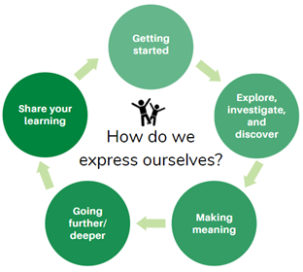
Layout of this resource
This pack is filled with learning activities that can be used at school or at home. All activities are framed around the big idea of Creativity – how do we express ourselves?
Suggestions are provided for starting each day with a karakia, check in with the teacher, and setting up the learning environment. You can replace these with how you want your learner to start their day.
Activities follow an inquiry learning model (figure 1) exploring one big idea through two contexts. Each day the learner will work through one part of the model culminating with sharing their learning on days five and ten.
Figure 1 Inquiry learning model

Setting up the learning environment
Encourage whānau to support learners to set up a space for learning at home. Learners might like to design their own space as a separate learning activity. Some materials they may need could include pen, pencils, paper, a notebook, colouring pencils, glue, scissors, and a device to access the internet.

Many of the suggested activities and experiences include the use of online resources which can be accessed and viewed using a Smartphone.

Overview of the learning in this pack
The big idea for this pack is creativity – how do we express ourselves?
- Week one looks at this idea through the context of language and culture
- Week two looks at the big idea through the context of how things change over time.

In week 1 we will look at how we as humans, as well as other animals, express emotions, culture and where we come from (whakapapa) and the connectedness of us all.
It would be easy to think we were the only animals that found ways to express ourselves. However, when we look around the animal kingdom this is most definitely not the case. This week of learning looks at the many ways different animals, including humans, express themselves through language and culture such as dance, art, traditions, and other means.
In week 2 learners will look at how people around the world, including Aotearoa New Zealand, use food and the way they culitvate, produce, prepare, and eat it. We will be looking at how food, and the way we use food to express ourselves, has changed over time. Food can express human beliefs in terms of sustainability, the environment, health and wellbeing, religion and culture, and our connections with other people, including our friends and whānau.
Each of the learning tasks connect back to the big idea of Creativity. Learners will:
- show an understanding of new ideas and concepts using a variety of texts and media
- show an understanding of how the natural world can be used to model mathematical, societal, scientific, and literacy concepts
- build on prior knowledge and experiences, to share and examine own and others knowledge.
Learners will explore, investigate, discover, and make meaning as they go through each task. There are times where they look a little deeper into the topic. Some of the tasks may be independent hands-on tasks while some may involve connecting and sharing with others.
Day 1 | Day 2 | Day 3 | Day 4 | Day 5
Looking at the similarities and differences in the way humans and other animals express themselves. | How animals and humans communicate, use language to express themselves, and to show emotion. | We are learning how dance can be used to express emotion. | How patterning can be used by animals to communicate and examining the cultural aspects of tattooing. | We are learning how to be creative and mindful through art.
Day 6 | Day 7 | Day 8 | Day 9 | Day 10
Making connections to prior knowledge on food and its cultural importance | We are learning about the history and changes of food culture and technology as well as customs in Aotearoa New Zealand. | We are learning how food impacts on the environment. | We are learning how diets and food trends have changed overtime and through the world. | We are learning how to bake potato bread and how to bring our learning together by way of a presentation

Daily timetable
Below is a possible daily timetable. We allocated 30 minutes for each activity; your learner may take more or less time than this for an activity. We suggest your learner takes the time they need to complete an activity. This may mean they choose which activities they will complete for the day, rather than complete them all.
At the start of each day the learner will draw up their timetable for learning. You can adjust the timing to suit the other activities that might be happening the day, such as Zooming with the class/teacher.

Time | Activity
9:00 am | Starting the day
9:30 am | Activity 1
10:00 am | Break
10:30 am | Activity 2
11:00 am | Fitness break
11:30 am | Activity 3
12:00 pm | Lunch time
1:00 pm | Activity 4
1:30 pm | Reflection time
2:00 pm | End of the school day

Daily fitness – Choose something each day
It is important to include a fitness activity every day. Please ensure that your learner includes this in their daily timetable. If possible, it would be great to do the fitness activity with your learner or have them complete it with their siblings where appropriate. Below are a range of activities to choose from – or you can make up your own ideas! Please choose activities that are appropriate to your learner’s abilities and talents.
Games, Games Games!
For this session, pick one of the activities below to do for the next 20-30 min. Remember the aim is to let out the bad stuff, take in the good stuff, and have fun while you’re doing it!
Hopscotch  Challenge yourself to say the numbers in te reo Māori as you play. | Obstacle course  Create your own course to challenge yourself.
Complete a Tik Tok dance challenge | Play with the family pet (if you have one)
Skipping  Can you make skipping into a game and challenge someone? | Foursquare  Find someone to play foursquare against or play up against a wall.

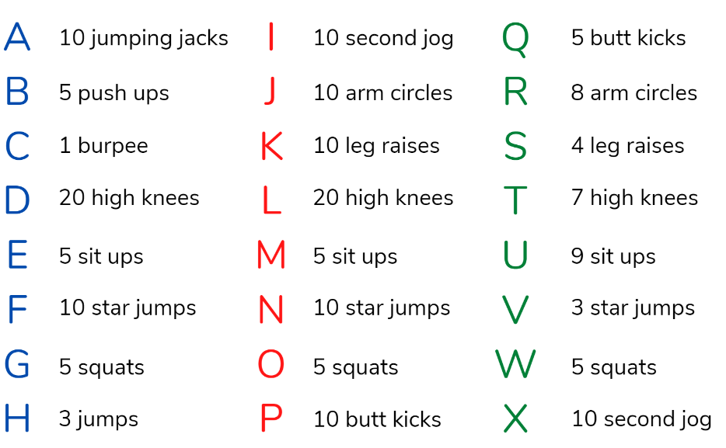
Alphabet Exercise
Choose three words to spell from the day 1 glossary. DO the exercise for each letter. Check your heart rate. Do you have more time left? Do another word!

Weekly fitness tracker
Keep daily track of your fitness. Can you improve your own record over time?
Do as many repetitions of each exercise as you can. Count them and record below
 | # push ups | # burpees | # star jumps | # sit ups | # squats
Monday
Tuesday
Wednesday
Thursday
Friday

Playing Card Fitness
PULL a card from the deck of cards
- The suit ( 💗 🔶) tells you how many repetitions to do.
- The number of the card (or jack, queen, king) tells you what activity to do.
10 times 💗5 times 3 times 🔶2 times
Ace – burpee | 5 – push ups | 9 – lunges
2 – walk on the spot | 6 – arm circles | 10 - squats
3 – sets of star kicks | 7 – glute bridge lifts | Jack – high knees
4 – side plank lifts | 8 – sit ups / crunches | Queen – star jumps
King, any suit – run around your section while you count to 100
E.g., The 4 of hearts means that you would do 5 side plank lifts and the 8 of clubs means you would do 3 sit ups and the queen of spades means that you would do 10 star jumps.
Role of dice workout
One die represents an exercise and the other, the number of repetitions.
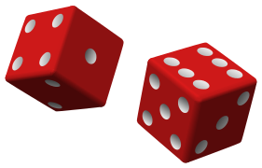
ROLL your die then DO the exercise represented on your first die.
1 | 1 x 30 second plank
2 | 2 x burpees
3 | 3 x bear crawls
4 | 4 x crab walk steps
5 | 5 x donkey kicks
6 | 6 x push ups

Fitness online activities
If you have access to the internet, you could try out this fitness activities:
52 Card fitness
- https://www.youtube.com/watch?v=_zaJa_U3ZJQ
- Online deck of cards http://random-cards.com/1-shuffled-deck/
Dice fitness – grab a die and follow along
- https://www.youtube.com/watch?v=lS5OlT7eMYc or https://www.youtube.com/watch?v=l61ZO9Qxoao
Born to Move: Les Mills Youtube channel: select some of the videos here to follow:
https://www.youtube.com/channel/UCJIZkpEAHfJ4kSkbkB8krDg
Born to Move: Baila with me video on the Home Learning TV channel: https://www.tvnz.co.nz/shows/les-mills-born-to-move/episodes/s2-e20

Born to Move: Heroes video on the Home Learning TV channel: https://www.tvnz.co.nz/shows/les-mills-born-to-move/episodes/s2-e13

Born to Move: Reflection video on the Home Learning TV channel: https://www.tvnz.co.nz/shows/les-mills-born-to-move/episodes/s2-e11

Watch The Graeme Dingle Foundation’s lesson about resilience and join in the activities:
https://www.tvnz.co.nz/shows/home-learning-tv/episodes/sage-5-8-e254

Mindfulness and Wellbeing check in activities
These activities are good to do at the beginning and the end of the day. They can help you get ready for learning, and help you to reflect on your learning:
Belly breathing
Put one hand on your belly just below your ribs and the other hand on your chest. Take a deep breath in through your nose, and let your belly push your hand out. Your chest should not move. Breathe out through pursed lips as if you were whistling.
Repeat 10 times
Square breathing
- Imagine you are drawing a large square in front of you while you are sitting down.
- Start at the bottom right of the square.
- Breathe in for 4 counts as you trace the first side of the square in the air with your finger.
- Hold your breath for 4 counts as you trace the second side of the square in the air.
- Breathe out for 4 counts as you trace the third side of the square in the air.
- Hold your breath for 4 counts as you trace the final side of the square in the air.
You just completed one deep breath! Repeat.
Reading a book or writing a journal
Take some time to read a chapter in your book, or an article in the newspaper, flip through a magazine, or read a story online. A wonderful mindfulness activity is to write in a journal or diary. You might like to write about your hopes, dreams, fears or get creative a write a story or poem.
Listen to music...
If you have time left – listen to some soothing music with your eyes closed. Concentrate on your breathing and let your body unwind.
Drawing to music
- Choose a favourite song (either one that you can listen to while you draw, or one that you already know off by heart)
- Spend some time thinking about what aspect of the song you want to communicate through your drawing and dance. Do the lyrics tell a story or is it the music (beat, rhythm, melody) that you want to portray?
- Think about the colours, shapes, lines, and moves as you think about how to translate your chosen song into picture form.
- Describe the whole feel of the song or a certain line/verse that you connect with.

Social and emotional wellbeing check-in
Consider doing a wellbeing self-check with your learner at the start of each day.
Checking in on how we feel is an important way to start the day.
Your learner could start the day by thinking about these questions and writing their thoughts in their reflective journal section of your notebook:
- How are you feeling today?
- How do you feel about your readiness to learn this morning?
- What do you need extra assistance with today? Who could you get to help you? What strategies could you put in place to help you make your learning more effective?
- What do you need to finish today from yesterday?
- What would you like to do as a quiet time activity to end your day?

Social and emotional wellbeing check-in: what to do with worry
Make a list of all the things that might make you worry. Then, write two strategies that you use to overcome worry.

Things that make me worry | Two things I can do to manage my worry when I feel this way

Social and emotional wellbeing check-in: online option
If you have access to a device, check out SPARX, an interactive game-world designed to help young people who are feeling down https://www.sparx.org.nz/home.

Starting the day – Each and every day
Notes for teachers and whānau
Starting the same way each day helps create a structure for your learner. Your school might have your own way to do this, for example starting the day together as a class on Zoom. In this pack we provide a karakia to settle into the day. Saying the karakia with your learner a few times will help them be able to do this more independently tomorrow and beyond. As part of the start of the day and setting up the learning environment, help your learner look through the activities suggested for that day and choose a fitness and mindfulness /wellbeing check in activity. They could fill out their daily timetable and think of other activities they might like to do, like reading.
Remind your learner of when and how to check in with the teacher/you.

In this activity I am learning to:  - Prepare my day of learning.  - Practise our karakia (See below)  - Do a mindfulness / wellbeing check in activity (See p.9)  - Check in with my teacher  - Choose a fitness activity (See p.6) | What do I need?
- 30 minutes
- Check with your teacher to see how they would like you to start your day
- My home learning book, pencil/pen
- Optional: Karakia video on YouTube at: https://www.youtube.com/watch?v=3em_pulEjT0

Karakia
Do you have a karakia that you say in your house or at school? If not here is a karakia to welcome in the day. You can listen to it here if you have a device: Kia Hora te Marino
Kia hora te marino May peace be widespread
Kia whakapapa pounamu te moana May the sea be like greenstone
Hei huarahi mā tātou it te rangi nei A pathway for us all this day
Aroha atu, aroha mai Give love, receive love
Tātou i a tātou katoa Let us show respect for each other

Planning my day
- Have you chosen which activities you will do today and in which order?
- Have you chosen a mindfulness / wellbeing check inactivity (See p. 9)?
- Remember to choose a fitness activity (See p. 6)
- How are you feeling today?
- How do you feel about your readiness to learn this morning?
- What do you need extra assistance with today? Who could you get to help you? What strategies could you use to help make your learning more effective?
- What would you like to do as a quiet time activity to end your day?
- Remember: don’t forget to do your Reflection at the end of the day (see p.12)

Everyday end of day reflection
Notes for teachers and whānau
Please ensure your learner does this at the end of each day.
Reflection can be challenging for all learners, but it can also provide them with rich opportunities to think about how their learning is progressing. Use the questions below as prompts to encourage your learner to think about what they have learned so far and help them to plan out their next steps. If you have concerns with their learning or find that your learner is needing more help, contact their teacher for more support.
What do I need?
- A notebook or online doc that you can use each day for your reflection activity. We will call this your “reflective journal”
- Materials for your quiet time activity

In this activity I am learning to: Reflect on my learning.
Take some time to think about how you are feeling and after today’s learning activities. Reflect on the following prompts in your reflective journal.
- What did you enjoy most about today?
- What is one thing you feel you learnt today?
- What is one strategy that helped you with your learning?
- What did you find challenging or distracting? (You ran out of time for some activities, or you finished them quite quickly and felt a little bored)
- Is there anything you need extra help with? Who can you ask to help you with that?
- Is there anything you need to catch up on tomorrow?

Extra reflection activity: create a wordsearch
CREATE: Use 10 new or unique words from today’s activities to create a wordsearch for a friend of family member. Remember to try and make it challenging but not too hard.
- Use the blank wordsearch template.
- Use uppercase letters in the puzzle area and keep your lettering consistent.
- Assign a catchy title to your wordsearch.
- Use forward, backward and diagonal methods to hide your words.
- Check your spelling to make sure your puzzle is accurate.

Wordsearch template
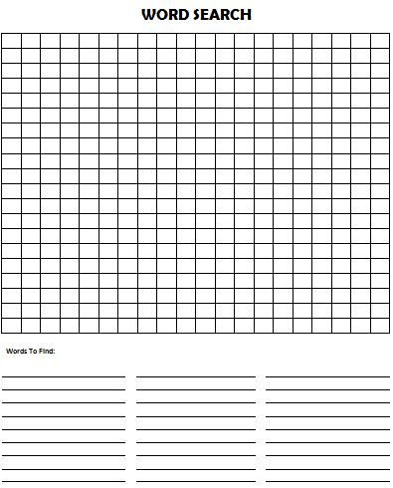

Day 1 activity 1: Inquiry getting started
Don’t forget to start your day right (See p. 11)
Notes for whānau
It would be easy to think we were the only animals that found ways to express ourselves. However, when we look around the animal kingdom this is most definitely not the case.
This learning pack will look at the many ways different animals, including humans, express themselves through language and culture e.g., dance, tattoos, and other means.
Each of the activities in this unit is designed to explore, investigate, make meaning, and create as we move along the unit. There may even be times where they will look a little deeper into the topic. Some of the tasks may be independent hands-on tasks while some may involve connecting with others to share your learning.
Today our inquiry focus is ‘getting started’ which includes engaging in provocations, introducing the big idea, activating prior knowledge, sharing wonderings and/or generating questions.
What do I need?
- 30 minutes
- Paper, notebook, or a digital doc to record my answers
- pen/pencil/device

In this activity I am learning to: Make connections to my prior knowledge

Take time to reflect – How are you feeling today?
Answer these self-reflection questions in your notebook.
- Write 3 things you like about learning at home
- Write 3 things you like about learning at school
- What are you looking forward to this term?
- What do you hope to learn about in this learning pack?

Activate your prior knowledge
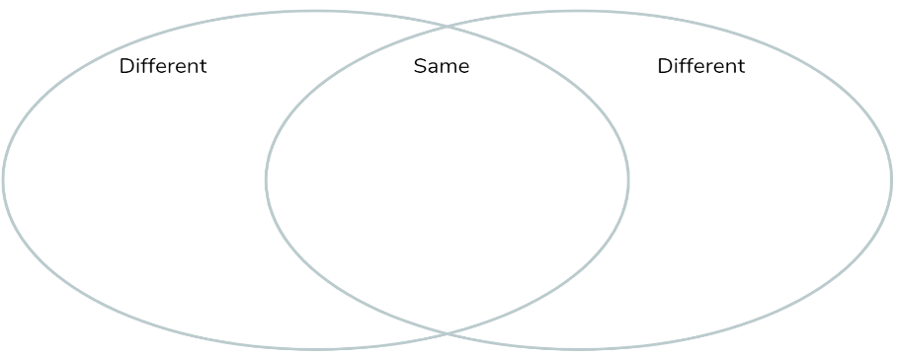
Draw a Venn diagram in your notebook to list your ideas by brainstorming the similarities and differences about how animals and humans express themselves.
What conclusion can you draw from your list? Write this in a statement below your diagram.

Day 1 activity 2: Let’s get physical, animal yoga
It is important your learner includes a fitness activity in their plan for each day. Encourage them to take regular breaks and if possible, do the fitness activity with your learner or have them complete it with their siblings where appropriate.
What do I need?
- 30 minutes
- A quiet space
- Yoga pose information (below)

In this activity I am learning to: Move my body and practise mindfulness by doing animal yoga poses.

Animal yoga
Use this guided yoga practise in your class to practise being in different animal yoga poses. These poses can be beneficial for mindfulness and help bring on a feeling of calm as well as reducing anxiety.
It also turns out that yoga can be helpful in tapping into our creativity fostering creative energy. Research also states that regularly practising yoga can have a positive impact on how we communicate with each other!
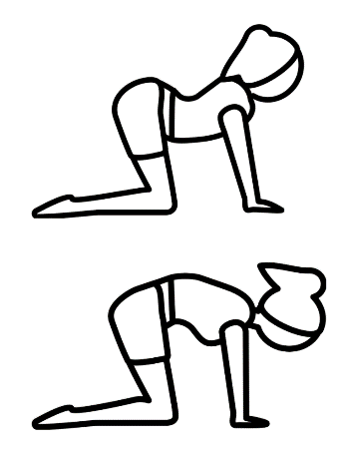
Have a go at the poses below and see if you can incorporate them regularly into your day.

Cat/cow breathing
Start on your hands and knees on your mat. Take a deep breath and drop your belly to the floor and look up to the sky, this is the cow pose.
Now breathe out, tuck your chin towards your chest and arch your back up to the sky like an angry cat.
Repeat your cat/cow breathing counting to 4 as you breathe in (cow) and counting to 4 as you breathe out (cat)

Eagle pose
Start by standing tall. Lift your arms over your head and swing your left arm under your right crossing at the elbows and try to clasp your hands.
Now bend your knees and bring your left leg over your right leg and twist it around like a rope. Try to get your toes tucked behind your calf muscle. See if you can hold the pose while you slowly breathe in for four counts and out for four counts.
Swap to the other side – swing your right arm under your left arm, and your right leg over your left leg. Breathe in for four counts and out for four counts.

Upward facing dog
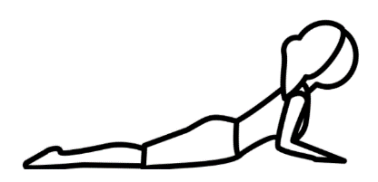
Lay face down on your mat. Bring your arms under your shoulders so that your fingers are in line with your shoulders. Take a deep breath and lift your chest off the ground without pushing too much into your hands. You are using your back muscles not your arms.
Hold the pose for a count of four and then lay back down. Repeat the pose four times slowly, breathing in for a count of four as you lift, and breathing out for a count of four as you lay back down.

Puppy pose
We are going to open our heart space just like a playful puppy. Start on your hands and knees (like cat/cow). Walk your hands forwards. Keep your hips high but let your chest and your heart melt towards the ground.
Lower your forehead to the ground and let your neck relax. Take four slow breaths here, focusing on feeling the stretch in your arms and back.

Day 1 activity 3: Reading
This task encourages your learner to develop their skills in analysing text for facts and information, as well as justifying their position. There may be a few new and unfamiliar words for your learner in the text. Encourage them to make note of these words in their glossary, find the meaning, and then reread the text with their new understanding of the word. This will help them to analyse the text more effectively.
What do I need?
- 45-60 minutes
- Look for a copy of this article in your pack or access here: https://www.dogonews.com/2021/12/20/orangutans-have-distinct-artistic-styles-too
- Dictionary (or online www.dictionary.com)
- Paper, notebook, or online doc to record your glossary, thinking and the answers to the questions
- Something to write with

In this activity I am learning to: Identify ways primates and humans are similar in their artistic ability.

Make meaning
Read DOGO news | Artistic orangutans.
Write down any words that you do not know the meaning of in a GLOSSARY in your notebook or digital doc
Use a dictionary, or similar, to find the meaning of these words
Re-read the article, thinking about the meaning of the new words and how this helps you understand the sentence.
Choose three of the tasks below and write your responses in your notebook or online doc after reading through the article.
- List 3 ideas/findings presented in this article
- Write the similarities between how orangutans and humans draw. Can you identify any differences?
- Think about what you already knew about orangutans. What new information did you find out about orangutans?
Extension: The last sentence states, “They [researchers] hope that the orangutan drawings which resemble those of young children – may provide clues into the evolution of human art.” Think of a way this could be further studied or researched. Write a brief statement of a research plan.
Persuade: After reading this article do you agree/disagree with the title Orangutans have artistic style too? Write a statement explaining why/why not.

Day 1 activity 4: Maths with statistics
This task encourages your learner to develop their skills in analysing text for facts and information, as well as interpreting graphs. There may be a few new and unfamiliar words that your learner may come across in the text. Encourage your learner to make note of these words in their glossary, find the meaning and then reread the text with their new understanding of the word. This will help them to engage with the task more effectively.
What do I need?
- 30 minutes
- Paper, notebook, or online doc to record your thinking and the answers to the questions
In this activity I am learning to: Analyse graphs for specific information and draw conclusions based on the information provided.
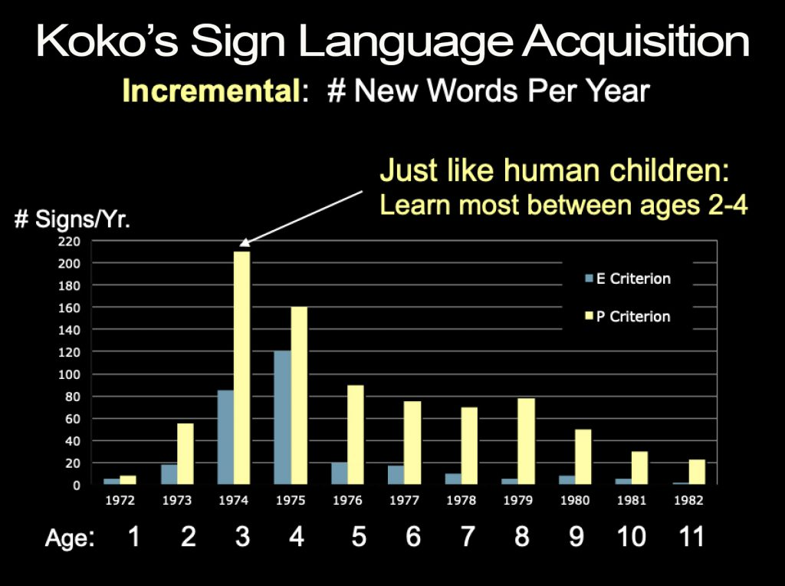
Graph obtained from https://www.koko.org/communication/

Thinking critically
Answer the following in your notebook or digital doc:
- Describe in your own words what you think this graph is showing.
- What year did Koko learn the most new words? How many?
- What year did Koko learn the least new words? How many?
- The title of this graph is Koko’s Sign Language Acquisition. “Acquisition” means to “learn or develop a new skill”. Based on this definition and using the graph above, what conclusion can you make about Koko’s sign language acquisition over time?
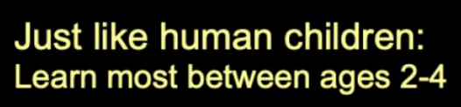
- What do you think this statement means?
- What conclusion can we make from this statement about the language development of Koko?
Remember to do your end of day reflection activity (See p.12).

Day 2: Let’s get started ...
Don’t forget to start your day right (See p. 11)
Note that our Inquiry focus for today is – “explore, investigate, and discover” which includes choosing and evaluating information, and thinking critically.
What do you think the following quote means? Write your thoughts down in your notebook.
“One thing to remember is to talk to the animals. If you do, they will talk back to you. But if you don't talk to the animals, they won't talk back to you, then you won't understand, and when you don't understand you will fear, and when you fear you will destroy the animals, and if you destroy the animals, you will destroy yourself.” ~ Chief Dan George

Day 2 activity 1: Reading
This activity engages your learner with the text and enables them to think critically about the reading. You may want to ask your learner to give reasons for their choices and thoughts about the text to assist them with their critical thought processes.
What do I need?
- 30 minutes
- Home learning book or digital doc,
- Look for a copy of this article in your pack or access here: http://smart-earpiece-translates-foreign-languages-in-real-time/
- Something to write with

In this activity I am learning to: Identify positives and negatives of a new technology.

Making meaning

Read this article Smart earpiece translates foreign language in real time.
Draw a PMI (Plus/Minus/Interesting) table in your notebook after reading this article.
Fill in the table to think of the plus side (benefits), minus side (challenges/negatives), and interesting points (use your critical thinking) about this new technological invention.
Plus | Minus | Interesting
Write your conclusions about whether you think this invention is a positive one or not for humankind.

Day 2 activity 2: Literacy in Maths
This activity helps your learner become familiar with common geometrical words and understand that subjects like maths use their own unique language to express meaning
What do I need?
- 30 minutes
- Access to a dictionary or similar.
- Copy of the table below in your notebook or online doc.
- A dictionary
- Option for digital: https://nzmaths.co.nz/nzc-glossary-mathematics-terms, https://mathsmate.co.nz/wp-content/uploads/2014/08/Glossary3.pdf

In this activity I am learning to: Recognise and define mathematical words that are common in geometry.

The language of maths
Maths uses its own language and vocabulary to express meaning. Below are common geometrical, mathematical words. Write the meaning of each term in the first column then give an example (this could be a drawing) to show it in practice.
You might like to read some examples of definitions/explanations: https://nzmaths.co.nz/nzc-glossary-mathematics-terms but you will have to investigate elsewhere (and tap into your prior knowledge) to define these mathematical terms.
You can check your answers and fill in any gaps using this resource https://mathsmate.co.nz/wp-content/uploads/2014/08/Glossary3.pdf Good luck!
Word | Definition | Example
equation
axis
congruent
adjacent
apex
midpoint
intersect
perpendicular
parallel
equidistant
diagonal
right angle

Day 2 activity 3: Discover and write
This activity is designed to enable your learner to explore the ways in which animals communicate. It also gives them to get outside and take a walk around to identify animal sounds, this could be a good opportunity for whanau/siblings to join in.
Note that our Inquiry focus for today is – “explore, investigate, and discover” which includes choosing and evaluating information, and thinking critically.
What do I need?
- 30-45 minutes
- A device to access ‘Do animals have language’ https://www.youtube.com/watch?v=_1FY5kL_zXU
- Paper, workbook, or online doc to record new glossary words, your thinking, and responses to the questions
- Something to write with
- Optional: ‘What animals are thinking and feeling, and why it should matter’ by Carl Safina https://www.youtube.com/watch?v=-wkdH_wluhw

In this activity I am learning to: Identify the different sounds animals use to communicate in nature and the possible reasons why and to Record my findings accurately in a table.

Discover
If you have access to a device/internet, watch Do animals have language? - Michele Bishop. This can be viewed on a smartphone. Otherwise you can read the transcript on the next page.
As you watch (or read), add any words you don’t know the meaning of to your glossary. Use a dictionary or other means to find out what the words mean.
Re watch the clip and see if you have more understanding of the content.

Comprehension questions
After watching the clip answer the following questions in your notebook or digital doc:
- What are the four specific properties associated with language?
- How do honeybees communicate with each other and why?
- How do Prairie dogs communicate with each other and why?

Go for a walk around your neighbourhood and listen for all the different animal sounds you can hear birds, dogs, cats, cicada’s. When you return discuss with a family member what you heard.

Transcript:
All animals communicate. Crabs wave their claws at each other to signal that they're healthy and ready to mate. Cuttlefish use pigmented skin cells called chromatophores to create patterns on their skin that act as camouflage or warnings to rivals. Honeybees perform complex dances to let other bees know the location and quality of a food source. All of these animals have impressive communication systems, but do they have language? To answer that question, we can look at four specific qualities that are often associated with language: discreteness, grammar, productivity, and displacement.
Discreteness means there is a set of individual units, such as sounds or words, that can be combined to communicate new ideas, like a set of refrigerator poetry magnets you can rearrange to create different phrases. Grammar provides a system of rules that tells you how to combine those individual units. Productivity is the ability to use language to create an infinite number of messages. And displacement is the ability to talk about things that aren't right in front of you, such as past, future, or fictional events.
Does animal communication exhibit any of these qualities? For crabs and cuttlefish, the answer is no. They don't combine their signals in creative ways or have a grammatical order, and they only communicate current conditions, like, "I am healthy," or "I am poisonous." But some animals do display some of these properties. Bees use the moves, angle, duration, and intensity of their waggle dance to describe the location and richness of a food source. That source is outside the hives, so they exhibit the property of displacement. They share that language trait with prairie dogs, which live in towns of thousands, and are hunted by coyotes, hawks, badgers, snakes, and humans. Their alarm calls indicate the predator's size, shape, speed, and, even for human predators, what the person is wearing and if he's carrying a gun.
Great apes, like chimps and gorillas, are great communicators. Some have even learned a modified sign language. A chimpanzee named Washoe demonstrated discreteness by combining multiple signs into original phrases, like, "Please open. Hurry." Coco, a gorilla who understood more than 1000 signs and around 2000 words of spoken English referred to a kitten that had died. In doing so, she displayed displacement, though it's worth noting that the apes in these examples were using a human communication system, not one that appeared naturally in the wild. There are other examples of sophisticated animal communication, such as in dolphins, using whistles to identify age, location, names, and gender. They can also understand some grammar in a gestural language researchers use to communicate with them. However, grammar is not seen in the dolphin's natural communication.
While these communication systems may have some of the qualities of language we've identified, none display all four. Even Washoe and Coco's impressive abilities are still outpaced by the language skills of most three-year-old humans. And animals' topics of conversation are usually limited. Bees talk about food, prairie dogs talk about predators, and crabs talk about themselves.
Human language stands alone due to the powerful combination of grammar and productivity, on top of discreteness and displacement. The human brain can take a finite number of elements and create an infinite number of messages. We can craft and understand complex sentences, as well as words that have never been spoken before. We can use language to communicate about an endless range of subjects, talk about imaginary things, and even lie. Research continues to reveal more and more about animal communication. It may turn out that human language and animal communication aren't entirely different but exist on a continuum. After all, we are all animals.
Think about the following:
- Did it seem like the animals were communicating with other animals of same/different species?
- Did the sounds appear like they were warning sounds, inviting, territorial, aggressive, stressed, or frightened?
- Use your findings to complete the table on the next page. You can do some extra research if needed to help you fill in the table.

Animal Communication
Animal | Sound or action  (How they are communicating, describe the sounds) | Purpose  (What are they communicating and with who?)

Optional: To dive a little deeper, you might like to watch this TED Talk: What animals are thinking and feeling, and why it should matter | Carl Safina https://www.youtube.com/watch?v=-wkdH_wluhw

Day 2 activity 4: Social & emotional learning
This task is designed to encourage your learner to think about the different ways animals express or communicate their emotions and compare these with ways in which they themselves individually express emotions.
What do I need?
- 30 minutes
- Home learning book or digital doc
- Something to write with
- Optional: a device to access the article on Khan Academy: https://www.khanacademy.org/science/biology/behavioral-biology/animal-behavior/a/animal-communication#:~:text=Animals%20communicate%20using%20signals%2C%20which,behavior%2C%20and%20care%20for%20young

In this activity I am learning to: Compare and contrast how humans and other animals’ express emotions by using specific examples.

Animal communication
As humans, we find many ways to express our emotions. Our faces, our gestures, and even our voices are ways to show our emotions.
Communication takes place when one animal transmits information to another animal causing some kind of change in the animal that receives the information. Animal communication:
- is usually between animals of a single species, but it can also happen between two animals of different species.
- uses signals, which can include visual; auditory, or sound-based; chemical, involving pheromones; or tactile, touch-based, cues.
- Involves behaviours and can help animals find mates, establish dominance, defend territory, coordinate group behaviour, and care for young.

You may like to read more about animal communication on Khan Academy: Animal-communication

Copy and complete the following chart in your notebook or digital doc. You are comparing how different animals’ express emotions to ways in which you express yourself.
Animal –emotion | Info | You
Skunk – scared | What do you do when you’re scared? Do you know how skunks communicate when they’re scared – they spray! Skunks have glands that store the spray. They release it when they feel scared to fend off predators. | When I’m scared I....
Wolf – Happy | How do you show you’re happy? Wolves express happiness in many ways, the most common being wagging their tails. They also communicate with howls, yips, and barks to share their happiness with their pack. | When I am happy I....
Whale –  Love | How do you show someone you love them? Some whales express love for others by gently touching fins and swimming together! | When I love someone I.....
Tiger – frustrated
Cat – angry

Dog – sad

What are some other animal emotions that you recognize? Do you have some ideas on how certain animals might express themselves? Write your thought down in your book or doc.

Remember to do your end of day reflection activity (See p. 12).

Day 3: Let’s get started ...
Don’t forget to start your day right (See p. 11)
Note that our Inquiry focus for today is – “making meaning” which includes making connections, organising information, and thinking critically.
What do you think the following quote means? Can you provide a list of examples of animal communication? Write your thoughts down in your notebook.
“Visual communication involves signals that can be seen. Examples of these signals include gestures, facial expressions, body postures, and coloration.”
~ Khan Academy

Day 3 activity 1: Drama – act it out!
This is a bit of fun, and whānau can get involved with too, based on the classic game of charades. This activity will help your learning make connections to their learning and prior knowledge and require good communication through body language.
What do I need?
- 30 minutes (or more)
- Other people to play charades with

In this activity I am learning to: Use gestures and body language to communicate the features of an animal for your team mates to guess

Using body language to communicate:
Using people in your household or connect with friends online to have a game of animal charades. Charades is when you ‘act out’ a word or phrase.
Drawing on previous knowledge on how animals communicate:
- Use your body to imitate an animal of your choice (or cut up the animal list below and put them into a hat – then you can make random picks).
- Take turns and make 3 guesses. The person who guesses correctly is the winner of that round.
You might want to do some research ahead of time to learn more about some of the animals in the table if you are unsure how they communicate or what they sound like.

List of animals

Albatross  Alligator  Ant  Anteater  Antelope  Armadillo  Axolotl  Baboon  Badger  Bandicoot  Barnacle  Barracuda  Bonobo  Brown bear  Budgerigar  Buffalo | Caiman  Camel  Capybara  Caracal  Cassowary  Cat  Caterpillar  Chicken  Chihuahua  Chimpanzee  Chinchilla  Chipmunk  Donkey  Duck  Dolphin  Eagle | Earwig  Echidna  Elephant  Fish  Flamingo  Fly  Fox  Lizard  Lion  Penguin  Seal  Shark  Squirrel  Tarantula  Tiger  Zebra

Day 3 activity 2: Writing
This activity focuses on the use of literary language features to help give extra meaning to your learner’s writing. It may be of assistance to discuss the requirements of this task with your learner to ensure they are comfortable with it.
What do I need?
- 30 minutes (or more)
- Writing equipment or digital device with word document capabilities

In this activity I am learning to: Use similes and metaphors to describe the emotion and expression a dancer might show.

Literary language features:
Writers often use literary language features to add different layers of meaning to their work. Similes and metaphors are two features that are used to create a picture in the reader’s mind which instantly communicates what the writer is trying to describe, and a poem with a simile uses the words “like” or “as to compare two things which are not alike.
A metaphor is a comparison between two things that states one thing is another to show similarities. Unlike a simile that uses “like” or “as” a metaphor does not use these two words. For example, she IS the sun (metaphor) rather than she is LIKE the sun (simile).
Not only do humans and other animals use language and sound to communicate and express emotion they use movement. Below is a photo of a traditional Indian dancer.

Activity:
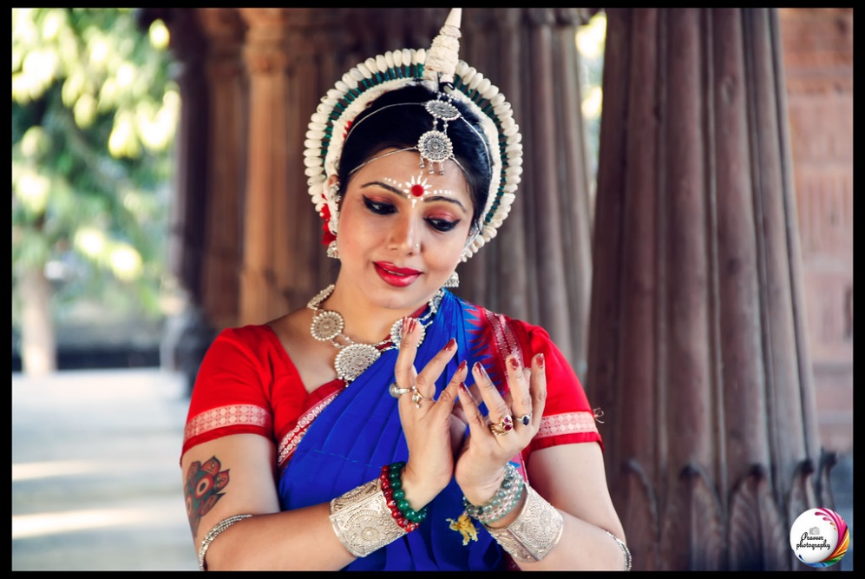
STUDY the photo
In your learning book or digital document, CREATE a poem containing at least one simile, one metaphor and two other language features, to describe the dancer's appearance and possible emotion she is portraying.
Option: You might like to find another image that captures human or animal movement to inspire your poetic nature, please ensure you include the image and record where your sourced it from.
2 "Indian cultural dance" by MEMORIES BASKET STUDIO is licensed under CC BY-NC 2.0

This table outlines a number of literary features.
Terminology | Definition | Examples
simile | A comparison using “like" or “as" to create a vivid image. | as big as a whale, “Float like a butterfly, sting like a bee”
metaphor | A comparison made without using "like" or "as". | sea of troubles, drowning in debt
personification | A type of imagery in which non-human objects, animals or ideas are given human characteristics. | the jaws of the cave, the leaves danced in the breeze
pathetic fallacy | The environment (usually the weather) reflects the mood of the character or scene. | The fog crept evilly through the streets as he stalked his victim.
onomatopoeia | The sounds of words to express or underline their meaning, sensory imagery. | crunch, pop, screech
alliteration | The repetition of the same sounds usually at the beginning of words. | "Reuse, renew, recycle"
rule of three | Repetition in a group of three to strengthen an idea or argument. | "Freedom, equality, and justice"
connotations | Implied meanings suggested by a word rather than its literal meanings. | Red is a colour but can imply danger, anger, or stop.
repetition | Words, phrases, or ideas that are repeated for effect. | "This is serious. Incredibly serious."
rhetorical questions | A question asked for effect with no answer expected. | Do you think that I'm made of money?
emotive language | Words chosen to bring an emotional response. | defenceless", hard-hearted
Sourced from: https://www.bbc.co.uk/bitesize/guides/zcpg4j6/revision/1

Day 3 activity 3-4: Reading and reporting
Dance is a way humans express themselves and their culture. This activity requires your learner to research and understand another culture through dance and movement. The activities will lead to a compare and contrast exercise which is a powerful tool for helping to make meaning of new information, employing critical thinking skills.
What do I need?
- 60 minutes
- A device for doing research and writing (optional)
- Writing materials
- A device to access the article on Kapa haka at: https://www.newzealand.com/ca/feature/kapa-haka-maori-performance/ and https://www.youtube.com/watch?v=t2b1c69nXz0 (first 4 min)

In this activity I am learning to: Identify specific movements in a cultural dance and the requirements to carry out this dance and to Compare and contrast information

Cultural dances
Research a dance from another culture OR use the reading about Kapa haka which can be found on the 100% New Zealand | Kapa Haka or Traditional Māori performing arts website.
In your notebook or digital doc, WRITE down 3 things you would need in order to be able to do this dance (you could draw and label a diagram) – think about:
- costume – what do you need to wear to perform this dance?
- props – do you need to use anything in this dance?
- what type of music is this dance performed to?
Take a deep dive with this activity
Various other animals also use dance to communicate. Optional: Watch the first 4 minutes of the following YouTube clip https://www.youtube.com/watch?v=t2b1c69nXz0
As in the activity above answer the following questions relating the dance performed by the male Birds of Paradise (or you may like to research how another animal communicates through dance and report on that instead).
- What costume do they require?
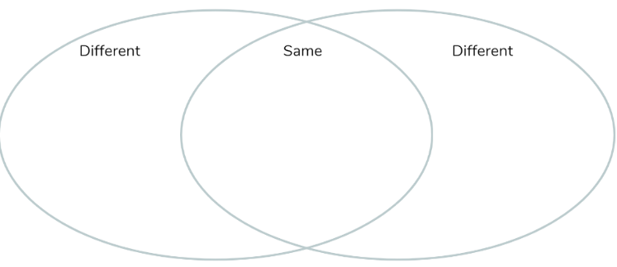
- Props – do they require anything for their dance?
- Instead of music, describe the movement and sounds of the birds in the clip
Compare and contrast your two animal dances using a Venn diagram in your notebook.
Remember to do your end of day reflection activity (See p.12).

Day 4: Let’s get started ...
Don’t forget to start your day right (See p. 11)
Note that today our Inquiry focus is –” Going further, deeper”. This may include promoting opportunities to engage further and dive deeper through discussions, provocations, exploring further contexts, taking action, or thinking critically and drawing conclusions.
What do you think the following quote means? Write your thoughts down in your notebook.
“The moko is my voice; it is my visible presence in this time and in this space. It is my rite of passage to the past and to the future. It is the revolving door to my tupuna [ancestors] and my descendants. My children and grandchildren will not suffer the oppression of intolerance because I have asserted my tino rangatiratanga [sovereignty, autonomy].”~ Tuhipo Maria Rapido Kereopa

Day 4 activity 1: PE and performing arts
Another fun activity to energize and refocus us. Your learner could encourage a sibling or other member of the whanau to join them. If they do not have access to the clip, the learner could be encouraged to make up their own dance moves to their favourite song, go for a walk, run, or bike ride.
What do I need?
- 30 minutes
- A device to watch the Royal Family 2019 MEGACREW first place dance YouTube clip here: https://www.youtube.com/watch?v=-mKzJIW9w2c

In this activity I am learning to: Express myself through dance and movement.
We have previously looked at traditional cultural dancing. Now watch this dance clip choreographed by internationally renowned performing artist Parris Goebel - performed by her award-winning contemporary Aotearoa hip hop dance crew, “The Royal Family”.

Activity
Choose a segment of 20-30 seconds and try and replicate the dance or follow along (you can use the settings button (gear icon) to slow the playback speed if that is helpful.
- Repeat the segment 3 x to get heart rate up! Or find another YouTube dance to follow along too.
- Create your own dance routine and perform it or record it to share.

Day 4 activity 2: Descriptive writing
This is an activity for the learner to research and understand more about Ta Moko. Body tattooing is a traditional way that many humans express themselves and their culture. This is also a great opportunity to learn more about tikanga Māori or your own culture if tattooing is a part of it. Your learner will be drawing conclusions, exploring a new context, and applying critical thinking.
What do I need?
- 30 minutes
- A device for watching tā moko on YouTube: https://www.youtube.com/watch?v=yF3w66aa2VI&t=1s
- Writing materials for recording your responses
- Home learning book or digital doc

In this activity I am learning to: Describe the cultural significance of traditional art forms and body adornment.
Watch Tā moko or read the transcript on the next page.
After watching (or reading) answer the following questions in your notebook or digital doc:
- How is Kapa Haka linked to Tā Moko?
- Why would it be important for a Tā Moko tattooist to look at other cultures and their tattoos?
- What other cultural practises did you see take place during the process of Tā Moko at the museum?
Other cultures also have traditional tattoos.
- Draw a table (like the example below) in your notebook
- Using the internet, research to find three other cultures/countries that use tattoos to express their culture. What is the significance for each?
- List 3 examples of other cultural tattoos.
- Copy and paste or sketch a picture into the table.
- Write an informative blurb into the meaning and significance of each cultural tattoo underneath.
 | Tattoo example 1 | Tattoo example 2 | Tattoo example 3
Drawing or picture example of the tattoo
The meaning and/or significance of the tattoo

Transcript:
My Tā moko today I got from Turumakina- and it's a representation of what happened here at the National Gallery of Australia with this Tā moko exhibition and there's two manaia which represents the two groups of people coming together and meeting for this amazing exhibition. So we're in the presence of our tupuna who have Tā moko and if you can see around me from the 17th century on and what's really exciting is that Tu who did my Tā moko for me today is the picture of him getting his Tā moko here on his face.
I've been in Canberra for the last 25 years and I come to the NGA every few weeks to have a look at our taonga and to let them know that that they have Māori here that think of them and look after them. So seeing something like this here today is the most incredible collection of our work and we're just so grateful that it happened.
I started tattooing about 25 years ago after kapa haka cultural performance. Having been involved with kapa haka you have to draw on Tā moko for stage, so I spent 10 years drawing on myself and people for stage performance and so one of the bros come along one day and asked me to tattoo him and with a homemade machine. So I tattooed him, made my own machine from there and probably used that machine for about five years or so before I was picked up by an artist who took me under his wing and shared his knowledge with me about Tā moko. Since then have been involved with toi Māori in the past being sent over to some of the Native American tribes with cultural collaborations going on. It has been a privilege for me to be able to rub shoulders with the likes of Rungi, Derek and Ricky Manuel, Mark all those guys. Like another day at the office for us I guess. I had, two walk ins today that weren't expected but that's fine. As long as you have that discussion with the client about their motives and their reasoning for coming to get their Tā moko so yes once that's established then the design flows from there. Man, after 25 years of tattooing it's you know I guess it's like conditioning perhaps. Yeah once you're once you're in the zone time flies by. You don't even know it's gone. It's great when the public come in and actually ask questions about what we're doing and what it's all about. That's just an opportunity to educate, educate people up. Yup feeling quite energized and buzzing I suppose is the word.
There’s support there for us just a physical presence our spiritual presence. The songs you hear in the background are there to help not only the practitioner and Tā moko but for the actual person lying in front of that artist as well. And so it's creating a space of peace. It's calming all of them because there are a number of things taking place here apart from all the talking which really shouldn't be! We're trying to set a different tone within the room, so our brothers know that we're here physically. They can feel our presence here simply by the interaction between Māori and non-Māori so it was forever connecting. We’re hear specifically predominantly for Tā moko exhibition and traditionally with Māori there's a male and a female presence and they can't go without each other and so we add that femininity, that feminine essence and we're there to help to settle them as well as that person lying there receiving their taonga. Everything in our world is genealogy so we're forever tied. Every living thing has a beginning. It has a mauri; a life essence and we're all connected because we're all living things.
We're handling people all the time and you know you're in their zone and you're, you're interfering with their spirit and you're interfering with their body and so you know you just cover yourself and you get on with it. I suppose we are you know been doing it for a long time too, so you know you've got a job to do and that's why the most the time that's the reason why we have music playing. I always have music playing it because it just it frees you up to just float off you know while you're working so you know once I've done my pen work then I just I just get on with it and rock into it. It's great opportunity to work on someone's face anyway but just considering that we're in Canberra and outside of Aotearoa it’s not often here that the average person will get to see the ritual.
That pain transference works like half of the whakapapa on this side they're in there now yeah. So I've gone back three generations so far yeah. You try and envisage in your mind. See you're following the curves as he's going and t's hard, it's hard to picture exactly how it'll look yeah. Now the last especially going around the ears I could feel things in the sole of my feet yeah.
Yeah ah he was he was amazing. I mean I was really impressed you know because it's mean, it's tough anyway physically but um it's something else again when you're in the public zone. You know in the public sphere, and you can't control everything that's going on around you. So you've got noise that's interfering. You got people's voices you know you've got you know light issue all this sort of stuff you know just peripheral activity which can easily interfere with your concentration I suppose. But he's sat really well I was really impressed. Yeah well you know I mean it's not often that you can get through you know two of those designs, basically you know this whole lower half of his face and in like I don't know three four hours that's good. It's nice seeing someone to get further along
Today's experience was surreal having it done here in the Tā moko exhibition at National Gallery of Australia was fantastic. We've had so many people come through and share the experience while I've been having my Tā moko done. Also to have out tipuna around some of the amazing people from our past on the walls here sort of looking over me as I was having it done that's fantastic. Look I just went and had a look in the mirror and I'm I can't describe it. I can't. I'm so happy I feel complete. Really pleased. With the Tā moko process it's like people talk about the pain and there is, there is pain, but you know first I want to say that when you look at our tipuna our ancestors they had them. They actually had been chiselled in you know, chiselled into the skin and I can't even imagine what that would feel like and the hours and hours days and weeks of unique Tā moko chiselled into your skin. So I don’t want to try and compare this experience to what they would have gone through in the past. But you know like you go through these waves so you get waves of pain, and they sort of they rise and fall but what happens is I have a process where I look to my ancestors so I look at my family tree my whakapapa and whenever it starts to become unbearable or I think - yeah - too painful what I do is I picture someone in my family tree and then I asked him to come and be with me for a specific period of time. And it's sort of like I think if you look at it psychologically it's probably pain transference. So I'm asking them to be there and I'm transferring pain from me physically to them. The room was full it was full of people and that was a really good experience to share so you know for me I got sort of that experience of having my Tā moko or you know more complete and I'm not sure how many people came through but for the amount of people that came through they got the experience of actually, the experience of watching you know someone take on Tā moko with a Tā moko artist. So that was awesome.
I want to thank Toi Māori for the opportunity of having my pharmacal done but more specifically Rangi Kipa. You can see that the quality of work the calibre work that it has and, and I, I can't ask for more than that.

Day 4 activity 3: Literacy - critical thinking
This activity is designed to encourage the learner to think critically about statements made by the writer and draw conclusions about what they have read. They will also need to justify their conclusions with evidence from the text.
What do I need?
- 30 minutes
- Writing equipment
- Check your pack for a copy of the article or access it online here: https://www.bookaway.com/blog/the-philippines-dying-art-of-kalinga-body-tattoos

In this activity I am learning to: Justify my point of view on a topic

Your task
Read the article on the cultural adornment practices of the Kalinga people in the Philippines.

Answer the questions that follow in your notebook or digital doc using the text to justify your conclusions.
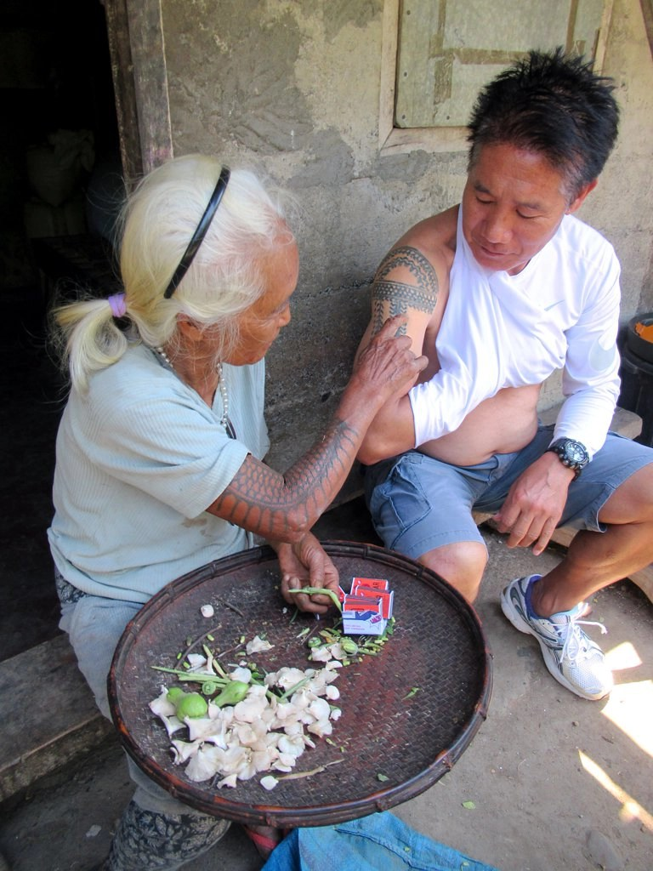
3 Image source: Traditional Tattoos | ©David Stanley/Flickr
- What did the writer mean when she said, “Kalinga tattoos had to be earned by the wearer”?
- Why is the Kalinga tattooing at risk of dying out?
- The writer described the Kalinga tattoos as being different from other types of tattooing - “Their social symbolism is what sets them apart from modern tattoo art as we see in our cities.” Do you agree with statement or not? Justify your answer.
- Tattooing was used on both men and women of the Kalinga tribes, but they communicated different messages. Explain these messages in your own words.

Day 4 activity 4: Maths
In this activity the learners will explore symmetry in the natural and manmade world.
What do I need?
- 30 minutes
- Check your pack for a copy of the maths activities or access online here:
- https://nzmaths.co.nz/resource/i-spy-symmetry
- https://nzmaths.co.nz/sites/default/files/ISpySymmetryCM.pdf
- A measuring tape
- Someone to work with
In this activity I am learning how to: Identify symmetry in manmade and natural objects.

Symmetry
Animals have amazing patterning, often to communicate a message. That message could be one of warning, to attract a mate, or used as camouflage or defence.
Patterns such as that on the wings of the monarch butterfly are usually considered symmetrical. When we think of symmetry, we tend to think of reflective (mirror line) symmetry.
However, symmetry in fact, can also be rotational or translational.
- Rotational symmetry is the result of turning about a point (centre), even if it is not obvious where this point is.
- Translation is the result of movement in a straight line. Many designs that use symmetry involve combinations of two or more of these different transformations

Activity A
Grab your notebook or a camera and GO for a walk outside, a local park, forest, bush walk, beach or even your own backyard/neighbourhood and see if you can identify:
- two man-made symmetrical objects
- two symmetrical objects found in nature
- two more examples of symmetry.

Activity B
COMPLETE the tasks in the “I Spy Symmetry” worksheets
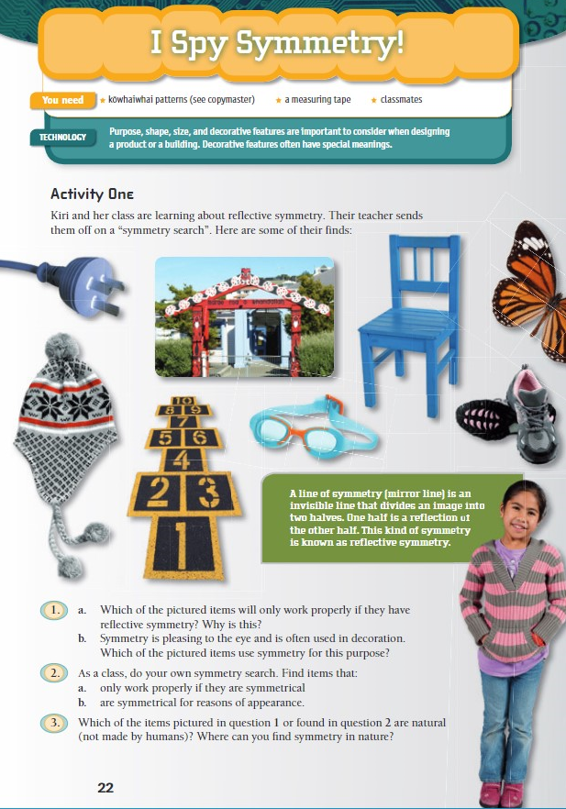
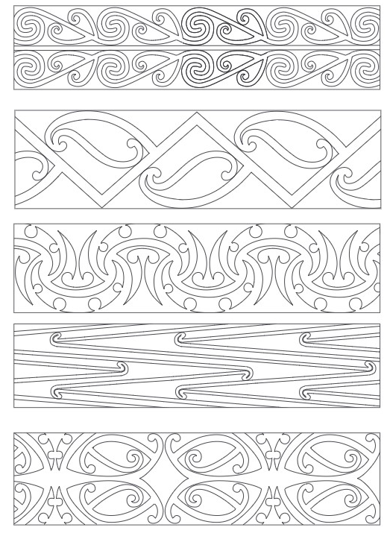

Remember to do your end of day reflection activity (See p.12).

Day 5: Let’s get started...
Don’t forget to start your day right (See p. 11)
Today our Inquiry focus is – "Present- share learning about the big idea" which includes thinking about who the audience is and considering different ways of communicating learning e.g., presentation, video, poster, etc.
What do you think the following quote means? Do you agree with it? Why or why not? Write your thoughts down in your notebook.
“You can’t use up creativity. The more you use, the more you have.” ~Maya Angelou

Day 5 activity 1: Literacy and visual art
This activity is designed to encourage the learner to think about how imagery connects us to our cultural ideas and values. If your own culture uses this practice to communicate feel free to share those stories with your learner.
What do I need?
- 30 minutes
- Optional: A device to watch ‘What is a mandala?’ on YouTube: https://www.youtube.com/watch?v=NpLnnQpYdyk&t=37s

In this activity I am learning about to: Explain how different cultures use artforms to express themselves.
A mandala is a beautiful kind of art that uses intricate designs made up of geometric shapes and symbols starting from a central point. They can have a special meaning to the person who created them as they are reportedly a representation of the soul. A mandala can be seen as a tool to help self-awareness, so it is a wonderful way for people to express themselves.
Optional: Watch the video clip on making mandala
Find out from whānau or friends what their knowledge is about this art form. Has anyone in your home ever seen or made one before?
Explain verbally to someone in your household/whānau what a mandala is.
How do other cultures express themselves through art?
Choose two cultures that use imagery or icons to express ideas or values. Research what they mean and write an explanation to go along with a sketch or diagram of the artform.
Copy this table into your notebook and complete
Culture | Art form (explain and include an image)

Day 5 activity 2: Social and Emotional Wellbeing
Mindfulness is an important philosophy and learning the skills to maintain your hauora is integral to surviving and thriving in the modern world. Your learner will combine learning from previous activities in this wellbeing activity.
What do I need?
- 30 minutes (or more)
- Colouring equipment like felt pens, colouring pencils, or crayons
- Look in your pack for a copy of the mandala template or access online here: https://sparklers.org.nz/media/documents/AllRight_MandalaOne.pdf

In this activity I am learning to: Practise mindfulness for wellbeing.
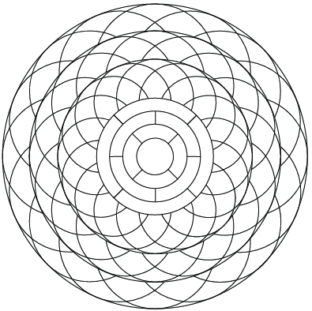
“When we are fully immersed in an activity and lose track of time (like we do when colouring in), we call this ‘flow’ (also known as being ‘in the zone’). Flow is associated with happiness because it helps us stay present (mindful). People who experience this state regularly often develop other positive traits such as increased concentration and self-esteem.”

Get creative!
Use your understanding of symmetry to design a mandala of your own. Use the shape below.

Breathe! – spend time colouring in your mandala. Use colour (with coloured pencils, pens, or anything suitable) or monochrome (using biro or a simple pencil).

4 Sourced from: https://sparklers.org.nz/media/documents/AllRight_MandalaOne.pdf

Day 5 activity 3: Writing
Writing is an important form of communication. It allows the writer to pass on to others what they feel is important for them to know. Procedural writing encourages the writer to be brief but precise with their written instructions. This task provides the learner with the opportunity to develop and enhance their procedural writing skills further.
What do I need?
- 30 minutes
- Optional: A device to view “How to draw a mandala - https://www.youtube.com/watch?v=U49TaN-MkM8
- Home learning book and writing materials.

In this activity I am learning to: Write a set of instructions
A mandala is a complex abstract design usually circular in form. Mandala generally have one identifiable centre point, from which comes an array of symbols, shapes, and forms.
Mandala can contain both geometric and organic forms. They can also contain recognizable images that carry meaning for the person who is creating it.
- Watch the clip on how to draw a mandala
- Write a 5-step process for others to follow. Make sure you add in enough detail – This should be easy enough for someone who has never seen a mandala to follow.
- Or follow the instructions below.
Instructions:
- Measure out your paper into a square shape. The square can be as big or as small as you like. The bigger the square, the more room you will have for putting in lots of detail and colour.
- Use your ruler and a pencil to draw a dot in the very centre of the square.
- Draw a series of circles around this dot, 3 is good. Once you've drawn the dot in the centre of your square, one easy way to draw circles is to use a compass. If you don't have a compass, don't worry try using round objects in your kitchen and trace them.
- Use a straight edge to draw a straight line through the middle of your circles from the top of your biggest circle to the bottom of your biggest circle. Repeat with a horizontal line across your circles and then two more lines diagonally (equal distance apart).
This is your basic design and now you can start to draw symmetrical designs inside each part. Try circle, ovals, petals, diamonds, triangles, rain drops etc. The important this is to repeat your pattern. For example, if you draw a circle on one of the lines, be sure to draw it in the same spot on the other lines.
This creates repetition, which is a key element in creating a mandala.
The more designs you add, the more complex your mandala will be. Take your time adding more patterns, neat as you can. Use different coloured pens or do it all in black and then colour it in or shade with a pencil. Enjoy!

Day 5 activity 4: Let’s get creative!
In this activity learners will reflect on their own feelings about themselves, practicing self-awareness and getting in touch with their emotions by expressing this through art.
What do I need?
- 30 minutes (or more)
- A device to take pictures (optional)
- Writing materials

In this activity I am learning to: Relate imagery to personal feelings about myself.

Go for a walk
Find an object with a pattern – this could be a flower, the footpath, a fallen leaf, or the neighbour's fence. Take a photo or if it is ok to pick it up and take with you, do so.
Create a mandala pattern based on your chosen object or collect a number of natural items and create a mandala pattern with them (take a photo if you can). Here is an example:
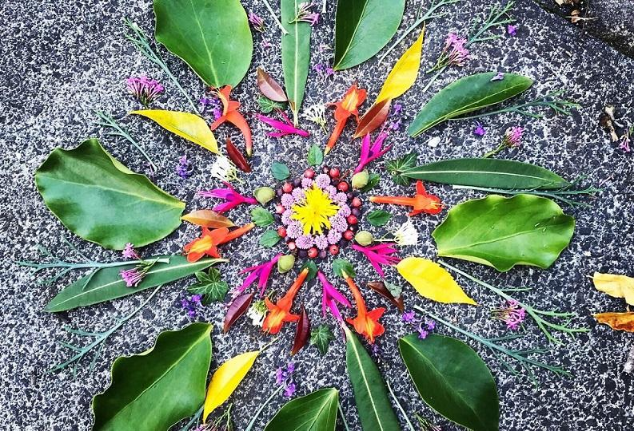
Image sourced from: https://www.healthykids.org.nz/sites/default/files/styles/scale_width_media/public/2020-05/Mandala.jpg?itok=3VtA1IU9
Once you have finished creating your mandala, complete the following tasks in your notebook or digital doc:
- Choose 3 words from the list below that describe your mandala or choose your own!
Courage, bravery, strength, wisdom, elegant, colourful, monochrome, fun,
- Write a statement about what your mandala represents to you, and the choices you made in terms of colour, pattern, object chosen
- Share your learning – If you feel comfortable you could present this via a social media post on a platform of your choice, or alternatively share it with your whānau or friends.
Remember to do your end of day reflection activity (See p.12).

Day 6: Let’s get started...
Don’t forget to start your day right (See p. 11)
Over the next five days, the learner will engage in a series of activities designed to look at the way cultures cultivate, produce and prepare their traditional or significant foods as well as the ceremony that might surround how people gather together around a meal.
One of the core ideas is to think about the way different peoples use food to reflect their culture and express their beliefs around sustainability and the environment, health and wellbeing, religion and culture and connection with friends and whānau.
Today our inquiry focus is ‘getting started’ which includes engaging in provocations, introducing the big idea, activating prior knowledge, sharing wonderings and/or generating questions.
Think: What do you think the following quote means? Do you agree with it? Why or why not? Write your thoughts down in your notebook.
“Food is not just what we put in our mouths to fill up; it is culture and identity. Reason plays some role in our decisions about food, but it's rarely driving the car.” ~ Jonathan Safran Foer

Day 6 activity 1: Activating prior knowledge
This activity is a brainstorming activity designed to explore what learners already know about different cultures and their food.
What do I need?
- 45 minutes

In this activity I am learning to: Think critically about how different cultures express their beliefs through food
Reflect on the following focus question:
“How do different people around the world express their beliefs through food (i.e. through cultivation, production, preparation, eating)?”
- Draw the table below and use the first 2 columns to capture your thoughts and your prior knowledge around the focus question
- List other questions you may have about food and beliefs in the third column
What I ALREADY know | What I THINK I know | What I WANT to know
List the sources you could use to help answer your questions.

Day 6 activity 2: Literacy
This activity begins with a clip to encourage thinking around food and the connections people have with it. Learners will then have the opportunity to explore the significance certain food or dishes have within their own family. This might also be a great chance for whānau to discuss some favourite family foods and the significance of them!
What do I need?
- 60 minutes
- Colouring pens, pencils or crayons
- A4 Paper for placemat
- A book for writing in or an online doc
- A device to watch ‘How Food Connects Us’ https://www.youtube.com/watch?v=7C7vFHeos8U

In this activity I am learning to: Describe a cultural or family dish and explain its significance.
Watch ‘How Food Connects Us’ by National Geographic or read the transcript on the next page.
Think about the points of view being shared by the different people in the video. What do they have in common? What opinions do they share? What points do they offer a different opinion on?
Describe in writing a meal that has personal significance to you or your family. ADD details such as what it is eaten with or on, is it only eaten on a special occasion, time of year or with certain people.
Record these details in your learning book or online doc.
Draw or sketch out this meal on a piece of blank A4 paper. Label each part.
Describe the preparation that goes into create such a special dish/meal. Explain (in 350-400 words) the significance of this dish/meal to you and your family.

Some questions and tips that may help you with crafting your writing:
What is a memory you have the includes this meal/dish
Who usually prepares the meal? How is it prepared?
What do you like most about this meal/dish?
What is something no one else would know about this meal/dish?

Transcript:
Eat: The story of food
Nigella Lawson: I firmly believe that how and what we eat is who we are. I think it was Bertrand Russel who said, ‘There is no more sincere love than the love of food.’
Graham Elliot: I think that to me food is a looking glass into that culture wherever you’re at, whatever country, or city, or even neighbourhood in the States that you’re in to understand where the locals eat to go and try that, read the menu, go to the market, you really understand who those people are.
Nigella: The drive towards taste and flavour is the elemental part of us because anyone that has seen a new-born baby has seen that the first thing a baby wants to do after breathing is feed. So, its who we are, and it absolutely can’t be separated, and I think that that’s why we have slightly separate tastes. We like certain different foods. Which is why eating the food of someone else's childhood can be fabulously exciting because everyone has a different truth. Like why everyone has a slightly different personality.
Marcus Samuelsson: In the best way food can connect us and tell a story about why we eat the way we eat, and you will invite a friend into that conversation and that dinner and in a prideful way say hey we eat this part and we cut our meat this way, isn’t that great you know?
Ed Mitchell: Food has that common denominator that allows us to slow down and enjoy life and smell the coffee so to say.
Nigella: We are all original and yet we share so much so food is the one common language. It doesn’t matter when you speak, French, you speak German, you speak Chinese...the one common language we have is food and that connects us all.

Day 6 activity 3: Literacy
This task is designed to get learners to reflect on changes that have taken place over time in relation to the way food is handled or made available, by talking with older whānau. If someone isn’t available within the household, learners should be encouraged to make contact with someone else who may be able to assist and interview them over the phone or via a video call.
What do I need?
- 30 minutes
- Pen and paper
- Someone to interview
- Optional – a phone or digital device to contact someone outside the family for an interview

In this activity I am learning to: Compare how food practices have changed over time.
Choose someone in your household to interview. Try and choose someone like a parent or grandparent (someone who has been around a while to see changes in way things are done).
Write down a series of questions to gather information on:
  - how they think food customs have changed for them, or in general, over time.
  - how food and related customs, such as cooking techniques, table manners and eating habits have changed in the last 50 years.
Here are some examples questions you could use:
- What type of food was common when you were younger?
- Where did you get your food from mostly (did you grow your own or was it from the supermarket?)
- How many people did your meals need to feed each time?
- Were there any other challenges that came with getting, preparing or storing food?
- What are some of the BIGGEST differences between now and then (regarding food)?
- What things were BETTER in your days compared to now?

Interview your chosen family member and record their responses in a book or in an online doc. If you are able, interview more than one person. If not, just compare their answers with your own thoughts.
Replicate the Venn diagram below into your book or online doc and compare and contrast the two sets of answers using a Venn diagam.

Day 6 activity 4: Numeracy
This activity gives the learner opportunities to use a range of strategies to solve practical problems involving statistical data. It may be helpful to read the task with them to ensure they understand what they need to do or what the questions are asking, especially if they need extra support with their reading comprehension.
Answers are available if you need support
The extension activity is optional if the learner would like to investigate further and test their statistical investigation skills.
What do I need?
- 30 minutes
- Check your pack for a copy of the maths activities or access online:
  - Dinner Time Ads worksheet https://nzmaths.co.nz/sites/default/files/DinnerTimeAds.pdf
  - Daniels Data https://nzmaths.co.nz/sites/default/files/DanielsData.pdf
- Pen and paper to complete activity

In this activity I am learning to: Analyse real-life statistical data and communicate my findings in different forms.

Dinner time ads
In this activity, a young boy asks himself an “I wonder” question, which he then follows up with a statistical investigation. It is important that students come to view statistics as a means of investigating and answering questions about their world.

Your task
Complete the activity on the next page. If you need support talk to your teacher.

Extension
Advertising (in any medium) offers great potential for statistical investigations. Students could design and conduct a further investigation, this time trying to answer a question that is of personal interest. It could relate, for example, to the kinds of ads that are shown at different times of the day, the lengths of ads, the emotions that ads play on, the relationship between programmes and products, or the advertising of a single product or service.
Take some time to think about how you are feeling and after today’s learning activities. Reflect on the following prompts and record your thinking: – choose a quiet activity like reading a good book or listening to some soothing music with your eyes closed. Concentrate on your breathing and let your body unwind.
Remember to do your end of day reflection activity (See p.12).

Day 7: Let’s get started ...
Don’t forget to start your day right (See p. 11)
Note that our Inquiry focus for today is – “making meaning” which includes making connections, organising information, and thinking critically.
Today your learning will focus around exploring the history of food culture, technology, and changes as well as food customs in Aotearoa and around the world.
Think: What do you think the following quote means? Do you agree with it? Why or why not? Write your thoughts down in your notebook.
“Food is a central activity of mankind and one of the single most significant trademarks of a culture.” ~Mark Kuralansky

Day 7 activity 1: Inquiry
Learners can link foods from different cultures to the significance behind them. You could help by suggesting some other examples.
What do I need?
- 30 minutes
- Access to a device/internet

In this activity I am learning to: Explore and investigate how different people express their beliefs, culture, and traditions through food.

Conduct some research
- Copy and complete this table about cultural and religious food traditions in your notebook.
Traditional Food | Cultural or religious meaning | Picture of food or people preparing/eating food or description of food or a recipe
Easter eggs and hot cross buns
Thanksgiving Turkey with all the trimmings
Chinese wedding with 8 dishes including sea cucumbers and vegetables
Fanesca (Ecuadorian soup)
Buche de Noel
‘Seven Colours’ meal South Africa
- Find three of your own examples of traditional foods that have cultural or religious signifiance. Provide an illustration then write a short explanation of the importance of this food to those that prepare and eat it.

Day 7 activity 2: Literacy and Social Studies
This activity looks at the cultural importance of food to Māori. Students will translate some important kupu (vocabulary) and also look at tikanga when preparing and eating food.
What do I need?
- 30 minutes
- Pen and paper
- Device/internet for research or access to Encycolpedias reference material
- Check your pack for a copy of the articles or access online:
- https://bpac.org.nz/BPJ/2008/August/docs/bpj15_tikanga_pages_46-47.pdf
- https://bpac.org.nz/BPJ/2008/August/tikanga.aspx

In this activity I am learning to:
- Define important kupu (vocabulary) that maori use when preparing and eating food.
- Explain the ‘tikanga’ and customs that Maori uphold when preparing and eating food.
- Compare and contrast traditional maori food tools with modern day equivalents.

Research and write the English equivalents or meanings of the following kupu Māori related to food:
- Kai
- kai whenua
- kai moana
- manaakitanga
- mana
- noa
- tapu
- tikanga,
- whānau

Use as many of the words above to explain the ‘tikanga’ Māori have when preparing and sharing a meal with others.
The tikanga article on this website may provide helpful information. https://bpac.org.nz/BPJ/2008/August/tikanga.aspx

Hint: Sentence starter - “When preparing or eating food, Māori observe basic principles and protocols (tikanga). This includes....”

Day 7 activity 3: Science and literacy
This activity is a literacy (reading) and Science activity looking at the cultural importance and the reproduction of the taewa (potato). If students have a device they could make the flyer in a digital format.
What do I need?
- 60 minutes
- Look for a copy of the articles in your pack or access online:
  - https://www.sciencelearn.org.nz/resources/783-the-cultural-value-of-taewa-maori-potatoes
  - https://www.sciencelearn.org.nz/resources/788-the-benefits-of-taewa
  - https://www.sciencelearn.org.nz/resources/1662-vegetative-plant-propagation.
- Pens/coloured pencils
- Poster paper

In this activity I am learning to: Understand the benefits of a culturally important foood - taewa (potato) and to Create an advertisement which adverstises the benefits of a food

Instructions:
Read the following articles on taewa:
https://www.sciencelearn.org.nz/resources/783-the-cultural-value-of-taewa-maori-potatoes
And
https://www.sciencelearn.org.nz/resources/788-the-benefits-of-taewa
Create a supermarket flyer that advertises taewa and persuades the buyer. Include the following:
- A catchy title
- The benefits of eating taewa
- The importance of taewa to Māori
- Why they want to buy this particular variety
Potatoes are an example of a plant that can reproduce via vegetative propagation (asexual reproduction).
Read this article to find out more about what vegetative propagation is https://www.sciencelearn.org.nz/resources/1662-vegetative-plant-propagation.
Copy and complete the table below on the advantages and disadvantages of vegetative (asexual) reproduction in plants.
Advantages | Disadvantages

Day 7 activity 4: Inquiry
This activity may require supervision with the use of kitchen utensils, ovens etc and help finding ingredients. It involves making rēwana paraoa (potato) bread. The recipe could be halved if ingredients are scarce. Today we will prepare the ‘bug” and allow it to ferment. Over the next 3 days students will observe the ‘bug’ . At the beginning of day 2 and 3 of fermentation time, students add 1 teaspoon of sugar to the jar.
What do I need?
- 60 minutes
- Potatoes
- Sugar
- Water
- Glass jars or equivalent, and kitchen measuring tools
- Look for a copy of the article in your pack or access online here: http://link.sciencelearn.org.nz/resources/8-the-role-of-observation-in-science

In this activity I am learning to: Follow a recipe to make potato bread.
- Use skills to observe the changes in the potato as fermentation takes place
- Use our measurement skills to ensure correct amounts of ingredients are used.

Making Rēwana bread
This activity involves making Rēwana paraoa (potato) bread. The process takes three stages: preparing the ‘bug’, mixing and baking, then serving. Alternatively you could use a recipe that is from your own culture or heritage.
We will be coming back to this activity over the next 3 days. Check with your whānau for permission to use these ingredients! Find a member of your whānau and read the instructions together to make sense of them.

Step 1 - Make “a bug”

Ingredients
- 1 peeled medium potato
- 2 cups of flour
- 1 teaspoon of sugar
- Up to one cup of lukewarm water
- Clean glass jars
Instructions
To make one batch of ‘the bug’ cut up the potatoes and boil in clean water (no salt) until soft. Let the potatoes cool and don’t drain the water. Mash the potatoes, water included. Add in flour and sugar and up to one cup of luke-warm water (a paste-like consistency)
After you have made a bulk lot of ‘the bug’ put it into clean glass jars to ferment. Fill each jar to one third as the mixture will expand. Cover the jar with greaseproof paper and fix with a rubber band. Over 3-4 days the mixture will ferment. Feed it daily with a mix of one teaspoon of sugar dissolved in half a cup of potato water.
Record your observations of the ‘bug’ in your notebook.
Remember to do your end of day reflection activity (See p. 12).

Day 8: Let’s get started...
Don’t forget to start your day right (See p. 11)
Note that today our inquiry focus for today is – “making meaning” which includes making connections, organising information, and thinking critically. In this activity your learner will delve deeper into an investigation of their choice before writing about their learning.
Remember to ADD 1 teaspoon of sugar to your potato bread “bug” and RECORD your observations onto your Potato Bread pages from yesterday

Day 8 activity 1 and 2: Reading about observation
This reading activity helps your learner to dig in beyond what is written in a text.
What do I need?
- 60 minutes
- Pen/pencil to answer questions
- Refer to the article from yesterday or access online: http://link.sciencelearn.org.nz/resources/8-the-role-of-observation-in-science

In this activity I am learning to: Read for factual information in a text, identify ideas suggested by the text, and make connections between ideas in a text.
Read the article The role of observation in science and answer the following questions.

Reading on the lines
When reading ‘on’ the lines, you use/select factual statements from the text.
- List the three main ideas covered in the article.
- Name 2 tools scientists use to help extend their vision or hearing as they observe.
- What did Charles Darwin find out about by observing earthworms?
- What is the most reliable method to use to observe earthworms in the field? (Counting earthworm burrows, CAT scans, photos, hand sorting)

Reading between the lines
When reading ‘between’ the lines, you use ideas that are suggested by the text.
- How do scientists use observation as part of scientific investigations?
- Why did Dr Trish Fraser use CAT scans to find out more about earthworm burrows?

Reading beyond the lines
When reading ‘beyond’ the lines, you link ideas that are either suggested in the text and/or from your own understanding of the topic.
- Why is observing and knowing more about earthworms important for our future?

Day 8 activity 3: Kai Moana
This activity requires access to a TV to watch a home learning tv episode.
Various activities pop up for students to answer in the episode so they can discuss answers with someone in household who might like to watch it with them or jot their answers down.
What do I need?
- 45 minutes
- TV/Device to watch Home learning tv –episode on Kai Moana: https://www.tvnz.co.nz/shows/home-learning-tv/episodes/sage-9-11-e302

In this activity I am learning to:
- Understand the importance of Kai moana to Maori
- Understand the importance of mussels to the ecology of the sea bed and rocky shore
- Identify the issues kai moana and the people who harvest them are facing with changes in the environment and how we could change this.

Instructions:
Watch this episode on Home Learning TV about Kai moana – an important traditional food source of Maori and a loved food source of all New Zealanders today.
https://www.tvnz.co.nz/shows/home-learning-tv/episodes/sage-9-11-e302

Complete the activites suggested throughout the episode.

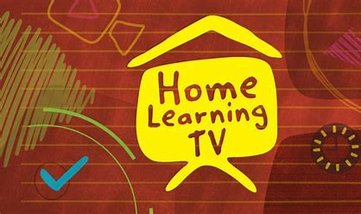

Day 8 activity 4: Kai moana maths
This activity learners will recognise that a pattern has consistency so that you make predictions from the pattern.
What do I need?
- 30 minutes
- https://nzmaths.co.nz/sites/default/files/KaiMoana.pdf

In this activity I am learning to: Use a graph to look for a pattern

Instructions
Every year, the whānau gather for Christmas. Hōhepa leads the fishing group because he has a dinghy. He has kept a record of how many fish he has caught over the last 10 years:
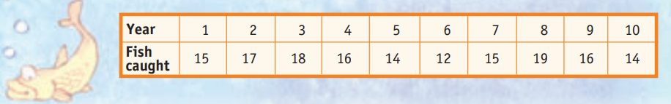
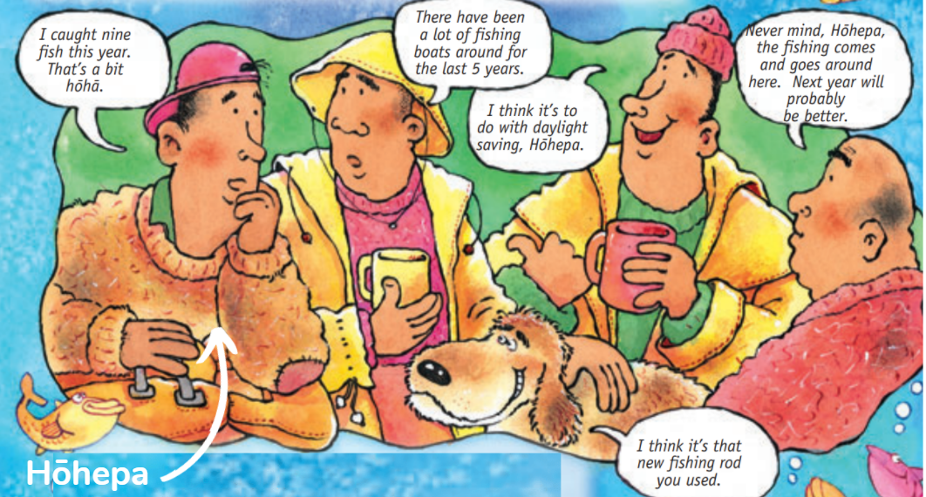
One night, the whānau talked about how few fish there have been this year.

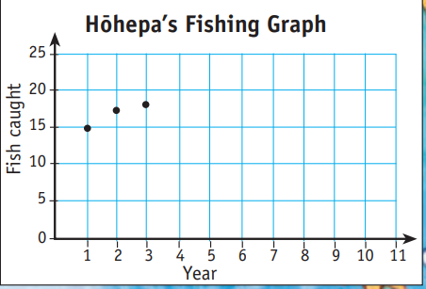
- Copy and complete the graph that shows the number of fish Hōhepa has caught over the last 10 years. Now add on his catch for this year.
- Compare the graph with each of the reasons the whānau have given above. Which person is most likely to be correct?
- How many fish do you think Hōhepa will catch in the next 3 years? Why? Add these 3 years to your graph.

Remember to do your end of day reflection activity (See p. 12).

Day 9: Let’s get started...
Don’t forget to start your day right (See p. 11)
Note that today our Inquiry focus is –” Going further, deeper”. This may include promoting opportunities to engage further and dive deeper through discussions, provocations, exploring further contexts, taking action, or thinking critically and drawing conclusions.

Today your learning will help delve deeper to make more connections by thinking critically about the changes and trends in diets across the world.
Remember to ADD 1 teaspoon of sugar to your potato bread “bug” and RECORD your observations onto your Potato Bread pages from Day 7

Day 9 activity 1: Numeracy
This activity requires access to the internet.
This activity is comparing and contrasting worldwide food consumption and answering questions using critical thinking and the resource given. The website has other interesting comparisons students could look at.
What do I need?
- 60 minutes
- Pen/pencil to answer questions and complete acitivty
- A device to access the website: What the World Eats | National Geographic

In this activity I am learning to: Compare and contrast and to Identify food trends

Visit https://media.nationalgeographic.org/assets/richmedia/0/226/project/index.html and explore the wheel charts about daily diets.
This is an interactive site.

Play the animation to see how the consumption of daily calories has changed through the years.
Take some time to explore the wheel charts about the daily diets of different countries.

Answer these questions comparing wheel charts in your notebook or digital doc:
- Which food groups have increased in their consumption between 1961 and 2011? Suggest some reasons for why.
- Which food groups have decreased in their consumption between 1961 and 2011? Suggest some reasons for why.
- Which food groups appear to have stayed the same in their consumption between 1961 and 2011? Suggest some reasons for why.
- What has happened to the amount of daily grams consumed for all food between 1961-2011? Suggest reasons why this is the case.
- Write a conclusion based on the overall changes in the world diet and consumption from 1961-2011.
- Hypothesize what trends in food consumption we might see today (2022)

Write a conclusion on the trends in food consumption from 1961-2011
Hypothesise what the trend might be in terms of food consumption in 2022 – 10 years later and write your hypothesis on what might be seen in terms of food consumption today (2022).
Draw a wheel chart that reflects this hypothesis.
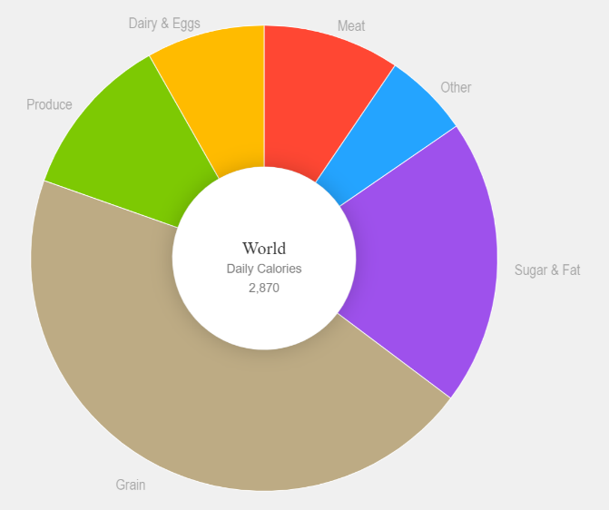

Day 9 activity 2: Literacy and Inquiry
This is a reading activity about dietary needs and trends. If food/eating is a sensitive topic for a student this may require some guidance and support when discussing diets.
What do I need?
- 60 minutes
- Paper and pens/felts
- Internet for research

In this activity I am learning to: Design a menu to suit dietary needs
You may be aware that more people are expressing their dietary needs and preferences. As people become more health conscious they identify that what they put into their bodies contributes to how they feel, their energy levels, and even their moods.
Some people suffer conditions such as severe allergies, lactose or gluten intolerance, irritable bowel syndrome, coeliac disease, and others, which mean they need to exclude some food items, or limit their intake. Other people have made a decision to reduce or limit certain foods as a preference, lifestyle choice, or ethical reason.
The most important thing is for you to consider your food choices mindfully – what do you need to sustain you and your whānau, to live a healthy and active life?

Instructions:
- Brainstorm what trends (or specific needs) you know of in food consumption or diets in your notebook.
- Consider if anyone in your whānau has particular dietary needs or preferences.
- Have a look online, or in cookbooks at your house, for how famous cooks design and present their healthy meals. Try to find examples from within New Zealand and in other parts of the world.
- Imagine you are writing your own healthy cookbook. What kinds of food would you include?
- Conceptualise a healthy meal plan for your whānau. It can be for a day, or for a week. You could even have a theme for the week – such as choosing food from different environments (land, sea, air, earth) or different cultures.
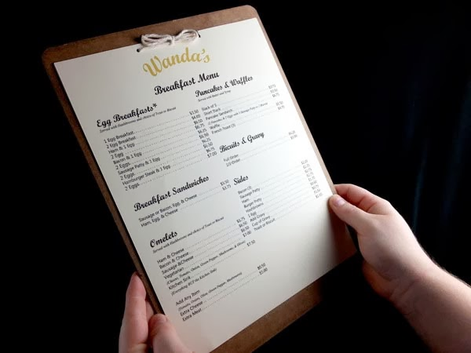
- Design a menu for your meal plan with a range of options for breakfast, lunch, and dinner (you could even add prices on your menu like a real restaurant).
- Present your menu to your whānau or share it with friends and see which of your meals would be the most popular if you were to open a restaurant.

Day 9 activity 3: Inquiry
A new innovation in food production is the use of insects! Students can explore this innovation and look at its benefits to health and the environment.
What do I need?
- 60 minutes
- Optional: Device to watch: ‘Why companies are mass producing edible insects’: https://www.youtube.com/watch?v=PvEj2GL_hDU
- Yummy bugs – text included below or access online here: https://www.sciencenewsforstudents.org/article/yummy-bugs

In this activity I am learning to: Describe an innovation in food technology (eating insects) and explain the health benefits and environmental benefits this innovation has.
Watch this clip on ‘Why companies are mass producing edible insects’ and/or
Read Yummy bugs | Science News for Students

Your task
Describe what entomophagy is in your notebook.
Complete a PMI (positives, minuses, and interesting points) of edible insects
Plus | Minus | Interesting
Use your PMI table to write an explanation about the health and environmental benefits of edible insects (try to use evidence and data from the two sources above) in your notebook or digital doc.

Yummy bugs
Adapted from https://www.sciencenewsforstudents.org/article/yummy-bugs
Eating insects is a common practice in most places, at least outside of New Zealand.

Why not eat bugs?
Most people are happy to eat crab, lobster, and shrimp as food items. Yet crustaceans are “the ocean equivalent of insects,” says David Gracer. In fact, crustaceans belong to the same part of the animal family tree as insects do. Gracer also argues that insects can be “a better choice” than most meats — at least ecologically.
It takes a lot of natural resources — land, water, feed, and energy — to create a kilogram of beef or chicken. Those resources are not only costly but can also be damaged or polluted by livestock operations. By contrast, insects can be grown on low-quality plants — even weeds, sometimes — and often using little water.
The environmental resources associated with bringing every kilogram of insect protein to market, therefore, are far fewer than for an equivalent amount of regular meat.

Good for the body
The muscle tissue in livestock is what we think of as meat. It’s made primarily of protein. By eating protein, we give our bodies a nutrient needed to build structural materials, including muscle. Insects are tiny animals. And studies have shown their protein typically has higher quantities of minerals and vitamins than occur in many conventional meats that people eat.
Many cultures have eaten insects for thousands of years. Although many people in wealthy Asian nations, like Japan, will snack on certain bugs, most insect dining takes place in poorer countries. Insects are popular, for instance, throughout India, much of Asia and Africa, and in South America’s rural populations.
In Mexico, however, insect dining is common. As a result, insects can be purchased from street stalls or at expensive five-star restaurants. Altogether some 1,700 different species of insects are eaten in Mexico.

Mini livestock
Until recently, most people interested in insects have collected their own. Kids in central Africa may nibble on ants or grubs while out playing. Aborigines in Australia’s outback may picnic on honey ants. And some families in Ecuador wait for the spring rainy season to collect scarab beetles. That’s when the adult insects crawl out of the soil. People then fry the beetles with some spices or add them to flavour rice. Mopane worms are eaten throughout central and southern Africa. These are not true worms, but caterpillars of a moth that lays its eggs on mopane trees. The number of people who want to eat this bug is so large that biologists have begun worrying these insects might be harvested to extinction.
Scientists in Thailand have found one solution to overhunting wild bugs: They’ve begun farming insects. Crickets are the one they raise most. In less than 10 years, nearly 20,000 Thai families have taken up cricket farming. A “farm” may consist of just a few cement cylinders, topped with window-screening material. Together, 400 families can produce up to 10 tons of crickets per month in the summer. That’s the peak season. And it’s profitable. Each family can earn $100 to $1,500 per month. Each crop of bugs will eventually be shipped to food markets in big cities throughout Southeast Asia.

Bug free bugs
Still not convinced that insects are a food for you? Well, scientists in the Netherlands are growing cells from different types of insects, including silkworms and gypsy moths, in large vats of liquid. It’s a type of biotechnology operation that produces isolated cells, but no actual bugs. The goal is to produce a clean source of bug proteins that can be dried and added to breads or perhaps moulded into pseudo-burgers. So, would you consider eating muffins fortified with cricket cells? What if the muffin wrapper merely said the baked goods contained animal protein?

Day 9 activity 4: Inquiry, visual language
Another task which looks at presenting information to an audience by way of a flyer/poster. It can be done digitally or by hand. Aimed to persuade teenagers of a similar age to incorporate edible insects into their diet.
What do I need?
- 30 minutes
- Poster paper or device for making poster
- Coloured pens, pencils, crayons etc

In this activity I am learning to: Design an informative flyer/poster that could advertise the benefits of ‘edible insects’
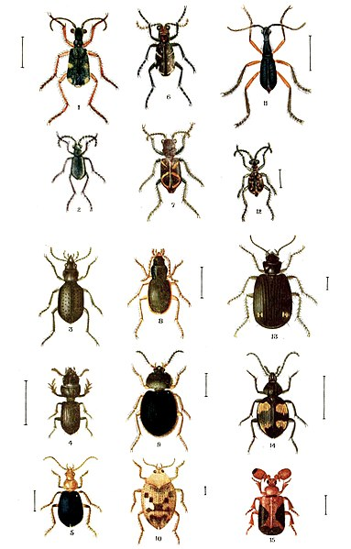

Instructions:
Construct an informative poster/flyer on the benefits of eating insects
Producing an informative flyer/poster that could advertise the beneftis of ‘edible insects’ is a persuasive writing and visual language task that will reflect the depth of your learning and ability to promote an idea.
Your advertisement should be:
- aimed at convincing teenagers why insects could be part of their diet
- provide scientific information (data and evidence) to persuade
- use Pictures and colour if possible

Remember to do your end of day reflection activity (See p. 12).

Day 10: Let’s get started
Don’t forget to start your day right (See p. 11)
Today our Inquiry focus is – "Present- share learning about the big idea" which includes thinking about who the audience is and considering different ways of communicating learning e.g., presentation, video, poster, etc.

Today your learning will be about creating or recreating a meal that considers a particular dietary requirement.
Remember to ADD 1 teaspoon of sugar to your potato bread “bug” and RECORD your observations onto your Potato Bread pages from Day 7

Day 10 activity 1&2: Food technology & science
This is where students will use the bug they have been fermenting to bake the potato bread. It requires the use of the oven and so can be done at a time of day which suits the household.
What do I need?
- 90 minutes
- Ingredients: flour, water, salt, sugar, and your ‘bug’
- Kitchen space, bowls, utensils, oven

In this activity I am learning to: Make and bake potato bread

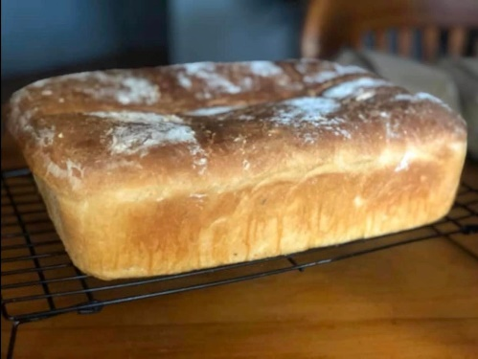
Making Rēwana | potato bread
Use your ”bug" and follow the recipe:

Ingredients
- 4 Tablespoons sugar
- 5 cups flour
- 1 teaspoon of salt
- Half a litre of ‘potato bug’
- Mix sugar, flour, salt into a large bowl. Make a well in the middle of the bowl.
- Pour in half a litre (500mL) of ‘the bug’. Mix up the dough using a spoon. The dough should be sticky.
- Put some flour on a table and knead your dough for no longer than 10 minutes. You may need to put a little water in the mix, so it stays sticky.
- Make a cake using all your dough. Cut the cake into quarters and roll into balls.
- Put the quarters into a big clean bowl. Cover with a damp tea towel and leave the pieces to rise in a warm place for the next few hours.
- Knead the pieces again for a short time.
- Put into a baking tin and bake in the oven at 200 degrees Celsius for 45-50 minutes.
- Test that the bread is cooked by poking in a skewer. Enjoy!

Day 10 activity 3-4: Inquiry
This activity should take the remainder of the day. It ia a summary of the learning completed. It would be great if this could be presented to whānau, fellow classmates and the teacher..
What do I need?
- 90-120 minutes
- Device for research and creation of presentation
- OR Poster paper, coloured paper, felts, coloured pencils, crayons etc.

In this activity you are learning to: Prepare and create a presentation that combines all my knowledge from the week, and research and present to my whānau or back at class

Instructions:
Choose one of the below areas of the world
- Middle East
- South Pacific
- Eastern Europe
- South East Asia
- Asia
- Africa
- Central, South or North America
- Mediterranean

Create a poster, powerpoint, pamphlet, booklet etc which gives an overview of how the people of that region express their cultures, religion and traditions through food, language, costume, dance etc. Be creative and ensure that you incorporate your knowledge from week one for language and culture and this week for food
Consider the following
- Traditional dance and dress what/when/where do they dance and dress
- Are their particular ceremonies, festivals, times of year when they dress up in traditional costumes/clothing....as with dancing?
- Language – what langauge is spoken, is there traditional v modern language spoken? What are some common sayings/collaquilisms for those people?
Particularly for food include the following
- Traditional and/or modern cultivation methods
- How weather i the region effects certain crops used for food
- Lifestyle influences
- Cultural influences
Try and include, pictures/drawings/ colours/quotes etc where you can. Present your research to your whānau or back at class (online if able to or when in class)
Congratulations on an amazing job!
If you have time left why not celebrate a successful week of learning by having a good old sing-along or boogie it out to your favourite song!
Remember to do your end of day reflection activity (See p.12 ).

