A learning from home pack

For learners in years 1–3 (Week 1 Draft)

Curiosity | Māhirahira

Context 1: What if ...?

Context 2: How does ... work?

Layout of the resource
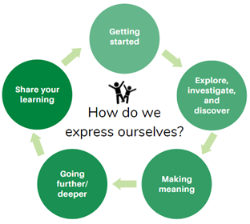
This pack is filled with learning activities for your learners that can be used at school or at home. All activities are framed around the theme of curiosity | māhirahira.
Suggestions are provided for starting the day with a karakia (see p. 7), check in with the teacher, and setting up the learning environment. You can replace these with how you want your learner to start their day.
The activities follow an inquiry learning model (figure 1) exploring one theme through two contexts. Each day the learner will be working through one part of the model culminating with sharing their learning on days 5 and 10.
Figure 1 Inquiry learning model

Realities
You know your learners and have a good understanding of their learning situations.
Many learners will have siblings at home, as well as whānau who share the same space and materials. Some may have access to the internet and devices, and others may not. Learners will also have varying levels of adult support.
There are a mix of activities in this pack that use materials commonly found in most homes. Some activities will require adult support while others can be managed independently. This resource is provided as a Word document so that you can adapt it for your learners.
We suggest starting each day with a karakia (see p. 7), check in with the teacher, followed by setting up the learning environment. The pack contains suggestions, but you can replace these with however you want your learner to start their day.

Resources
The pack uses a range of books from the Ready to Read series. You might want to send these home with the learner, along with a “my home learning” exercise book, pencils, crayons, or felts, and some craft materials (glue, scissors, construction paper). Learners can bring their notebook back to class to share.
If your learners do not have reliable access to the internet, create a paper-based pack and print off the below resources to send home with the pack.

Resources to print
- https://nzmaths.co.nz/sites/default/files/ProblemPikelets.pdf
- https://nzmaths.co.nz/sites/default/files/HowManyStrips_0.pdf

Resources to send home
- Ready to Read Bread by Bernadette Wilson https://instructionalseries.tki.org.nz/Instructional-Series/Ready-to-Read-Colour-Wheel/Bread
- Ready to Read The Little Red Hen retold by Kylie Parry https://instructionalseries.tki.org.nz/Instructional-Series/Ready-to-Read-Colour-Wheel/The-Little-Red-Hen
- Ready to Read The Queen of Spain by Alan Bagnall https://instructionalseries.tki.org.nz/Instructional-Series/Ready-to-Read-Colour-Wheel/The-Queen-of-Spain
- Ready to Read Will they float? by Feana Tu’akoi https://instructionalseries.tki.org.nz/Instructional-Series/Ready-to-Read-Colour-Wheel/Will-They-Float
- Ready to Read Weka’s Boat by Samantha Montgomerie https://instructionalseries.tki.org.nz/Instructional-Series/Ready-to-Read-Phonics-Plus/Weka-s-Boat
- A4 paper

Setting up the learning environment
You might like to encourage whānau to support learners to set up a space for learning at home. This will help create structure for the learners, and they could even design their own space as a separate learning activity. Many of the suggested activities and experiences have the option to include online resources which can be accessed and viewed using a Smartphone if learners do not have access to a computer or tablet.

Overview of the learning in this pack
The theme of curiosity | māhirahira will be explored through two contexts.
- Days 1–5 look at this idea through the context of what if…?
- Days 6–10 look at this idea through the context of how does … work?
Learners will explore, investigate, discover, and make meaning as they go through each task. There are times where they look a little deeper into the topic. Some of the tasks may be independent hands-on tasks while some may involve connecting and sharing with others.
Day 1 | Day 2 | Day 3 | Day 4 | Day 5
Sparking my curiosity with Goldilocks and the three bears – reading, writing and maths. | Exploring bread through reading, maths, and science. | Making meaning through investigating more about bread and following a process. | Going further with The Little Red Hen, planning a recipe and considering tikanga around food. | Sharing my learning by publishing my recipe and applying my new learning in maths.
Day 6 | Day 7 | Day 8 | Day 9 | Day 10
Week 2 activities to be added soon

Daily timetable
Below is a possible daily timetable. We have allocated 30 minutes for each activity; your learner may take more or less time than this for an activity. We suggest your learner takes the time they need to complete an activity. This may mean they choose which activities they will complete for the day, rather than complete them all.
At the start of each day the learner will draw up their timetable for learning. You can adjust the timing to suit the other activities that might be happening throughout the day, such as Zooming with the class/teacher.
Time | Activity
9:00 am | Starting the day
9:30 am | Activity 1
10:00 am | Break
10:30 am | Activity 2
11:00 am | Fitness break
11:30 am | Activity 3
12:00 pm | Lunch time
1:00 pm | Activity 4
1:30 pm | Reflection time
2:00 pm | End of the school day

Daily fitness – Choose something each day
It is important to include a fitness activity, at the learner’s ability level, every day. Please ensure that your learner includes this in their daily timetable. If possible, it would be great to do the fitness activity with your learner or have them complete it with their siblings where appropriate. Remind your learner to exercise safely!
Below are some activities to choose from, adapt, or you can make up your own ideas!
Alphabet exercise
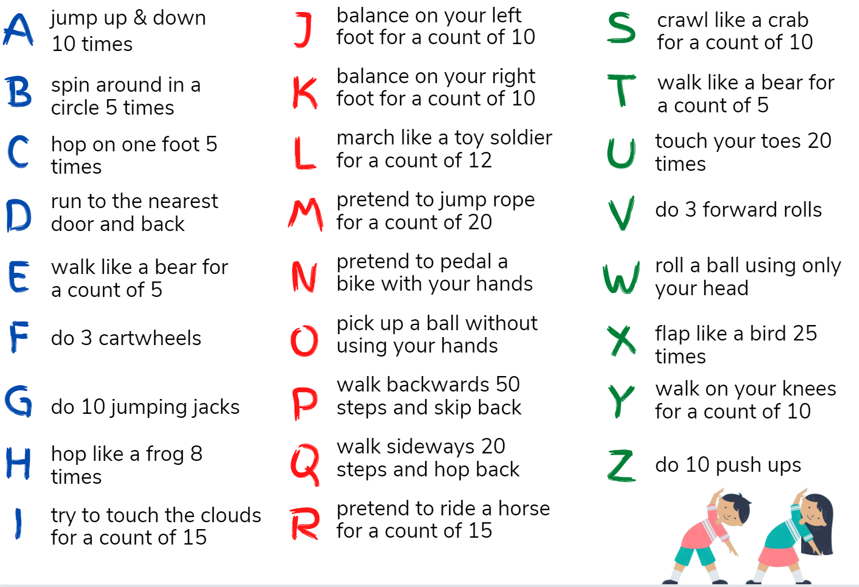
You’ve got rhythm
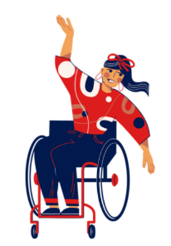
Listen to various types of music with different rhythms. See if you can find out what your favourite type of music is. See if you can feel the rhythm through vibrations. Think of different ways you can move to the rhythm with different parts of your body.
Are you able to make up a dance with another body part?
Are you able to make up a dance sitting down?
Are you able to make up a dance with your face and head?
How else could you dance?
Video exercises
Red light, green light dance party https://www.youtube.com/watch?v=2tRCBPk4NMQ
Goldilocks and the three bears yoga https://www.youtube.com/watch?v=bxd71qzw0UM

Daily wellbeing – Choose something each day
These activities are good to do at the beginning and end of the day, but they can be done anytime. They can help you get ready for learning; calm your mind and body, and they can help you to reflect on your learning:
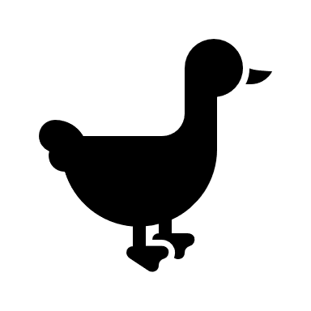
Relaxation stretches
Little goose – lay on your back with your feet up on the wall and legs straight. Spread your arms apart flat on the floor
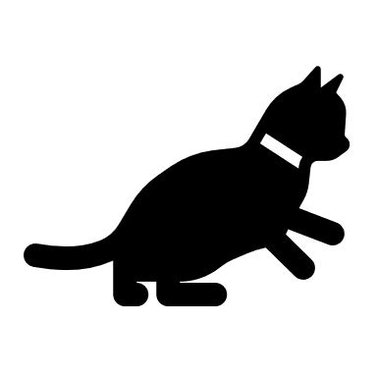
Little cat – Snuggle in tight! Sit cross legged on the floor. Bend forward at the hips and place your forehead on the floor.
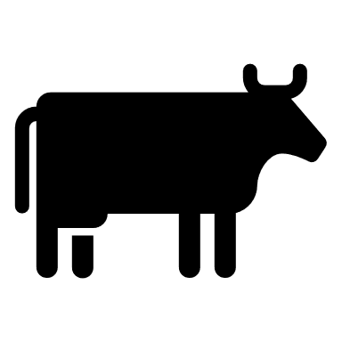
Little cow – Standing up, clasp your hands together behind your back and bend forward at your hips.
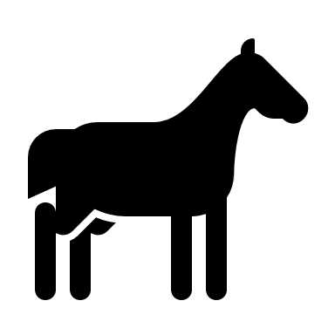
Little foal – Lay on your back. Pull your knees in and hold them tight. Whisper something about your day.
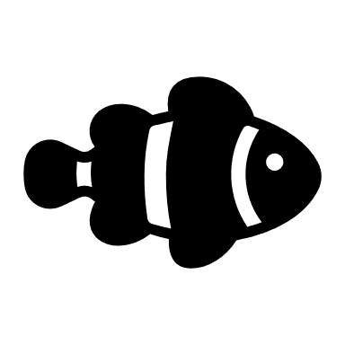
Little fish – Sit comfortably. Take a deep breath. Puff up your cheeks and hold your breath. Slowly let it out.
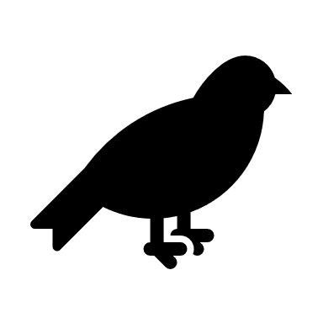
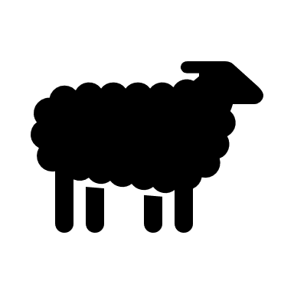
Little sheep – Stand near a wall. Place both hands on the wall at your shoulder height. Bend your elbows slightly and push in and out against the wall.
Little bird – Sit comfortably. Close your eyes and take deep breaths. Breathe in through your nose and out through your mouth.
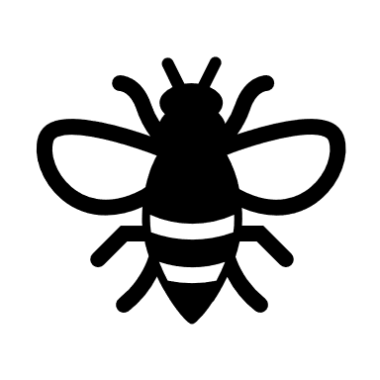
Little bee – Stand with your feet slightly apart. Bend forward at your hips. Swing your arms in a figure 8 motion.
Little snake – Lie on your back with your legs straight and cross at the ankles. Raise your arms over your head and cross them at the risks. Stretch out long.
Little pup – Stand with your feet slightly apart. Bend forward at the hips and place your hands on the ground.
Little deer – Sit on the floor with your feet spread far apart. Bend forward at the hips and touch one fort and then the other.
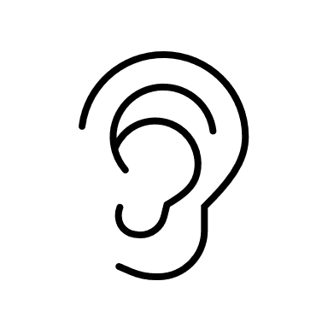
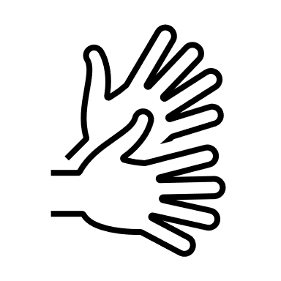
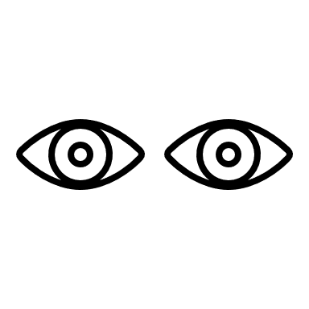
5–4–3–2–1 Mindfulness
Look for:
- 5 things you can see
- 4 things you can touch
- 3 things you can hear
- 2 things you can smell
- 1 thing you can taste
Video resources
Triangle breathing https://www.youtube.com/watch?v=u9Q8D6n-3qw
Cosmic kids “Peace Out” https://www.youtube.com/watch?v=a1dgkivX9-A

Starting each day
Notes for teachers and whānau:
Starting the same way each day helps create a structure for your learner. Your school might have your own way to do this, for example starting the day together as a class on Zoom. In this pack we provide a karakia to settle into the day. Saying the karakia with your learner a few times will help them be able to do this more independently tomorrow and beyond. As part of the start of the day and setting up the learning environment, help your learner look through the activities suggested for that day and choose a fitness and wellbeing activity. They could fill out their daily timetable and think of other activities they might like to do, such as reading.
Remind your learner of when and how to check in with the teacher/you.

Karakia
Here is a karakia to welcome in the day
https://www.otago.ac.nz/cs/groups/public/@maori/documents/webcontent/otago667429.mp3
Whakataka te hau ki te uru  Whakataka te hau ki te tonga  Kia mākinakina ki uta  Kia mātaratara ki tai  E hī ake ana te atakura  He tio, he huka, he hau hū  Tīhei mauri ora! | Cease the winds from the west  Cease the winds from the south  Let the breeze blow over the land  Let the breeze blow over the ocean  Let the red-tipped dawn come with a sharpened air.  A touch of frost, a promise of a glorious day.

Planning my day
- Have you chosen which activities you will do today and when?
- Have you chosen a fitness activity (see p. 5)?
- Have you chosen a wellbeing activity (see p. 6)?
- Have you done a ‘Wellbeing check-in'?
  - How are you feeling today?
  - How do you feel about your readiness to learn this morning?
  - What do you need extra help with today? Who could you get to help you? What strategies could you use to make your learning more effective?
  - What would you like to do as a quiet time activity to end your day?
- Remember to do your Reflection at the end of the day (see p. 8).

Ending each day
Please ensure your learner does this at the end of each day.
Reflection can be challenging for all learners, but it can also provide them with rich opportunities to think about how their learning is progressing. Use the questions below as prompts to encourage your learner to think about what they have learned so far and help them to plan out their next steps. If you have concerns with their learning, or find that your learner is needing more help, contact their teacher for more support.

In this activity I am learning to: Reflect on my learning.
What do I need?
- A notebook or online doc that you can use each day for your reflection activity. We will call this your “reflective journal”
- Materials for your quiet time activity

Take some time to think about how you are feeling after today’s learning activities.
Reflect on the following prompts in your reflective journal.
- What did you enjoy most about today?
- What is one thing you feel you learnt today?
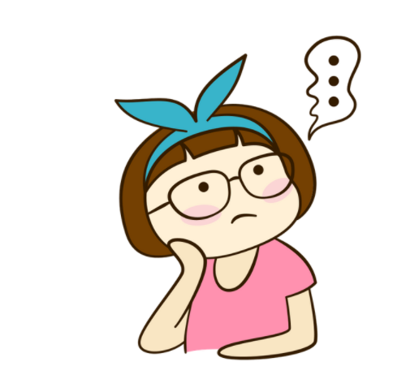
- What is one strategy that helped you with your learning?
- What did you find challenging or distracting? (You ran out of time for some activities, or you finished them quite quickly and wanted to dig in a little deeper.)
- Is there anything you need extra help with? Who can you ask to help you with that?
- Is there anything you want to catch up on tomorrow?

Remember to finish with a wellbeing activity and/or your chosen quiet time activity.

Context 1: What if...?

The next five days indulge our curiosity by asking ourselves the question what if...?

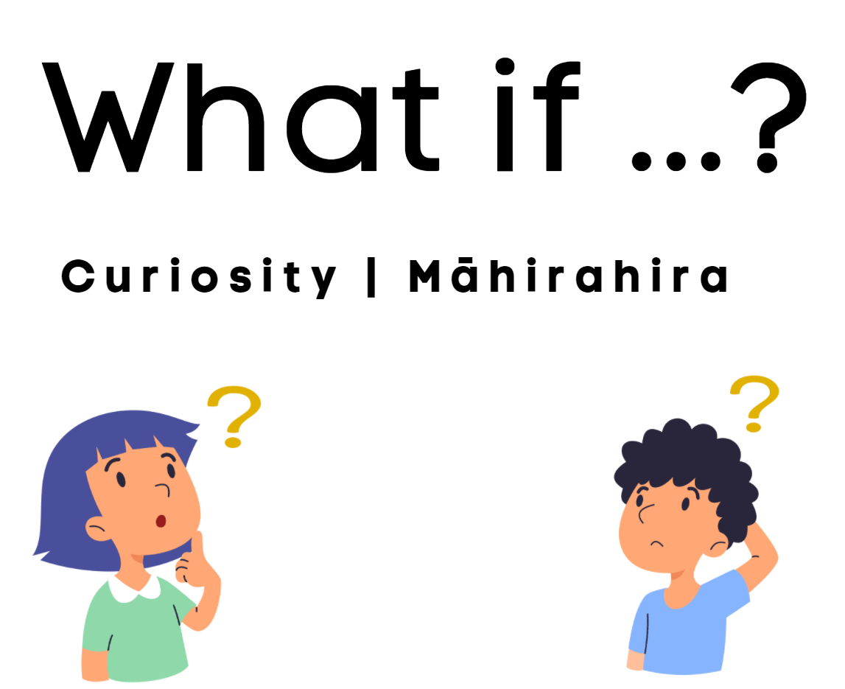

Day 1 activity 1: Inquiry getting started
Notes for teachers and whānau
Activity 1 requires learners to consider examples of curiosity in the story Goldilocks and the three bears and then make connections to themselves by sharing examples of when they have been curious about something. Younger learners may need someone to read the story to them if they don’t have internet access and may need support from a whānau member to record their ideas in their home learning book.
Note that our Inquiry focus for today is – “getting started” which includes generating questions, activating prior knowledge, and introducing the theme.

In this activity I am learning to: identify examples of curiosity.
What do I need?
- 30 minutes
- Copy of Goldilocks and the three bears (or follow the youtube link here: https://www.youtube.com/watch?v=bxy2hCYX3SE
- Home learning book

Instructions:
You will listen to/read the story of Goldilocks and the three bears on the next page. In this story we see examples of curiosity. Goldilocks was curious about who lived in the house and the bears were curious about who was in their house. Being curious helps us to learn more about the world around us. What are some things you have been curious about before?

Your task:
Listen to or read the story of Goldilocks and the three bears.
In your home learning book write a list or draw pictures or talk to somebody in your whānau about things you are curious about. Some examples might be:
- Why does detergent turn into bubbles when it is added to water?
- What makes a car move?
- Do carrots really help me see in the dark?
- Who invented the cell phone?

Transcript of YouTube video https://www.youtube.com/watch?v=bxy2hCYX3SE
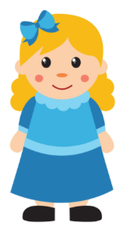
Goldilocks and the three bears
Once upon a time, there was a little girl named Goldilocks. She went for a walk in the forest. Pretty soon, she came upon a house. She knocked and, when no one answered, she walked right in.
At the table in the kitchen, there were three bowls of porridge. Goldilocks was hungry. She tasted the porridge from the first bowl.
"This porridge is too hot!" she exclaimed. So, she tasted the porridge from the second bowl. "This porridge is too cold," she said. So, she tasted the last bowl of porridge. "Ahhh, this porridge is just right," she said happily, and she ate it all up.
After she'd eaten the three bears' breakfasts, she decided she was feeling a little tired. So, she walked into the living room where she saw three chairs. Goldilocks sat in the first chair to rest. "This chair is too big!" she exclaimed. So she sat in the second chair. "This chair is too big, too!" she whined. So she tried the last and smallest chair. "Ahhh, this chair is just right," she sighed. But just as she settled down into the chair to rest, it broke into pieces.
Goldilocks was very tired by this time; she went upstairs to the bedroom. She lay down in the first bed, but it was too hard. Then she lay in the second bed, but it was too soft. Then she lay in the third bed, and it was just right. Goldilocks fell asleep.
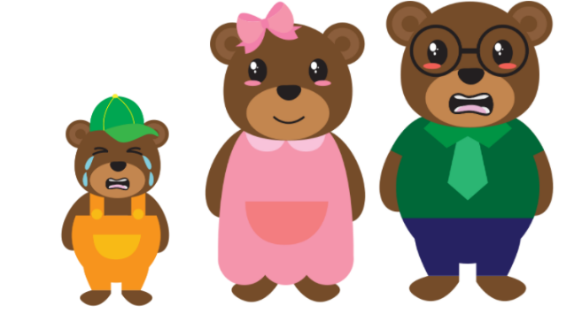
As she was sleeping, the three bears came home. "Someone's been eating my porridge," growled Papa bear. "Someone's been eating my porridge," said Mama bear. "Someone's been eating my porridge and they ate it all up!" cried Baby bear.
"Someone's been sitting in my chair," growled Papa bear. "Someone's been sitting in my chair," said Mama bear. "Someone's been sitting in my chair, and they've broken it to pieces," cried Baby bear.
They decided to look around some more and when they got upstairs to the bedroom, Papa bear growled. "Someone's been sleeping in my bed.” "Someone's been sleeping in my bed too" said Mama bear. "Someone's been sleeping in my bed and she's still there!" exclaimed Baby bear.
Just then, Goldilocks woke up. She saw the three bears. She screamed, "Help!" and she jumped up and ran out of the room. Goldilocks ran down the stairs, opened the door, and ran away into the forest. She never returned to the home of the three bears.
The End

Day 1 activity 2: Writing
Notes for teachers and whānau
Learners retell the story of Goldilocks and the three bears but add a twist and consider how this might change the story. Younger learners may need support from a whānau member to record their story in their home learning book.

In this activity I am learning to: retell a story while changing one part of it.
What do I need?
- 30 minutes
- Home learning book

Instructions:
What if the three bears had eaten toast instead of porridge?
Today you are going to use your curiosity and rewrite the story of the three bears, imagining what might happen if they were eating toast instead of porridge. Think about:
- What kind of toast would each bear have had?
- What might they have put on each piece of toast?
- Whose toast would Goldilocks have eaten and why?
Have a look at the kupu Māori (Māori words) list in the table below and see how many of the words you can use to replace the English ones in your new story.

Your task:
Think about Goldilocks and the three bears. What are the main parts of the story?
Retell the story of Goldilocks and the three bears in your own words but change part of the story so that the bears were eating toast instead of porridge.
Depending on your writing confidence you could do one of the following:
- Write your retell into your home learning book. Remember to:
- Start your retell with “Once upon a time”
- Write in the past tense
- Summarise the story by retelling the key events that take place
- Include information about the setting, characters, problem, and resolution.
- Draw pictures that retell the story and write a short sentence under each picture.
- Speak your story to a whānau member.
Remember to include some kupu Māori in your story too.
Tūru — chair  Moenga — bed | Hīkoi — walk  Toru — three  Tōhi — toast | Pereti — plate  Ngenge — tired  Wera — hot | Makariri — cold  Oma — run  Māmā — mother | Pāpā — father  Pēpē — baby  Pea — bear

Day 1 activity 3: Mathematics
Notes for teachers and whānau
Learners will compare the volumes of different containers by pouring from one to another. By using this direct comparison they will order containers from those that hold the least to those that hold the most. Task adapted from https://nzmaths.co.nz/resource/three-bears.

In this activity I am learning to: compare and order the volume of containers.
What do I need?
- 30 minutes
- Home learning book
- Three bowls and three cups of different sizes
- Water
- A type of cereal (or something to represent cereal) that can be poured

Instructions:
Today you are looking at different sized bowls and cups and deciding which would be most suitable for Father bear, Mother bear, and Baby bear. Father bear has the biggest bowl, Mother bear has the middle-sized bowl, and Baby bear has the smallest bowl.
You are going to think about how to use measurement to prove which bowl or cup is the biggest, medium sized, and smallest.

Your task:
Find 3 different sized bowls and fill each one with cereal. Pour the cereal carefully so that none is wasted so you can put it back into its bag or container later.
- Which bowl would belong to Father bear?
- Which bowl do you think has the most cereal in it?
- What makes you think that?
- How could you find out which bowl holds the most cereal?
Record the answers to these questions in your home learning book. Some younger learners may need to discuss their answers with someone instead and to record their answers if they are unable to.
Find 3 different sized cups and fill them with water (you may want to do this part of the activity outside so that you don’t spill water all over the floor).
Put the cups in order from the largest to the smallest for Father, Mother, and Baby bear.
- Which cup do you think has the most water in it?
- Why do you think that one?
- How could you check?
Record the answers to these questions in your home learning book.
- Is there another way you could prove which cup holds the most water?

Day 1 activity 4: The Arts/Drama
Notes for teachers and whānau
Learners act out the story of Goldilocks and the three bears by using toys and other household objects. Learners might choose to use the retell that they completed earlier in the day. Encourage them to use an expressive voice to engage their audience.

In this activity I am learning to: act out a story using an expressive voice to engage an audience.
What do I need?
- 30 minutes
- Toys

Instructions:
Using your toys and other household objects, see if you can act out the story of Goldilocks and the three bears.
Before you act out the story think about the following:
- What toys can I use to be Goldilocks and each of the bears?
- What other objects will I need? (e.g. bowls, spoons, cushions, pillows, etc)
- How can I change my voice, so people know which character is which?
- Who might have a deep sounding voice?
- Who might have a soft voice?
- Who might have a high-pitched sounding voice?
- What order will I tell the story in?

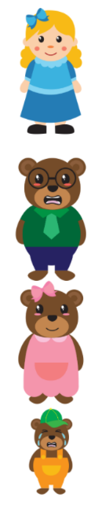
Your task:
Think about the story of Goldilocks and the three bears or your retell from the earlier activity.
Choose some toys to be each of the characters and other things around your house to represent the objects in the story.
Think about what sort of voice each character would have and practice these.
Think about how the characters might move around and practice this.
Practice telling the story in the right order.
After you have had some time to practice, show your performance to a member of your whānau or to your teacher. Or you could record your performance on a phone, iPad, or other digital device and share it with whānau or your teacher at another time.
Remember to do your end of day reflection and wellbeing activities (see p. 6 & 8).

Day 2 activity 1: Reading
Notes for teachers and whānau
Learners are introduced to the text Bread by Bernadette Wilson. Once they have read or listened to the story, they can make meaning by generating their own questions about the book and by exploring unknown or interesting vocabulary.
Note that our Inquiry focus for today is – “explore, investigate, and discover” which includes choosing and evaluating information, and thinking critically.

In this activity I am learning to: use questions and vocabulary to help me understand what I am reading.
What do I need?
- 30 minutes
- Home learning book
- Look for the book Bread in your pack or access the PDF and audio online https://instructionalseries.tki.org.nz/Instructional-Serieshttps://instructionalseries.tki.org.nz/Instructional-Series/Ready-to-Read-Colour-Wheel/Bread

Remember to start your day right (see p. 7).

Instructions:
Today you are going to listen to or read the book Bread. Once you have finished the book, use your curiosity to think of any questions you have and find the meaning of words that are new to you, or that you find interesting.

Your task:
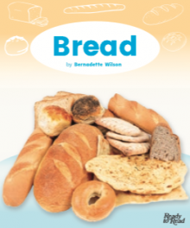
Read or listen to Bread by Bernadette Wilson.
Think of 3–5 questions you have after reading this text.
Write them in your home learning book (younger learners might tell a whānau member their questions and get that person to write the questions for them).
Find 3–5 words in the text that you don’t know the meaning of, or that you think are interesting words. Use a dictionary, internet, or whānau member to find out what each of these words mean.
Write each word and its meaning in your home learning book.

Day 2 activity 2: Writing
Notes for teachers and whānau
Learners take their learning further by researching bread recipes. This lets them familiarise themselves with vocabulary from the book and identify key ingredients used when baking bread. They will engage in procedural writing by writing out a chosen recipe, taking note of how it is set out and the language used.

In this activity I am learning to: identify the key features of a recipe.
What do I need?
- 30 minutes
- Home learning book
- 2–3 different bread recipes

Instructions:
Now that you have read the book Bread you are going to search out other bread recipes and choose your favourite one to record in your home learning book. Use cookbooks, the internet, or knowledge from a whānau member to look for bread recipes, or you could use the examples below.

Your task:
- Search for and read 2–3 different bread recipes.
- Choose your favourite recipe.
- Copy it into your home learning book.
Answer the following questions:
- What do you write first in a recipe?
- How are the ingredients written up? (Sentences, list, amounts at the start, etc.)
Discuss with a member of your whānau:
- What is a method?
- How are the instructions set out?
- What do you notice about the first word of each instruction?

Basic Bread
Source: https://www.tasteofhome.com/recipes/basic-homemade-bread/
Ingredients
- 1 package (¼ ounce) active dry yeast
- 3 tablespoons sugar plus ½ teaspoon sugar
- 2 ¼ cups warm water
- 1 tablespoon salt
- 6 cups flour
- 2 tablespoons canola oil

Method
- Dissolve yeast and ½ teaspoon sugar in warm water in a large bowl and leave it to stand until bubbles form on surface.
- Whisk together remaining 3 tablespoons sugar, salt and 3 cups flour.
- Stir oil into yeast mixture; pour into flour mixture and beat until smooth. Stir in enough remaining flour, ½ cup at a time, to form a soft dough.
- Turn dough onto a floured surface and knead until smooth and elastic (about 8–10 minutes).
- Place in a greased bowl, cover and let rise in a warm place until it has doubled in size (about 1 ½ to 2 hours).
- Punch dough down. Turn onto a lightly floured surface; divide dough in half. Shape each into a loaf. Place in 2 greased 23 by 13 centimetre loaf pans. Cover and let rise until doubled, 1 to 1 ½ hours.
- Bake at 190°c until golden brown and bread sounds hollow when tapped (about 30–35 minutes). Place on wire racks to cool.
Best Banana Bread
Source: https://thesaltymarshmallow.com/best-banana-bread-recipe/
Ingredients
- ½ cup butter
- 3 large ripe bananas
- 2 large eggs
- 1 teaspoon vanilla extract
- 2 cups flour
- 1 cup sugar
- 1 teaspoon baking soda
- ½ teaspoon salt
- ½ teaspoon cinnamon
Method
- Preheat oven to 175°c. Grease a bread pan with non-stick cooking spray or butter and put aside.
- Melt butter in a large bowl in the microwave.
- Add bananas to the same bowl and mash with a fork.
- Add vanilla extract and egg to the bowl and use the same fork to mash and stir until everything is well mixed.
- In a second large bowl whisk together flour, sugar, baking soda, salt, and cinnamon.
- Add the dry ingredients to the wet ingredients and mix together with a wooden spoon until just until combined.
- Pour mixture into the greased bread pan and bake for 45–55 minutes or until a skewer inserted into the bread comes out clean.

Rēwena Bread
Source: https://totspantry.co.nz/blogs/recipe/rewena-maori-bread-recipe

There are two parts to this recipe. The first part is the ‘bug’ which helps the bread to rise without adding yeast and is made a few days before you make the bread. The second part is the bread dough which makes the bread.

Part one

Bug

Ingredients:
- 1 tsp sugar
- 1 cup water
- 2 cups flour
- 1 medium potato (diced)

Method:
- Boil potato in the 1 cup of water until soft, then leave to cool.
- Mash potato and water together once it is lukewarm and mix in the flour and sugar.
- Add more water if needed to make a batter.
- Cover batter and leave to rise for 1 day in a warm place (the batter will smell like yeast and have small bubbles on the surface).

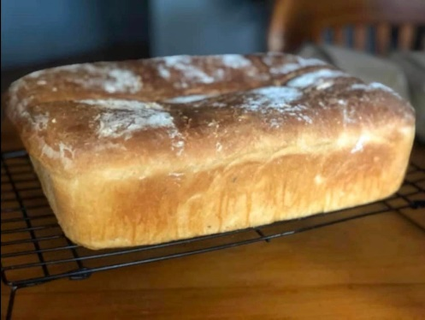
Part two

Bread

Ingredients:
- 5 cups flour
- 1 tbsp salt
- 1 tbsp baking powder
- 1–2 tsp sugar
- 1 cup rēwena bug

Method:
- Mix flour and salt in a large bowl and make a well in the centre.
- Place rēwena bug in well and sprinkle over baking soda.
- Mix together gently then knead lightly for 10–15 minutes adding more water if mixture seems too firm.
- Shape into a ball and leave in a warm place to rise (a few hours or overnight).
- Sprinkle flour over a baking tray and brush bread lightly with oil.
- Bake at 200°c for about 40 minutes or until a skewer inserted into the centre of the bread comes out clean.

Day 2 activity 3: Mathematics
Notes for teachers and whānau
Learners practice estimation and compare the capacity of objects using different dimensions. To complete this task, they will need two cups or glasses that have different dimensions but similar capacity. There is a reading component to this activity so younger learners may need support from a whānau member.

In this activity I am learning to: order and compare objects by volume and capacity.
What do I need?
- 30 minutes
- Home learning book
- 2 cups or glasses that are different shapes but similar in capacity

Instructions:
You are going to compare how much water different glasses can hold and using estimation, predict which glass holds more, then you will test that prediction. Look for 2 different sized glasses – perhaps one that is tall and skinny and one that is short and fat. You may want to do this activity outside so that you don’t spill water on the floor.

Your task:
Choose 2 glasses (one tall and skinny and the other short and fat if possible.)
Fill the glasses with water.
Which of these 2 glasses would you choose if you wanted the one that holds the most liquid?
Answer these questions in your home learning book as you work through them.
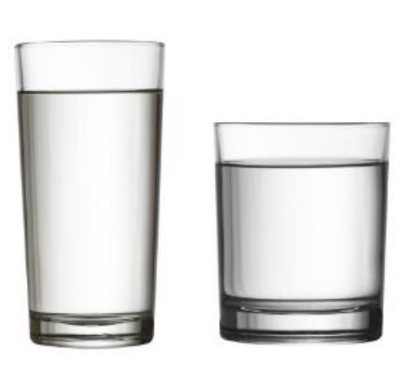
- Which glass do you think can hold more? Or do you think they can hold the same amount? Give a reason for your answer.
- Try your idea out. Fill one of the glasses with water.
- Now carefully tip the water from one glass to the other. What did you notice?
- Which glass can hold more? Or do they both contain the same amount.
- Give reasons for your answer.
Check back – were your predictions at the start of the lesson correct?

Day 2 activity 4: Science
Notes for teachers and whānau
Learners follow instructions to create a bread “bug” and use the scientific skill of observation so that they can record what changes happen over a period of time. This experiment requires some cooking so younger learners may need support from an adult There are follow up activities to this on day 3 activity 5, and day 5 activity 3.

In this activity I am learning to: follow and describe the steps of an experiment.
What do I need?
- 30 minutes
- Home learning book
- Ingredients: One medium potato, water
- Equipment: a pot, potato peeler, fork, glass jar, oven

Instructions:
Yeast is an important ingredient in bread, but during the COVID–19 pandemic yeast has been tricky to find. Today we are going to learn how to make yeast from a potato. Your job is to follow the instructions, observe and record what you notice each day.

Your task:
Read the instructions and create your potato yeast by following each instruction carefully.
Write up the experiment in your home learning book and fill in the hypothesis (what do you think is going to happen?). Younger learners may decide to discuss the experiment and their hypothesis with a teacher or whānau member instead of writing it up.
Potato Yeast (Source: https://practicalselfreliance.com/potato-yeast-starter/)
Aim: to create yeast from a potato that we can use for cooking.
Equipment:  - Peeler  - Pot  - Fork  - Oven  - Glass jar | Ingredients  - Potato  - Water
Method:
- Peel the potato and place it in a pot of water. Bring the water to a boil and simmer for 35–45 minutes or until the potato is completely soft.
- Pour the cooking water into a container and leave it to cool.
- Mash the potato thoroughly and place it into a glass jar. Pour the cooled cooking water into the jar until it is full. Leave the jar on the kitchen bench either open or uncovered and wait.
- Check back on your potato yeast after 24 hours to see if the first tiny bubbles have started to appear on the surface. Once you see the bubbles, put the lid on the jar and give it a really good shake up so that the yeast moves around.
- Take the lid off and leave on the bench for another 24 hours. Record what you notice.
Write about or discuss the results of your experiment (what happened?).
Draw a picture of what you can see in the jar and label the picture “day 0”.
Remember to do your end of day reflection and wellbeing activities (see p. 6 & 8).

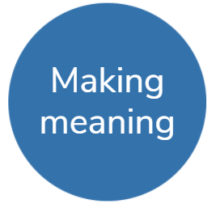
Day 3 activity 1: Reading
Notes for teachers and whānau
Learners revisit the text Bread by Bernadette. In this task they can choose to complete one of the activities depending on the resources and support they can access. Some activities can be completed independently, and others will require adult support.
Note that our Inquiry focus for today is – "making meaning" which includes analysing data, organising, and sorting information, summarising, synthesising, making connections/conclusions, building deeper understandings, and thinking critically.

In this activity I am learning to: make connections to the text so that I can improve my understanding
What do I need?
- 30 minutes
- Home learning book
- Look for the book Bread in your pack or access the PDF and audio online https://instructionalseries.tki.org.nz/Instructional-Serieshttps://instructionalseries.tki.org.nz/Instructional-Series/Ready-to-Read-Colour-Wheel/Bread

Remember to start your day right (see p. 7).

Instructions:
Today you are going to re-read Bread by Bernadette Wilson and choose one of the activities listed below to complete in your home learning book.

Your task:
Read or listen to Bread by Bernadette Wilson, then complete one of these activities:
- How do you like to eat bread? Draw a picture or take a photo of your favourite way to eat bread and write about it in your home learning book.
- What are the different recipes or meals that you use bread for at home? Write a list of these in your home learning book (think about puddings, side dishes and recipes that use breadcrumbs.)
- Bake bread with a member of your whānau.
- Where do you get your bread from? Draw a table in your home learning book that looks like the one that is on page 9 of the book and draw a picture in each box that shows the different places that your whānau get their bread from. Write a sentence to go with each picture.
- Follow this link: https://www.newzealand.com/nz/feature/traditional-maori-foods/ to read about traditional Māori foods. Create a chart in your home learning book that shows traditional Māori foods on one side and introduced ingredients on the other. Do you think that bread was a traditional Māori food or was it introduced? How do you know?

Day 3 activity 2: Writing
Notes for teachers and whānau
Learners explore the features of a flow chart as shown in the text Bread by Bernadette Wilson and use this as an exemplar to create a flow chart of their own. Learners will need to have the flow chart available to look at, and an idea in their mind of what they will create their flow chart about. To make this task more accessible for younger learners you may want to encourage them to draw the pictures in order, and then get them to tell you what they would like written underneath each picture.

In this activity I am learning to: create a flow chart.
What do I need?
- 30 minutes
- Home learning book
- Look for the book Bread in your pack or access the PDF and audio online https://instructionalseries.tki.org.nz/Instructional-Serieshttps://instructionalseries.tki.org.nz/Instructional-Series/Ready-to-Read-Colour-Wheel/Bread

Instructions:
Look at page 7 of the book Bread by Bernadette Wilson. Notice how they have made a flow chart for how to make bread. Today you are going to create your own flow chart in your home learning book. You could choose one of the following ideas or you could choose one of your own:
- How to make your favourite sandwich or meal
- How to brush your teeth
- How to make a cake/smoothie/etc
- How to get ready for school
- How to weave something using harakeke/flax

Your task:
Re-read page 7 of Bread by Bernadette Wilson. This is an example of a flow chart. Notice how:
- The flow chart has been broken up into steps.
- Each step is numbered.
- Each step has a picture.
- Each step has one sentence underneath the picture explaining what is happening.
- The steps are linked together with arrows showing the order things happen in.
Choose an idea and brainstorm each of the steps involved.
Create a flow chart in your home learning book to show each of those steps in order.
Remember to include the ideas you were asked to notice above and check back to page 7 as you need to.

Day 3 activity 3: Mathematics
Notes for teachers and whānau
Learners explore aspects of measurement using non-standard units to answer a ‘how many’ question. They make predictions and test them as they measure the capacity of a container using everyday household objects. This activity uses water so it could get messy, and we recommend a suitable space outside.

In this activity I am learning to: order and compare objects by volume and capacity.
What do I need?
- 30 minutes
- Home learning book
- Tablespoon, a metric cup, bowl
- Water

Instructions:
You are going to guess how many spoons of water fill a cup and how many cups fill a bowl. You will test your prediction by checking how much each container can actually hold.
Two words you will use today are:
- Estimate — A careful guess about the amount, size, or value of something.
- Actual — Something that is real or true. When you record the “actual” number today you are writing down the real number it takes instead of your guess.

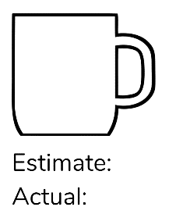
Your task:
Draw a picture of a cup in your home learning book and write the words “estimate” and “actual” underneath as shown:

Repeat this process, but this time draw a bowl and write the words “estimate” and “actual” underneath.

Look at the tablespoon and look at the cup and estimate how many spoons of water it will take to fill the cup. Write this number next to the word “estimate”.

Carefully pour tablespoons of water into the cup counting as you go until the cup is full. How many tablespoons did it take to fill the cup? Write this number next to “actual”.

Now look at the cup and look at the bowl and estimate how many cups of water it will take to fill the bowl. Write this number next to the word “estimate”.

Carefully pour cups of water into the bowl counting as you go until the bowl is full. How many cups did it take to fill the bowl? Write this number next to the word “actual”.

Compare your estimated number with the actual number. Were your estimates close or were they quite far apart?

Estimate and measure out water into other containers. Were your estimates closer this time or still far apart? Write what you have noticed in your home learning book.

Day 3 activity 4: Science
Notes for teachers and whānau
Learners use the scientific skill of observation so that they can record what changes happen over a period of time. Today they will check back on the potato yeast they began to make on day 2 and make simple observations about what they can see and smell. Learners will then record these in their home learning books. Younger learners may require assistance with this task and depending on their confidence, they could draw the picture and then explain their thinking to a whānau member or teacher who could then write this for them underneath the picture.

In this activity I am learning to: make observations and record them.
What do I need?
- 30 minutes
- Home learning book
- Potato yeast experiment from previous day

Instructions:
Today you are going to look at your potato yeast experiment from yesterday and use your curiosity to make observations about what you can see and smell. You will then record these in your home learning book. For best results make sure it has been 24 hours since you first did the experiment before you complete this task.

Your task:
Look at the potato yeast you started making yesterday and think about:
- What does it look like?
- What does it smell like?
- What changes have you noticed since yesterday?

Record your answers to these questions in your home learning book. Younger learners might discuss the answers to these questions with a whānau member and ask them to write their ideas for them.
Draw what you can see in the jar and write “day 1” underneath your drawing. Put the lid on the jar, give it a good shake and then remove the lid again.
Remember to do your end of day reflection and wellbeing activities (see p. 6 & 8).

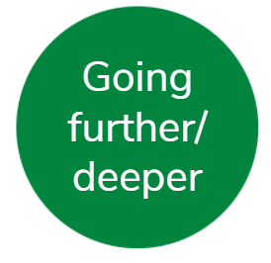
Day 4 activity 1: Reading
Notes for teachers and whānau
Learners are asked to read or listen to The Little Red Hen, retold by Kylie Parry, and then make a connection to the text by exploring what they have in their home that can be used to make something. Younger learners may require adult support as they look at different ingredients in their homes and think about how they can use them.
Note that our Inquiry focus is – “Going further, deeper”. This may include promoting opportunities to engage further and dive deeper through discussions, provocations, exploring further contexts, taking action, or thinking critically and drawing conclusions.

In this activity I am learning to: make connections to the text.
What do I need?
- 30 minutes
- Look for the book The Little Red Hen in your pack or access the PDF and audio online https://instructionalseries.tki.org.nz/Instructional-Series/Ready-to-Read-Colour-Wheel/The-Little-Red-Hen

Remember to start your day right (see p. 7).

Instructions:
You are going to read or listen to the story The Little Red Hen. In this story Little Red Hen sees some wheat and says, “I can use that wheat to make some bread”. After you have read/listened to the story think about what ingredients you have in your house that you could use to make something. Some ingredients or ideas you could consider are:
- Some fruit or juice that you could use to make an ice block or smoothie
- Some flour that you could use to make a cake or bread
- The potato yeast that you made to make bread
- Some vegetables that you could use to make a soup
- Some fillings for a sandwich
Once you have decided what you would like to make, use cookbooks, whānau knowledge or the internet to help you create your own special recipe. Use your curiosity to add new flavours or ingredients, but be careful what you add, we don’t want to waste food.

Your task:
Read or listen to The Little Red Hen, retold by Kylie Parry.
Talk with a member of your whānau about an ingredient that you have in your home and brainstorm different foods you could make using that ingredient.
Decide which food you would like to make and use cookbooks, whānau knowledge or the internet to research a recipe you would like to make.
Think about whether there is anything else you could add to the recipe to make it even better.

Day 4 activity 2: Writing
Notes for teachers and whānau
Learners take their ideas from the previous activity and use them to write up their own recipe. This task requires learners to think about the process of procedural writing and specifically how a recipe is set out. Younger learners may require the support of a whānau member or teacher to record their ideas, or alternatively they could use a series of pictures to show the ingredients required and the method that should be followed.

In this activity I am learning to: write a recipe.
What do I need?
- 30 minutes
- Home learning book
- Ideas from previous task

Instructions:
Now that you have used your curiosity to create a recipe, you are going to write it up in your home learning book. Remember to include:
- A title for your recipe
- A list of ingredients which include the amounts needed
- A list of instructions that are numbered
- And start each instruction with a verb
You can use the recipes that were included in your Day 2 learning as an exemplar to check you have remembered everything.

Your task:
Think about the recipe you brainstormed in activity 1.
Write the title of the recipe in your home learning book.
Write the list of ingredients one after the other, remembering to include the amount needed of each ingredient.
Think about the steps that you need to take to make your recipe.
Write each instruction one at a time. Number each instruction and start the sentence with a verb.

Day 4 activity 3: Mathematics
Notes for teachers and whānau
Learners work with fractions and capacity in the context of cooking. To support learning it could be helpful to discuss the mathematics involved in cooking and explore the measuring devices used when baking. Younger learners may need support reading the questions and answering the questions. The use of materials is strongly recommended to help learners work out the answers to these problems.

In this activity I am learning to: use appropriate units to measure volume and capacity.
What do I need?
- 30 minutes
- Home learning book
- Look for this activity supplied in your home learning pack: https://nzmaths.co.nz/sites/default/files/ProblemPikelets.pdf

Instructions:
Today you are going to apply your mathematics skills to some recipe problems. Read through your copy of Problem Pikelets and answer the questions in Activity 1 on the sheet.
If you complete those questions quite quickly, you may want to have a try at Activity 2 as well.
Remember to record your answers in your home learning book.

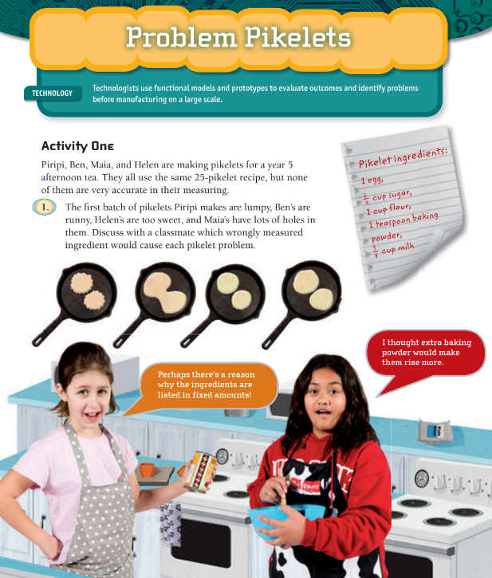
Your task:
Read through Activity 1 of Problem Pikelets.
Talk to your whānau, teacher or a buddy about the questions and use materials to help you solve the problems if needed.
Write your answers into your home learning book.
Fast finishers could try answering the questions in Activity 2 as well.

Day 4 activity 4: Te Ao Māori
Notes for teachers and whānau
Learners will engage with Māori tikanga (practices) around food and consider how this tikanga is similar or different to their own tikanga at home. Younger learners may need a whānau member to read and discuss the article with them. They may also need support recording their ideas, or they could draw pictures to represent their thinking.

In this activity I am learning to: recognise Māori tikanga (practices) around food.
What do I need?
- 30 minutes
- Home learning book
Optional: Te mahi kai (preparing food) https://hereoora.tki.org.nz/Unit-plans/Unit-3-Kai/Reomations/Te-mahi-kai-Preparing-food

Instructions:
For this activity you are going to read the information on the next page about Māori tikanga related to food and talk with a whānau member about what practices you already follow in your home, and which ones are new. Once you have done this you are going to write your responses to the questions in your home learning book.

Your task:
Read “Tikanga Related to Food” on the next page or ask a whānau member to read it to you.
Ask yourself these questions (talk to a whānau member if you are unsure):
- What practices do you already follow in your home?
- What practices are new to you?
Write the answers to these questions in your home learning book.
After reading this article, are there any new tikanga (practices) you would like to introduce in your home? Write these in your home learning book or talk to a whānau member about them.

Tikanga Relating to Food
In te ao Māori, tikanga can be translated to mean the correct procedure, custom, or practice. Here are examples of tikanga that relate to food and how you handle food. You will see that these examples are also good manners, as well as helpful health and safety practices.
- You look after your manuhiri (visitors) by offering food and drinks to them first and making sure they have what they need before you start eating.
- You also show care for manuhiri by ensuring elders (kaumātua and kuia) are seated and served first.
- You should be kind and respectful in what and how you share food with others, such as offering your manuhiri the biggest piece of baking or the freshest food.
- You should not pass food over the heads of people as your head is considered to be tapu (or sacred).
- Clothing (especially things you wear on your head or face such as sunglasses, hats, and face masks) or items that come into contact with bodily fluids (such as tissues) should not be placed on surfaces where you also place food and drinks.
- Items used in the preparation and serving of food should only really be used for those purposes, e.g. containers for drinks and water, tea towels for drying dishes, pots for cooking food.
- You shouldn’t sit on tables, especially as these are surfaces where you might also place food.
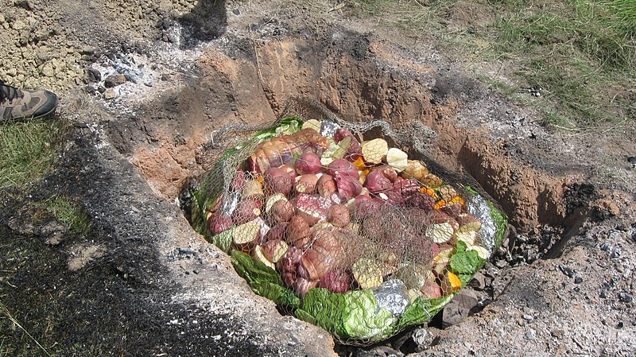
Sarah Stewart, CC BY 2.0 <https://creativecommons.org/licenses/by/2.0>, via Wikimedia Commons
Remember to do your end of day reflection and wellbeing activities (see p. 6 & 8).

Day 5 activity 1: Reading
Notes for teachers and whānau
Learners re-read The Little Red Hen, retold by Kylie Parry, and practice retelling the story in their own words. Once they feel confident, learners will share their retell in the way that is best suited for them.
Note that today our Inquiry focus is “Present− share learning about the theme” which includes thinking about who the audience is and considering different ways of communicating learning for example, presentation, video, poster, etc.

In this activity I am learning to: retell a story.
What do I need?
- 30 minutes
- Home learning book
- A digital device for recording (if you have one)
- Look for the book The Little Red Hen in your pack or access the PDF and audio online https://instructionalseries.tki.org.nz/Instructional-Series/Ready-to-Read-Colour-Wheel/The-Little-Red-Hen

Remember to start your day right (see p. 7).

Instructions:
Today you are going to re-read or re-listen to The Little Red Hen and then retell the story in your own words. You could:
- Retell the story to a whānau member in your home or a friend at school.
- Use a digital device to record yourself telling the story and share this recording with whānau or your teacher.
- Retell the story to your favourite stuffed animal.

Your task:
Read or listen to The Little Red Hen.
Think about the characters, the main events, and the order they happen in and record your ideas in your home learning book, either by writing them down or drawing pictures.
Practice telling the story in the order it happened, using your own words.
Share your retell using one of the ideas mentioned above in the instructions.

Day 5 activity 2: Writing
Notes for teachers and whānau
Learners are applying editing and publishing skills to their writing from the previous day. Once learners have produced a quality piece of published writing, they will share it in a way that is most suitable for them. Younger learners will need support from whānau to check they have an accurate draft of their recipe to copy over for their published recipe.

In this activity I am learning to: publish my writing.
What do I need?
- 30 minutes
- Recipe that was created on previous day
- Home learning book or digital device

Instructions:
You are going publish the recipe you created yesterday. When we publish a piece of work, here are some things to remember:
- Check there are no spelling mistakes
- Set it out correctly
- Use your neatest handwriting (or you could type it on a device)
- Include a picture of what your finished product will look like (this could be a photo or drawing)
Once you have finished publishing your recipe, share it in one of the following ways:
- Show it to a whānau member at home
- Show it to your teacher or friend at school
- Email it to whānau or your teacher

Your task:
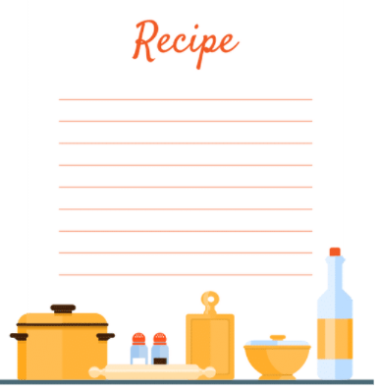
Re-read the recipe you wrote yesterday and check there are no spelling mistakes (you could get a whānau member or teacher to do this with you).
Using your neatest handwriting and a pencil (if possible), carefully copy your recipe onto a clean sheet of lined paper, or onto a new page in your home learning book or type it up on the computer. If you make a mistake along the way, use an eraser to rub it out and fix it up. Check the list in the instructions above for useful reminders.
Draw a picture of what your completed recipe would look like at the bottom of your recipe and colour it in or take a photo and attach it to the bottom of your recipe.
Share your published recipe using one of the ideas in the instructions above.
You could also ask a whānau member or teacher to give you feedback on what they think of your recipe.

Day 5 activity 3: Science
Notes for teachers and whānau
Learners use the scientific skill of observation to record what changes happen over a period of time. Today they will check back on the potato yeast again from day 2 and make another set of observations. Younger learners may require assistance with this task and depending on their confidence, they could draw the picture and then explain their thinking to a whānau member who could then write this underneath the picture.

In this activity I am learning to: make observations and record them.
What do I need?
- 30 minutes
- Home learning book
- Potato yeast experiment from day 2
Optional: https://practicalselfreliance.com/potato-yeast-starter/

Instructions:
Today you are going to look at your potato yeast experiment again and use your curiosity to make a final observation about what you can see and smell. You will then record these in your home learning book. Since this is the last day of your experiment you may want to use your potato yeast to bake some delicious bread to celebrate the learning from the week. You can head to the website above for instructions on how to use the potato yeast to make bread:

Your task:
Look at the potato yeast you made on day 2 and think about:
- What does it look like?
- What does it smell like?
- What changes have you noticed since Wednesday?

Record your answers to these questions in your home learning book. Younger learners might discuss the answers to these questions with a whānau member and ask them to write their ideas for them.
Draw what you can see in the jar and write “day 3” underneath your drawing.
Think about what changes have taken place over the last few days. Go back to the experiment you wrote up in your home learning book on day 2 this week and record your thoughts in the section that says “results”. Younger learners may decide to discuss this with a whānau member or teacher instead of writing it up.

Day 5 activity 4: Mathematics, Te Ao Māori
Notes for teachers and whānau
Learners use their mathematics learning from the week to compare and order the capacity of a range of household items that can hold something in them. Younger learners may need help reading the instructions for this task and identifying the correct words to match each of their pictures.

In this activity I am learning to: order and compare objects by volume and capacity.
What do I need?
- 30 minutes
- Home learning book
- A variety of household items of different sizes (see list below)

Instructions:
Show your learning from this week! Create a chart in your home learning book that shows different household items in order of the capacity (how much they can hold) from smallest to largest. Some household items you could include:
- teaspoon
- tablespoon
- cup
- serving spoon
- bowl
- drinking glass
- lunchbox
- laundry basket

Your task:
Collect between 5–8 household items and order them from the one that can hold the smallest amount, to the one that can hold the largest amount in it.
Draw these objects into your home learning book, making sure you draw them in the same order that you have placed them in.
Label your pictures using the correct word in English and Māori.
Kupu Māori  Tīpūnu — teaspoon  tēpu pūnu — tablespoon  kapu — cup  kokotoha — serving spoon | kumete — bowl  karaihe inu — drinking glass  pouaka tina — lunchbox  kōwara — laundry basket
You can look up the Māori words for other objects using the Te Aka Māori Dictionary.
Remember to do your end of day reflection and wellbeing activities (see p. 6 & 8).

