A learning from home pack

For learners in years 7–8 (Weeks 1 & 2 Draft)

Curiosity | Māhirahira

Context 1: What if ...?

Context 2: How does ... work?

Layout of the resource
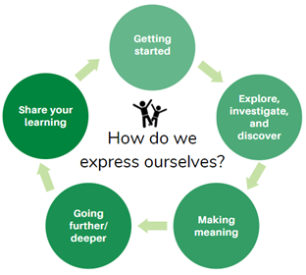
This pack is filled with learning activities for your learners that can be used at school or at home. All activities are framed around the theme of curiosity | māhirahira.
Suggestions are provided for starting the day with a karakia (see p.10), check in with the teacher, and setting up the learning environment. You can replace these with how you want your learner to start their day.
The activities follow an inquiry learning model (figure 1) exploring one theme through two contexts. Each day the learner will be working through one part of the model culminating with sharing their learning on days 5 and 10.
Figure 1 Inquiry learning model

Realities
You know your learners and have a good understanding of their learning situations.
Many learners will have siblings at home, as well as whānau who share the same space and materials. Some may have access to the internet and devices, and others may not. Learners will also have varying levels of adult support.
There are a mix of activities in this pack that use materials commonly found in most homes. Some activities will require adult support while others can be managed independently. This resource is provided as a Word document so that you can adapt it for your learners.

Resources
The pack uses a range of books from the Figure it Out, School Journal, and Connected series. You might want to send these home with the learner, along with a “my home learning” exercise book, pencils or felts, and some craft materials (glue, scissors, construction paper). Learners can bring their notebook back to class to share.
If your learners do not have reliable access to the internet, here are the resources to print and send home with this to create a paper–based pack.

Resources to print
- Day 1 – https://nzmaths.co.nz/sites/default/files/2021-03/order-of-operations-2.pdf
- Day 1 – https://nzmaths.co.nz/sites/default/files/2020-05/OrderOfOperation.pdf
- Day 2 – https://nzmaths.co.nz/sites/default/files/2020–06/AwesomeAthletes.pdf
- Day 6 – https://nzmaths.co.nz/sites/default/files/PipeMusicClass.pdf
- Day 6 – https://nzmaths.co.nz/sites/default/files/2021–02/social–sounds.pdf
- Day 7 – https://nzmaths.co.nz/sites/default/files/See–sawAntics.pdf
- Day 7 – https://nzmaths.co.nz/sites/default/files/NumberCrunching_0.pdf
- Day 8 – https://nzmaths.co.nz/sites/default/files/TheEscape_0.pdf

Resources to send home
- Day 4 – Return of the Moa?’ https://instructionalseries.tki.org.nz/content/download/36507/409508/file/Return%20of%20the%20Moa?-SJ%20L4%20Oct%202015.pdf
- Day 5 – Baskets of Fire https://instructionalseries.tki.org.nz/content/download/41482/462245/file/Baskets%20of%20Fire-SJ%20L2%20November%202018.pdf
- Day 6 – Connected ‘Show and Tell’ for the “I am Alice”. https://instructionalseries.tki.org.nz/Instructional-Series/Connected/Connected-2016-Level-2-Show-and-Tell
- Day 6 – Connected ‘Cracking the Code’ for the ‘To build a bot’ article. https://instructionalseries.tki.org.nz/Instructional-Series/Connected/Connected-2018-Level-3-Cracking-the-Code
- Day 8 – Puaki https://instructionalseries.tki.org.nz/content/download/ 41983/466720/file/SJL4%20Puaki.pdf
- Day 8 – Emotional robots https://instructionalseries.tki.org.nz/Instructional-Series/Connected/Connected-2018-Level-4-Digital-Space/Emotional-Robots

Setting up the learning environment
Encourage whānau to support learners to set up a space for learning at home. This provides structure for the learners, and they might like to design their own space as a separate learning activity.
Many of the suggested activities and experiences have options to include online resources which can be accessed and viewed using a Smartphone.

Overview of the learning in this pack
The theme of curiosity | māhirahira will be explored through two contexts.
- Days 1–5 look at this idea through the context of what if…?
- Days 6–10 look at this idea through the context of how does … work?
Learners will explore, investigate, discover, and make meaning as they go through each task. There are times where they look a little deeper into the topic. Some of the tasks may be independent hands–on tasks while some may involve connecting and sharing with others.
Day 1 | Day 2 | Day 3 | Day 4 | Day 5
Launching our learning: time to brainstorm, think and wonder ‘what if’? Knowing the difference between diversive and epistemic curiosities. | Curiosity = what if? Explore our curiosities through sport, captioning, problem solving and natural disasters. | Making meaning of our curiosities through problem solving, thinking skills and creativity. Using the Thinker’s Keys. | Diving deeper into topics that provoke our curiosity and utilise our critical thinking | Sharing our learning about our curiosity explorations by creating a Quiz Game.
Day 6 | Day 7 | Day 8 | Day 9 | Day 10
Launching our learning: exploring provocations and brainstorming ‘how does ** work’? questions. | Curiosity = how does ** work? Exploring machines, tools, infographics and other cool things. | Making meaning of our curiosities through problem solving, questioning and artificial intelligence. | Diving deeper into AI and our own ‘how does ** work?’ questions. | Sharing my learning from this week by planning and hosting an event.

Daily timetable
Below is a possible daily timetable. We have allocated 30 minutes for each activity; your learner may take more or less time than this for an activity. We suggest your learner takes the time they need to complete an activity. This may mean they choose which activities they will complete for the day, rather than complete them all.
At the start of each day the learner will draw up their timetable for learning. You can adjust the timing to suit the other activities that might be happening the day, such as Zooming with the class/teacher.

Time | Activity
9:00 am | Starting the day
9:30 am | Activity 1
10:00 am | Break
10:30 am | Activity 2
11:00 am | Fitness break
11:30 am | Activity 3
12:00 pm | Lunch time
1:00 pm | Activity 4
1:30 pm | Reflection time
2:00 pm | End of the school day

Daily fitness – Choose something each day
It is important to include a fitness activity every day. Please ensure that your learner includes this in their daily timetable. If possible, it would be great to do the fitness activity with your learner or have them complete it with their siblings where appropriate. Below are some activities to choose from – or you can make up your own ideas!
You may prefer to go for a walk or run around your house. Time yourself for fun! Maybe you’d like to go for a bike ride with your whānau? Play a game with whānau? Have a boogie to your favourite song? Or do some yoga? It is up to you.
Please note: you can change or modify the exercises (in addition to those outlined) if you are not able to do the ones we have suggested, get creative and change it up.
Fitness countdown
You don’t need anything for this activity but a positive attitude and a water bottle!
- tekau (10) jumping jacks **modify: right leg step out to the side then left leg
- iwa (9) forward lunges (on each leg) **modify: use a box and step up and down
- waru (8) squats (don’t let your knees go past your toes) **modify: sit in chair, stand up
- whitu (7) donkey kicks (each leg) – can do standing or sitting
- ono (6) sit ups **modify: touch knees
- rima (5) high knees **modify: lift knees up while laying down on back
- whā (4) push-ups **modify: do on your knees
- toru (3) star kicks (right leg – kick forward, side, back; then left leg)
- rua (2) burpees **modify: walk outs – walk out with your hands and walk back
- tahi (1) superman pose or high plank for as long as you can hold! **modify: on your knees
Take a rest and repeat. Tumeke!
Tahi – rua – toru – whā fitness challenge
You will need a timer for this activity (alternatively you can count). Time yourself – how long you can remain in each position during each set? Will you get better/longer?
Tahi – Wall sit. Stand in front of the wall facing away. Slide down the wall until you are sitting. Your knees/thighs should be parallel to the floor. How long can you remain in this position?
Rua – Superman. Lay on the floor with your face towards the floor, relax. Now lift your legs slightly off the floor and put your arms out like superman. How long can you remain in this position?
Toru – Tree pose. Standing tall and straight, slide your right foot up your left leg until it reaches your knee, ensure your right knee is facing outwards, not forwards. At the same time raise both arms straight above your head and bring your palms together. How long can you remain in this position? Try the other side.
Whā – Quad stretch. Standing tall and straight swing one leg behind and catch it with your same arm. Hold the stretch for as long as you can. Try the other leg. Is one side easier to balance on?
Repeat x 3.
Can you beat yourself? Great efforts!
Mahuru Dance
Go to https://music.youtube.com/watch?v=-BrdaUUTMBY&feature=share and watch Pere Wihongi sing Mahuru (earth Wind and Fire’s song ‘September’ in Te reo Māori). Practice singing it in te reo and then make up a little dance or fitness routine. Maybe you have to jump up every time you ‘Mahuru’? Maybe you have to squat every time you hear ‘korero Māori’? Have fun with it and move your body!
Māori Movement
Start with a warmup here: http://www.Māorimovement.co.nz/warm-up
Rūamoko is the Māori God of Earthquakes and Volcanic Activity.
- You will practice Rū Nuku – to move and specifically Rū Tuki – to ‘shake and shoot’ in this video.
- Māori movement is mokomoko (ground strength). Mokomoko is a lizard.
Here is your challenge – http://www.Māorimovement.co.nz/courses/ruaumoko/level-1- ruaumoko
Toru + Tekau + Rima Fitness Challenge:
Can you do this? Tekau tāruarua (10 reps), e rima ngā huinga (5 sets) – let’s go!
These are our toru (3) exercises
  - Squats **modify: sit down on a chair and stand up
  - Lunges (lunge forward on each leg) **modify: sit down and lift each leg
  - Inchworms (squat down, crawl out into a plank, crawl back into a squat, and stand up again) **modify: sit down and lift opposite arm to leg, then switch
Tekau tāruarua (10) reps – do each exercise 10 times
E rima ngā huinga (5) sets– do each set of toru (3) exercises rima (5) times
**Hōngai tō puku – remember to brace your abs.
Ka pai!? Here we go! Haere mai? Good? Let’s go!

Daily wellbeing – Choose something each day
These activities are good to do at the beginning and end of the day but can be done anytime. They can help you get ready for learning; calm your mind and body and they can help you to reflect on your learning:
Gratitude Scavenger hunt:
Find something:
- That makes you happy
- That makes you think of someone you love
- That you like to touch
- That makes you feel proud
- To give to someone to make them smile
- You love to smell
- You enjoy looking at
- That is your favourite colour
- You are thankful for in nature
- That you find useful
Make it digital: Complete the Gratitude Scavenger Hunt by taking photos of the items and using Pic Collage to capture them all in one place.
Clouds and Triangles
Find a nice quiet place outside to look up at the clouds. Focus on their shapes and movements. Once you are feeling comfortable, start some triangle breathing.
- Using your finger in the air, start at the bottom left of the triangle.
- Breathe in for three counts as you trace the first side of the triangle.
- Hold your breath for three counts as you trace the second side of the triangle.
- Breathe out for three counts as you trace the final side of the triangle. You have just completed one deep breath.
- Repeat 5 times
- Focus on the clouds in the sky again.
- Repeat more triangle breathing
- Return to your learning once you are feeling relaxed.
Hikitia te hā
This is s “a series of simple te ao Māori breathing exercises that anyone can learn. Focusing on our breathing calms the body and mind and is a very helpful practice for feeling more present and mindful. Hikitia Te Hā was developed by Rawiri Hindle”.
Go to the website and follow along to the videos.
https://www.allright.org.nz/tools/hikitia-te-ha

Fill your whare tapa whā
Choose one activity from each whare or create your own to fill your whare tapa whā:
Taha wairua – spiritual  - Go outside and notice the weather and elements: sun, wind, temperature, how does it make you feel?  - Lay down on your back, close your eyes, when you open them focus on one thing. Repeat three times. | Taha hinengaro – mental & emotional  - Sing a waiata  - Draw a picture  - Write a reflective journal about how you are feeling  - Make time to korero with a friend or family member, listen intently
Taha tinana – physical  - Walk or run around your section 3 times  - Run up and down your stairs 3 times  - Play your favourite song and singalong while you dance | Taha whānau – family & social  - Hug someone  - Help with a family chore  - Try to smile at everyone all day – how does that make you feel?  - Make someone a hot drink
WHENUA – LAND
- Walk barefoot around your section, what do you notice?
- Stop to smell the plants around your house, what do you notice?
- Sit quietly outside with your eyes closed, what do you notice?

Write with feeling!
Write about what makes you feel these emotions.
- e.g. I feel amused when my puppy chases his tail.
Try some simple feeling responses in te reo Māori.
- e.g. Ka tau ahau. (I feel calm)

energised  inspired  proud  relaxed  amused  confused  bored,  peaceful  accepted  loved | trusting  critical,  distant  indifferent  inspired  hopeful  thankful  curious  cheeky  sleepy | happy / harikoa  calm / tau  excited / hiamo  grateful / whakawhetai  disappointed / pāpouri  frustrated / hōhā  optimistic / whakapono  amazed / mīharo  strong / kaha  sad / hinapōuri

Starting each day
Notes for teachers and whānau:
Starting the same way each day helps create a structure for your learner. Your school might have your own way to do this, for example starting the day together as a class on Zoom. In this pack we provide a karakia to settle into the day. Saying the karakia with your learner a few times will help them be able to do this more independently tomorrow and beyond. As part of the start of the day and setting up the learning environment, help your learner look through the activities suggested for that day and choose a fitness and wellbeing activity. They could fill out their daily timetable and think of other activities they might like to do, like reading.
Remind your learner of when and how to check in with the teacher/you.

Karakia
Here is a karakia to welcome in the day
https://www.otago.ac.nz/cs/groups/public/@maori/documents/webcontent/otago667429.mp3
Whakataka te hau ki te uru  Whakataka te hau ki te tonga  Kia mākinakina ki uta  Kia mātaratara ki tai  E hī ake ana te atakura  He tio, he huka, he hau hū  Tīhei mauri ora! | Cease the winds from the west  Cease the winds from the south  Let the breeze blow over the land  Let the breeze blow over the ocean  Let the red–tipped dawn come with a sharpened air.  A touch of frost, a promise of a glorious day.

Planning my day
- Have you chosen which activities you will do today and in which order?
- Have you chosen a fitness activity? (See p. 5–6)
- Have you chosen a wellbeing activity? (See p. 7–8)
- Have you done a ‘Wellbeing check–in'?
  - How are you feeling today?
  - How do you feel about your readiness to learn this morning?
  - What do you need extra assistance with today? Who could you get to help you? What strategies could you use to help make your learning more effective?
  - What would you like to do as a quiet time activity to end your day?
- Remember to do your Reflection at the end of the day (see p. 10–11)

Ending each day
Please ensure your learner does this at the end of each day.
Reflection can be challenging for all learners, but it can also provide them with rich opportunities to think about how their learning is progressing. Use the questions below as prompts to encourage your learner to think about what they have learned so far and help them to plan out their next steps. If you have concerns with their learning or find that your learner is needing more help, contact their teacher for more support.

In this activity I am learning to: reflect on my learning, my day and myself
What do I need?
- A notebook or online doc that you can use each day for your reflection activity. We will call this your “reflective journal”
- Materials for your quiet time activity

Option 1: Reflections about my learning
Take some time to think about how you are feeling and after today’s learning activities.
Reflect on the following prompts in your reflective journal.
- What did you enjoy most about today?
- What is one thing you feel you learnt today?
- What is one strategy that helped you with your learning?
- What did you find challenging or distracting? (You ran out of time for some activities, or you finished them quite quickly and wanted to dig in a little deeper.)
- Is there anything you need extra help with? Who can you ask to help you with that?
- Is there anything you want to catch up on tomorrow?
Option 2: Reflections about my day
Choose 3 questions to respond to in your reflective journal:
- What is something kind you did for someone else today?
- What made you laugh today?
- What is something that frustrated you today?
- What is something you wish you had done differently today?
- On a scale of 1–10, with 10 being the best day ever, how would you rate your day? Why?
- What goal do you have for tomorrow?
- Were you able to finish all of your work today? Why or why not?
Option 3: Reflections about myself
Look at the quote or whakataukī for today (at the top of activity 1 each day). What do you think it means? How did it relate to you and your learning today?

Choose 3–5 questions to respond to in your reflective journal:
- What are your greatest strengths?
- If you could live anywhere in the world, where would it be? Why?
- What are your goals for this school year?
- Who do you talk to when you have a problem? How do they help?
- What do you like to do for fun?
- What are you worried about?
- What do you wish your parents knew about you? What do you wish your friends or classmates knew about you?
- If you could have one wish, what would it be?
- Where do you feel safest?
- What are you grateful for?
- What do you like about yourself?

Whakataukī and quotes for the pack
Week 1 | Explanation | Week 2 | Explanation
“The important thing is not to stop questioning. Curiosity has its own reason for existence.” – Albert Einstein | Humans are naturally curious and this is how we learn so it is important for us to ask questions and seek answers. | “Accident is the name of the greatest of all inventors.” ~ Mark Twain | We can discover wonderful things by accident. E.g. Sir Alexander Flemming discovered penicillin in 1928 by accident and penicillin is the most widely used antibiotic in the world.
Ko ia kāhore nei i rapu, tē kitea | He who does not seek will not find. | If you do not ask questions, if you are not curious, you will not learn. | “Nothing is less instructive than a machine.” ~ Simone Weil | Speaks to the importance of human connection.
He rangi tā matawhāiti, he rangi tā matawhānui. – A person with narrow vision has a restricted horizon; a person with wide vision has plentiful opportunities. | We must look beyond what we already know to increase our knowledge base and our opportunities to learn. | “We are not thinking machines that feel; rather we are feeling machines that think.” ~ Antonio Damasio | Speaks to the fact that humans have emotions and that this is very natural and instinctive, and we learn to think as we develop skills and knowledge.
Whaowhia te kete mātauranga | Fill the basket of knowledge. | This inspires us access knowledge from a variety of sources so we can continue to learn. | “The best way to predict the future is to invent it.” ~ Alan Kay | If you want to influence the future, take action, take risks, prototype and invent things yourself.
“Curiosity is the most powerful thing you own.” ~ James Cameron | Our natural sense of wonder is what gives us the desire to learn, imagine and create. | He waka eke noa – A canoe which we are all in with no exception | We are all in it together. When we work together as a team we can achieve great things.
Remember to finish with a wellbeing activity and/or your chosen quiet time activity

Context 1: What if...?

The next five days indulge our curiosity by asking ourselves the question what if...?

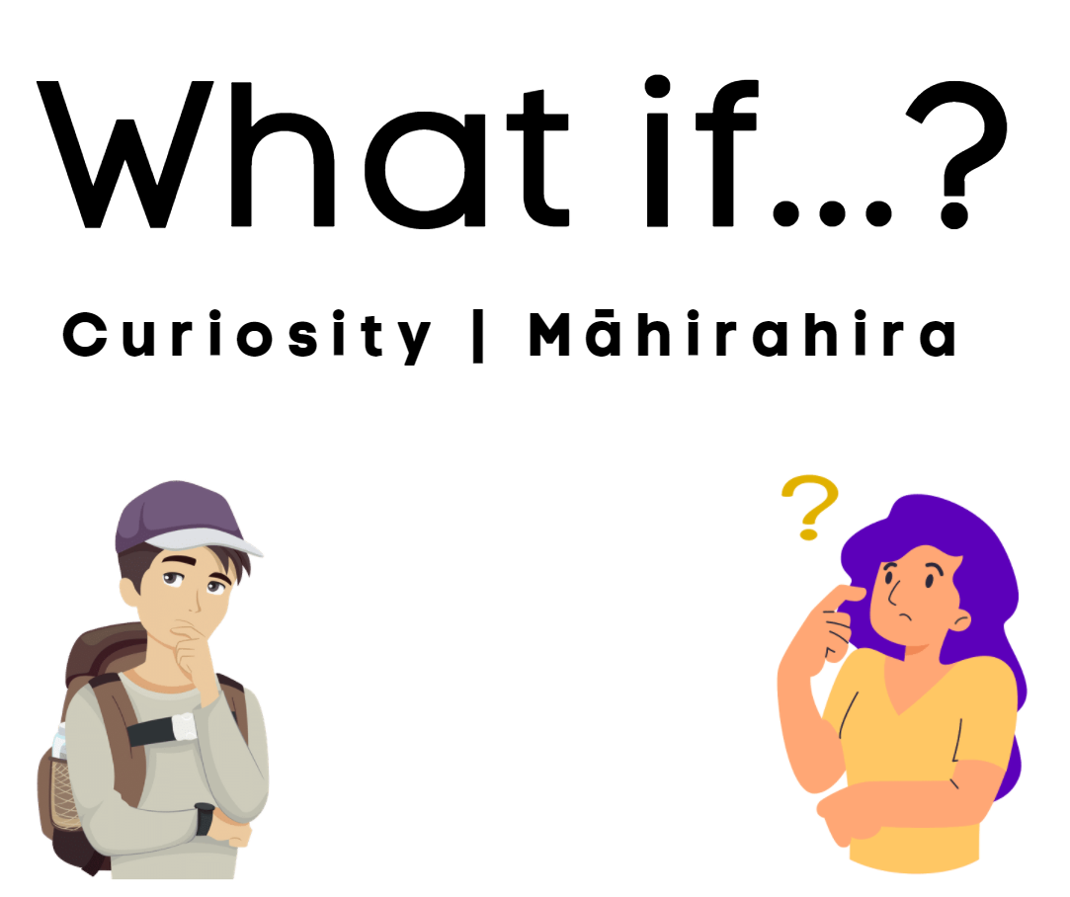

Day 1 activity 1: Inquiry getting started
“The important thing is not to stop questioning. Curiosity has its own reason for existence.” – Albert Einstein
Notes for teachers and whānau
For this first task the learner is going to explore two ‘what if’ questions they may be curious about – making predictions and then checking their thinking using a text. They will also be completing a ‘what if’ brainstorm to get them started thinking about everything they are curious about using the question prompt ‘what if…?’
Learners will be exploring the literacy, science, and technology learning areas.
Note that our Inquiry focus for today is “getting started” which includes generating questions, activating prior knowledge, and introducing the theme.

In this activity I am learning to: use my curiosity and prior knowledge to generate what if questions
What do I need?
- 30 minutes
- Online option: Learners could explore Wonderopolis
What if we swallowed gum? https://wonderopolis.org/wonder/What-Happens-if-You-Swallow-Gum
What if you don’t brush your teeth? https://wonderopolis.org/wonder/What-Happens-If-You-Don%E2%80%99t-Brush-Your-Teeth

Instructions:
Have your home learning book or digital doc ready to record your thinking. Follow the sequence below.

Your task:
Think about these two questions (before you read the text or visit the websites):
- What if you swallowed gum?
- What if you didn’t brush your teeth.
Respond to the two provocation questions in the second column of your table (do this before you read the text or visit the websites):
Prepare your table: Using a whole page in your home learning book or digital doc, create a simple 2 column table as follows:
 | What I think… | What I learned….
What if I swallow gum?
What if I don’t brush my teeth?
Read the following text or visit the Wonderopolis sites using the links above.
What if I swallow gum?  When you swallow gum, your digestive system (which includes parts of your body, like your stomach, small intestine, and large intestine) treats the gum like any other food. Some of the parts of gum, such as sweeteners, softeners, and flavourings, are broken down by the digestive juices in your stomach. Any nutrients your body can use are saved and the rest is pushed on through your digestive system.  There is one part of gum that can't be digested, though. It's the gum base or resin. Gum base consists of chemicals developed by scientists to make gum chewy. These chemicals resist digestion, but they don't sit around in your stomach for seven years.  Instead, your body recognizes that it can't digest the gum base and simply moves it along in the digestive process until it is eventually eliminated from your body. Doctors estimate it would usually take about two days to digest and eliminate any gum you may swallow.  Although swallowing gum is usually harmless, it's not a good practice to swallow your gum regularly. Doctors point out that swallowing a large amount of gum at once or swallowing many smaller pieces in a short time span could lead — in rare cases — to problems in the digestive system.  So enjoy your chewing gum but spit it out in the trash when you're finished with it. Doctors also recommend you stick to sugar–free gums, so that you won't put your teeth in jeopardy of developing cavities.  Text adapted from: https://wonderopolis.org/wonder/What-Happens-if-You-Swallow-Gum | What if I don’t brush my teeth?  The next time you brush your teeth, be thankful for your toothbrush. People used to use only a twig or branch! It helps you clean your teeth and stay healthy. But is it really necessary to brush your teeth so often? It sure is!  After you eat, bacteria in your mouth break down sugar left on your teeth. As the sugar breaks down, it turns into acid that can damage the outer coating of your teeth — called enamel — and make holes called cavities.  If you don't brush your teeth regularly, bacteria can build up to form a clear sticky film on your teeth called plaque. Brushing your teeth regularly helps to remove plaque and prevent it from forming. It's important to avoid plaque since it can cause tooth decay (cavities) and a gum disease known as gingivitis.  To avoid these potential problems, be sure to make regular brushing, flossing, and rinsing with a fluoride rinse part of your daily routine. Dentists recommend brushing for two minutes, twice per day and flossing once per day!  Text adapted from: https://wonderopolis.org/wonder/What-Happens-If-You-Don%E2%80%99t-Brush-Your-Teeth

Write your new learning in the third column of your table. Were your predictions correct? Were you surprised by anything?
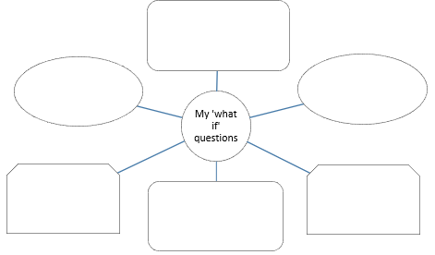
Now that you have explored two ‘what if’ questions it is time to tap into your curiosity. What are you curious about?
Brainstorm all the ‘What if’ questions you have.

Using a new page, make a concept map like the one pictured here in your home learning book or digital doc.

Complete your concept map.

Day 1 activity 2: Literacy, What is curiosity?
Notes for teachers and whānau
This activity builds on activity 1. Learners at this age are ready to understand two different types of curiosity, diversive and epistemic. This will help them understand that knowledge gives curiosity staying power. In this activity learners will complete a Y chart, write definitions, and complete a KWLH chart. This will enable them to frame their own curiosities in their future learning
A Y chart is a graphic organiser that allows learners to think about an idea in terms of what it ‘looks like, sounds like and feels like’. It is a thinking strategy that helps learners think about their learning differently.
A KWLH chart is a graphic organiser the learner can use to document their learning progress from start to finish. We will revisit this KWLH chart on day 5. The ‘K’ is for what the learner already knows. The ‘W’ is for what the learner would like to know, and the ‘L’ is the reflection column for what they learnt (completed at the end of the week). The ‘H’ is for how they can learn more.
Learners will be exploring the literacy and social studies learning areas.

In this activity I am learning to: use graphic organisers to record my knowledge and wonderings.
What do I need?
- 30 minutes
- Home learning book (pen/pencil and ruler) or digital doc to create a:
  - Y chart and KWLH chart
- Optional online: The Power of Curiosity video: https://www.pbs.org/video/the-power-of-curiosity-xb3qql/
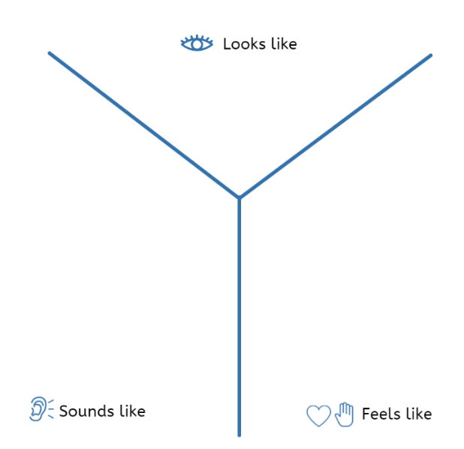

Instructions:
In this activity you will use some graphic organisers to explore your thinking about ‘curiosity’ as a theme or topic. Have your home learning book or digital doc ready to record your thinking.

Your task:
Complete a Curiosity Y chart in your home learning book or digital doc. Using a whole page, create a Y chart like this one.
Think about and record what you think curiosity looks like, sounds like, and feels like. If you were a scientist or engineer exploring their curiosities, what would you see, hear, and feel? Remember there is no right or wrong answer.
Read the following text:
Curiosity helps us learn. It contributes to the speed of our learning, motivates us, increases our knowledge, and helps us adapt to new situations. Humans are curious creatures and have always been explorers, discoverers, and learners. Curiosity is a primary contributor to how humans have adapted to their environments, travelled the world, and created inventions. Curiosity is kind of like a mental muscle – so to keep it strong we need to use it. Did you know there are different kinds of curiosity? The first kind is called ‘diversive’. Diversive curiosity is that natural, instinctive interest we have in the world around us. It is what makes us want to explore new places, people, and things. The other kind of curiosity is called ‘epistemic’. Epistemic curiosity is what makes us want to learn more, to go deep, to even become an expert on or a specialist in something! Epistemic curiosity involves very deliberate exploration of something (concepts, ideas, facts, disciplines) and requires hard work and dedication, but it is also very rewarding and the learning stays with you longer. The internet satisfies a lot of our diversive curiosity. Whereas epistemic curiosity requires much more time and energy to be satisfied.
Define: the two types of curiosity: diversive and epistemic in a table like this one in your home learning book or digital document. Then make a list of 5 examples for each.
Diversive curiosity is: | Epistemic curiosity is:
5 examples of diversive curiosity: | 5 examples of epistemic curiosity:
e.g. Seeing a picture and wondering where it was taken  - ..  - ..  - ..  - ..  - .. | e.g. Learning to be an expert at Minecraft by practicing extensively, reading about how to get better, talking to experts and trialling new approaches  1. …  2. …  3. …  4. …  5. …

Brainstorm in your KWHL chart choose one your What if questions from the first activity. Write down what you know about this, what you want to know and how you might learn more. Leave the ‘what I learned’ part blank. On a new page in your home learning book or digital doc, make a KWLH chart like this (leave lots of room to write in each column):

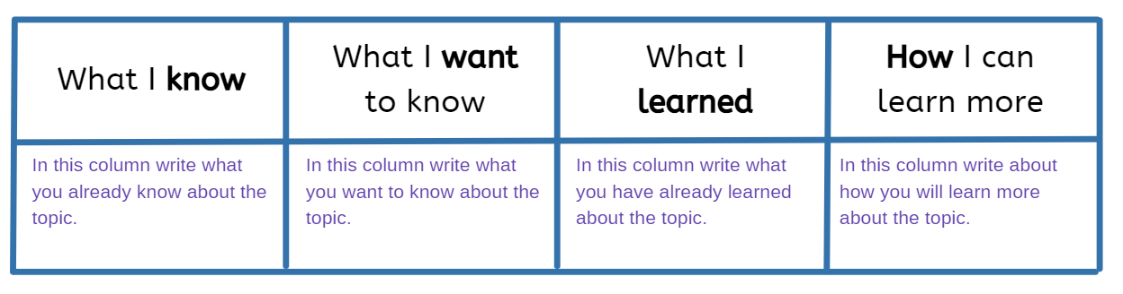
Day 1 activity 3: Numeracy, ‘what if’ maths
Notes for teachers and whānau
This activity is from the Figure it Out (FIO) series. Learners need to understand and correctly use common symbols for number operations (+ – x ÷) so they can express simple mathematical ideas and problems and interpret (and solve) mathematical equations and expressions. However, when they encounter problems that involve more than one operation, they may be confused about how to solve it and without a rule this can lead to different solutions. For example, 4 + 2 x 5 = ☐. Is this equal to 30 or to 14?
Learners use the BEDMAS rule (Brackets. Exponents, Division, Multiplication, Addition, Subtraction.) to know which order to solve a complex problem. They will also have the opportunity to explore the ‘order of operations’ in reverse, as a ‘what if’ exploration. Learners will be exploring the maths learning area and apply thinking skills.

In this activity I am learning to: apply my understanding of the order of operations in maths
What do I need?
- 30 minutes
- Look for these activities supplied in your learning pack:
- https://nzmaths.co.nz/sites/default/files/2021-03/order-of-operations-2.pdf https://nzmaths.co.nz/sites/default/files/2020-05/OrderOfOperation.pdf

Instructions:
The order of operations in maths is a set of rules that we follow when solving maths problems. You may have heard of the BEDMAS rule before:
- B :brackets
- E: exponents
- D: division
- M: multiplication
- A: addition
- S: subtraction.
We use this to solve mathematical equations and problems in a systematic way. Have your home learning book or digital doc ready to record your thinking.

Your task:
Complete the NZMaths Order of Operations activity to refresh your thinking. Solve each problem and then explain which operation was completed first and why.
Complete the Figure it Out activity FIO L4: Order of operations using your home learning book or digital doc to record your thinking
Explore: the question ‘what if’ the order of operations was reversed? What if we changed the order of operations around in our ‘number stories’ from the NZMaths Order of Operations? In your home learning book or digital doc solve the 15 problems, reversing the order of BEDMAS. What happens to the answers? What conclusion can you make?

Day 1 activity 4: Literacy, ‘what if’ writing
Notes for teachers and whānau
Learners write funny, amusing, or curious ‘what if’ captions about images and a ‘what if’ description about one of their ’what if’ questions from activity 1. Note, if they are finding that tricky they have the option to write about an animal such as ‘What if cats could talk?’ and add a picture for fun! Learners will be exploring the literacy learning area and others depending on which ‘what if’ questions they choose to write about.

In this activity I am learning to: write captions to explain what is in a photograph and write a description
What do I need?
- 30 minutes
- Home learning book, paper, or digital document

Instructions:
Let’s get creative for this one! Captions are a way to explain, elaborate or entertain using a photograph. They are like a ‘headline for a photo’ and they can be a lot of fun! Have your home learning book or digital doc ready to record your thinking.

Your task:
Examine the pictures and write funny or curious ‘what if’ captions. What are they thinking?
 |  |  |  |  |  | 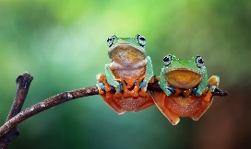 |  | 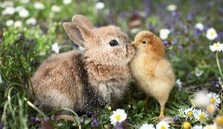
What if I wasn’t so tall?
“I have my head in the clouds today.”
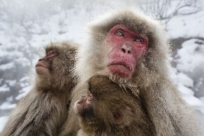 |  | 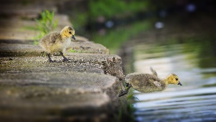 | 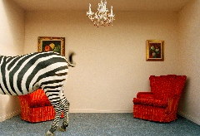 |  | 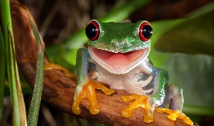 |  | 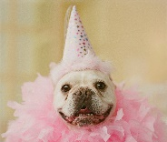
Write a ‘what if’ about an animal such as ‘What if cats could talk?’ and add a picture for fun! Remember when writing a description to use a lot of descriptive language like adjectives (huge, hilarious, bizarre) and adverbs (quietly, funnily, cautiously).
Find your own funny pictures and write some more captions.
Extension: Write a creative story about one of your ‘what if’ questions from activity 1 in your home learning book or digital doc. Add a picture to illustrate.
Congrats! That is day 1 almost finished. Today our Inquiry focus was all around “getting started” which included generating questions, activating prior knowledge, and introducing the theme ‘Curiosity’ and the context of ‘what if…’. Tomorrow we will start to explore, discover, and investigate the theme and context even more!
Remember to do your end of day reflection + wellbeing activity (See p.11 & 8–9).

Day 2 activity 1: PE, curious olympics
Ko ia kāhore nei i rapu, tē kitea | He who does not seek will not find.
Notes for teachers and whānau
Learners will explore ‘curiosity’ through some ‘what if’ activities and opportunities to explore questions and discover new knowledge. If your child has some ‘what if’ questions about sports, athletes, or the Olympics – help them make those connections to this activity. They will design their own version of the Olympic games and explore the physical education, literacy, and social studies learning areas in this activity.
Note that our Inquiry focus for today is “explore, investigate, and discover” which includes choosing and evaluating information, and thinking critically.

In this activity I am learning to: design a sporting competition
What do I need?
- 30 minutes
- List of sports

Remember to start your day right (See p. 10)

Instructions:
Today you will be designing your own Olympic Games competition with interesting and ‘curious’ sports. You may modify existing sports e.g. What if the 100m dash had to be done backward? Or you could invent an ‘animal olympics’. e.g. What if there was an olympics for animals? Let’s get creative for this one!

Your task:
Choose at least 5 sports for your Olympic competition. The table below might be useful.
List of Olympic sports
3x3 basketball  Gymnastics  Archery  Artistic swimming  Skateboarding  Sport Climbing | Beach volleyball  BMX freestyle  boxing  Canoe/kayak  Table tennis  Water polo | Diving  Equestrian  Fencing  Football  Track cycling  Trampoline | Handball  Karate  Mountain biking  Swimming  Volleyball  Weightlifting | Wrestling Tennis  Rugby  Triathlon  Rowing  Futsal
- Modify each sport using a ‘what if’ question. Give your sport a curious, new name.
- Copy the table below into your book or digital doc to plan your competition.
 | Original name | New name of sport | What if question | Notes e.g. how to win? Rules? | Materials needed
e.g. | 100m dash | Do it backwards | What if runners had to run backwards? | First to finish line wins but if everyone falls, the person closest wins | nil
Be clear: Include important notes about how the sport has been modified and make sure that you think ‘safety first’ for any sports you might like to trial today in fitness time.
Fitness fun: You could try some of the events in your fitness time. Make sure you are being safe.

Day 2 activity 2: PE, thinking skills, and maths
Notes for teachers and whānau
In this task, learners will continue to explore our theme of ‘curiosity’ through some ‘what if’ activities involving PE and sports. They will apply maths concepts they will already be familiar with and there is help and guidance if needed at https://nzmaths.co.nz/resource/awesome-athletes
Learners will be exploring the PE/Health and maths learning areas.

In this activity I am learning to: apply my knowledge of place value structure, positive and negative integers, and decimals to two places.
What do I need?
- 30 minutes
- Copy of: https://nzmaths.co.nz/sites/default/files/2020-06/AwesomeAthletes.pdf

Instructions:
In the context of racing ‘fastest’ means the lowest number, the shortest time is a smaller number. Consider what is being measured here? Now think about:
- Who wins in a jumping event: shortest or longest distance?
- Which is faster: 15.12 second or 15.21 seconds? Why?

Your task:
Explore these 3 weird world records.
- 100–year–old Cyclist: Frenchman Robert Marchand completed 300 laps at a track in Lyon, France, in record time (4:17:27) and now holds the centenarian record for the fastest 100 kilometres on bicycle.
- Treadmill distance: Christopher Bergland is officially the stationary record holder for treadmill running. He ran 247.45km in 24 hours in 2008.
- Monkey Man: Kenichi Ito completed the fastest four legged 100m run in 18.58 seconds.
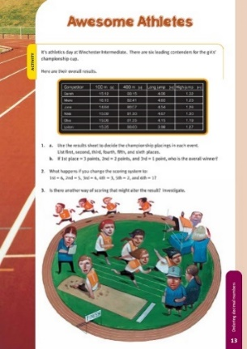
Think: How were each of these three world records measured? What units are they measured in? They are usually the first, fastest, best, most... Often in sport, athletes are ranked. Do you know of any other world records?
Complete the Awesome Athletes activity.
You will be looking at decimal numbers and the concept of ranking.
You will explore “What if you change the scoring system” and ‘What if’ there was another way of scoring”
Reflect on the Olympic sports you designed. How will winners be ranked? How is their ‘score’ measured?

Day 2 activity 3: Literacy and science, natural disasters
Notes for teachers and whānau
Today learners will have an opportunity to explore our theme of ‘curiosity’ through some ‘what if’ activities related to natural disasters. If you have a device, the links included below provide a lot of additional information to supplement the short text included here from the Science Learning Hub and the getready.govt.nz sites.
Learners will be exploring the literacy, science, and technology learning areas.

In this activity I am learning to: make connections between natural disasters and the impacts they can have on people and the environment
What do I need?
- 30 minutes
- Text adapted courtesy of the Science Learning Hub
Optional:
https://getready.govt.nz/prepared/school/whats-the-plan-stan/

Instructions:
Have you ever wondered ‘what if’ we had a tsunami/earthquake/flood? There is a lot you can do to be prepared. Today you will explore some natural disasters and consider some of the preparations for and implications of each type.

Your task:
Make a list of natural disasters you can think of in your learning book or digital doc.
Are they all natural or are some in your list manmade? If so, categorise your list.
Explore the text below (optional: you may like to do additional research on the internet).

Earthquake
Text adapted from https://getready.govt.nz/prepared/school/whats-the-plan-stan/learn-about-earthquakes/ and https://www.sciencelearn.org.nz/resources/329-investigating-earthquakes-introduction
New Zealand lies on the boundary of the Pacific and Australian tectonic plates and tectonic plates are always on the move. Tension builds as they scrape over, under or past each other. In some places, this movement is happening all the time which causes frequent small or moderate earthquakes. Other areas get stronger quakes separated by longer periods of time because the tension builds up and releases in a bigger movement. Most (though not all) earthquakes occur at faults. These are breaks that go deep within the Earth, caused by the movement of these plates. An earthquake occurs when a fault gives way and creates a breakpoint in the rock under the Earth’s surface. The closer the breakpoint is to the surface and the greater the energy, the more destructive the earthquake. An earthquake occurs at a subduction zone, where two tectonic plates try to pass each other. Along faults, rocks grind past each other, some more easily than others. Instead of sliding, some rocks lock together – but they are still being pushed, so they bend and distort, and stresses build up. Eventually, the two sides of a fault jerk past each other. This releases stored energy as shock waves (called seismic waves) that travel out through the surrounding rock, sometimes to the other side of the world. Earthquakes are measured on the Richter scale which is a scale of 1–10 that indicates the magnitude of an earthquake (the strength or amount of energy it released). If you experience an earthquake, practice the ‘Drop, cover and Hold’ strategy.
Tsunami
Text adapted from https://getready.govt.nz/prepared/school/whats-the-plan-stan/learn-about-tsunami/ and https://www.sciencelearn.org.nz/resources/59- tsunami-shoaling
Tsunami is a Japanese word meaning ‘harbour wave’. A tsunami is a series of fast travelling waves caused by a large disturbance in the sea or on the ocean floor such as an earthquake, landslide, volcanic eruption, or meteorite. The waves can be as much as an hour apart and can travel thousands of kilometres across the oceans at speeds of up to 800 kilometres per hour. Tsunamis get much taller as they approach the continental shelf and coastline. This process is known as shoaling, and the devastation caused by tsunamis is linked to how high they shoal.
A tsunami may not be noticed as it crosses deep oceans, but it loses speed and gains height when it reaches shallow water. Large waves up to 15 metres or more in height can come crashing onto the land. The effects can be worse in narrow bays and inlets. Tsunami waves can be rapidly moving tides with very strong currents that can wash people and objects out to sea. They can also be large breaking waves that can cause major damage when they hit the shore.
Big earthquakes in or near New Zealand can cause tsunami. If you feel an earthquake that lasts longer than one minute, or that is so strong it is hard to walk or stand up, a tsunami could follow. Sometimes when tsunami waves arrive on shore, it looks like the water sucks out before rushing back in. Or the waves can make unusual noises like a jet engine. Move immediately to the nearest high ground, or as far inland as you can if you are at the coast and you:
- feel a strong earthquake, or a weak rolling earthquake that lasts a minute or more.
- see a sudden rise or fall in sea level.
- hear loud and unusual noises from the sea.
Remember: Long or Strong, Get Gone.

Volcanic Eruption
Text adapted from https://getready.govt.nz/prepared/school/whats-the-plan-stan/learn-about-volcanic-activity/ and https://www.sciencelearn.org.nz/resources/936- new-zealand-volcanoes
New Zealand is on the Ring of Fire, a geographic belt encircling the Pacific Ocean. This ring contains about 90% of the Earth’s volcanoes (extinct, active, and dormant). Volcanoes come in different shapes and sizes. There are three main types found in New Zealand:
- Cone volcanoes, such as Mounts Ruapehu, Taranaki and Ngauruhoe
- Volcanic fields, such as the Auckland Volcanic Field, which has about 50 volcanoes
- Calderas such as Lakes Taupō and Rotorua.
Volcanoes erupt when pressure builds up inside the Earth. The pressure forces molten rock (magma) towards the surface. New Zealand volcanoes have different levels of activity. Some volcanoes can have hundreds, or even thousands of years between eruptions. The type of eruption depends on the amount of gases in the magma and the silica content. The gas determines how explosive the eruption will be. The silica content determines how runny the eruption will be. Some eruptions are explosive, blowing out great volumes of rocks and molten material. Others erupt in flows, pouring out clouds of hot gas mixed with streams of liquid lava. People living in volcanic regions are at risk from ash, debris, and lava flows. When there is a crater lake or torrential rain, water can mix with volcanic debris to form a swiftly moving avalanche of mud called a lahar. If you are near a volcano when it erupts:
- Close all doors and windows and stay indoors.
- If you are outside near an eruption, shelter in a car or building.
- If you are outside in volcanic ashfall, wear a dust mask or cover your mouth and nose with a cloth.
- Listen to the radio. Follow the instructions of emergency services and keep out of restricted areas.

Complete the table to make meaning, using what you have read, your prior knowledge and your inference skills. Copy this in your home learning book or digital document:
 | What is it? | Implications for people? | Implications for environment? | Top tips to keep safe.
Earthquake
Tsunami
Volcanic eruption

Day 2 activity 4: Critical thinking, curious ‘thinker’s keys’
Notes for teachers and whānau
Today learners will have multiple opportunities to explore our theme of ‘curiosity’ through some ‘what if’ activities and opportunities to explore questions and discover new knowledge using Tony Ryan’s ‘Thinker’s Keys’. The learners will be applying critical thinking skills and making connections to new learning and prior knowledge.
Learners will be exploring the literacy, social science, maths, science, and technology learning areas.

In this activity I am learning to: apply critical thinking skills
What do I need?
- 30 minutes (or more if learners want to do more!)
- Copy of the Curiosity thinkers’ keys (next page)

Instructions:
You are going to use a task grid called ‘Thinker’s Keys’ for our theme of Curiosity. You get lots of choice with this activity so pick the ones that you think sound fun or hard if you want a challenge. You will be applying your critical thinking skills.

Your task:
Using your home learning book or digital doc complete at least four of the tasks in the Curious Thinker’s Key doc on the next page.

Extension activity:
Create 4 new thinker’s keys tasks using some of your own ‘what if’ questions from activity 1 and/or your KWLH chart from activity 2. You might like to try:
- Create a Reverse Key
- Create a Combination Key
- Create a ‘What if’ Key
- Create a Different Uses Key
If you have time, do your new Thinker’s Keys activities or share with a classmate to do.
Congrats! That is day 2 almost finished. Today our Inquiry focus was “explore, investigate, and discover” which includes choosing and evaluating information, and thinking critically’. Tomorrow we will have opportunities to make meaning around our curiosities.
Remember to do your end of day reflection and wellbeing activities (See p. 11 & 8–9).

CURIOSITY Thinker’s Keys (framework based on Tony Ryan’s thinker’s keys)
The Reverse Key  List ten things you are not curious about. | The Prediction Key  Predict 10 consequences of happiness. | The Question Key  The answer is ‘curiosity’. Write 5 questions. | The Different Uses Key  List as many different uses for a water bottle as you can. | The Combination Key  Combine the body parts of 5 animals to make a new creature. Draw and describe it.
The Brick Wall Key  What if you weren’t allowed to ask questions at school? How could you explore your curiosities? | The Interpretation Key  There is a new law stating curiosity must be banished from schools. Explain why this is so. | The Inventions Key  Invent a way to save a polar bear trapped on an iceberg using rope, a rack of lamb and a pack of cards. | The Forced Relationship Key  How might a TV, book, string, and a pencil help protect the Maui dolphin? | The Alternative Key  List ways to write a book without using a pen/paper or a computer.
The Ridiculous Key  What would happen if fish could breathe and walk on land? | The Commonality Key  What do a volcanic eruption and a tornado have in common? | The Disadvantage Key  What are the disadvantages of being curious? | The Brainstorming Key  Brainstorm all of the coolest inventions you can think of. | The Alphabet Key  Create an A–Z of things you are curious about.  Create an A–Z list of Māori kupu.  Create an A–Z list of words related to inventions.
The Variations Key  Suggest 5 or more ways to explore your curiosities.  Suggest 5 ways to improve your Te Reo Māori. | The Picture Key  What does this picture have to do with curiosity? | The What if Key  What if the world didn’t have any natural disasters?  What if everyone could speak te reo Māori in NZ? | The BAR Key  Think of your bedroom. Can you make it better? Make something bigger, add something to it and replace something in it. Explain your changes and why it is better.

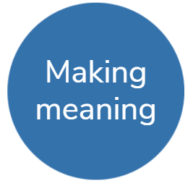
Day 3 activity 1: Maths, problem solving
He rangi tā matawhāiti, he rangi tā matawhānui. – A person with narrow vision has a restricted horizon; a person with wide vision has plentiful opportunities.
Notes for teachers and whānau
Today learners will explore ‘curiosity’ through ‘what if’ activities and questions and discover new knowledge. Learners will be exploring the maths learning area.
Note that our Inquiry focus for today is "making meaning" which includes analysing data, organising, and sorting information, summarising, synthesising, making connections/conclusions, building deeper understandings, and thinking critically.

In this activity I am learning to: solve mathematical word problems
What do I need?
- 30 minutes

Remember to start your day right (See p. 10)

Instructions:
Complete one or both problems.

Your task:
Problem 1 – Legs in a barn
One third of the animals in the barns are chickens. The rest are pigs. There are 20 legs in all. How many pigs are there?
Try: finding fractions of the whole numbers – you might like to ‘guess and check’ and/or draw a picture or table to work out the solution.
Problem 2 – Topsy turvy twins
Tia and Tom are twins. Tia saves and Tom spends. Tom finds a $20 note on Sunday evening and spends $2 a day starting on Monday. Coincidentally, Tia starts work on Monday and gets $2.50 a day. How long will it be before Tia has more money than Tom?
Try: guess and check, systematic approach and making a drawing. You might like to use a graph to compare two number sequences.
Extension activity:
In your home learning book, do the following to practice your maths skills!
Today’s number is 135
- Write it in words  - 50 less than  - 20 more than  - Add 42.  - Subtract 17  - Next odd number is | - Is it a prime or composite?  - Is it divisible by 5?  - Times by 100 and 1000  - Round to the nearest 10  - Round to the nearest 100  - What is the place value for each digit? | - Is it odd or even?  - Complete the pattern: add 9: 135,___,___,__  - List some factors  - Find one tenth  - Halve it  - Double it
BONUS: the answer is 135 write 5 questions

Day 3 activity 2: Curious about earthquakes
Notes for teachers and whānau
Today learners will practice analysing data, organising, and sorting information, summarising, synthesising, and making connections/ conclusions. Learners will be exploring science, literacy and social studies learning areas.

In this activity I am learning to: analyse data and make conclusions
What do I need?
- 30 minutes
- Texts adapted courtesy of the Science Learning Hub

Instructions:
You will read a short text to learn more about earthquakes in NZ and the Richter scale. You will then answer some questions, analyse some data, and make conclusions.

Your task:
Read the following adapted text or explore the website: https://www.sciencelearn.org.nz/resources/329-investigating-earthquakes-introduction
About 14,000 earthquakes are recorded in and around New Zealand every year. Fortunately, most of them are too small for us to feel, however there are some big ones that have become part of New Zealand history. The earthquakes in and around Christchurch in February 2011 and Kaikōura in 2016 were devastating, and reminded us all that we must be prepared for ‘the big one’. Earthquakes are measured by the Richter scale which shows the strength of the seismic waves in an earthquake. In the Richter scale, an increase of one in earthquake magnitude (e.g. from magnitude 6 to magnitude 7) represents 30 times increase in energy released.
Review the table of information below:
When? | Where? | How big? | What happened?
23 Jan 1855 | Wairarapa | 8.2 | Land raised in Wellington region
17 Jun 1929 | Buller, S. Island | 7.8 | Much destruction in Murchison area
3 Feb 1931 | Hawkes Bay | 7.8 | Napier and Hastings badly damaged, land uplifted, 256 people killed
24 May 1968 | Īnangahua Junction | 7.1 | Shallow earthquake killed 3 people and caused many slips and damaged roads and bridges
2 Mar 1987 | Edgecumbe | 6.6 | Much faulting and land sinking
4 Sept 2010 | Christchurch and surrounds | 7.1 | Many buildings damaged, land shifted, but few people injured
22 Feb 2011 | Christchurch and surrounds | 6.3 | Widespread destruction of buildings and services, hundreds injured and 185 killed
14 Nov 2016 | Kaikōura and further | 7.8 | Extensive destruction of buildings and services, land uplifted, widely felt, 2 deaths

Use your critical thinking to answer a series of questions using the table of information and what you read/already know about earthquakes in New Zealand in your home learning book or digital doc.
Knowledge | - List the three strongest earthquakes.  - Order them all from weakest to strongest.  - Which earthquakes caused fatalities?
Comprehension | - Predict which earthquake was the most destructive. Explain your thinking.  - Summarise all this information in a few sentences.
Application | - Make a map of these earthquake locations.
Analysis | - Compare what happened between the weakest and the strongest earthquakes. What do you notice?
Synthesis | - What if the earthquake in 2016 took place in Auckland?
Evaluation | - Assess where you think the most earthquake activity occurs in Aotearoa.  10. Write a conclusion from this information.

Create a timeline of earthquakes in NZ
- Offline option: using the information above or around the world
- Online option: using this site https://en.wikipedia.org/wiki/Lists_of_20th-century_earthquakes
Remember to include the year in the label and order from oldest to newest. Here is an example of how to set it up.
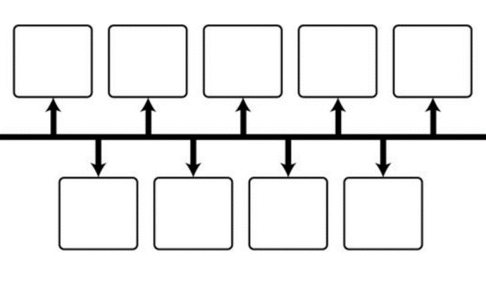

Day 3 activity 3: Thinking skills, curious ‘Thinkers Keys’
Notes for teachers and whānau
Learners will explore ‘curiosity’ through some ‘what if’ activities and opportunities to explore questions and discover new knowledge using an activity grid called ‘Thinker’s Keys’. They will be analysing data, organising, and sorting information, summarising, synthesising, and making connections/conclusions while applying critical thinking skills.
Learners will be exploring the literacy, social science, maths, science, and technology learning areas.

In this activity I am learning to: apply critical thinking skills
What do I need?
- 30 minutes (or more if learners want to do more!)
- Copy of the Curiosity thinkers’ keys (p.25 screenshot below)

Instructions:
You are going to use our Curiosity ‘Thinker’s Keys’. This time, while you still get lots of choice, challenge yourself to do the ones you think are trickier. You be applying your critical thinking skills and analysing information, synthesising knowledge, and making connections.

Your task:
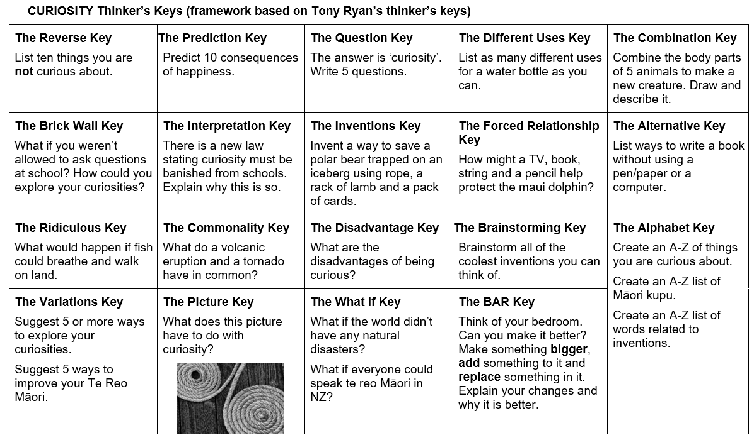
Using your home learning book or digital doc complete at least four more of the tasks in the Curious Thinker’s Key doc

Day 3 activity 4: Visual arts, curious shapes
Notes for teachers and whānau
In this task learners will tap into their curiosity and consider: what if I could turn shapes into art? Encourage them to think ‘outside the box’ and be really creative. Learners will be exploring visual arts and literacy.

In this activity I am learning to: use my curiosity to reimagine simple shapes into unique art/artefacts
What do I need?
- 30 minutes
- Paper and coloured pens/pencils

Instructions:
Let’s get creative! Let’s be curious. Today we are going to take simple shapes and then thinking like an artist or inventor, turn the simple shapes into unique pieces of art.

Your task:
What if we had to turn simple shapes into interesting art? What can you turn the humble circle into? E.g. planet earth, an emoji, a pizza. Give it a go!
Draw and create: On a piece of paper use a compass to draw 9 circles (or find something small and round to trace). Then turn each circle into something unique.
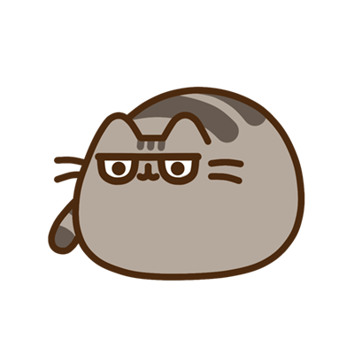

Maybe you would like to try it with another shape? A triangle, square, diamond?
Analysis: compare and contrast, which was harder? better?
Congrats! That is day 3 almost finished. Today our Inquiry focus was "making meaning" which included analysing data, organising, and sorting information, summarising, synthesising, making connections/conclusions, building deeper understandings, and thinking critically. Tomorrow we will have opportunities to dig deeper into our curiosities.
Remember to do your end of day reflection and wellbeing activities (See p. 11 & 8–9).

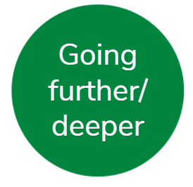
Day 4 activity 1: The giant moa lives
Whaowhia te kete mātauranga | Fill the basket of knowledge.
Notes for teachers and whānau
In this activity learners will read two texts to learn more about the moa. They will then be provoked to write a response to: “what if the moa was not extinct?”. Encourage the learners to take their time reading the texts so they can respond with more new knowledge – as this increases their ability to apply their critical thinking skills.
Learners will be exploring the literacy, science and social studies learning areas.
Note that today our Inquiry focus is “going further, deeper”. This may include opportunities to engage further and dive deeper through discussions, provocations, exploring further contexts, taking action, or thinking critically and drawing conclusions.

In this activity I am learning to: write and think creatively
What do I need?
- 30 minutes
- Copy of ‘Return of the Moa?’
- https://instructionalseries.tki.org.nz/Instructional-Series/School-Journal/School-Journal-Level-4-October-2015/Return-of-the-Moa

Remember to start your day right (See p. 10)

Instructions:
You will be reading two resources about the giant moa and consider: what if the moa could come back? Your task will be to answer high order thinking skill and comprehension questions and then respond to: What if the giant moa was not extinct?

Your task:
Read “Return of the Moa?’ by Quinn Berentson
Read this text:
There were nine species of Moa in New Zealand until about 500 years ago. Belonging to the ratite group of birds, which also includes ostriches, emus and kiwi, genetic comparisons suggest their closest relatives are the flighted tinamous of South America.
Moa lived in New Zealand, including Great Barrier, D’Urville and Stewart islands. Different species preferred different habitats, depending on the food that was available. For example, little bush moa and Mantell’s moa lived in dense forest, while the crested moa and upland moa occupied mountain zones in the South Island. It was thought that moa were exclusively grass–eating and lived only on grassy plains. It is now accepted that the coastal plains were originally forested, and that moa browsed trees, shrubs, and herbs as well as grasses. Usually, three or four moa species lived together in a habitat that had particular vegetation types.

Analysis of fossilised excrement and gizzard contents preserved in swamps suggests that moa ate a variety of shrubs and trees. However, moa foraging at heights up to 1,800 metres on a site such as Mt Owen (in north–west Nelson) must have eaten grasses and herbs since no shrubs or trees existed there above 1,200 metres. Heavy–footed moa are known to have lived in areas rich in loess (fine, wind–blown sediment) and with little vegetation. Moa had different shaped beaks and gizzard structures, indicating they were adapted to different plants.
It is uncertain what moa looked like. It is thought they were similar to emus, with a domed back. They had three front–facing toes on each foot and a small toe at the back. Their feathers were rough and furry. Female moa were usually larger than males. The largest were female giant moa, at about 2 metres tall and weighing over 250 kilograms. Some moa, such as Mantell’s moa, and males of northern populations of stout–legged moa, were smaller than a turkey.
Māori ate moa flesh, made feathers and skins into clothing, and used the bones for fishhooks and pendants. In the archaeological record, Māori use of moa began about 650–700 years ago, but moa remains do not appear in middens later than 1550. There have been claimed historic sightings of the bird, but none stood up to scrutiny. Having survived in New Zealand for millennia, with only the giant eagle as a predator, moa were almost certainly extinct by the time of European colonisation in the early 1800s. Hunting and loss of habitat led to their extinction.
Text adapted from: Trevor H. Worthy, 'Moa–Scientific classification', Te Ara–the Encyclopedia of New Zealand, http://www.TeAra.govt.nz/en/moa/page-1 (accessed 7 March 2022)
Write: using what you have learned, write a response in your home learning book or digital doc to this provocation:
“What if the moa was not extinct?”
Consider the implications of this for early Māori, European settlers, the environment, and modern–day New Zealand.
Optional online: for more information you may like to visit https://nzbirdsonline.org.nz/species/south-island-giant-moa

Extension activity:
Complete a pro–con table in your home learning book or digital doc outlining the arguments for and against de–extinction (as described in ‘Return of the Moa’).
Pro ‘de–extinction’ | Con ‘de–extinction’

Day 4 activity 2: Paper fortune teller in te reo Māori
Notes for teachers and whānau
In this activity learners will make an origami ‘fortune teller’ using Māori kupu (words). Then they will use their knowledge of te reo number kupu to solve some maths word problems. They will have the opportunity to engage further and dive
Learners will be exploring the Te Ao Māori, maths, and literacy learning areas.

In this activity I am learning to: understand and apply Māori kupu on a ‘fortune teller’ and to solve math problems
What do I need?
- 30 minutes
- Online option: Watch the video ‘How to make a fortune teller’ on YouTube at: https://www.youtube.com/watch?v=SAhiIlTxUYA

Instructions:
You will watch the video or follow the instructions to create a “Fortune Teller”. Then you will use te reo Māori number kupu to solve some math word problems.

Your task:
Can you create a Fortune Teller in te reo Māori?
Watch the video ‘How to make a fortune teller’ https://www.youtube.com/watch?v=SAhiIlTxUYA

Or follow these instructions:
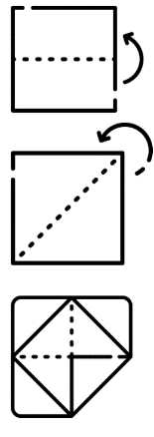
- Start with a square piece of paper
- Fold in half both ways (to make 4 equal squares when you lay it flat)
- Fold from corner to corner to create a diagonal crease. Unfold it completely.
- Take each of the 4 corners and fold them into the centre point (where all the lines cross). It will look like a small square made up of 4 folded triangles.
- Flip it over.
- Now fold in the four corners again as you did in step 4. Use your fingernail or a ruler to ensure the creases are strong.
- Flip it over – it will look like a small square made of 4 smaller squares.
- Open the pockets. Pinch the corners of the model – this will open the pockets (you may need to insert your finger into the pocket to keep it open while you work on the next corner). Once all the pockets are open you are ready.
- Insert your thumbs and index fingers into each pocket so you can use it.
Source: https://www.instructables.com/How-to-Fold-an-Origami-Fortune-Teller-How-to-Use/
Using the kupu (words) below:
- Write a colour in te reo Māori on each of the four exterior (outside) flaps. Then open and flatten it out.
- Turn it to the side that does not have the colours on it and write the numbers 1–8 in te reo Māori. Do this clockwise.
- Under each number write an emotion (or a whakataukī). **You will have to lift a flap to write the whakataukī or feeling.
- To use it: ask someone to choose one of the four colours.

Te reo Māori kupu:
Colours | Numbers | Whakataukī
Red in Māori = Whero.  Blue in Māori = Kikorangi.  Green in Māori = Kakariki.  Yellow in Māori = Kowhai.  Purple in Māori = Waiporoporo.  Orange in Māori = Karaka.  Black in Māori = mangu  White in Māori = mā | One = Tahi.  Two = Rua.  Three = Toru.  Four = Whā  Five = Rima.  Six = Ono.  Seven = Whitu.  Eight = Waru. | happy / harikoa  excited / hiamo  grateful / whakawhetai  disappointed / pāpouri  frustrated / hōhā  optimistic / whakapono  amazed / mīharo  strong / kaha  sad / hinapōuri

Consider:
- What colours will you have on the outside – write them in te reo Māori.
- What numbers will you have – write the numbers in te reo Māori.
- What Māori message will the ‘fortunes’ be in the final fold? Perhaps you can use some of the emotion kupu we learned in our wellbeing activity? Or maybe you’d like to use some whakataukī?
- Practice using your fortune teller with whānau and friends.
Solve:
Take some time to solve these te reo Māori kupu word story problems.
Problem | Your answer (remember BEDMAS)
Whitu x toru + rima =
Waru – whā ÷ rua =
Ono x whitu – rima =
Toru + toru x waru =
Tahi + ono ÷ rua =

Day 4 activity 3: Literacy, writing – curious fairy tales
Notes for teachers and whānau
In this activity learners will have some fun writing a creative ending to their favourite childhood fairy tale or writing it as if it took place in a different setting. We want them to be thinking ‘what if …’? e.g. What if ‘Goldilocks and the three bears took place in Australia? What if Cinderella and her stepsisters were best friends?’ so they can reframe the story in a new creative way. This promotes thinking critically and drawing conclusions.
Learners will be exploring the literacy learning area.

In this activity I am learning to: write creatively
What do I need?
- 30 minutes
- Home learning book or digital doc

Instructions:
Today you are going to think like a writer and reimagine your favourite childhood fairy tale. Have your home learning book or digital doc ready and follow the sequence below.

Your task:
Think:
- What if *insert fairy tale* was real? Or
- What if “insert fairy tale” had a different ending? A different setting?
- What if “insert fairy tale” characters had a different relationship or personality?
- What if “insert fairy tale” had different characters?

Re–write and illustrate your favourite fairy tale in a creative way.

Respond: Use your critical thinking – which story is better (yours or the original) and why? There are no right or wrong answers but be sure to justify your opinion. Write your response in your home learning book or digital doc.

Day 4 activity 4: Natural disasters in Māori history
Notes for teachers and whānau
In this activity learners will read more about earthquakes and apply what they have learned. Using a new text, we are encouraging learners to engage further and dive deeper through discussions, provocations, thinking critically and drawing conclusions.
Learners will be exploring the literacy, science and social studies learning areas.

In this activity I am learning to: make connections between earthquakes and Māori history
What do I need?
- 30 minutes
- Home learning book and pen or digital doc

Instructions:
You will read a text and use this to dive deeper into your understanding of earthquakes and the impact they have had on people and the environment in the past. You will also consider how to prepare for a natural disaster. Follow the sequence below.

Your task:
Read the adapted text below:
Earthquakes in Māori tradition
Long before Europeans arrived in New Zealand, Māori had experienced rū whenua (the shaking of the land). According to Māori tradition, earthquakes are caused by the god Rūaumoko (or Rūamoko), the son of Ranginui (the Sky) and his wife Papatūānuku (the Earth). Rangi was separated from Papa, and his tears flooded the land. Their sons turned their mother’s face downwards, so that she and Rangi should not see each other’s sorrow. When Papatūānuku was turned over, Rūaumoko was still at her breast, and was carried to the world below. To keep him warm he was given fire. He is the god of earthquakes and volcanoes, and he makes the rumblings that disturb the land as he walks about.
Māori accounts of earthquakes
European writers recorded several accounts of earthquakes experienced by Māori. In Old Whanganui (1915), T. W. Downes wrote that Māori reported earthquakes being less frequent and less violent before Europeans arrived. They described how about 1000 people at a Rotorua pā were swallowed up and the area became a lake.
Māori also spoke of two earthquakes along the Whanganui River. In 1838 huge falls of earth on both sides of the river caused a backwash leaving canoes stranded high on the cliffs. The earthquake caused the earth to open in parallel fissures above the pā at Utapu. The next year large masses of rock were lifted up in the riverbed below the pā; they later disappeared.
The wrath of the taniwha
In Māori tradition some earthquakes were attributed to taniwha. It was said that a taniwha travelled north from Porirua to Te Aute in Hawke’s Bay leaving a trail of destruction. At Te Aute it battled with the god Tāne, and its thrashing tail created a sandbank island in Lake Roto–a–Tara. The sandbank remains although this lake is now drained. Te Aute has two other lakes dammed by earthquakes – Poukawa and Hātuma.
Haowhenua
In the early 1900s Māori told the ethnologist Elsdon Best that Wellington’s harbour, Port Nicholson, originally had two entrances. One was the current entrance at Pencarrow, and the other was through the area which is now the suburb of Rongotai and Wellington’s airport. The nearby suburb of Miramar was an island – Motukairangi.
According to Māori tradition, there was a great earthquake in about 1460, known as Haowhenua (land swallower or destroyer). The channel between Motukairangi and the mainland became shallow enough to wade, and filled with sediment, converting the island to the present–day Miramar Peninsula.
By the time Captain James Cook arrived in the area in 1773 there was only one harbour entrance. Studies of the sediment in the isthmus indicate that the area was once below sea level, and it has been suggested that uplift might have occurred along a fault through Miramar.
European settlers arriving in the Wellington region from 1840 soon became used to the numerous small earthquakes. As these minor tremors caused no damage, people were not prepared for the severity of the quakes that followed in the future.
Source: Eileen McSaveney, 'Historic earthquakes – Earthquakes in Māori tradition', Te Ara – the Encyclopedia of New Zealand, http://www.TeAra.govt.nz/en/historic-earthquakes/page-1 (accessed 6/3/22)

Respond: in your home learning book or digital doc:
- Summarise the text in your own words.
- What conclusions can you make from reading this text about earthquakes?
Think – What if we have an earthquake?
Write a procedure of how to prepare for an earthquake or another natural disaster. Use words like first, next, then …

Congrats! That is day 4 almost finished. Today our Inquiry focus was “Going further, deeper”. This included opportunities for you to engage further and dive deeper through discussions, provocations, exploring further contexts, taking action, thinking critically, and drawing conclusions.. Tomorrow we will have opportunities to make some final connections and share our learning.
Remember to do your end of day reflection and wellbeing activities (See p. 11 & 8–9).

Day 5 activity 1–2: Preparation is key
“Curiosity is the most powerful thing you own.” ~ James Cameron
Notes for teachers and whānau
In this activity learners will use what they have learned to create a poster or video to help others be prepared in the event of a natural disaster. Learners will be exploring the literacy, science and social studies learning areas.
Note that today our Inquiry focus is: “present – share learning about the theme” which includes thinking about who the audience is and considering different ways of communicating learning for example, presentation, video, poster, etc.

In this activity I am learning to: create an information media
What do I need?
- 60 minutes
- Poster materials – paper, pens, coloured pencils
Optional: device to make a video / do additional research at https://getready.govt.nz/prepared/school/whats-the-plan-stan/
Remember to start your day right (See p. 10)

Instructions:
You will design a poster or video to help others prepare for a natural disaster. You may use earthquakes or another natural disaster that you are more curious about.

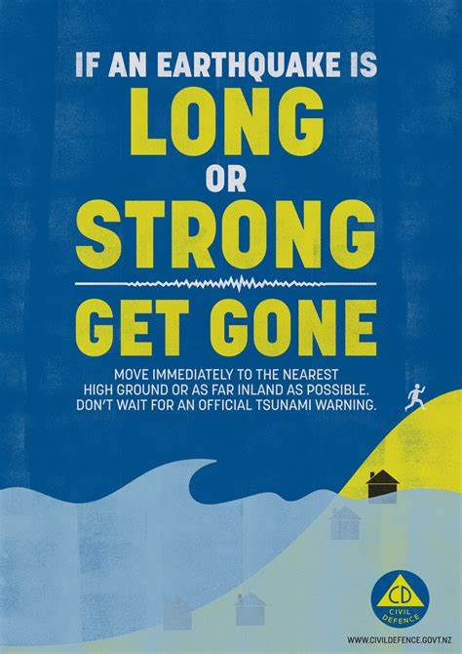
Your task:
Create an informative poster or video that:
- Has a clear message
- Uses succinct language
- Uses interesting visuals – graphic, colour, fonts, images
- Provides accurate and useful information about how to prepare for the natural disaster e.g. What to do before, during after, what to include in a survival kit, top tips etc.
When you are finished, share your poster with your whānau, teacher, or class.

Day 5 activity 3: ’What if’ natural disasters
Notes for teachers and whānau
Learners will apply their learning to write for an audience. They will make connections to the learning experiences from the week and/or their initial what if curiosities. Learners will be exploring the literacy, science and social studies learning areas.

In this activity I am learning to: write for a specific audience and purpose using descriptive language
What do I need?
- 30 minutes
- Copy of Baskets of Fire https://instructionalseries.tki.org.nz/Instructional-Series/School-Journal/School-Journal-Level-2-November-2018/Baskets-of-Fire

Instructions:
You are going to use your best writing skills to invite your reading audience to engage with your story. Follow the sequence below.

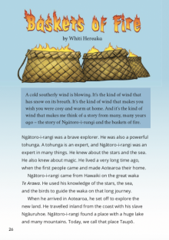
Your task:
Read Baskets of Fire and then
Write a story as if you experienced a natural disaster OR write a story about one of your ‘What if…?’ questions from Day 1.
Think about this ‘what if’ scenario and really tap into your senses to be descriptive in your writing – take your audience on a journey with you.
Share: When you are ready, read it out loud to your teacher, classmate or whānau. Optional: record yourself reading using a device.

Day 5 activity 4: Literacy, te ao Māori – curious quiz
Notes for teachers and whānau
In this final activity learners have the opportunity to create a quiz for their whānau including some information about what they have learned this week. Learners will be exploring the literacy, science and social studies learning areas.

In this activity I am learning to: write engaging questions for a trivia quiz
What do I need?
- 30 minutes

Instructions:
You will create a Quiz game that you can host for your whānau or friends to show off all your learning. Follow the sequence below.

Your task:
Read some curious facts about early New Zealand.
- New Zealand was the first country in the world to approve women’s right to vote. This took place in 1893.
- 30% of New Zealand is a national reserve
- New Zealand has the town with the longest name in the world: it is
Taumatawhakatangihangakoauauotamateaturipukakapikimaungahoronukupokaiwhenuakitanatahu.
- We have more sheep than people in New Zealand
- Dunedin has the steepest street in the world
- Aotearoa has three official languages – Māori, English and New Zealand Sign Language (NZSL)
- Each ‘tā moko’ Māori tattoo is unique
- The ‘haka’ is not only a war dance, but there are also lots of different types of haka used for different events
- Kiwis invented the referee’s whistle and ‘jogging’
Use these facts and anything from your learning this week to create a Quiz Game for your friends and/or whānau. How many questions will you make? 10? 20? 30?
**Digital option: use an online tool like Kahoot.it to create your quiz.
Still have some learning time? Do some additional Thinker’s Keys activities. Ka pai! Week one is almost done 😊 Take a few moments to revist your KWLH table.
Remember to do your end of day reflection and wellbeing activities (See p. 11 & 8–9).

Context 2: How does ... work?

The next five days indulge our curiosity by looking at how different things work.

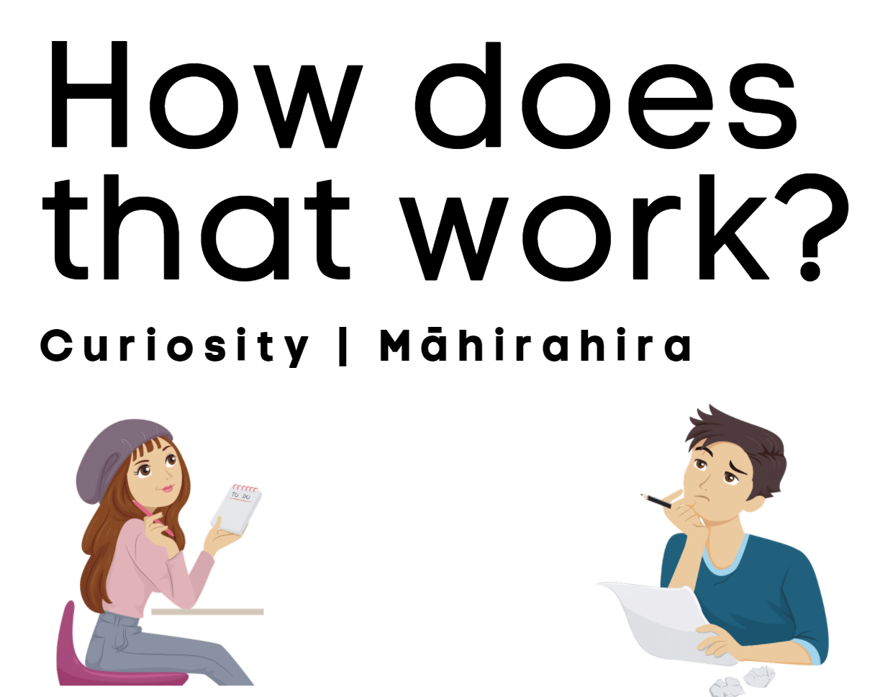

Day 6 activity 1: Inquiry getting started
“Accident is the name of the greatest of all inventors.” ~ Mark Twain
Notes for teachers and whānau
For this first task the learner will explore a text about how an x–ray works. They will be making predictions and then checking their thinking using a text. They will also complete a ‘how things work’ brainstorm to get started thinking about everything they are curious about using the question prompt ‘How does **** work?’ Learners will be exploring the literacy, science, and technology learning areas.
Note that our Inquiry focus for today is “getting started” which includes generating questions, activating prior knowledge, and introducing the theme.

In this activity I am learning to: make predictions and check my understanding
What do I need?
- 30 minutes
- Online option: Learners could explore Wonderopolis using this link: https://wonderopolis.org/wonder/how-does-an-x-ray-work

Instructions:
Today we are launching our learning around our theme ‘Curiosity’ and considering ‘How things work’. You will look at a specific example about how an X–ray works. You will need to make a prediction about how you think an X–ray works before you complete the first column in your table. Have your home learning book or digital doc ready to record your thinking. Follow the sequence below.
Your task:
Think about these this question (before you read the text or visit the websites):
- How does an X–ray work?
Respond to the question in the second column of your table (do this before you read the text or visit the websites):
Prepare your table using a whole page (leave enough room for your answers) in your home learning book or digital doc as follows:
 | What I think… | What I learned….
How does an X–ray work?
Other questions to answer:
Who invented the X–ray?
What does light have to do with X–rays?
Why is an X–ray machine such a useful invention?

Read the following text or visit the Wonderopolis site using the link below.
Text adapted from: https://wonderopolis.org/wonder/how-does-an-x-ray-work
“What do penicillin, Super Glue and X–rays have in common? Their inventors all discovered them by accident!
In 1895, German physicist Wilhelm Roentgen was experimenting with electricity in a special tube to find out how electricity acts in a vacuum. Roentgen removed as much air from the tube as possible which allowed electrons to move very quickly through the tube. The electrons bumped into each other, and the glass, cathode, and anode of the tube as they moved. Roentgen discovered that when these fast electrons bumped into the tube’s anode, they would send off a type of light called an x–ray.
X–rays are a light ray, much like the visible light we see every day. The difference between visible light and x–rays is the wavelength of the rays. Our eyes can’t see light with longer wavelengths, such as radio waves, or light with shorter wavelengths, such as x–rays. Roentgen also noticed that a fluorescent screen in his lab glowed while he conducted his experiment. He knew fluorescent material glows when exposed to electromagnetic radiation, but he was surprised because he thought the heavy cardboard around the tube would have blocked the radiation.
He experimented placing different objects between the tube and the screen. No matter what he used, the screen still glowed. Roentgen even placed his hand in front of the tube and saw a silhouette of his bones projected onto the screen. Roentgen discovered how x–rays could become extremely helpful to medicine. X–rays can pass through nonmetallic objects, including human tissues and organs. An x–ray machine is like a giant camera allowing doctors to see inside a patient without surgery.
It took a long time for scientists to make the x–ray safe. Today’s x–ray machines produce a stream of electromagnetic radiation that interacts with an anode in an x–ray tube. To reduce radiation exposure, x–ray machines aim the x–rays at only the focus area. When x–rays come into contact with our body tissues, they produce an image on a metal film. Soft tissue, such as skin and organs, can’t absorb the high–energy rays, and the beam passes through them. Dense materials like bones absorb the radiation. Black areas on an x–ray represent where the x–rays have passed through soft tissues. White areas show where denser tissues, such as bones, have absorbed the x–rays.
Have you had an x–ray? They’re commonly used to see broken bones. Doctors might order an x–ray when trying to figure out why you don’t feel well. X–rays are nothing to be nervous about. They don’t hurt at all.”

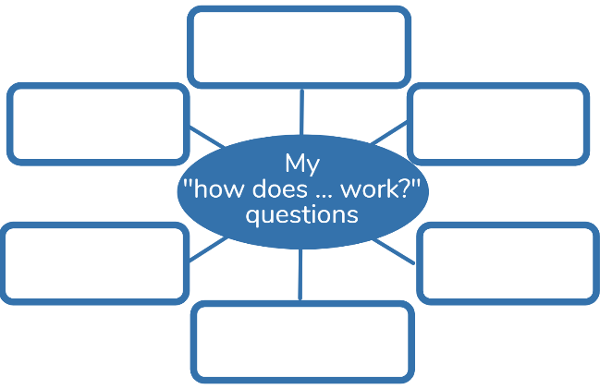
Write your new learning in the third column of your table. Were your predictions correct? Were you surprised by anything? Answer the other questions
Now that you have explored this ‘How an X–ray works’ question, it is time to tap into your curiosity. What are you curious about?
Brainstorm all the ‘How does … work?’ questions you have using a concept map like this one in your home learning book or digital doc.
Using a new page in your home learning book or digital doc, make a concept map

Day 6 activity 2: Simple and compound machines
Notes for teachers and whānau
For this first task the learner is going explore more about ‘how things work’ by reconnecting with their prior knowledge around simple machines and applying this to compound machines. They will also be using their ‘how things work’ brainstorm to reflect on their curiosities. Learners will be exploring the literacy, science, and technology learning areas.

In this activity I am learning to: use knowledge of simple machines to create a compound machine
What do I need?
- 30 minutes
- Texts below adapted courtesy of the Science Learning Hub
Digital option: for more info and a bit of fun explore http://edheads.org/simple-machines

Instructions:
In this task we continue to explore our theme ‘Curiosity’ and consider ‘How things work’. You will look at simple machines to see the role they play in compound machines and actually how many things work. Have your home learning book or digital doc ready to record your thinking. Follow the sequence below.

Your task:
Read the information below and review the table of information. Have you studied simple machines before?
Simple Machine – a machine with few or no moving parts, designed to make work easier. A simple machine is a mechanical device that changes the direction or magnitude of a force. It uses a single applied force to do work against a single load force. Examples: screw, wheel and axle, wedge, pulley, inclined plane, lever
Compound Machine – when two or more simple machines work together to make work easier. Examples: wheelbarrow, can opener, bicycle.
Using the information table on the next page Make your own table of information in your home learning book or digital doc using your own words.
Name of Simple Machine | Describe ‘how it works’ | Give 2 more examples
Inclined plane
Wheel and axle
Wedge
Screw
Pulley
Lever

Simple machine table of information (text adapted from: http://edheads.org/simple-machines and https://www.sciencelearn.org.nz/collections/shared/2c24f5428f9659e4777b23dc32e00279 )

Simple machine | Picture | Description
- Inclined plane |  | A sloping, flat surface, such as a ramp. An inclined plane can be used to alter the effort and distance involved in doing work, such as lifting loads. The trade–off is that an object must be moved a longer distance than if it was lifted straight up, but less force is needed. It helps things move up or down. Examples: staircase, ramp
- Wheel and Axle |  | A wheel and axle has a larger wheel (or wheels) connected by a smaller cylinder (axle) and is fastened to the wheel so that they turn together. When the axle is turned, the wheel moves a greater distance than the axle, but less force is needed to move it. The axle moves a shorter distance, but it takes greater force to move it. Examples: doorknob, wagon
- Wedge |  | Two inclined planes joined back–to–back. Wedges help to cut or split things. Examples: axe, zipper, knife
- Screw | 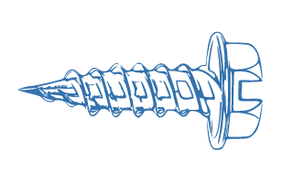 | An inclined plane wrapped around a shaft or cylinder. This inclined plane allows the screw to move itself or to move an object or material surrounding it when rotated. It helps to join things together. Examples: Bolt, Spiral Staircase
- Pulley | 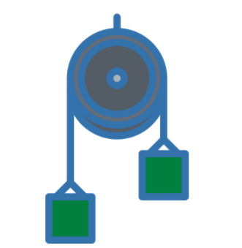 | A wheel that usually has a groove around the outside edge. This groove is for a rope or belt to move around the pulley. Pulling down on the rope can lift an object attached to the rope. Work is made easier because pulling down on the rope is made easier due to gravity. It helps to lift things up or move things down. Examples: flagpole, crane
- Lever |  | A straight rod, bar or board that pivots on a point known as a fulcrum. The fulcrum can be moved depending on the weight of the object to be lifted or the force you wish to exert. Pushing down on one end of a lever results in the upward motion of the opposite end of the fulcrum. A lever helps is lift, push, or pull objects. Examples: door on hinges, seesaw, hammer
Extra: Gear |  | Two toothed wheels fit together either directly or through a chain or belt so one wheel will turn the other. Some gears may have a screw or a toothed shaft in place of one of the wheels. A gear may also be a combination of toothed wheels that produces a certain speed (such as a bicycle's top gear which makes the bike go fast, and the low gear for slow speed.) Examples: clock, car

Look at your ‘How does *** work?’ question from your brainstorm yesterday. Which ones do you think involve simple machines? Record this in your learning book.

Challenge: combine two or more simple machines to create a compound machine. Draw and label it in your book. What does it do?

Day 6 activity 3: How things work
Notes for teachers and whānau
The learner will explore ‘how things work. They will be using their knowledge about simple and compound machines to make predictions and connections about how things work. Learners will be exploring literacy, science, and technology.

In this activity I am learning to: explore how things work and make connections
What do I need?
- 30 minutes
- Connected ‘Show and Tell’ for the “I am Alice” article by Bronwen Wall. https://instructionalseries.tki.org.nz/Instructional-Series/Connected/Connected-2016-Level-2-Show-and-Tell
- And/or Connected ‘Cracking the Code’ for the ‘To build a bot’ article by Rebecca Hawkes. https://instructionalseries.tki.org.nz/Instructional-Series/Connected/Connected-2018-Level-3-Cracking-the-Code

Instructions:
Today you are going to look at and read about some common items to consider ‘how they work’. Have your home learning book or digital doc ready to record your thinking.

Your task:
- Choose ‘I am Alice’ or ‘To build a bot’ (or both!) Quickly read or skim the article.
- Think: What simple machines do you notice? Record in your book or digital doc.
- Copy and complete this table in your home learning book or digital doc.
Table of information: What am I and how do I work?
What am I? | How do I work? (Include simple machines) | Image / drawing
Toaster |  | 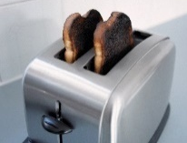
 | I am a combination of simple machines – the lever, pulley and gears enable me to lift heavy objects like steel beams and concrete, up to 18000 kilograms. This means no stairs or ramps are needed. I have a heavy sturdy base, a long arm that acts like a simple lever and at least one pulley (usually more). The lever and pulley work together to multiply the lifting force. You often see me on a construction site.
 | I am an example of a wheel and axle used to mix ingredients. Turning the wheel and axle rotates the beater requiring less effort to mix things quickly and evenly. I have one or two metal blades which rotate when you hand turn my geared wheel.
Bicycle |  | 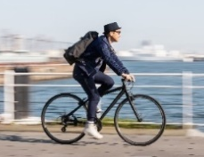
Extension activity:
Challenge: Do one of your own. Maybe one from your ‘How does ** work?’ brainstorm.

Day 6 activity 4: Music and maths
Notes for teachers and whānau
The learner is going explore more about ‘how things work’. They will be using their prior knowledge about data displays to consider ‘how data displays work’ so they can evaluate the best ways to represent different data. There is an extension activity as well if time permits. Learners will be exploring the maths and arts learning areas.

In this activity I am learning to: evaluate data displays while making connections between music and maths
What do I need?
- 30 minutes
- Pipe Music https://nzmaths.co.nz/sites/default/files/PipeMusicClass.pdf
- Social Sounds https://nzmaths.co.nz/sites/default/files/2021-02/social-sounds.pdf

Instructions:
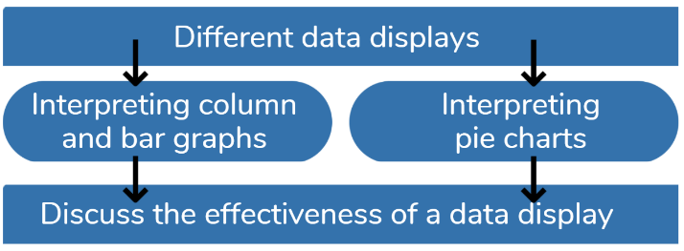
Today you are going to evaluate data displays to see if they represent the findings of a statistical investigation. You will also practice your addition and subtraction of decimals. Then you have the option to create your own survey and data display.

Your task:
Think and reflect:
- How do people make music? How has this changed over time?
- How do people listen to music? How has this changed over time?
- How can music create a mood? What music makes you sad? Happy? What would you say are the differences between happy and sad music?
- Think about a scary movie. Would it be scary without the soundtrack?
Follow the instructions:
Use your prior knowledge about data displays, graphs, interpreting data displays and determining the effectiveness of a data display. Can you think of ways to display data?
Think: Which is a bar graph? Pie chart? Line graph? Column graph? How do you know?
Answer: Using the data displays above answer the following:
- Look at the pie chart: What percentage of class pets are dogs or birds?
- Look at the column graph: How many pets are neither cats nor dogs?
- Which data display is the best for displaying which are the most popular types of pets? Why do you think so?
Look at the following data set:
A year 6 class investigated how people listen to music with the following question:
Which way do you usually listen to music?
They grouped their data and set it out in the table below:
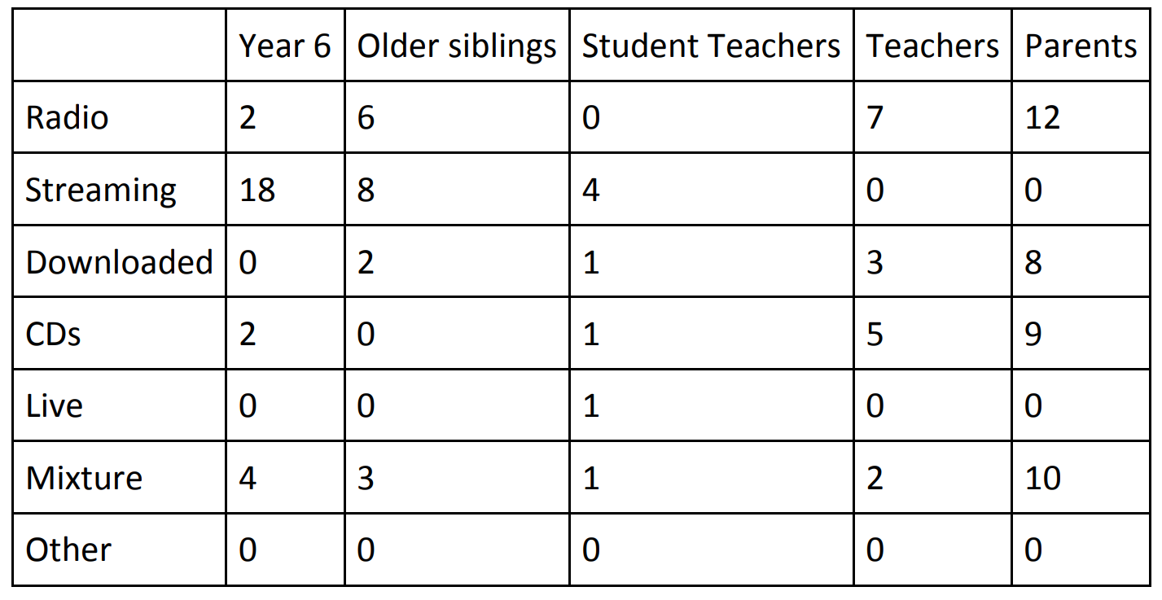
When they analysed the data, they came up with the following conclusions:
- Older people (parents and teachers) listen to the radio or CDs, iTunes, etc.
- Younger people prefer the internet.
Discuss the effectiveness of the data table in leading to their conclusions
Record your thinking in your home learning book or google doc referring to the table as needed. Reminder: you are writing down whether you think this table helped the students make logical, true conclusions.
Complete the problems in the Pipe Music with Decimals task – there should be a copy in your pack or online: https://nzmaths.co.nz/sites/default/files/PipeMusicClass.pdf

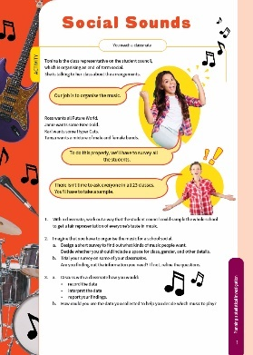
Extension: Complete the Social Sounds activity from the Figure it Out series
https://nzmaths.co.nz/sites/default/files/2021-02/social-sounds.pdf

Remember to do your end of day reflection and wellbeing activities (See p. 11 & 8–9).

Day 7 activity 1: Infographics
“Nothing is less instructive than a machine.” ~ Simone Weil
Notes for teachers and whānau
For this first task the learner is going explore more about ‘how things work. They will investigate how to make and use infographics to represent data and information visually to help others understand ‘how things work’. Learners will be exploring the literacy, visual language and te ao Māori.
Note that our Inquiry focus for today is “explore, investigate, and discover” which includes choosing and evaluating information, and thinking critically.

In this activity I am learning to: understand what an infographic is
What do I need?
- 30 minutes
- Home learning book or digital doc

Remember to start your day right (See p. 10)

Instructions:
Today you are going to look at an infographic to understand what they are and how they work. Then you will have time to create one of your own. Have your home learning book or digital doc ready to record your thinking. Follow the sequence below.

Your task:
Read this:
We just looked at some graphs and pie charts which are ways to communicate information in a clear way for maths. Infographics are different and they are a powerful way to communicate information because they can depict a variety of things in one document. They are often used for scientific topics. They are also able to show relationships between pieces of information. They are visual, simple and have limited text. They are usually used to supplement an article, essay, or opinion piece.
Infographics generally have 3 parts: a visual component – the graphics and colour, content component – statistics and data and a knowledge component – the insights or conclusions that come from the data.
Examine the infographic on the next page and write your answer to these questions:
- What are the visual components? How do the graphics help you understand the message?
- What are the content components? What content is being shared? How do you know it is true?
- What are the knowledge components? What is the main message being communicated?

Māori identity and wellbeing is threatened by climate change
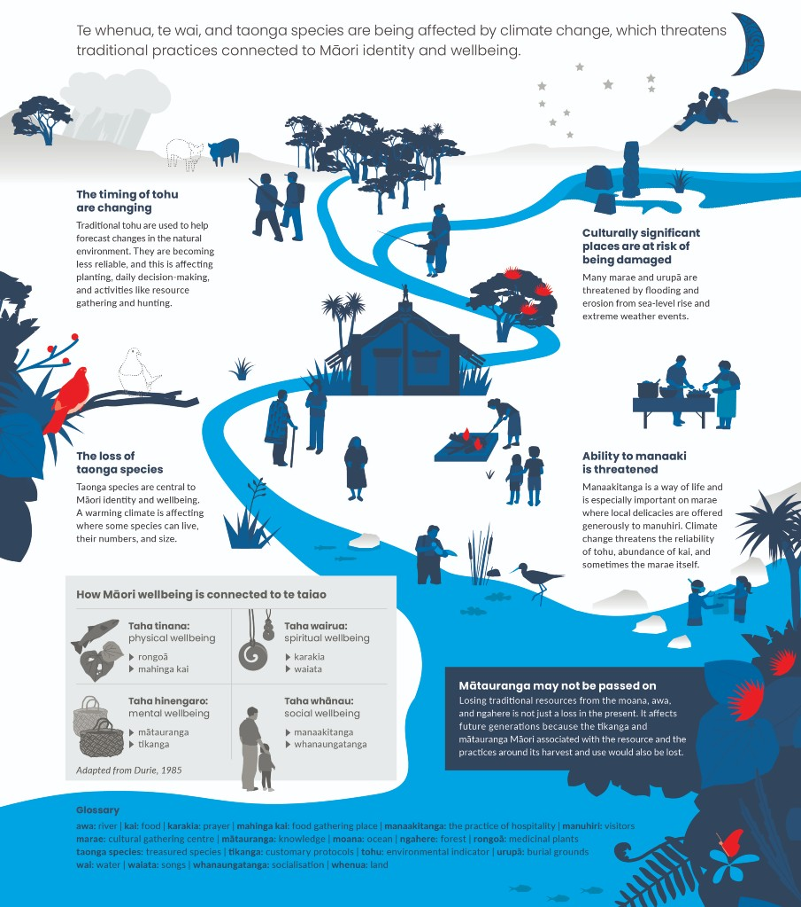
Source: https://environment.govt.nz/publications/our-atmosphere-and-climate-2020/chapter-4-climate-change-and-our-wellbeing/
Te reo Māori – kupu connections
Which te reo Māori kupu were used in this infographic? Highlight or circle.
awa – river | mātauranga – knowledge | tikanga – customary protocols | ngahere – forest
kai – food | manuhiri – visitors | marae – cultural gathering centre | moana – ocean
whenua – land | Rongoa – medicinal plants | whānaungatanga – socialisation | waiata – songs
wai – water | manaakitanga – hospitality | tohu – environmental indicator
 | urupā – burial grounds | taonga species – treasured species
Answer:
- Do you notice any other te reo Māori kupu in the infographic? Write them down.
- What purpose and/or effect does using te reo Māori in an infographic have?

Day 7 activity 2: Te ao Māori – tools and simple machines
Notes for teachers and whānau
For this first task the learner is going to demonstrate ‘how things work’ by creating an infographic about Māori tools. So they will be using their knowledge from the previous activity and applying it to new knowledge. Learners will be exploring the literacy, science, and technology learning areas.

In this activity I am learning to: identify a variety of tools used by Māori and create an infographic
What do I need?
- 30 minutes
- Paper/pens to draw an infographic

Instructions:
Using what you have learned in activity 1, you are going to read some information and then create an infographic about Māori tools.

Your task:
Read:
Stone tools
When Māori ancestors first arrived in New Zealand from East Polynesia, around 1250 to 1300, they found a range of rock types for making tools, ornaments, and other items. They were familiar with materials like basalt and chert (flint) but not with others, such as pounamu. Within 50–100 years several major centres of stone–tool manufacture was established. In the 1300s, Māori were transporting both finished tools and selected raw materials around the country.
Adzes and chisels
The most important tools were adzes (toki) and chisels (whao). Stone adze heads were tied to a wooden handle and used in working wood, including canoe building. Chisels were used for finer carving. Early adzes had a well–defined grip for tying to a handle. The majority were made from basalt or other hard rock, notably adzite, a very tough, fine–grained metamorphic rock, also called baked argillite greywacke, which is hard sandstone. In the North Island, the main type of adze style was a relatively simple form without a defined butt, generally made from greywacke or basalt, but in some cases from nephrite, argillite, and gabbro (a coarse–grained plutonic rock). Similar adzes in the South Island were made from nephrite. Adzite and nephrite are found only in the South Island, yet adzes made from these materials have been found throughout New Zealand, indicating extensive trade.
Making an adze
Making a stone adze was a skilled job. Boulders or blocks were broken up using other boulders. Pieces were worked into the desired shape (a roughout) by striking flakes off the edges with hammer stones, which were also used to smooth rough surfaces by ‘pecking’ or ‘bruising’. The final step was to polish the adze and sharpen the cutting edge by rubbing it back and forth on a wet grinding stone (hōanga).

Flake tools
Sharp flakes of obsidian (matā – volcanic glass) and chert were used for cutting and scraping. Obsidian is found almost exclusively in the north of the North Island, with the largest deposits on Mayor Island (Tūhua). Obsidian from this source was traded throughout the country. Chert was widely exploited in New Zealand, and in Otago silcrete (hard quartz sandstone) and porcelanite (baked clay) were used on sites of moa hunters. Other flake tools were made from basalt and greywacke. In Taranaki, large ‘choppers’ were common, and may have been used for slaughtering seals.
Drills and files
Drill points were used to make holes in wood and stone, and, during the early period, for making one–piece bone fishhooks. They were made from various materials, chert, obsidian, and some of the same rock types used for adzes. Making a fishhook involved drilling out the central part of a flat, rectangular piece of bone (usually moa), then shaping it with stone files. The files were sandstone, or in some cases schist or petrified wood. Larger slabs of sandstone (hōanga) were used like modern whetstones, for polishing and sharpening adzes.
Weapons
During the 17th and 18th centuries, patu (shorthand clubs) were Māori stone weapons. Patu ōnewa were made from greywacke, various volcanic rock types – including pumice – and from nephrite (mere pounamu). These appear to have been used mainly in the north and can be found in artefact collections from Ōruarangi pā on the Hauraki Plains. In the South Island, patu may have been used for killing seals and moa.
Fishing
Fishing was an important activity in Māori life. Stone trolling lures (also called minnow lures), with bone or shell points attached, were used to catch fish such as kahawai and barracouta. They were made from argillite, schist, or greywacke, but also from other materials, including limestone and serpentine. Stone sinkers were made by forming a shallow groove around a pebble or cobble and winding a line around it. Large stones were used as anchors, and pumice as floats for fishing nets.
Gardening
Māori used stone extensively for gardening adding sand and gravel to soil, to make them friable, retain moisture, and improve heat retention – critical for subtropical plants growing in temperate climate. Sand and gravel dug out of old river terraces were placed in hollows in the topsoil up to 30 centimetres deep, and the excavated topsoil placed on top, to form a mound.
Stone rows
Cobbles and rough stones were used to make low, rows 1–2 metres wide and up to tens of metres long. These were usually in groups, called stone row systems, and were laid out parallel, often in association with circular stone mounds 1–2 metres in diameter. Some stone rows marked garden plot boundaries. Other stones were dug from nearby underground deposits (leaving well–defined pits) or brought from riverbeds and put into purpose–built shallow trenches. The excavated soil was replaced over the stones. The stones improved heat retention and warmed the soil above them, and the rows themselves were probably gardened.
Other uses
Flax was prepared for use as a fibre by beating it with stone pounders (patu muka). These pounders were often made from greywacke or volcanic rock.
Rounded stones were used in earth ovens (hāngī or umu) and were carefully selected as certain rocks explode violently when heated in a fire. Good stones would be presented as a gift to other tribes. Volcanic rocks were the most suitable, while greywacke was also used.
At Ruarangi in Northland, they were considered so well–suited for the task that they were called ‘stones crying for food’ (ngā kōwhatu tangi kai o Ruarangi).
Water–smoothed cobbles (autoru) were used for crushing kōkōwai, a red or yellow iron oxide. The powder was used in body painting and on carvings and stored in pumice pots. Red kōkōwai or ochre is still used on carvings.
Children and adults used spinning or whipping tops, made from pumice but also greywacke, volcanic rock, and wood. They were spun with a flax whip. Some nose flutes (nguru), like those found at Ōruarangi on the Hauraki Plains, were made from stone, including sandstone, pumice, and hard volcanic ash.”
Information adapted from: Phil Moore and Bruce McFadgen, 'Kōhatu–Māori use of stone – Stone tools', Te Ara – the Encyclopedia of New Zealand, http://www.teara.govt.nz/en/kohatu-maori-use-of-stone/page-1 (accessed 7 March 2022)
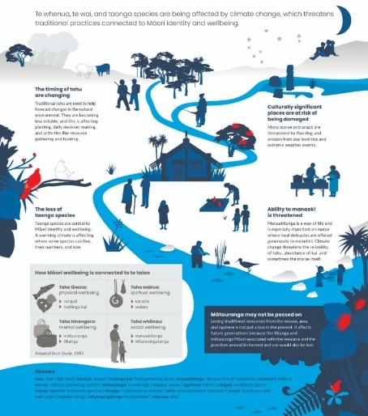
Refer to the infographic we used in activity 1.
Create your own infographic to communicate the information you just read about Māori Tools.

Consider:
- Who is your intended audience?
- What is your infographic going to communicate? E.g. the knowledge component. How will you ensure this is credible? (Fact checking).
- What visual components will you use? (What images, diagrams, data charts?)
- What content components will you use? (What facts, stats, or information?)
- How will you use colour to amplify the effect?

Extension: create another infographic about one of your ‘How does ** work?’ questions or any other topic that interests you. Remember to fact check.
Bonus: can you identify which tools were simple machines? Which simple machines?

Day 7 activity 3: Critical thinking – a choice grid
Notes for teachers and whānau
The learner is going explore more about ‘how things work using a choice grid that uses Bloom’s taxonomy which is a series of questions that develops critical thinking. It is expected that they will choose activities that have different levels of thinking, the simplest being ‘Knowing’ to the higher learning level of ‘Evaluating’. As they complete an activity they could highlight it so you can both see where they have been.
There are multiple opportunities to explore ‘curiosity’ through these activities as well as opportunities to explore questions and discover new knowledge. Learners will be making meaning as they make connections between newer learning and prior knowledge. The learners will have a lot of choice for this and will have additional opportunities to engage with this grid in the coming days.
Learners will be exploring the literacy, science, and technology.

In this activity I am learning to: apply critical thinking skills
What do I need?
- 30 minutes
- Copy of the Curiosity Choice Grid

Instructions:
This task is all about curiosity and choice! You will use the Curiosity Choice Grid to apply your learning and critical thinking skills. There are a range of activities depending on what you like and a series of activities that start at the ‘Knowing’ level which is the simplest form and moving along to ‘Evaluating’ which are more complex activities.

Your task:
Using your home learning book or digital doc complete at least four of the tasks in the Curious Choice grid on the next page.

Extension: Create a new row of activities to add to the Curiosity Choice Grid for ‘I like to learn at home’. What fun activities could you design for others to complete?

CURIOSITY Choice Grid (question levels based on Bloom’s Taxonomy)
 | Knowing | Understanding | Applying | Analysing | Creating | Evaluating
I like language | Make a Venn diagram to compare two simple machines | Translate ten words from the texts you have used into te reo Māori. | Create an acrostic poem for the word CURIOSITY | Choose a machine and make an argument that it is the best! | Invent a new compound machine that makes something better. | Design a rubric to assess your own learning this week.
I like maths | Make a table to categorise / classify examples of simple machines | Prepare a flow chart to show the stages of a making a see saw or other simple machine. | Calculate: How much is CURIOSITY worth (vowels =$5 and consonants =$3, each syllable is worth $10) | If a=1, b=2, c=3, d=4, =5, f=6, g=7, h=8 etc. Calculate the total for each simple machine. E.g. Lever= 12+5+22+5+18=62 Do this for: inclined plane, wedge, wheel & axle, pulley, screw | Hypothesise what would happen if the world didn’t have any levers | Make a list of criteria to evaluate the effectiveness of a machine
I like visual art | Make an illustrated timeline of 10 inventions | Make a cartoon of how man discovered the wheel and axle | Sketch a compound machine. | How do simple/compound machines have anything to do with fashion? | Design a string game that you can play on your own. | Compare two inventions using a Venn diagram
I like movement | Walk around your house and make a list of ten curious items | Express yourself. Make a cheer like a cheerleader for the word ‘pulley’ | Act out the 6 simple machines using props you can find around your house | Classify items around your home into the 6 simple machine categories. | Explore your yard and make a list of all the simple/compound machines you see | Adapt an instrument to make it better – can you add, enlarge, replace something?
I like music | Use some of the new words you have learned to make a tongue twister | Identify 5 songs that are about curious things | Write a silly song about how things work to the tune of twinkle litter star. | Compare the wheel and axle to a pulley | Judge 3 songs using a criteria grid that you make. | Compose an original song about inventions
I like to collaborate and create for others | Create a What am I game using ‘fast facts’ about machines | Explain how something works in your house. | Combine 5 new words to write a story about a curious child. | Create a wordsearch for a classmate | Convince – write a persuasive speech about why the skateboard is an important invention. | Modify and adapt a skateboard to make it better. Explain why it is.
I like to learn and reflect on my own | Write a paragraph about what would happen if there were no machines. | Write a letter to your principal explaining why playground equipment teaches us science. | Write a series of interview Qs to ask a parent about inventions. | Advertise – create an ad for what you think is the best invention. | Defend – why the world would fall apart without simple machines. | Rewrite a famous song or poem to be about inventions.

Day 7 activity 4: Maths problem solving
Notes for teachers and whānau
For this task the learner will explore their curiosity through maths problem solving.
Learners will be exploring the maths learning area.

In this activity I am learning to: apply my number knowledge and make connections to our Curiosity theme
What do I need?
- 30 minutes
- Copy of Level 3: https://nzmaths.co.nz/sites/default/files/See-sawAntics.pdf
- Copy of Level 4:https://nzmaths.co.nz/sites/default/files/NumberCrunching_0.pdf

Instructions:
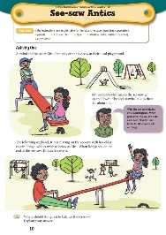
You are going to complete some ‘curious’ problem–solving tasks. You be applying your critical thinking skills and maths knowledge. Have your home learning book or digital doc ready to record your thinking. Follow the sequence below.

Your task:
Complete 1 or both problems using the NZMaths resources.
Option 1: from https://nzmaths.co.nz/resource/see-saw-antics
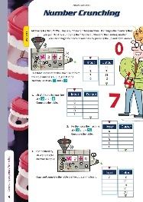
Use your knowledge of number strategies with whole numbers, fractions, decimals, and percentages to solve problems about simple machines
Option 2: from https://nzmaths.co.nz/resource/number-crunching
Use your awesome algebra skills to solve simple linear equations. You will be able to create and apply a ‘what if’ number machine to different inputs and predict the outputs.
Extension: Complete this Number of the Day problem.
Today’s number is 287
In your home learning book, do the following to practice your maths skills!
- Write it in words  - 50 less than  - 20 more than  - Add 42.  - Subtract 17  - Next odd number is  - Halve it  - Double it | - Is it a prime or composite?  - Times by 100  - Times by 1000  - Round to the nearest 10  - Round to the nearest 100  - What is the place value for each digit? | - Is it odd or even?  - Is it divisible by 5?  - Complete the pattern: add 9: 287,___,___,__  - List some factors  - Find one tenth  - Write a word problem whose answer is 287
BONUS: the answer is 287 write 5 questions
Remember to do your end of day reflection and wellbeing activities (See p.8–11).

Day 8 activity 1: How does artificial intelligence work?
“We are not thinking machines that feel; rather we are feeling machines that think.” ~ Antonio Damasio
Notes for teachers and whānau
The learner is going explore more about ‘how things work’ and use their knowledge from previous activities. They will be exploring the literacy, science, and technology.
Note that our Inquiry focus for today is "making meaning" which includes analysing data, organising, and sorting information, summarising, synthesising, making connections/conclusions, building deeper understandings, and thinking critically.

In this activity I am learning to: explain how artificial intelligence (AI) works
What do I need?
- 30 minutes
- Connected: Emotional Robots from https://instructionalseries.tki.org.nz/Instructional-Series/Connected/Connected-2018-Level-4-Digital-Space/Emotional-Robots

Remember to start your day right (See p. 10)

Instructions:
Today you are going to look at ‘how does artificial intelligence work?’

Your task:
Get ready – Find the text Emotional Robots (there should be a copy in your pack or access online at the link above.
Before you read!
- Scan the text – look at the title, subheadings and images. What is the article’s purpose?
- Read to the bottom of page 3.
- Noticing – What do you notice at the bottom of page 3?
Questions! Yes, what do you notice about the questions? These are called ‘rhetorical questions’. Rhetorical questions do not require an answer, rather they are there to make a point, to emphasise something or to get people thinking. This article uses many rhetorical questions. Can you find them? What is your response to each? Make a note of this.
Purpose – the author is trying to make us think about advantages and disadvantages of AI.
- Skim the text to look for any new vocabulary in the text and write these new words or terms in your home learning book or digital doc.
- Complete a PMI in your book using the perspective of two direct quotes to identify what Greg and Nick think the positives/negatives/interesting points are about AI.
What might have influenced their perspectives/points of view. Answer these questions:
- What is Greg’s job? How might that influence his perspective on AI?
- What about Nick’s background? How might that influence his thinking about AI?
- Whose perspective do you trust the most? Why?
- Should someone’s background influence your view of their opinion? Why do you say that?
- Has this discussion prompted any more questions for you?

Day 8 activity 2: Maths problem solving
Notes for teachers and whānau
For this task the learner will explore their curiosity through maths problem solving.
Learners will be exploring the maths learning area.

In this activity I am learning to: use a range of multiplicative strategies when operating on whole numbers
What do I need?
- 30 minutes
- Copy of https://nzmaths.co.nz/resource/escape

Instructions:
Complete this problem

Your task:
A prisoner sits in his cell planning his escape The prisoner is kept in by 5 laser beams, which operate along a corridor. Each laser is switched off at a specific time interval for just long enough to allow a person to walk through. The time between being switched off for each laser is shown below:
- Laser one = every 3 minutes
- Laser two = every 2 minutes
- Laser three = every 5 minutes
- Laser four = every 4 minutes
- Laser five = every 1 minute
The guard checks the prisoner when all beams are off simultaneously. As each laser only switches off for a short time the prisoner knows he can only get past one laser at a time. He has to get past the five lasers from 1 to 5 in order. Laser one is at the entrance of the cell and Laser five is at the outside door. He also knows that if he spends longer than 4 minutes 12 seconds in the corridor an alarm will go off. Can the prisoner escape without the alarm going off? If he can escape, how many minutes should he wait before passing Laser one? How much time will he have after passing Laser five before the guard raises the alarm?
Consider:
- What information is given? What strategy can you use?
- How can you group the information? Is there another way to write the problem?
- Is there a sequence of times when the laser beams are off that can help us?
- Can you look for a sequence of common multiples?
- How can we use the information? What can we do to solve the problem?
- Have we considered all the information? Is there another solution?
Complete this Number of the Day problem. Today’s number is 465
- Write it in words  - 50 less than  - 20 more than  - Add 42.  - Subtract 17  - Next odd number is  - Halve it  - Double it | - Is it a prime or composite?  - Times by 100  - Times by 1000  - Round to the nearest 10  - Round to the nearest 100  - What is the place value for each digit? | - Is it odd or even?  - Is it divisible by 5?  - Complete the pattern: add 9: 287,___,___,__  - List some factors  - Find one tenth  - Write a word problem whose answer is 465
BONUS: the answer is 465 write 5 questions

Day 8 activity 3: Tā moko
Notes for teachers and whānau
In this lesson they will learn more about how ‘Tā moko’, the Māori tradition of tattooing. They are going to learn from those who have received them and those who know about how they are designed to dive deep into this important cultural tradition for Māori people. Learners will be exploring te ao Māori, literacy, and visual art.

In this activity I am learning to: describe the process and significance of traditional tā moko tattoo
What do I need?
- 30 minutes
- Puaki https://instructionalseries.tki.org.nz/content/download/ 41983/466720/file/SJL4%20Puaki.pdf
Online optional resources: https://www.zealandtattoo.co.nz/tattoo-styles/maori-tattoo/ and https://www.teaomaori.news/kaiti-students-witness-live-ta-moko-classroom

Instructions:
You are going to read and learn about ‘Tā moko’, the art and practice of traditional Māori tattoo. Puaki means “to come forth, to reveal, to give testimony” and in this article four people explain why they proudly wear tā moko and how their facial moko connect the past with the present.

Your task:
- Copy the table below into your home learning book.
- Brainstorm what you already know about Tā moko and ‘how it works’ in the first column.
What I know | What I learned
- Read the text ‘Puaki’.
- Complete the ‘what I learned’ column in the table.
- Write about Tā moko from the various perspectives (summarise key message). You might like to use a table like this.
 | Hapu/Iwi affiliations | Key message
Kaana Cooper Skipper
Gary Te Ruki
Priscilla Ruha
Rangi McLean

- Skim the article again hunting for kupu (words) and create lists in a table:
New or unfamiliar words in English | Te reo Māori kupu | Names of places, iwi/hapu

Explore the different designs used in tā moko.
Choose a few designs that you related to tā moko, and draw these in your home learning book. Provide the name of each design, the meaning, and how it might be used.
Optional digital: watch this Te ao Māori news story : https://www.teaoMāori.news/kaiti–students–witness–live–ta–moko–classroom

Day 8 activity 4: Curiosity choice grid
Notes for teachers and whānau
For this task the learner is going to return to Curiosity choice grid. It is expected that they will choose new activities with a range of different levels of thinking. The simplest being ‘Knowing’ to the higher learning level of ‘Evaluating’. As they complete an activity they could highlight it so you can both see where they have been.

The learners will be making meaning as they make connections between newer learning and prior knowledge. The learners will have a lot of choice for this activity.

Learners will be exploring the literacy, science, and technology learning areas.

In this activity I am learning to: apply critical thinking skills
What do I need?
- 30 minutes
- Copy of the Curiosity Choice Grid

Instructions:
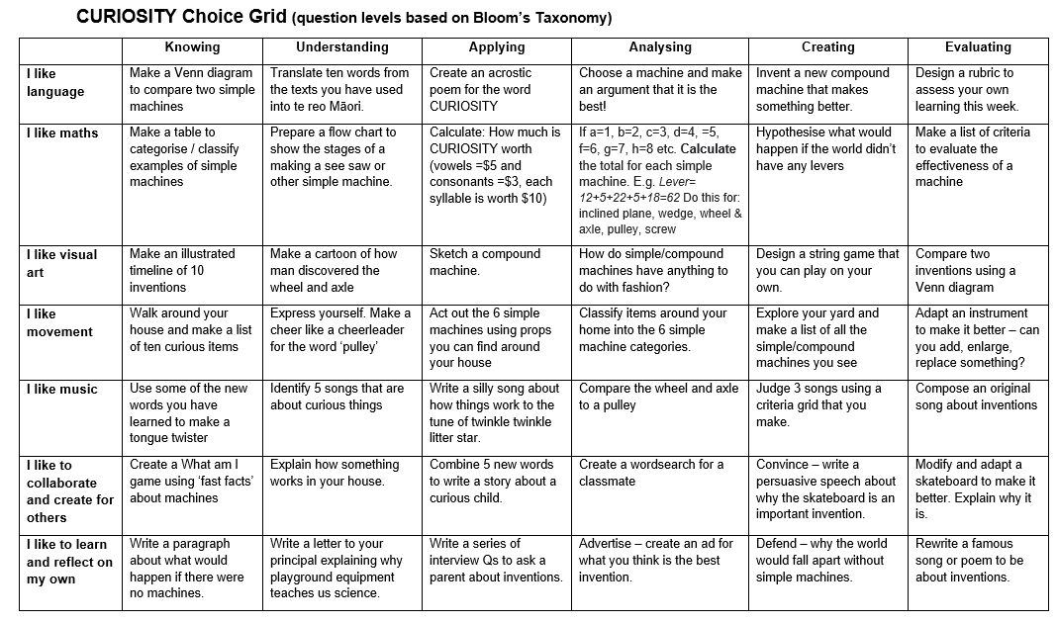
It is time to return to our Curiosity choice grid (page 55) to apply your learning and critical thinking skills. There are a range of activities depending on what you like and a series of activities that start at the ‘Knowing’ level which is the simplest form and moving along to ‘Evaluating’ which are more complex activities. Make sure you choose new activities from yesterday.

Your task:
Using your home learning book or digital doc complete at least four of the tasks in the Curious choice grid from yesterday.

Remember to do your end of day reflection and wellbeing activities (See p. 11 and 8–9).

Day 9 activity 1: Pros and cons of AI
“The best way to predict the future is to invent it.” ~ Alan Kay
Notes for teachers and whānau
For this first task the learner is going explore more about ‘how AI works’ and then choosing to defend or criticise AI in a persuasive piece of writing. They will also be using their knowledge from the previous activities. Have them refer to the text we used in activity 1 yesterday. Learners will be exploring literacy, science, and technology.
Note today our Inquiry focus is “going further, deeper”. This may include promoting opportunities to engage further and dive deeper through discussions, provocations, exploring further contexts, taking action, or thinking critically and drawing conclusions.

In this activity I am learning to: defend pros and cons about AI
What do I need?
- 30 minutes
- Connected: Emotional Robots https://instructionalseries.tki.org.nz/Instructional-Series/Connected/Connected-2018-Level-4-Digital-Space/Emotional-Robots

Remember to start your day right (See p. 10)

Instructions:
Yesterday we read ‘Emotional Robots’ and today you are going to write a persuasive piece of text to either defend or criticise AI. Have your home learning book or digital doc ready to record your thinking. Follow the sequence below

Your task:
Revisit the text ‘Emotional Robots’
AI is a controversial topic. Let’s consider some of the implications.
Complete a pro and con chart for AI. Copy this into your home learning book.
Pros of AI | Cons of AI
Write: use the information in your pro/con chart to write a persuasive paragraph to defend or criticise AI and the creation of robots with increasingly human attributes.
Before you write you might also like to consider:
- Who will choose the cultures of the robots?
- How could a chatbot be programmed to behave in culturally appropriate ways?
- What about the gender of the robot?
- In books, movies, and TV shows, the drive is for robots to be “faster, stronger, better”. How does this fit with the ideas about inclusivity? What are the implications for people with disabilities?
- The AI may require personal information about you so you can interact with it. Who would own the information?
- What are the potential consequences of sharing your personal information with an automated assistant?

Day 9 activity 2: Design and promote your own AI
Notes for teachers and whānau
For this task the learner is going explore more about ‘how AI works’ by creating their own. They will also be using their knowledge from the previous activities. Have them refer to the text we used in activity 1 yesterday. Learners will be exploring the literacy, visual language, and technology.

In this activity I am learning to: design and promote your own AI teacher, friend, or parent
What do I need?
- 30 minutes
- Copy of Level 4 Connected: Emotional Robots from https://instructionalseries.tki.org.nz/Instructional-Series/Connected/Connected-2018-Level-4-Digital-Space/Emotional-Robots (Emotional Robots google slides)
- Optional online for fun: https://quickdraw.withgoogle.com/

Instructions:
Today you are going to design your own AI parent, teacher, or friend. Have your home learning book or digital doc ready to record your thinking. Follow the sequence below

Your task:
Think about the qualities you would want your AI to have.
Design an AI teacher or parent or friend
Consider:
- What can your AI do?
- What can’t it do?
- What could go wrong?
- How would you prevent that from happening?
Create an advertisement for your AI design, to promote their functions and explain how they work and what has been done to ensure they are safe and fit for purpose.
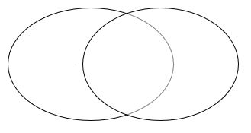
Extension:
Can you think of some automated assistants? E.g. Siri, Cortana, Google Assistant, and Alexa. How are they different with regards to speech recognition, clarity, relevance of the answers, accuracy of the answers, speed of the answers, or range of functions. Compare 2 of them in a Venn Diagram.

Day 9 activity 3: ‘How does ... work?’
Notes for teachers and whānau
For this task the learner is going explore more about ‘how things work’ using their own original questions from Day 6. They will engage further and dive deeper through discussions, provocations, exploring further contexts, taking action, or thinking critically and drawing conclusions
Learners will be exploring the literacy, science, and technology learning areas.

In this activity I am learning to: dig deeper into one of my own ‘how does ** work’ questions
What do I need?
- 30 minutes
- Your ‘how does ** work’ brainstorm from Day 6

Instructions:
Today you are going to ‘go deeper’ on a question of your choice from the ones you brainstormed on Day 6 (or a new ‘how does ** work** question you now have). Going deeper on a topic of inquiry requires you to engage further and dive deeper through discussions, provocations, exploring further contexts, taking action, or thinking critically and drawing conclusions.

Your task:
Choose from the following options:
Option 1: Select one of your original questions and make an infographic to explain ‘how it works’. | Option 2: Research one of your questions more thoroughly and write an explanation. You might like to include a diagram.
Option 4: Make an infographic about tā moko, AI, types of instruments, history of music or natural disasters / Olympics (our learning from week 1). | Option 4: use what you know about simple machines to create a machine that will improve an aspect of your daily life. Draw and label it.

Day 9 activity 4: Curiosity choice grid
Notes for teachers and whānau
For this task the learner is going to return to Curiosity choice grid. It is expected that they will choose new activities with a range of different levels of thinking. The simplest being ‘Knowing’ to the higher learning level of ‘Evaluating’. As they complete an activity, they could highlight it so you can both see where they have been. The learner will be going deeper and using critical thinking as they make connections between newer learning and prior knowledge.

Learners will be exploring the literacy, science, and technology.

In this activity I am learning to: explore my curiosity and practice my critical thinking skills
What do I need?
- 30 minutes
- Copy of the Curiosity Choice Grid

Instructions:
It is time to return to our Curiosity choice grid (page 55) to apply your learning and critical thinking skills. There are a range of activities depending on what you like and a series of activities that start at the ‘Knowing’ level which is the simplest form and moving along to ‘Evaluating’ which are more complex activities. Make sure you choose new activities from yesterday and try to choose the ones that will challenge you and stretch your thinking skills.

Your task:
Using your home learning book or digital doc complete at least four of the tasks in the Curious choice grid. Highlight all the ones that you have completed. Ka pai!

Remember to do your end of day reflection and wellbeing activities (See p. 11 and 8–9).

Day 10 activity 1: Connecting & sharing – create a quiz to show what I know
He waka eke noa – A canoe which we are all in with no exception
Notes for teachers and whānau
Today your learner will make connections to all their learning this week by preparing a True/False quiz. They will be showing their learning across multiple learning areas and the key competencies too.
Note that today our Inquiry focus is “present – share learning about the theme” which includes thinking about who the audience is and considering different ways of communicating learning for example, presentation, video, poster, etc.

In this activity I am learning to: connect my learning to create a quiz
What do I need?
- 30 minutes
- Home learning book or digital doc

Remember to start your day right (See p. 10)

Instructions:
Today you are going to ‘be the teacher’! You will create an assessment task that will demonstrate your learning. Have your home learning book or digital doc ready to record your thinking. Follow the sequence below

Your task:
Create a quiz to show what you know!
Choose the type of quiz you wish to create (multiple choice, true/false, short answer, matching, or all types!)
Create the questions (at least 10)
Make the answer sheet (this demonstrates that you know the answer).
Find someone to give your quiz to – you could even make it a game!

Day 10 activity 2: The machines in our body
Notes for teachers and whānau
For this task the learner is going explore more about ‘how things work’ by applying what they have learned about simple machine to their own bodies. They will also be using their knowledge from the previous activities. Learners will be exploring the literacy, te ao Māori, science, and technology.

In this activity I am learning to: identify the 3 types of levers and identify examples in our bodies
What do I need?
- 30 minutes
- Text below courtesy of the Science Learning Hub
https://www.sciencelearn.org.nz/resources/1924-what-levers-does-your-body-use

Instructions:
Today you are going to read more about machines. This time about the simple machines in your won body! Have your home learning book or digital doc ready to record your thinking. Follow the sequence below.

Your task:
Read:
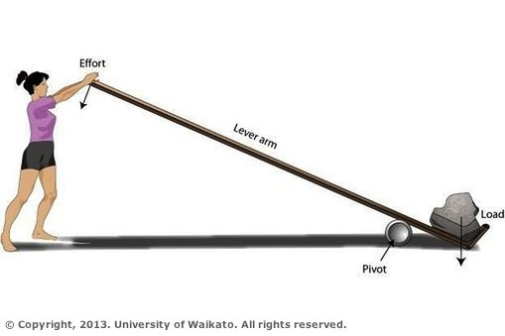
What levers does your body use?
Muscles and bones act together to form levers. A lever is a rigid rod (usually a length of bone) that turns about a pivot (usually a joint). Levers can be used so that a small force can move a much bigger force. This is called mechanical advantage.
Mechanical advantage – Levers can be used so that a small force can move a much bigger force. This is called mechanical advantage. In our body’s bones act as lever arms, joints act as pivots, and muscles provide the effort forces to move loads.
There are four parts to a lever – lever arm, pivot, effort, and load. In our bodies:
- bones act as lever arms
- joints act as pivots
- muscles provide the effort forces to move loads
- load forces are often the weights of the body parts that are moved, or forces needed to lift, push, or pull things outside our bodies.
Levers can also be used to magnify movement, for example, when kicking a ball, small contractions of leg muscles produce a much larger movement at the end of the leg. Levers are able to give us a strength advantage or a movement advantage but not both together.

Types of levers
Different classes of levers are identified by the way the joint and muscles attached to the bone are arranged.
Different classes of levers are identified by the way the joint and muscles attached to the bone are arranged.
For the Class 1 lever the pivot lies between the effort and load. A see saw in a playground is an example of a Class 1 lever where the effort balances the load.
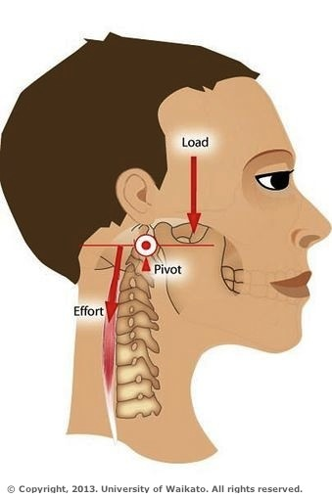
This pivot exists in the place where your skull meets the top of your spine. Your skull is the lever arm and the neck muscles at the back of the skull provide the force (effort) to lift your head up against the weight of the head (load). When the neck muscles relax, your head nods forward.

Class 1 lever – nod your head
Different classes of levers are identified by the way the joint and muscles attached to the bone are arranged.
For a Class 1 lever the pivot lies between the effort and the load. A see saw in a playground is an example of a Class 1 lever where the effort balances the load.
The place where your skull meets the top of your spine is a Class 1 lever. Your skull is the lever arm and the neck muscles at the back of the skull provide the force (effort) to lift your head up against the weight of the head (load). When the neck muscles relax, your head nods forward.
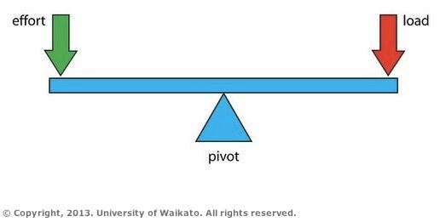
The pivot is the place where your skull meets the top of your spine. Your skull is the lever arm and the neck muscles at the back of the skull provide the force (effort) to lift your head up against the weight of the head (load). When the neck muscles relax, your head nods forward.
For this lever, the pivot lies between the effort and load. A see saw in a playground is another example of a Class 1 lever where the effort balances the load.

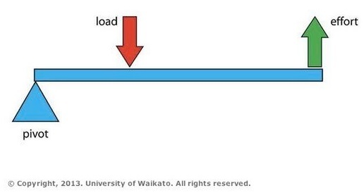
Class 2 lever – stand on tip toes
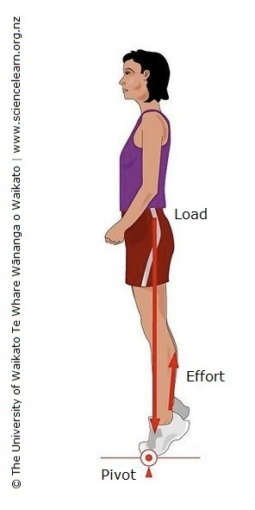
The pivot is at your toe joints and your foot acts as a lever arm. Your calf muscles and Achilles tendon provide the effort when the calf muscle contracts. The load is your body weight and is lifted by the effort (muscle contraction).
Different classes of levers are identified by the way the joint and muscles attached to the bone are arranged.
For the Class 2 lever the load is between the pivot and the effort (like a wheelbarrow). The effort force needed is less than the load force, so there is a mechanical advantage.
Standing on tip toes is a Class 2 lever. The pivot is at your toe joints and your foot acts as a lever arm. Your calf muscles and Achilles tendon provide the effort when the calf muscle contracts. The load is your body weight and is lifted by the effort (muscle contraction).
The load is between the pivot and the effort (like a wheelbarrow). The effort force needed is less than the load force, so there is a mechanical advantage. This muscular movement at the back of your legs allows you to move your whole body a small distance.
Different classes of levers are identified by the way the joint and muscles attached to the bone are arranged.
For the Class 2 lever the load is between the pivot and the effort (like a wheelbarrow). The effort force needed is less than the load force, so there is a mechanical advantage.
Standing on tip toes is a Class 2 lever. The pivot is at your toe joints and your foot acts as a lever arm. Your calf muscles and Achilles tendon provide the effort when the calf muscle contracts. The load is your body weight and is lifted by the effort (muscle contraction).

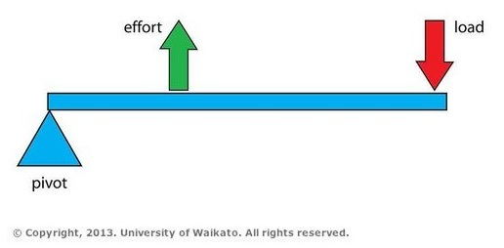
Class 3 lever – bend your arm
The pivot is at the elbow and the forearm acts as the lever arm. The biceps muscle provides the effort (force) and bends the forearm against the weight of the forearm and any weight that the hand might be holding.
Different classes of levers are identified by the way the joint and muscles attached to the bone are arranged.
For a Class 3 lever the load is further away from the pivot than the effort. There is no mechanical advantage because the effort is greater than the load. However this disadvantage is compensated with a larger movement. This type of lever system also gives us the advantage of a much greater speed of movement.
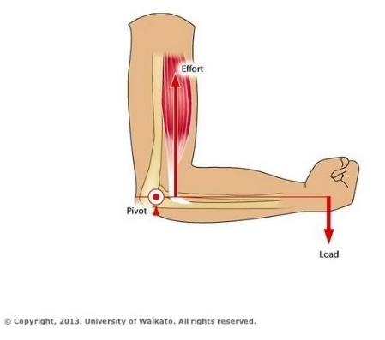
A bent arm is a Class 3 lever. The pivot is at the elbow and the forearm acts as the lever arm. The biceps muscle provides the effort (force) and bends the forearm against the weight of the forearm and any weight that the hand might be holding.
The load is further away from the pivot than the effort. There is no mechanical advantage because the effort is greater than the load. However, this disadvantage is compensated with a larger movement – a small contraction of the biceps produces a large movement of the forearm. This type of lever system also gives us the advantage of a much greater speed of movement.
Different classes of levers are identified by the way the joint and muscles attached to the bone are arranged.
For a Class 3 lever the load is further away from the pivot than the effort. There is no mechanical advantage because the effort is greater than the load. However, this disadvantage is compensated with a larger movement. This type of lever system also gives us the advantage of a much greater speed of movement.
A bent arm is a Class 3 lever. The pivot is at the elbow and the forearm acts as the lever arm. The biceps muscle provides the effort (force) and bends the forearm against the weight of the forearm and any weight that the hand might be holding. Many muscle and bone combinations in our bodies are of the Class 3 lever type.

Connect:
Go back through your home learning book or digital document. Can you see where there were examples of the three types of levers? Can you think of other examples?
Make a table:
Type 1 Levers | Type 2 levers | Type 3 levers

Day 10 activity 3: Visual language, health and te reo Māori
Notes for teachers and whānau
Today your learner will pick and choose aspects from this week’s learning to present and share. They are going to plan a ‘sharing my learning’ event that will include choosing what to showcase, preparing an invitation, planning a simple healthy snack, and using te reo Māori. You may like to support them with the direction they take with this task if there has been something they have shown particular interest in. Learners will be exploring visual language, health and te ao Māori.

In this activity I am learning to: plan an event using bi–lingual language
What do I need?
- 30 minutes
- Paper and coloured pencils

Instructions:
Today you are going to plan an event. Follow the sequence below

Your task:
Choose what you want to share from this week (and last week if you want to) and how you want to share it. Consider:
- A guided tour through your home learning book
- A gallery of learning artefacts
- A series of images from your learning in a slide show
- A video recording of your self – explaining what you’ve learned
- Or another wonderful way
Design an invitation. Who are you inviting? When will it take place? Where? Any special information to include? Use some Māori kupu such as:
Learning | Food related | Questions | Other
Taonga – treasure  Kia ora – hi, thanks  Tēnā koe – greet 1  Tēnā kōrua – greet 2  Tēnā koutou – greet 3  Ae – yes  Ako – learn  Ākonga – learner  Kaiako – teacher  āpōpō – tomorrow  Hangarau – technology  Tūrangawaewae – place to stand | Manaakitanga – hospitality  Puku – belly  Hauora – healthy  Inu – to drink  Kai – food  Wai – water  Ngaungau – snack | Aha? – what?  Hea? – where?  Hia? – how many?  Wai? – who?  āhea? – when?  pūtake – reason | Hui – gathering  Harae mai – welcome  Nau mai – welcome  Manuhiri – guests  Waiata – song  Koha – gift  Aroha – love  Tuākana – senior relative  Whānau – family  Hīkoi – journey  Kōrero – talk  Katakata – to laugh
Plan a healthy snack to have for your guest(s). Promote this in the invitation, everyone likes kai!
‘Send’ your invitation! And get ready for your event.

Day 10 activity 4: Sharing my learning, it’s show time!
Notes for teachers and whānau
For this first task the learner is going share their learning from the week with you at the event they have planned. You should have received an invitation!

Learners will be exploring the literacy, science, and technology learning areas.

In this activity I am learning to: confidently present my learning with others
What do I need?
- 30 minutes
- Materials as required to share your learning

Instructions:
Today you are going to host your ‘Sharing my Learning Event’.

Your task:
Before you start:
Prepare a short feedback form for your guest/guests. It could include:
- What went well / even better if
- PMI Chart
- Or you can create a series of questions
Host your event. Remember to be a good host – whānaungatanga is important.
Share all your learning with your guests.
Ask them to complete your feedback form.
Read the responses and reflect – what could you have done differently or better to improve your Sharing my Learning event?

Congrats – you have almost finished 2 weeks of amazing learning! Ka pai!

Remember to do your end of day reflection and wellbeing activities (See p. 11 and 8–9).

