A learning from home pack

For learners in years 9–10 (Week 1 Draft)

Curiosity | Māhirahira

Context 1: What if ...?

Context 2: How does ... work?

Layout of the resource
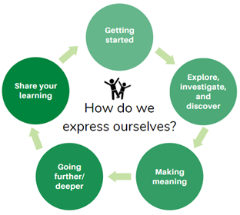
This pack is filled with learning activities for your learners that can be used at school or at home. All activities are framed around the theme of curiosity | māhirahira.
Suggestions are provided for starting the day with a karakia (see p. 8), check in with the teacher, and setting up the learning environment. You can replace these with how you want your learner to start their day.
The activities follow an inquiry learning model (figure 1) exploring one theme through two contexts. Each day the learner will be working through one part of the model culminating with sharing their learning on days 5 and 10.
Figure 1 Inquiry learning model

Realities
You know your learners and have a good understanding of their learning situations.
Many learners will have siblings at home, as well as whānau who share the same space and materials. Some may have access to the internet and devices, and others may not. Learners will also have varying levels of adult support.
There are a mix of activities in this pack that use materials commonly found in most homes. Some activities will require adult support while others can be managed independently. This resource is provided as a Word document so that you can adapt it for your learners.
We suggest starting each day with a karakia (see p. 8), check in with the teacher, followed by setting up the learning environment. The pack contains suggestions, but you can replace these with however you want your learner to start their day.

Resources
You might want to send these home with the learner: a “my home learning” exercise book, pencils, crayons, or felts, and some craft materials (glue, scissors, construction paper). Learners can bring their notebook back to class to share.
If your learners do not have reliable access to the internet, here are the resources to print and send home with this to create a paper-based pack.

Resources to print
- https://nzmaths.co.nz/resource/boxed-bisuits
- https://nzmaths.co.nz/resource/worms-work
- https://nzmaths.co.nz/sites/default/files/BirthdayTreat.pdf
- https://www.roadshow.org/content/resources/NZscientists/illingworthNorris.php)
- https://teara.govt.nz/en/maori-foods-kai-maori/page-2

Setting up the learning environment
Encourage whānau to support learners to set up a space for learning at home. Learners might like to design their own space as a separate learning activity. Some materials they may need could include pen, pencils, paper, a notebook, colouring pencils, glue, scissors, and a device to access the internet.
Many of the suggested activities and experiences include the use of optional online resources which can be accessed and viewed using a Smartphone if necessary.

Overview of the learning in this pack
The theme of curiosity | māhirahira will be explored through two contexts.
- Days 1–5 look at this idea through the context of what if…?
- Days 6–10 look at this idea through the context of how does … work?
Learners will explore, investigate, discover, and make meaning as they go through each task. There are times where they look a little deeper into the topic. Some of the tasks may be independent hands-on tasks while some may involve connecting and sharing with others.
Day 1 | Day 2 | Day 3 | Day 4 | Day 5
What is curiosity? Use prior knowledge to define the concept of curiosity | Investigate and discover using ‘what if’ questions | Being curious about food and our kitchens | Think of a problem/challenge in the kitchen to overcome. | Share your learning – find out ways you can be successful in presenting and put these skills to practice!
Day 6 | Day 7 | Day 8 | Day 9 | Day 10
Week 2 activities coming soon

Daily timetable
Below is a possible daily timetable. We have allocated 30 minutes for each activity; your learner may take more or less time than this for an activity. We suggest your learner takes the time they need to complete an activity. This may mean they choose which activities they will complete for the day, rather than complete them all.
At the start of each day the learner will draw up their timetable for learning. You can adjust the timing to suit the other activities that might be happening the day, such as Zooming with the class/teacher.
Time | Activity
9:00 am | Starting the day
9:30 am | Activity 1
10:00 am | Break
10:30 am | Activity 2
11:00 am | Fitness break
11:30 am | Activity 3
12:00 pm | Lunch time
1:00 pm | Activity 4
1:30 pm | Reflection time
2:00 pm | End of the school day

Daily fitness – Choose something each day
It is important to include a fitness activity every day. Please ensure that your learner includes activities at their fitness and ability level in their daily timetable. If possible, it would be great to do the fitness activity with your learner or have them complete it with their siblings where appropriate. Below are a range of activities to choose from – or you can make up your own ideas!
Create your own fitness circuit:
Select 5 or more of these exercises and create your own fitness circuit in your home or outside. Repeat your circuit multiple times.
- Running on the spot  - Skipping  - Galloping  - Slip stepping  - Brisk walking  - Marching on the spot  - Astride jumps/Straddle jumps  - Double foot jumps – side to side – forward and back | - Hops – on the spot – forward  - Jumping  - Knee Lifts  - Heel to Bottom kicks  - Step Ups  - Shuttle Runs/Line Sprints  - Abdominal Crunchies  - Push Ups  - Lunges
Tahi–rua–toru Fitness challenge – Crabwalk–superman–bear crawl
You will need a water bottle and your ‘can do’ attitude!
Tahi – Crab walk. Start sitting down on the floor and then use your legs and arms to lift up your torso and walk around like this for as long as you can.
Rua – Superman. Lay down on the floor with your face towards the floor, relax. Now lift your legs slightly off the floor and put your arms out like superman. How long can you remain in this position?
Toru– Bear crawl. Start the bear crawl in a push up position. Your hands should be beneath your shoulders, your back is strong, and your core is engaged. Your feet should be hip distance apart with heels off the floor.
- Move forward by simultaneously (at the same time) moving the right hand and the left leg in a crawling motion. **Your knees never touch the ground.
- Switch sides immediately after placing weight on the right hand and left leg, moving the left hand and right leg forward.
- Continue in a crawling motion, moving forward for as long as you can.
Repeat the three sets of exercises three times.
Can you beat yourself? Great efforts!

Ball challenge countdown
You need a small ball, like a tennis ball for this activity.
- Tekau − Toss the ball in the air and catch x 10
- Iwa − Toss the ball in the air and clap and catch x 9
- Waru − Toss the ball in the air and clap three times and catch x 8
- Whitu − Toss the ball in the air and clap behind your back and catch x 7
- Ono − Toss the ball in the air and clap behind and clap in front and catch x 6
- Rima − Toss the ball in the air, snap and clap and catch x 5
- Whā − Toss the ball in the air, clap behind, snap, clap in front and catch x 4
- Toru − Toss the ball in the air clap under each of your knees and catch x 3
- Rua − Toss the ball in the air, touch head, shoulder, knees & toes and catch x 2
- Tahi − Toss the ball in the air and turn around and catch x 1, and you’re done!
Mahuru Dance
Go to https://music.youtube.com/watch?v=-BrdaUUTMBY&feature=share and watch Pere Wihongi sing Mahuru (earth Wind and Fire’s song ‘September’ in Te reo Māori).
Practice singing it in te reo and then make up a little dance or fitness routine.
Maybe you can dance with lower body when you hear ‘Mahuru’?
Maybe you can dance with your upper body every time you hear ‘kōrero Māori’?
Have fun with it and move your body!
Māori Movement
Start with a warmup here: http://www.maorimovement.co.nz/warm-up
TŪMATAUENGA is the Māori God of War. Māori Movement is Manu waewae – focusing on isometrics and balance through ‘peruperu’. You will use your waewae (leg/feet) to build your understanding of ‘ihi’ which is your essential force and builds self-control by holding the position of Tū Tane (known as the war stance).
1.You will practice 3 levels of ‘peruperu’.
2.The challenge is to hold the position of Tū Tane for 30 seconds.
Here is your challenge
http://www.maorimovement.co.nz/courses/ruaumoko/level-1-ruaumoko

Daily wellbeing – Choose something each day
These activities are good to do at the beginning and end of the day but can be done anytime. They can help you get ready for learning; calm your mind and body and they can help you to reflect on your learning:
Relaxation routine
Plan a routine that might help you to relax before bedtime. Ask people in your house what they do to relax before going to sleep? Try your routine out for a week and observe any changes in your sleep patterns.
Time Capsule
Make a time capsule that includes information about your life today. Which people are important to you? What are you most grateful for? What are your favourite things? What goals do you have for the future? Keep this somewhere safe and write a date on the top that you plan to open it in the future. Don’t forget where you put it!
Gratitude: Overlooked blessings
Being grateful can help increase your happiness and reduce stress.
Take a moment to think …
- What does it mean to be grateful?
Feeling grateful isn’t always easy and might not come naturally. It’s pretty easy to compare yourself to others or focus on any challenges or frustrations in your life.
Gratitude is a muscle you can build, just like learning any skill or strength, through practice.
Take another moment to think …
- What are some things in your life that you take for granted but when you stop and think about it – you are grateful for them (e.g. Running water, electricity,
- What are some things about your health and the way your body works that you take for granted and are grateful for?
- What are some things about the people you know that you take for granted but you are really grateful for?
Breathe in and be curious about how you are feeling after finding your overlooked blessings.
Wellbeing checklist
Have you:
- Drunk water? Do you have a water bottle with you? Staying hydrated is important.
- Taken mini breaks to stretch/walk around? Keep your brain alert and your heart pumping.
- Stopped to think of something you are grateful for?
- Connected with someone to have a chat, korero?
- Planned time to do your favourite activity?
- Planned my fitness activity for today?
- Got healthy snacks ready for the day? Healthy food for a healthy body and mind!
- Made your bed? Tidied your workspace/bedroom?
- Been outside? Even for a brief walk? You need vitamin D and fresh air!
- Paid it forward? Have you done something nice for someone else?
Smile Scrapbook
Make a scrapbook or collage to show things that make you smile or things that you are proud of.

Starting each day
Notes for teachers and whānau:
Starting the same way each day helps create a structure for your learner. Your school might have your own way to do this, for example starting the day together as a class on Zoom. In this pack we provide a karakia to settle into the day. Saying the karakia with your learner a few times will help them be able to do this more independently tomorrow and beyond. As part of the start of the day and setting up the learning environment, help your learner look through the activities suggested for that day and choose a fitness and wellbeing activity. They could fill out their daily timetable and think of other activities they might like to do, like reading.
Remind your learner of when and how to check in with the teacher/you.

Karakia
Here is a karakia to welcome in the day
https://www.otago.ac.nz/cs/groups/public/@maori/documents/webcontent/otago667429.mp3
Whakataka te hau ki te uru  Whakataka te hau ki te tonga  Kia mākinakina ki uta  Kia mātaratara ki tai  E hī ake ana te atakura  He tio, he huka, he hau hū  Tīhei mauri ora! | Cease the winds from the west  Cease the winds from the south  Let the breeze blow over the land  Let the breeze blow over the ocean  Let the red-tipped dawn come with a sharpened air.  A touch of frost, a promise of a glorious day.

Planning my day
- Have you chosen which activities you will do today and in which order?
- Remember to choose a fitness activity (see p. 5).
- Have you chosen a wellbeing activity (see p. 7)?
- Have you done a ‘Wellbeing check-in’?
  - How are you feeling today?
  - How do you feel about your readiness to learn this morning?
  - What do you need extra assistance with today? Who could you get to help you? What strategies could you use to make your learning more effective?
  - What would you like to do as a quiet time activity to end your day?
- Remember to do your Reflection at the end of the day (see p. 9).

Ending each day
Please ensure your learner does this at the end of each day.
Reflection can be challenging, but it can also provide rich opportunities to think about how learning is progressing. Use the questions below as prompts to encourage your learner to think about what they have learned and to plan out their next steps. If you have concerns or find that they are needing more help, contact their teacher for support.

In this activity I am learning to: reflect on my learning.
What do I need?
- A notebook or online doc that you can use as your “reflective journal”
- Materials for your quiet time activity
Option 1: Reflections about my learning
Reflect on the following prompts in your reflective journal.
- What did you enjoy most about today?
- What is one thing you feel you learnt today?
- What is one strategy that helped you with your learning?
- What did you find challenging or distracting? (You ran out of time, or you finished quickly and wanted to dig in a little deeper.)
- Is there anything you need extra help with? Who can you ask to help you with that?
- Is there anything you want to catch up on tomorrow?
Option 2: Reflections about my day
Choose 3–5 questions to respond to in your reflective journal:
- What was the best part of your day? Why?
- What did you worry about today? Are you still worried?
- What is a problem you had today? How did you solve it?
- Would you want to re-live this day again? Why or why not?
- What is something you learned today that you want to remember tomorrow?
- If you could travel back in time to the start of the day, what advice would you give yourself?
- Were you able to finish all of your work today? Why or why not?
Option 3: Reflections about myself
Choose 3–5 questions to respond to in your reflective journal:
- What does having a growth mindset mean? When did you last notice yourself having one?
- How can you tell you're getting angry? How does it make your body feel and your mind think?
- How are you different from your parents/friends/a famous person of your choice?
- What's something adults say to you that's really stuck with you? Do you think they're right?
- What do you do when people don't seem to like you?
- What is your proudest accomplishment?
- What things are in your control? What's out of your control? How does it feel to notice that some things are out of your control?
- What do you like about your school? What do you dislike?
- What do you do when you're feeling overwhelmed or stressed out? What's something nice you could say to yourself?
- What is your happiest memory?
- What do you do when you're feeling down?
- What is your favourite book? Movie? Band? Food? Animal? Why is it your favourite?
Remember to finish with a wellbeing activity and/or your chosen quiet time activity

Context 1: What if...?

The next five days indulge our curiosity by asking ourselves the question what if...?

Day 1 activity 1: Inquiry getting started
Notes for teachers and whānau
Activity 1 requires the learner to identify what they already know about what the word ‘Curiosity’ means. They might ask you for your definition, or you might like to discuss with them what you think it means and see if your definitions are similar.
Learners will be exploring the literacy, science, and technology learning areas.
Note that our Inquiry focus for today is “getting started” which includes generating questions, activating prior knowledge, and introducing the theme.

In this activity I am learning to: activate my prior knowledge of the meaning of the word ‘Curiosity’ and find a source to define it correctly.
What do I need?
- 30 minutes
- Home learning book
- Pen/pencil

Instructions:
“The important thing is not to stop questioning. Curiosity has its own reason for existing” Albert Einstein
Read the quote above and think about the message Albert Einstein is trying to say. What does the word curiosity mean? Why do you think asking questions like “what if” is important?

Your task:
In your home learning book copy the following table and complete each box to show your prior knowledge of the word ‘Curiosity’.
Define ‘curiosity’ in your own words: |  | Draw a picture of what you think ‘Curiosity’ is/means
Definition from proper source e.g. dictionary:
Identify the root word:
List synonyms (words which mean the same):
List what you are curious about?

Day 1 activity 2: Food Science
Notes for teachers and whānau
Activity 2 requires the learner to watch a video (or read a transcript) about Food Science and Innovation. You might like to join them, come up with “what if” questions together and discuss food innovations to help them with creating their poster/collage.

In this activity I am learning to: get curious about food science and innovation by asking ‘What if?”
What do I need?
- 30 minutes
- Home learning book
- https://www.youtube.com/watch?v=mnoCy0j7DNs or transcript

Instructions:
This task will get you curious about the changes that will occur to food and in food science over the next 10 years.

Your task:
Watch ‘Future Food – the menu of 2030’ https://www.youtube.com/watch?v=mnoCy0j7DNs
Or read the transcript
Future food – the menu of 2030
The world’s population has been increasing faster than food production, even with modern agricultural technology. There will be 9 billion people to feed by 2050. Researchers have been looking at new food sources, tweaking existing ones, and even creating entirely new foods. We examine what could be on our dinner table 20 to 30 years from now.
Critters
A 2013 UN Food and Agricultural report reminds us that there are 1,900 insect species out there that 2 billion humans already regularly consume – beetles, butterflies, moths, bees, and locusts. Insects are abundantly available and rich in low fat protein, fibre, and minerals.
Lab meat
Scientists came up with synthetic meat grown in the lab as early as 2013. Scientists have already cultured ground beef from cow stem cells. Although that lab patty cost $330,000 to make and tasted quite bland, experts predict it will only take a decade or two for an affordable product that looks, cooks, smells, and tastes like ground beef.

Algae
While this is already used as a biofuel, algae is seen as a solution for the problem of food shortages as it can feed humans and animals alike. Algae is the fast-growing plant on earth and has long been cultivated in Asia. Food experts predict algae farming could become the world’s biggest crop industry as it can be grown in both the oceans and fresh water. It is a good source of vitamins and minerals.
Farmed fish
3.5 billion humans today depend on the oceans for their primary food source. That figure will double in 20 years. Fortunately humans are aware of this and have implemented sustainable commercial fishing practices and turned to cultivating fish. Aquaculture is going big with 35 countries producing more farmed fish than fish caught in the world. A milestone was reached in 2011 when for the first time more fish was farmed than beef. A trend that has continued.
GMO chow
Genetically modified food is nothing new. We first re-engineered the DNA of plants in the 80s to make them disease resistant. By the 90s GM foods were commercially available. Several food items we consume – fruits, crops, livestock, even fish – have undergone genetic modification. These are generally safe and went through strict standards.
3D printed dishes
Straight from the printer and onto the plate. You will be able to fully customise food shapes, textures, tastes, and forms. You can order online your favourite chocolate bar or snack and 3D print it with a machine at home. The food you’re craving will just be a print away.
Write down five “what if” questions in your home learning book or digital doc after watching the video – e.g. “what if we ate insects instead of meat?” “What if we didn’t have enough food for the world?”
The title of this YouTube clip is ‘Future Food – the menu of 2030’.
Based on the information, create a collage/poster/drawing of what you think a menu would look like in 2030.
- Clear title?
- Effective use of visuals? Colour?
- Clear and succinct text?
- Consideration to how food items would change is reflected.

Day 1 activity 3: ‘What if? ...’ food science and production
Notes for teachers and whānau
This task gets learners thinking about changes that have happened or could happen in the way we eat/produce or use food. It might be good to discuss consequences of these changes with the learner and see what you come up with!

In this activity I am learning to: activate my prior knowledge and define Curiosity
What do I need?
- 30 minutes
- Home learning book

Instructions:
Many changes might take place in the types of food and the ways we produce food in the future. This task asks us to get curious about what would happen if changes to how we use/produce/eat food happened/didn’t happen and to practise our literacy skills by writing a persuasive piece of writing.

Your task:
Choose 2 or more of these scenarios, and in your home learning book or digital doc write a paragraph for each about the consequences of ‘what if?’
- What if agriculture and domestication of animals never happened?
- What if humans never harnessed the use of fire – what would it mean for cooking?
- What if we allowed Genetically engineered food sources?
- What if the microwave was never invented?
You can use the following sentence starters
- The consequences of <given scenario> would be.... because.......
- Another consequence would be......due to the fact........
Try to use evidence in your statement from reputable sources.
Here is an example opinion that may help.
“What if there was no law enforcement (Police) in New Zealand?”
In my opinion, the consequences of not having any police would be dangerous, because it would then become an individual's job to hold others accountable for their actions. How would we all have the same idea of what is a fair consequence? What if someone felt unsafe but had no support to call? The New Zealand Police site https://www.police.govt.nz/ says police do the following things:
- keeping the peace and maintaining public safety
- law enforcement and crime prevention
- community support and reassurance
- national security and participation in policing activities outside New Zealand
- emergency management.
A consequence, if there were no police, would be that some people could feel like they had the ability to be reckless and not have consequences, and it would also cause many more road accidents because there would be no-one checking for speeding or drink driving.

Day 1 activity 4: Numeracy – boxed biscuits
Notes for teachers and whānau
This task requires learners to explore fractions and review their understanding of factors. It could be handy for learners to use coloured counters or something equivalent to help with their understanding.

In this activity I am learning to: identify factors of different numbers, find fractions of a whole number, and find equivalent fractions.
What do I need?
- 30 minutes
- Copy of the “Boxed Biscuits’ task https://nzmaths.co.nz/resource/boxed-bisuits
- Coloured counters or the equivalent (optional)

Instructions:
This task requires you to review your understanding of ‘factors’ and then use this information to work out different combinations of fractions that make a whole.

What is a Factor?
A factor is a number that divides another number leaving no remainder. In other words, if multiplying two whole numbers gives us a product, then the numbers we are multiplying are factors of the product because they are divisible by the product. There are two methods of finding factors: multiplication and division. In addition, rules of divisibility may also be used.

Your task:
Before completing the work sheet ‘Boxed biscuits’ it will be helpful to work out the factors of each “box” of biscuits 24,27,36,100.
Then use these factors to work out the different combinations of packets of biscuits in each box. The ‘24’ box has been done below for you as an example.
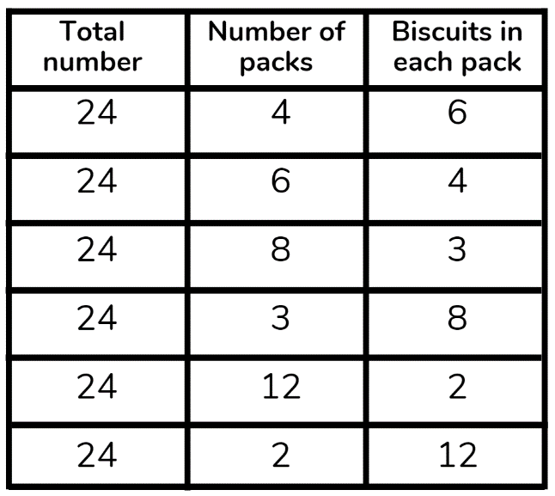
Complete tables like this one for 27,36 and 100. What do you notice?
Explanatory note: If we think about the number 8 we can determine that 8 can be a product of 1 and 8, and 2 and 4. As a result, the factors of 8 are 1, 2, 4, 8.
Therefore, when we are looking for solutions or solving problems that involve factors, only positive numbers, whole numbers, and non-fractional numbers can be considered
Complete the worksheet ‘Boxed Biscuits’ using the above information and applying your learning.
Remember to do your end of day reflection and wellbeing activities (see p. 7&9).

Day 2 activity 1: What if we could spread butter?
Notes for teachers and whānau
This activity explores the invention of spreadable butter. If ingredients are available, you could help the learner make their own butter.
Note our Inquiry focus for today is – “explore, investigate, and discover” which includes choosing and evaluating information, and thinking critically.

In this activity I am learning to: use information from an article to answer questions and design a comic strip showing a sequence of events.
What do I need?
- 30 minutes
- Access to this article https://www.roadshow.org/content/resources/NZscientists/illingworthNorris.php

Remember to start your day right (see p.8).

Instructions:
New Zealanders are famous for their curiosity and innovation. Sir Edmund Hilary was curious about whether a human could scale the heights of Mt Everest, Ernest Rutherford got curious about the atom – what if we could split a particle so small?
But did you know New Zealand Scientists, Robert Norris, and David Islington, also got curious about if you could get butter to spread, and hence developed the first spreadable butter!
This task will require you to read about the history behind spreadable butter, create a comic strip, and perhaps even try your hand at making your own butter!

Your task:
Read the following article (check your pack for a copy or access online here: https://www.roadshow.org/content/resources/NZscientists/illingworthNorris.php)
Design a comic strip that shows the sequence of events to creating spreadable butter. Showing how curiosity led to this invention!
Draw a table in your book (you may need more or less squares depending on how many pictures in your comic). The top squares are where you could write a brief description and the white part is where you can draw a picture.
As an extra – if the ingredients are available in your household – have a go at making butter! https://www.roadshow.org/downloads/Classroom_Activities/makingButter.pdf

Day 2 activity 2: Darwin, earthworms, and compost
Notes for teachers and whānau
Learners will read an article about the famous biologist Charles Darwin and put themselves in his shoes – thinking like a Scientist!
There is also a numeracy task to finish with, so if there is a calculator available in the home they may need it to complete the maths worksheet.

In this activity I am learning to: read an article on a research
What do I need?
- 30 minutes
- Transcript or https://www.sciencelearn.org.nz/resources/22-charles-darwin-and-earthworms
- Look in your pack for a copy of https://nzmaths.co.nz/resource/worms-work
- Calculator

Instructions:
The tasks up to this point have been related to food – so why earthworms?! Well did you know earthworms are the great recyclers of nature – and as humans we have used earthworms for our own recycling of food scraps. More and more people are using worm farms as creators of compost.
To start with we are going to look at a famous Biologist – Charles Darwin who got curious about these the creatures beneath your feet.
You will read an article and get curious!

Your task:
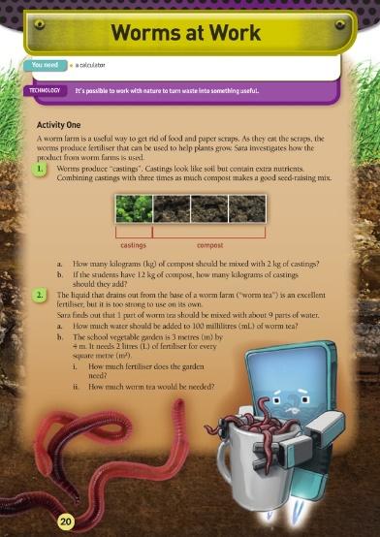
Read the article from Science Learning Hub on the next page. It explores Charles Darwin’s experiments and curiosities around earthworms.
After reading the article come up with 5 ‘What if’ questions you think Darwin wanted to know or tried to find answers for when investigating earthworms e.g. what if earthworms could hear?
Write your ‘what if’ questions in your home learning book or digital doc.
Complete the questions on the Figure it out task ‘Worms at Work’. You will need a calculator.

Charles Darwin and earthworms
https://www.sciencelearn.org.nz/resources/22-charles-darwin-and-earthworms
Charles Darwin is best known for his theory of evolution as set out in his book On the Origin of Species. He was a naturalist – an expert in geology, botany, and biology – whose interest in all things natural was apparent from a young age. His father wanted Charles to follow in his footsteps and become a doctor. However, Darwin couldn’t bear dissecting cadavers or watching surgery, so he quit.
His father remarked, “You care for nothing but shooting, dogs, and rat-catching and you will be a disgrace to yourself and all your family.” Darwin, of course, went on to prove his father wrong and became one of history’s most famous scientists.
Darwin’s association and interest with earthworms came shortly after his famous voyage on the HMS Beagle. His uncle showed him a spot in his garden where he had spread ashes and lime several years before. Darwin was amazed to see how soil cast up by earthworms had buried the substances. He went home and began a series of earthworm experiments that would go for the next 40 years. Darwin conducted both lab experiments in his study and billiard room and field investigations in his extensive gardens. He published his findings in 1881 in a book titled The Formation of Vegetable Mould through the Action of Worms, with Observations of their Habits. The book sold 6,000 copies in its first year, selling faster than On the Origin of Species had when it was first published.
Charles Darwin was fascinated by earthworm behaviour. He experimented with different types of food, placing the food on pieces of tinfoil to make sure the earthworms did not accidentally come upon the food by burrowing from below. He recorded that they preferred wild cherry and carrots, that raw fat was preferred to raw meat and that, “judging by their eagerness for certain kinds of food, they must enjoy the pleasures of eating”.
He tested their senses by exposing worms to lamps or candlelight and their sensitivity by holding “a poker heated to dull redness near some worms”. Earthworms do not have ears, but Darwin still tested their sense of hearing. He used a metal whistle and had his son play his bassoon loudly. Darwin even shouted at the worms but found that, if care was taken that his breath did not strike them, they were indifferent to noise. The earthworms also remained quiet when set on a table close to a piano, which was played as loudly as possible. That all changed, however, when the earthworm pots were placed on top of the piano. Darwin noted that earthworms are extremely sensitive to vibrations.
Darwin was curious to know if such lowly creatures were intelligent. He spent considerable time observing how earthworms pulled leaves into their burrows. They plugged the burrow openings, in Darwin’s opinion, to keep out chilled air. Darwin found they most often pulled leaves in by their tips, which is the most efficient method. When he substituted paper triangles for leaves, he noted the majority of earthworms drew them down their burrows by the apex. This led Darwin to state that worms have some degree of intelligence. He wasn’t convinced that all earthworms were equal, though. He placed leaves on the surface of pots kept in a warm room. These worms worked in “a careless or slovenly manner … they did not care about plugging up their holes effectually”. Darwin covered the pots with nets and left them outdoors for several nights. He wrote, “and now, 72 leaves were all properly drawn in by their bases”.
Darwin’s book also chronicled early New Zealand earthworm research. He mentions that worms appear to act in the same manner in New Zealand as in Europe, referring to earthworms’ ability to slowly cover objects left on the ground with their casts.

Day 2 activity 3: Science – earthworm investigation
Notes for teachers and whānau
This task requires the learner to find and observe earthworms. You may want to help them find a place in the garden that would be suitable for digging to find earthworms.

In this activity I am learning to: identify physical characteristics of earthworms; Discuss how observations and experiences can mirror those of real scientists
What do I need?
- 30 minutes
- Earthworms from the garden if you can find some
- Small jars or containers with lids, tongs, tweezers or small forceps
- https://www.sciencelearn.org.nz/videos/3-physical-adaptations-for-life-underground
- https://www.sciencelearn.org.nz/image_maps/24-inside-of-an-earthworm
- https://www.sciencelearn.org.nz/image_maps/27-outside-of-an-earthworm
- https://www.agresearch.co.nz/earthworms
- Magnifying glass, camera phone (optional)

Instructions:
Observation is an essential part of being a Scientist. Observation is more than just using one’s eyes to look at something. It may involve multiple senses and the use of instruments to go beyond human capabilities. This activity encourages you to take your time and observe how earthworms move and identify some of their physical attributes. Along the way, you are encouraged to think about how real scientists use observation to extend or modify their existing knowledge.

Your task:
Find some earthworms in the yard. Keep them in their usual medium (soil or compost) and out of direct sunlight until needed. Their skin needs to be kept moist so only have them out for short periods at a time. Earthworms can be gently handled. If you run your fingers on the underside of some earthworms you may be able to feel the setae even if you cannot see them. Observe them for a few minutes in their natural soil or compost so they don’t dry out. Jot down notes in your home learning book about what you have observed.
- Watch Physical adaptations for life underground, explore: Inside of an earthworm and Outside of an earthworm, and read The Great Kiwi Earthworm Survey.
- Write down any scientific terminology that may be new or unknown.
- Observe a second time, adding to your observation notes. Did you make changes to your initial observations? Did the additional information from the video or interactive change the way you made your observations or recorded your information?
This is how scientists work! They build their science knowledge through observation, with information from books or journals and discussions with the scientific community. When new evidence becomes available, scientists test it and, with time, may modify existing science knowledge. These changes are often very small!

Day 2 activity 4: Traditional knowledge and use of fungi
Notes for teachers and whānau
This task is a reading task for learner that helps them identify key ideas and vocabulary in a text.

In this activity I am learning to: process key ideas and vocabulary from information.
What do I need?
- 30 minutes
- Access to: https://www.sciencelearn.org.nz/image_maps/72-matauranga-maori-fungi-as-food-and-medicine or the transcript below

Instructions:
This activity will see you finding out the different uses early Māori had for fungi growing in the forest. Not only was it a food source it also had very important medicinal properties.

Your task:
Read the information ‘Mātauranga Māori fungi as food and medicine’ some information is found in the interactive graphic, or you can simply read the transcript below.
Copy the grid below into your home learning book and complete after reading the article.
3 most important ideas | 3 things I already knew | 3 questions about this text | 3 key/new words
Mātauranga Māori: Fungi as food and medicine
https://www.sciencelearn.org.nz/image_maps/72-matauranga-maori-fungi-as-food-and-medicine
Images from Manaaki Whenua – Landcare Research
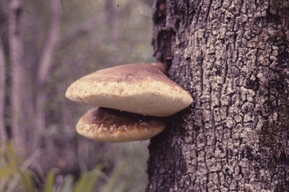
Te pūtawa, Laetiporus portentosus (pūtawa)
The pūtawa fungus feeds on the wood of living beech trees in Tāne-mahuta. Its fruitbodies are bracket shaped and often form high up on trunks. They grow quickly to a large size, but only last a few weeks to months before becoming old and falling. When collected on the ground, they need to be dried out before they can be used.
For medical use, pūtawa was cut into flexible strips and used to protect wounds. A hole larger than the wound was cut in the strip, and the pūtawa was tied in place as a protective pad.
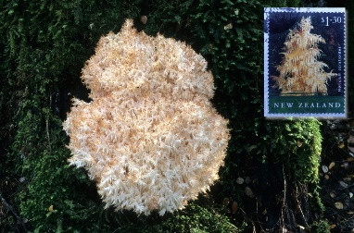
Fungus icicles, Hericium sp. (pekepekekiore)
Pekepekekiore has soft and fragile fruitbodies that look like hanging coral or icicles. This fungus feeds on dead wood, and its fruitbodies form only on softened, well-rotted trees. There are few reports of our ancestors eating pekepekekiore, but a closely related fungus in Asia is widely eaten. Hericium erinaceus is a delicious and popular mushroom grown on sawdust in several Asian countries. Small trials have recently started in Hawke’s Bay to cultivate pekepekekiore for restaurants. Recent research suggests that Hericium sp. may have potential as an extract for modern medicines and health. They were featured on a NZ$1.30 stamp in 2004.
Usnea species, (angiangi, hawa)
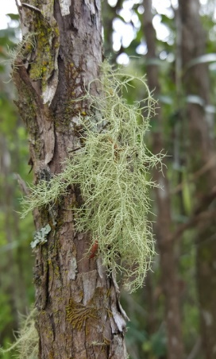
IMAGE: Mikey Watson, CC BY-NC 4.0
A number of lichens (fungi) and mosses (plants) were collected by our ancestors for use as a soft covering for wounds and to stop bleeding. Angiangi and hawa are names that may refer to several different kinds of lichens and mosses found in Tāne-mahuta. A lichen is a fungus that has partnered with tiny cells of algae. The fungus gives a home to these plant cells that can use light to produce sugars for use by both the algae and the fungus. So lichens can live in harsh places, even on concrete footpaths, fence posts, and roads, where neither the fungus nor the algae could live on their own. Mosses are not fungi at all. They are plants.
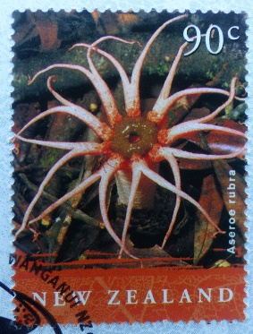
Flower fungus, Aseroe rubra (puapuatai)
Looks pretty, smells awful! This bright red fungus looks like a flower or maybe a starfish? It is found on the ground in Tāne-mahuta and probably was not eaten often. When fully formed, the red arms of puapuatai are covered at their base by a dark slime that smells like rotten meat – this is one of the stinkhorn fungi. The slime attracts flies that feed on it and so spread the spores. It is likely that puapuatai was only eaten in its young egg-like stage before the egg hatches and the smelly red arms expand.
Today, puapuatai is not common, but a related red stinkhorn fungus has become common on mulch in home and public gardens. This also has red arms and a bad smell. It is not native to Aotearoa, however, and is probably not edible. Why do you think the fruitbody of this fungus, the puapuatai, is red and has long petals or arms?
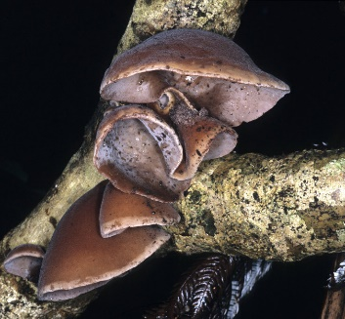
Wood ear, Auricularia cornea (hakeke, hakeka)
Fruitbodies of hakeke grow on wood and look like a thin soft rubbery ear. There is no stalk or gills. Instead, the upper surface is hairy, and spores form on the smooth lower surface. In Tāne-mahuta, hakeke is common on many kinds of dead wood, like tawa and māhoe, and can be collected during spring, summer, and autumn. When old, it dries out and becomes hard. Its taste is not much, though it does have a soft crunch when cooked and eaten. It was often cooked with vegetables and other foods to give it flavour. It is thought that this was only eaten when other foods were scarce as is suggested by a waiata by Sir George Grey in Ko nga moteatea, me nga hakirara o nga Māori in 1853.
A song about famine, what, what shall we eat?
Wood ear fungus that clings to the karaka or, convolvulus that stretches over the land?
Who will dig the convolvulus in the winter?
Hakeke is the only fungus from Tāne-mahuta that has been collected and exported overseas. Our ancestors including women and children collected and dried it for the export fungus trade to China. It thus became an important source of income, especially from 1870–1900. From 1872–1883, almost 2,000 tons (dry weight) was exported – an enormous amount considering that hakeke loses 90% of its fresh weight on drying. Like tawaka, hakeke was also sometimes given to invalids who were “recovering from poisoning by karaka or tutu”.
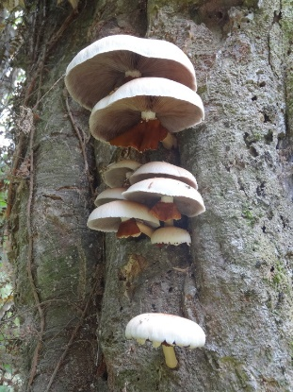
In Chinese and Asian medicine, hakeke has multiple uses including for colds and fevers by reducing the heat of the body and to strengthen blood vessels and the cardiovascular system. Forests in China also contain hakeke, and a method for cultivation was developed there on sawdust in bags. As a result, the export trade of hakeke from Aotearoa to China has been replaced by importation of hakeke from China and other Asian countries where it is now commercially cultivated. Today, it is rarely collected in Tāne-mahuta but is readily available in Aotearoa in Asian food shops.
Poplar mushroom, Agrocybe parasitica (tawaka)
This large mushroom (up to dinner-plate size) grows on living tawa and other trees, often appearing high up on the tree trunk in late summer to autumn. The mushroom has a long stalk with a hanging skirt that is coloured brown because it is coated with brown spores. When the mushroom is young in the button stage, this skirt is also attached to the edge of the cap covering the brown gills.
In addition to its use as a food, cooked tawaka was also considered to have medicinal benefit, reportedly being given to patients suffering fever and for health of expectant mothers. Tawaka was also given to invalids who were “recovering from poisoning by karaka or tutu”. On the other hand, there was an alleged negative impact of those who had eaten tawaka who then entered a garden growing gourd plants, apparently causing gourds to decay or fail to mature. Fishing success was also reduced for those who had consumed tawaka.
Puffball, Lycoperdon utriforme and Calvatia gigantea (pukurau)
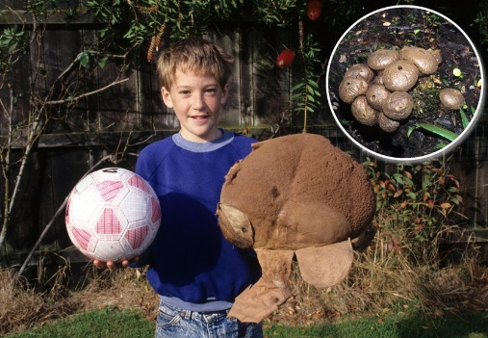
There are different kinds of pukurau, some growing in Tāne-mahuta and others on farmland. Their hyphae feed on plant matter in the soil. When the moisture and temperature is right, the puffball fruitbody grows rapidly above the soil surface – sometimes up to a very large size. Edible kinds were eaten when young and firm and when the inside of the puffball is white. Later, the inside part softens and turns brown and powdery as thousands of spores develop. The spores are spread in the wind after being puffed out of the puffball by the impact of raindrops or an animal. Pukurau were also used by our ancestors in medicine, for example, to stop bleeding from wounds and for pain relief from scalds and burns. Recent research suggests that Calvatia gigantea may have potential as an extract for modern medicines and health.
Pukurau grows widely in Aotearoa but may have been especially common around the Tukituki River in Hawke’s Bay. The name of the Hawke’s Bay town Waipukurau is linked to the fungus pukurau. Tūpuna tell of pukurau growing on a nearby hill pā. These were collected and taken to a pool known as Te Waipukurau-a-Ruakūhā to soften or treat the flesh.
Remember to do your end of day reflection and wellbeing activities (see p. 7&9).

Day 3 activity 1: What if we changed this food
Notes for teachers and whānau
This is a fun activity for learners to use their creative thinking and come up with a way to modify a common food item.
Note that our Inquiry focus for today is "making meaning" which includes analysing data, organising, and sorting information, summarising, synthesising, making connections/conclusions, building deeper understandings, and thinking critically.

In this activity I am learning to: identify physical and/or chemical changes that take place when different foods are combined
What do I need?
- 30 minutes
- Coloured pens/pencil/crayon
- Device/access to internet for finding a food item
- Optional: https://www.youtube.com/watch?v=ErDkRerNKvQ

Remember to start your day right (See p. 8)

Instructions:
Molecular gastronomy is the branch of food science that focuses on the physical and chemical processes that arise when cooking and often sees chefs create some very cool (sometimes literally!) meals.
This task will require you to get thinking about ways you could change the physical and chemical attributes of common foods to come up with something new!

Your task:
Find an example of a dish or food that is made using molecular gastronomy – if you have access to a device you could google this or maybe ask a household member, friend, sibling if they know of any.
Describe the food item and how it was made– can you identify what chemical or physical changes had taken place?
Choose a common food item of your choice e.g. blueberries, ice cream, sandwiches.
Get curious about how you could use these foods to create something amazing by using out of the square thinking e.g. What if we made powdered ice cream?
In your home learning book
- Describe your new food item, what it was originally and what it is now
- Explain the physical and chemical changes that the food item has undergone
- Draw a picture of your food item.
Watch this you tube clip for inspiration https://www.youtube.com/watch?v=ErDkRerNKvQ

Day 3 activity 2: Traditional cooking and preserving
Notes for teachers and whānau
In this activity learners will read an article and complete an Anticipation guide. This helps the learner establish what they know and what they need to learn before they read a text.

In this activity I am learning to: establish what I know and need to learn before reading a text
What do I need?
- 30 minutes
- https://teara.govt.nz/en/maori-foods-kai-maori/page-2

Instructions:
Your task is to make meaning from a text, and strategies such as the table below can help you identify what you know and what you might need to learn before reading. It also helps you think about whether you agree or already know the facts you are reading and how to re write something into your own words. When reading this text, consider that some of these customs have evolved over time, and many are still practiced today.

Your task:
Before reading
- Read the following statements in the grid below
- Decide whether you agree with them or not
- Tick ‘agree’ or ‘disagree’ in the opinion columns
After reading https://teara.govt.nz/en/maori-foods-kai-maori/page-2
- Decide whether what you have read supports your opinions
- Tick ‘agree’ or ‘disagree’ in the finding columns
- Provide evidence but in your own words.
Statement | Opinion  Agree Disagree | Finding  Agree Disagree | Evidence  Explain in your own words
- Early Māori never cooked in the same building they slept in
- Hangi has in some places been cooked using geothermal steam
- The moon has no impact on how food is cooked or prepared
- Fermented food would not be very nice or appealing to eat
- Early Māori used wooden bowls on the fire to boil water
- Early Māori would waste very little food sources

Day 3 activity 3: Numeracy – birthday treat
Notes for teachers and whānau
This is a worksheet from the NZ maths – Figure it out series. Learners will be solving addition, subtraction, multiplication, and division of money problems.

In this activity I am learning to: solve problems using addition, subtraction, multiplication, and division of money.
What do I need?
- 30 minutes
- Copy of https://nzmaths.co.nz/sites/default/files/BirthdayTreat.pdf

Instructions:
This activity encourages you to develop your problem-solving abilities.

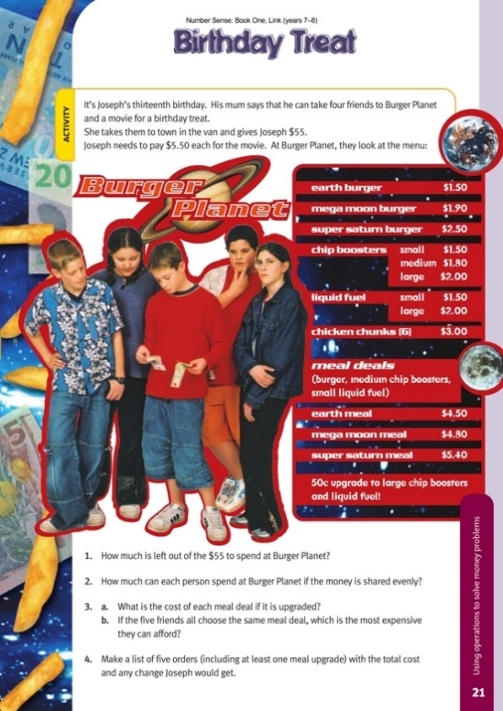
Your task:
Complete the worksheet “Birthday Treat”.
Write your answers in your home learning book.

Extra: Develop some new types of burgers for the burger planet menu, along with different prices. Use these new burgers to work out different options for the 5 boys.

Day 3 activity 4: Food science – making Ice cream
Notes for teachers and whānau
This activity will require a few ingredients below and the use of the kitchen.
If these ingredients aren’t available learners can watch a video of the process and identify the physical and chemical changes taking place.

In this activity I am learning to: follow a recipe; observe and identify physical and chemical changes during a process
What do I need?
- 30 minutes
- Equipment: Measuring spoons and measuring cup, tea towel, timer
- Ingredients: Sugar, milk or cream, vanilla essence/extract, salt, ice cubes
- Small zip lock bags or equivalent (x2) and large zip lock bag or equivalent (x2)
- Optional video https://www.youtube.com/watch?v=5ub_5_b6yOQ

Instructions:
Everyone loves ice cream right?! But did you know there is actually a lot of science involved in making ice cream. This activity will require you to make your own ice cream and investigate which temperature and factors makes it into a creamy treat!

Your task:
If you don’t have ingredients or equipment watch the video https://www.youtube.com/watch?v=5ub_5_b6yOQ and answer the questions in your book:
- What was the role of the salt in this recipe?
- What factors do you think are important in making ice cream?
- What are some physical and chemical changes occurring during this recipe?

Instructions
- In each small bag, place one tablespoon of sugar, ½ cup of milk or cream, and ¼ teaspoon of vanilla extract. Seal both bags well.
- Add 4 cups of ice cubes to one of the larger bags. Add ½ cup of salt to the bag.
- Put one of the small bags you prepared into the large bag with the ice cubes. Be sure both bags are sealed shut.
- Wrap the bag in a tea towel, shake the bag for 5–6 minutes. Feel the smaller bag every couple of minutes while you shake it, observe what is happening.
- Now add 8 cups of ice cubes to the other large bag, but this time do not add any salt to it. What do you think will happen without using salt?
- Put the other small bag you prepared into the large bag. Seal both bags.
- Using a tea towel shake the bag for 5–6 minutes, as you did before. Again, feel the smaller bag every couple of minutes while you shake it, and observe it.
- Compare how cold the ice cube bags feel. Does one feel colder than the other?
- If you successfully made some ice cream, enjoy!
Remember to do your end of day reflection and wellbeing activities (See p. 7 & 9).

Day 4 activity 1: STEM and inquiry – brainstorming
Notes for teachers and whānau
This task involves asking household members about their cooking experiences and brainstorming ways to make cooking easier in the home. During today’s activities we are encouraging the learner to take photos of their learning journey so they can use them for the final presentation
Note today our Inquiry focus is “Going further, deeper”. This may include promoting opportunities to engage further and dive deeper through discussions, provocations, exploring further contexts, taking action, or thinking critically and drawing conclusions.

In this activity I am learning to: identify challenges/problems in an everyday situation e.g. cooking
What do I need?
- 30 minutes
- Home learning book

Remember to start your day right (See p. 8)

Instructions:
Are there any challenges in the kitchen when cooking/preparing meals? When we are cooking, especially for multiple people, we often encounter problems/challenges that hinder the process. Cherry pitter, nut grinder, egg slicer – over time, people have come up with some interesting devices to make cooking easier, faster of just more enjoyable. This task will require you to unpack an example of one of these devices and come up with some of your own interesting kitchen helpers!

Your task:
Look at the photos of the gadget. Write your answers to the questions in your book.
- What was the problem/challenge that it was trying to solve?
- How do you think it works?
- Why is this useful/not useful?
- Who do you think this was intended for?
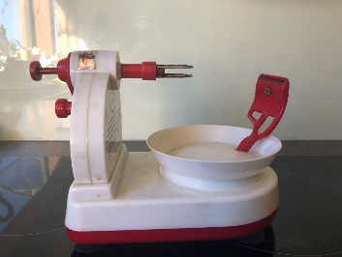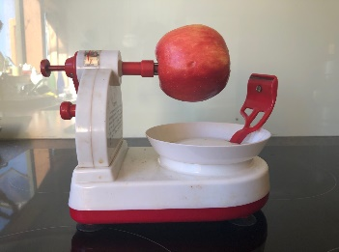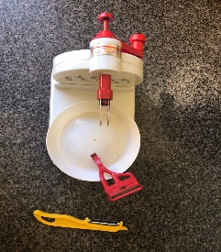
Brainstorm some things that could be made easier for cooks in the kitchen – think of things you could potentially create or design.
Gather ideas from household members or those that usually do the cooking!
e.g. “What if we had a device that could slice a whole block of cheese in one go...”
Write your ideas in your home learning book.

Day 4 activity 2: STEM and inquiry and literacy – plan
Notes for teachers and whānau
Learners will design and plan something that will help in the kitchen – choosing something they brainstormed above. This ‘project’ and presentation of the project will continue over into day 5 as well.
Projects can be defined as a planned undertaking to accomplish a specific aim and have been a valuable part of learning for a long time. Projects are often part of a larger body of work, with other types of learning building towards the final project. https://elearning.tki.org.nz/Teaching/Future-focused-learning/Project-based-learning

In this activity I am learning to: design and plan a gadget that has a specific purpose or could be used to overcome a particular challenge
What do I need?
- 30 minutes
- Home learning book

Instructions:
This task requires you to go deeper and come up with a plan for a gadget you brainstormed above that could make life easier in the kitchen.
Planning is an important part of any project as good planning and organisation will more likely result in a successful outcome of what you are trying to achieve!

Your task:
Choose one of your ideas from your above brainstorm – e.g. ‘what if we had a device that could slice a whole block of cheese in one go’
Write a list of materials for your idea
Draw (or design digitally) a labelled diagram of your idea.
Write three paragraphs in your home learning book which answer the following questions.
- 1.What was the problem/challenge the gadget could help overcome?
- How will it work?
- What are some key attributes that have been considered – is it safe to use? Portable?
- Why will it be useful? Who will use it?

Reflect on your planning process – what could be helpful when planning? Having a flow chart or tool to show progression? Talking and discussing it with others?

Day 4 activity 3: STEM, inquiry and literacy – create
Notes for teachers and whānau
In this activity learners can try and either make their gadget or a model – whatever they can manage to do at home. They made need your help accessing materials that could be useful for the object itself or the model – e.g. cardboard, plastic lids and containers, ice block sticks, blue tack, cellotape, glue etc.
If they are using sharp objects this may need to be done under supervision– so please ensure safe practice.

In this activity I am learning to: make a gadget or model of a gadget that is useful to overcome a problem or challenge.
What do I need?
- 30 minutes
- Craft or building materials – cardboard, plastic lids and containers, ice block sticks, blu tack, cellotape, glue, stapler, craft knife, scissors (consider safety) etc.
- A space to construct
- Smartphone to take photos (optional)

Instructions:
Can you create your gadget? If you don’t have the actual materials can you create a model/prototype using cardboard, plastic, arts and crafts, wood any bits and pieces around the house. You may need glue, stapler, sticky tape etc to create.
Ask a household member to help you source materials and construct.

Your task:
Have a go at constructing your actual design or simply a model out of simple materials.
Use any material you have available
Ensure safe practice when you are using any sharp objects e.g. scissors, craft knives etc.
If available, take a photo using your phone camera and upload your photo to your home learning book. This will be helpful for day 5 activities.

Day 4 activity 4: STEM and inquiry – Improve
Notes for teachers and whānau
This task requires access to Home Learning TV online or on TVNZ.
The learner will evaluate and improve their original gadget. They may ask someone in the household/ whānau for feedback.

In this activity I am learning to: evaluate my model or gadget; gather and use feedback to improve my model or gadget; refine my model or gadget if needed
What do I need?
- 30 minutes
- Your gadget/model from above
- Video from Home learning tv https://www.tvnz.co.nz/shows/home-learning-tv/episodes/sage-9-11-e283
- whānau or household member to give feedback

Instructions:
From the last activity you will have made a gadget or model of a kitchen gadget that could be used to overcome a challenge.
This task requires you to evaluate your gadget or model, gain feedback and revise or modify if needed.

Your task:
Write the answers to these questions in your home learning book.
- Did your gadget work or come together as you hoped? Why/Why not?
- How could you make improvements?
- What would you do differently?

Watch this video from home learning tv on “Using feedback to step up our innovations” (15 minutes)
After watching this video, Gather feedback from a member of your household or whānau about your device/creation/model.

Remember to do your end of day reflection and wellbeing activities (see p. 7&9).

Day 5 activity 1–2: Presentation
Notes for teachers and whānau
Learners will be creating a poster (or equivalent) to summarize their learning and design process from the above activities. They may require some paper and materials to physically make the poster if they are available. Some may prefer to create it digitally.
Note that today our Inquiry focus is “Present– share learning about the theme” which includes thinking about who the audience is and considering different ways of communicating learning for example, presentation, video, poster, etc.

In this activity I am learning to: create a poster or presentation which communicates a learning process to others
What do I need?
- 30 minutes
- Resource or link on how to put together an informative poster
- Poster paper (A3 size if available), or white paper
- Computer or device (optional)

Remember to start your day right (See p. 8)

Instructions:
Having an amazing design is no use unless it is communicated to others. The next two activities will help you to develop effective presentation skills and then put together a presentation based on your learning this week. A poster/PowerPoint/brochure can convey a message or report your journey or process to others.

Your task:
Create an informative poster, PowerPoint, brochure about your learning process and journey over the last couple of days to creating your kitchen gadget or model.
Your poster/presentation needs to include the following
- Appropriate background information: challenges in the kitchen, history of cooking/preparing, using tools – you can use any of the information from previous day’s activities for this aspect.
- The aim of the project
- The initial planning (this can be copied/pasted from the activity above)
- Any photos you have taken/drawings/diagrams
- Evaluation and Feedback you gathered
Along with this information your poster will have to
- Look appealing
- Display your information simply but effective
- Contain the right balance of text and visual data

Day 5 activity 3: Present!
Notes for teachers and whānau
It would be great if learners could have some time with whānau, household members, teachers, and peers (online if appropriate/available) to present their work from the last week.
Talk to the learner and set aside a time to engage with them and listen to their presentation.

In this activity I am learning to: present confidently to an audience
What do I need?
- 30 minutes
- Poster or presentation from above

Instructions:
There is no point learning, researching, creating if you can’t share it with anyone. Presentation is a key part of the design process so this task will require you to find someone or an audience to present your poster (or equivalent) to.

Your task:
Present your poster or presentation you finished to a member of your household/ whānau/class.
Remember the following
- Practise makes perfect set some time aside before presenting to an audience to run through your presentation. This will give you confidence that you know your stuff!
- Create a story – what is the necessary background information and what do you want the audience to know? What led you to your design?
- Be welcoming – stand beside your poster/presentation and engage with your audience with a smile
- Engage with your audience – be enthusiastic about your learning. If you find your project interesting so will your audience
- Ask your audience if they have any questions about your work/design/process

Day 5 activity 4: Reflecting
Notes for teachers and whānau
This final task is simply learners reflecting on the learning from the week. What they learnt, what they enjoyed, what they would do differently. They will do this in the form of a letter to someone who cares about their learning.

In this activity I am learning to: reflect on the week’s learning in the form of a letter
What do I need?
- 30 minutes
- Home learning book
- Pen or pencil
- Paper for writing a letter

Instructions:
There are people in your life who really care about your learning, that could be a grandparent, parent, sibling, family friend, neighbour, teacher, or friend.
Reflect on your learning this week by way of a letter to this special person.

Your task:
Think of someone in your life who cares about your learning. Write a letter about your week of learning, expressing what you enjoyed, didn’t enjoy, what worked well, challenges and problems etc.
Use these prompts to help you write your letter.
- I feel good about…
- I used to… but now I…
- Two things I will remember about what I have learnt over the last week is..
- A strategy that really helped me learn better is…
- If I could do something again differently, I would…
- One thing I will remember to do in the future is…
- One thing I really want to learn is...

Remember to do your end of day reflection and wellbeing activities (See p. 7&9).

Context 2: How does ... work?

The next five days indulge our curiosity by looking at how different things work.

